Ahmed Kargbo
Intro To Cybersecurity
(CYSE 300) Prof. Quinn

Tea App Data Breach (2025)
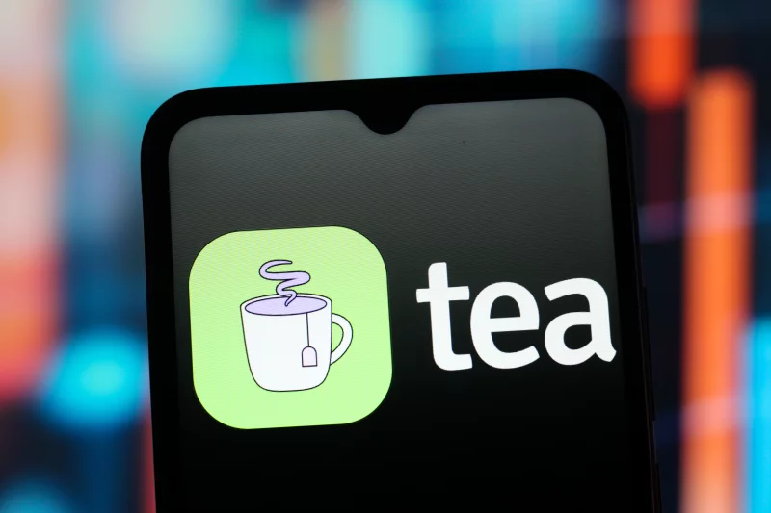

The Tea app is a U.S based dating app that was created in 2023, but unlike other dating apps like Tinder, Bumble, and Hinge where you try to find a match with other people, the Tea app was meant to be used for safety and giving out dating tips. The Tea app is a gender based app which only accepted females and allowed them to share anonymous information about men in the dating pool, identify sex offenders, identify abusers, allow women to give each other dating tips and advice just to have each other’s backs and form a sense of community. In July of 2025 the Tea app became the most popular app in the U.S following social media exposure and trends, it ranked #1 for the most downloaded app in July but its sudden rise to fame also became the app’s demise. After reaching new heights of fame the Tea app operated more like a social media platform rather than what it was created to do which was to help women in the dating pool.
The name ‘Tea app’ comes from the slang word tea, which basically means to spill tea aka to gossip and after reaching stardom the app became just that and was flipped to a gossiping platform. Upon its new found fame, the app stuck to its true identity and remained gender based still only accepting women. At this point, users were allowed to post pictures and other users could interact with these posts by commenting, liking, reposting and sharing etc. Users of the app used the platform to give insights on their dating lives, talk about their sex life, talk about their current and past partners etc etc. Obviously nothing could go wrong when you start telling strangers about your personal life and dating encounters haha…. WRONG!!! The app lost its identity and instead of a safety tool for women it became a weapon to slander and gossip about men. Women will for example post a picture of a guy and caption it with something like “whats the tea on him” and others would reply stating their personal experiences with said guy posted, this led to the downfall of many relationships, and conflicts even shifting to other social media platforms such as Instagram and Twitter etc. Despite all the chaos and drama one thing about the Tea app stayed the same, it kept all its users female only and restricted men from joining the platform.
As the app continued to grow, the more drama filled the app became and it continued to anger a specific target audience, MEN. Men who were posted on the app were angry they couldn’t do anything to defend themselves so this started the downfall of the Tea app. The way the platform remained female only and filtered out genders was by having all users go through a thorough application process. In the application process users were to enter their full government name, submitting a selfie, and providing a government or state issued ID such as a driver's license or a passport to confirm their identity and ensure their gender. Afterwards, all this information was reviewed by a team of humans since the platform didn’t want any fake ids or posers to slip by. All the information was meant to be deleted after review but it was instead just sent to a storage folder where all information remained and this here is a huge red flag in terms of data security and was the main vulnerability. As fast as the app grew it fell just as fast because in the same month it charted #1 in the U.S was the same month the breach took place. Towards the end of July, the 25th to be exact, the breach started. During the breach about 72,000 images were leaked; these images contained private pictures uploaded by users, government IDs, selfies that were meant to be used for verification; this all occurred after hackers were able to access an archived data storage system which had little to no security. All the images found on the data storage system were uploaded to 4chan for the public to see and this meant this was a targeted attack and it was likely an act of retaliation towards the gender based audience.
The vulnerabilities in this breach were exploited due to the recklessness of the creators of the platform. The platform stored sensitive user data in a cloud storage bucket under the platform Firebase and all the information was publicly available and the storage bucket lacked proper authentication and none of the data was even encrypted. Attackers simply followed the storage path which is what led to the mass extraction of all the data stored. Researchers also discovered that there was a lack of urgency from the Tea platform after the incident occurred, it was discovered that the platform failed to even conduct a detailed audit of all its data and infrastructure which led to a second breach a few days later. In the second breach hackers leaked over a million conversations between users which were supposed to be private. After the second breach the platform decided to disable the private messaging feature. After the breaches occurred a few days later on July 29, 2025, two class-action lawsuits were filed against the platform one for purging of sensitive information and the other accusing the company of breaking its promises of anonymity and by August more and more lawsuits piled up.
As of right now these cases are still being dealt with as this issue is very recent but the app that was meant to provide safety for its users lost most of its credibility and the media hype has since been quiet. The platform could have simply encrypted all sensitive data during uploads and while in the storage bin. The platform could have also segregated its data instead of keeping it all in one place causing a chain reaction. Although end to end encryption wasn’t guaranteed or was never a promise by the platform, it was still a feature that could have been implemented and would have at least protected the private messages and user upload contents. Though the Tea app data is very recent and is still being researched, it is important to point out the founder of the platform Sean Cook. Plenty of people pointed out his lack of experience in the tech field and upon research it was discovered that his background was in Business and Marketing, Cook later got into the tech field in 2019 at California Berkley where he got into Software Engineering. According to his Linkedin Cook took a full-stack course and “learned HTML, CSS, Ruby on Rails, JavaScript, React, interacting with RESTful APIs, Heroku, Git, Python, MySQL” but this only lasted about the length of a semester which raised many questions. Many believe Cook is severely underqualified and doesn’t fully grasp the responsibility to be in the tech field which is why his incident response was very poor. As of right now the Tea platform is still on the app store and has added new features and is now emphasizing security.

References
Allan, D. (2025, July 28). The Tea app hack explained – how a data breach spilled thousands of photos from the top free US app, and what to do. TechRadar. Retrieved September 4, 2025, from https://www.techradar.com/computing/software/the-tea-app-hack-explained-how-a-data-breach-spilled-thousands-of-photos-from-the-top-free-us-app-and-what-to-do
Cook, S. R. [seancook1] (24) Sean Cook | LinkedIn
Mark, M. (2025, July 29). Tea app hit with 2 class‑action lawsuits after a data breach exposed private messages and 72 K images. Business Insider. https://www.businessinsider.com/tea-dating-app-two-class-action-lawsuits-following-data-breach-2025-7
Tea Dating Advice, Inc. (n.d.). About. Tea for Women. Retrieved September 4, 2025, from https://www.teaforwomen.com/about
Wise, A. (2025, August 2). Tea encouraged its users to spill. Then the app’s data got leaked. NPR. Retrieved from https://www.npr.org/2025/08/02/nx-s1-5483886/tea-app-breach-hacked-whisper-networks
Yu, Y.-J., & Kindelan, K. (2025, July 25). Tea dating advice app confirms hack, says 72 K images, including selfies, accessed. ABC News. Retrieved from https://abcnews.go.com/GMA/Living/new-dating-advice-app-tea-rockets-1-app/story?id=124067965

