Old Dominion University
CYSE 301 Cybersecurity Techniques and Operations
Assignment #4.2 Password Cracking

Alysia
Beckles

Below is the snippet of a sample lab report.
Task A
- Establish a reverse shell connection to the target Windows 7 VM. Then use the hashdump command in the meterpreter shell to collect all user hashes?
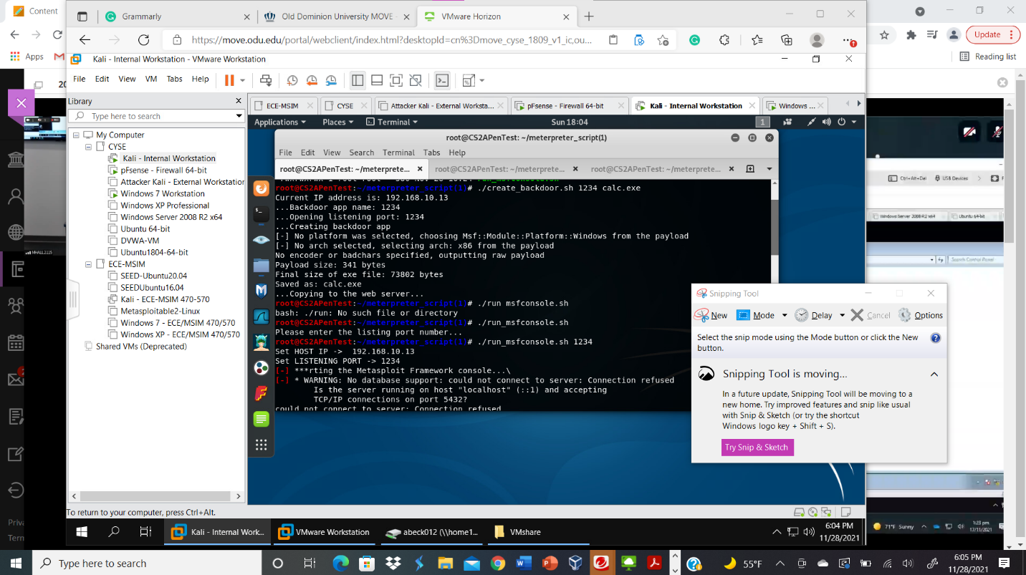
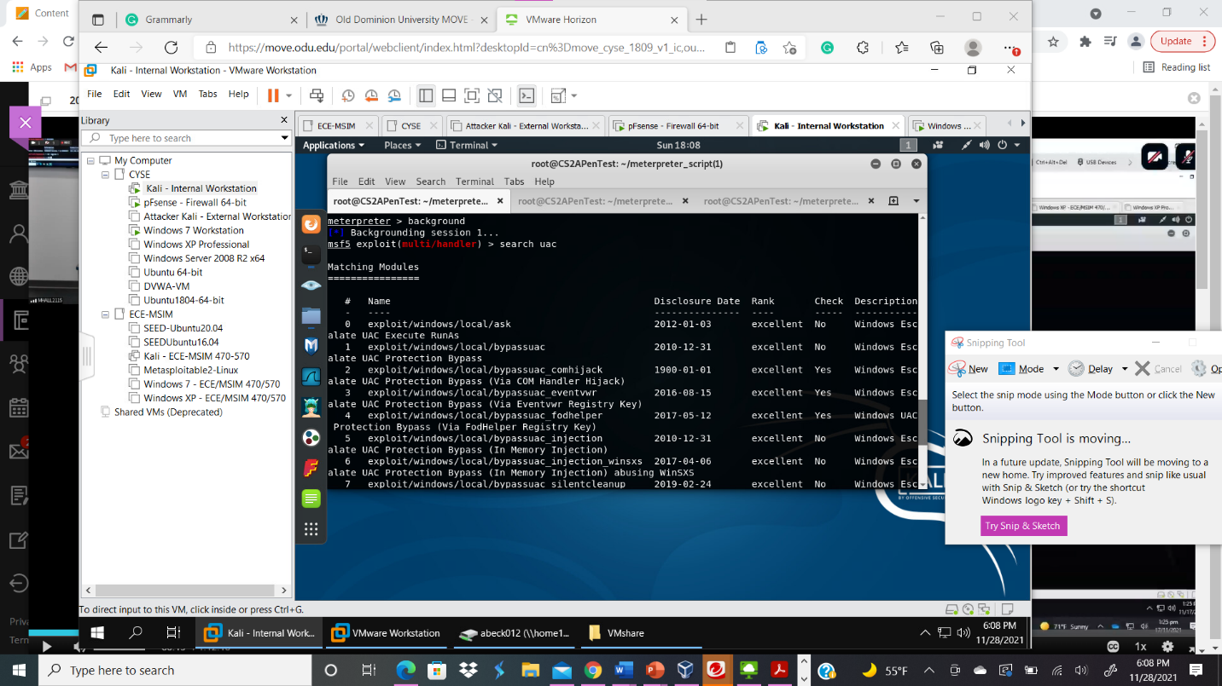
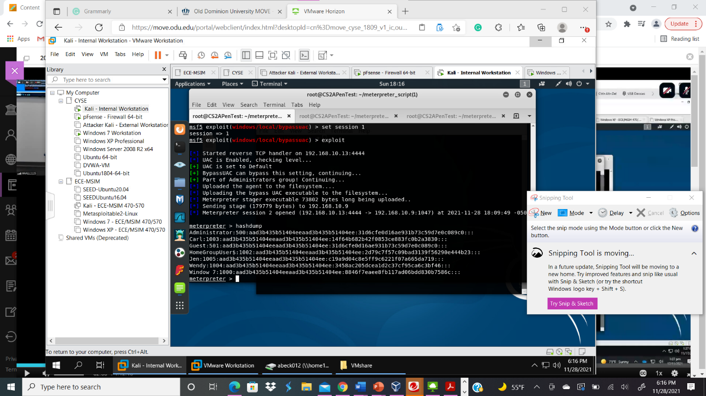
Your explanation goes here. For example:
Above I typed the script ./create_backdoor.sh 1234 calc.exe in order to establish a reverse shell connection that target the Windows 7 VM. I was able to set the listening port to 1234 and create a backdoor app and save it as a calc.exe file. Next, I typed the command ./run_msfconsole.sh 1234 to start meterpreter and set HOST IP and the listening port. Then, in order to gain access to the hashes from windows, I had to bypass the uac. First, I need to type background and type search uac to find the right uac to bypass. Next, I type set session 1 in order to set the current background session. Next, I type the command exploit and run the calc.exe file for the exploit to complete by typing 192.168.10.13/calc.exe in Windows 7 VM on Google. Finally, I type the command hashdump to obtain the hashes from windows.
- Save the password hashes into a file called “your_midas.WinHASH” in Kali Linux, then display its content. (You need to replace the “your_midas” with your university MIDAS ID?
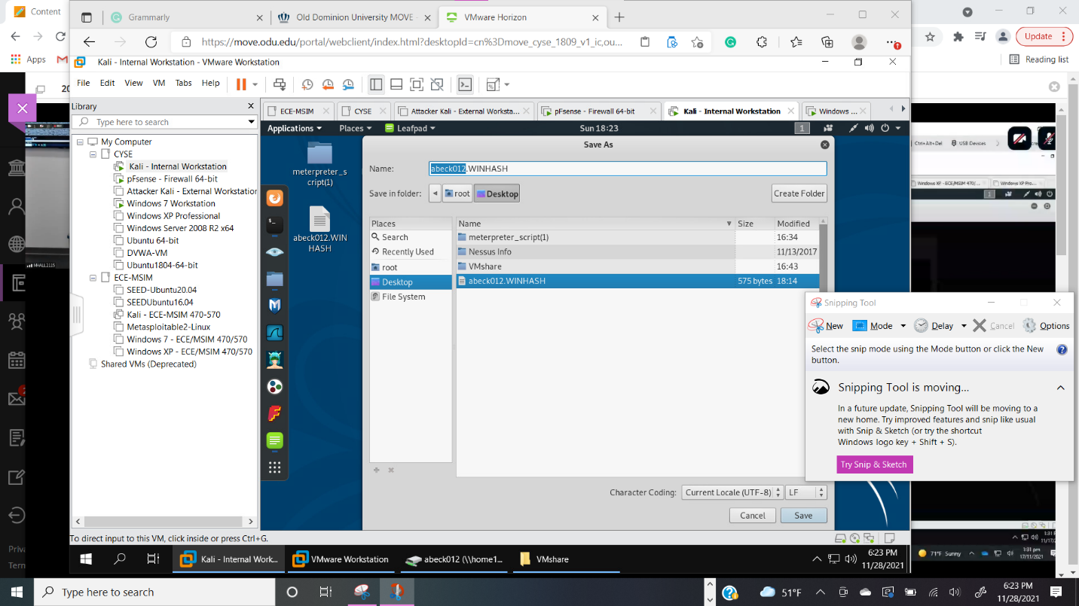
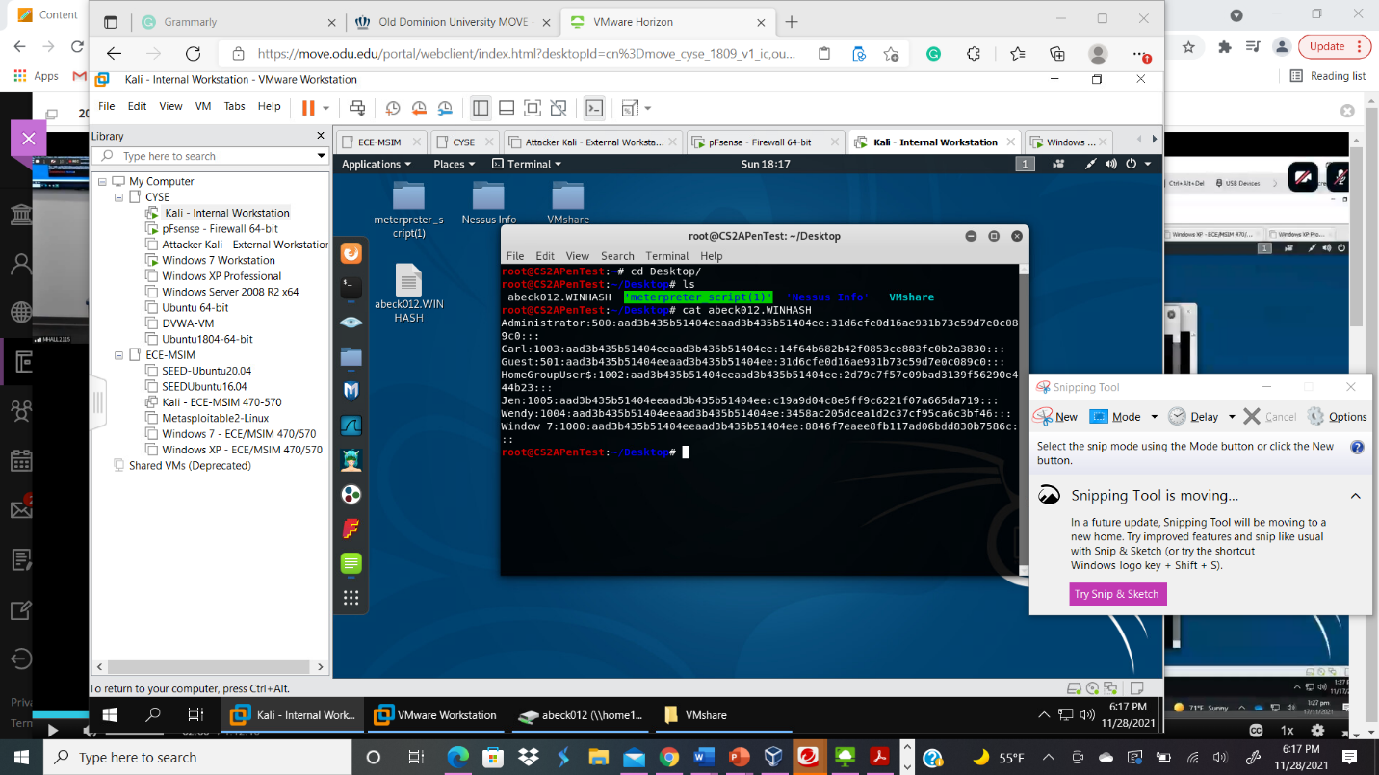
Your explanation goes here. For example:
In order to save the password hashes into the file abeck012.WINHASH, I opened leafpad and copy and pasted the contents from hashdump. Next, I clicked save as and typed abeck012.WINHASH, and put it under desktop. Then, I typed the command cd Desktop/ to change the directory and gain access to the abeck012.WINHASH file. Next, I type the command cat abeck012.WINHASH to see the contents of the file which were the hashes to the windows users.
- Run John the ripper for 10 minutes to crack the passwords (no need to crack all the passwords).
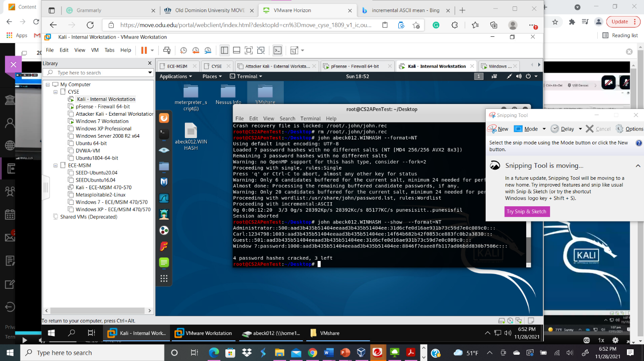

Your explanation goes here. For example:
In order to utilize the password cracker john the ripper to decrypt the hashes in the hash file abeck012.WINHASH, I typed the command john abeck012.WINHASH –format=NT. Then, I utilized the command john abeck012.WINHASH --show --format=NT to see the hashes I cracked from the abeck012.WINHASH hash file. I was able to crack four hashes, which were 500, 1234798,501, and password.
Task B
- Keep your meterpreter reverse shell active, and upload “Cain and Abel” to the target Windows 7 VM (under C: drive). Then create a malicious user with admin privilege in your meterpreter shell. Access this malicious user with a remote desktop.
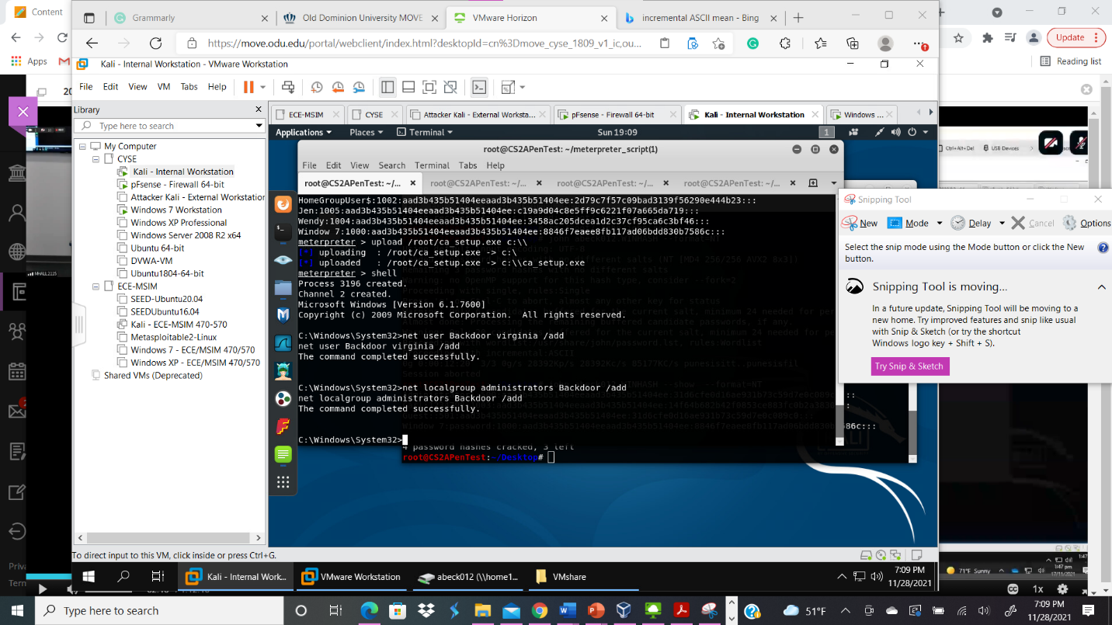
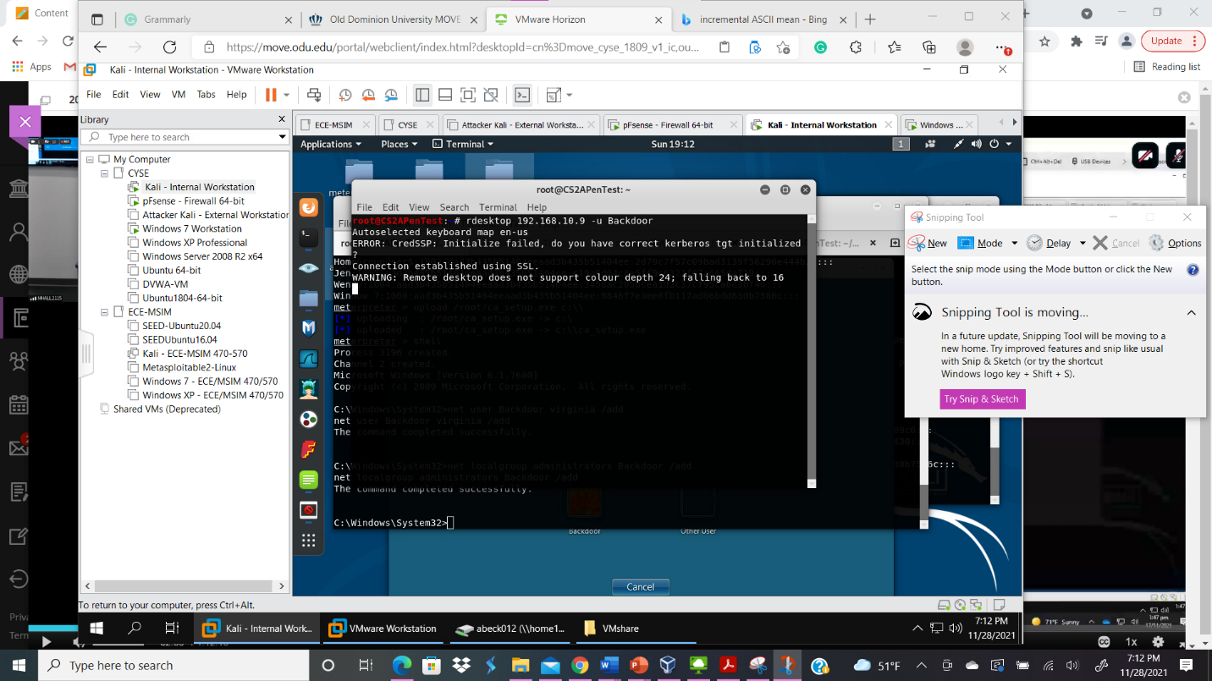
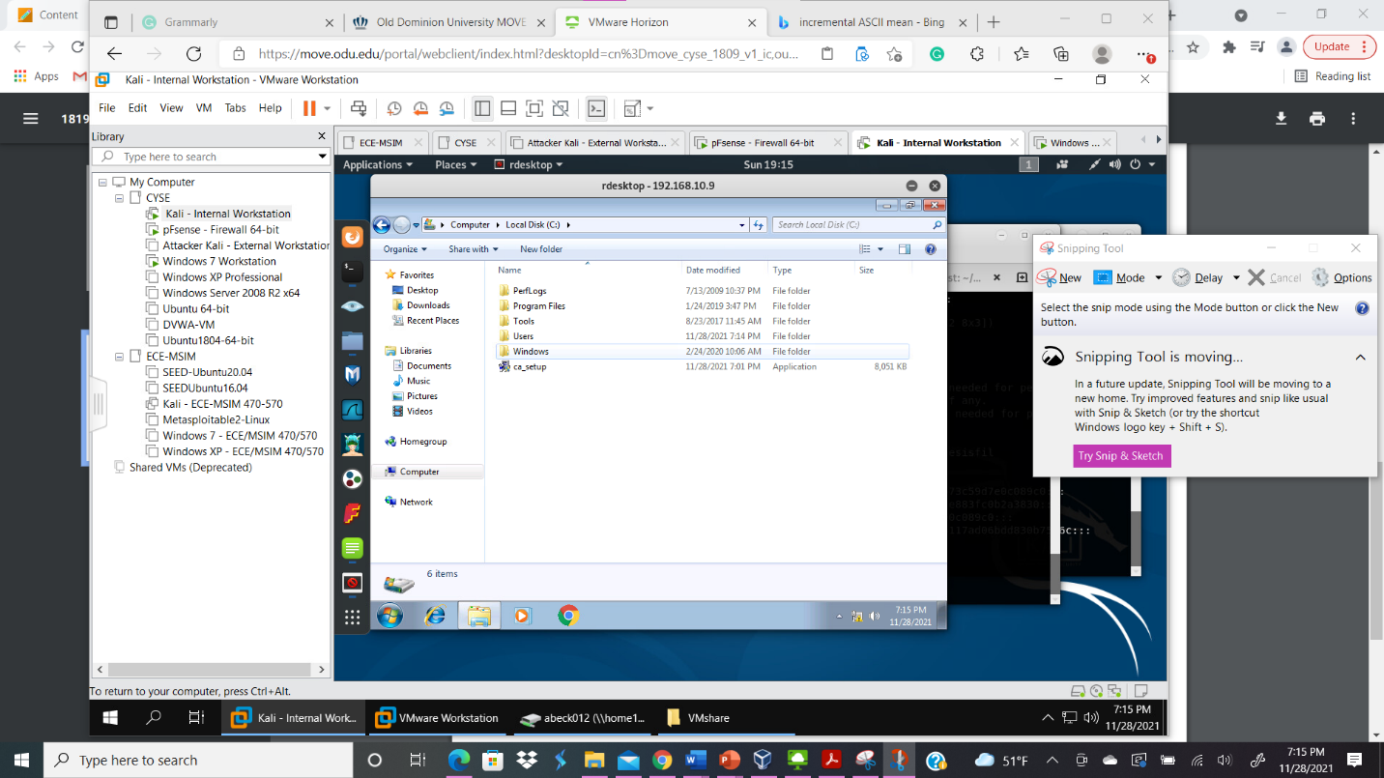
Your explanation goes here. For example:
In order to upload Cain and Abel, I kept my reverse shell active and uploaded it to the c drive by typing the command upload /root/ca_setup.exe c:\\. Next, I typed the shell command in order go into windows. Then, created a malicious user by typing the command net user Backdoor virginia /add to add the user to windows and create the password virginia. To elevate the Backdoor user privilege to admin in meterpreter shell I typed the command net localgroup administrators Backdoor /add. Finally, I was able to access the malicious user, Backdoor, with a remote desktop and go in the c drive.
- Install the password cracking tool, Cain and Abel, in the remote desktop.
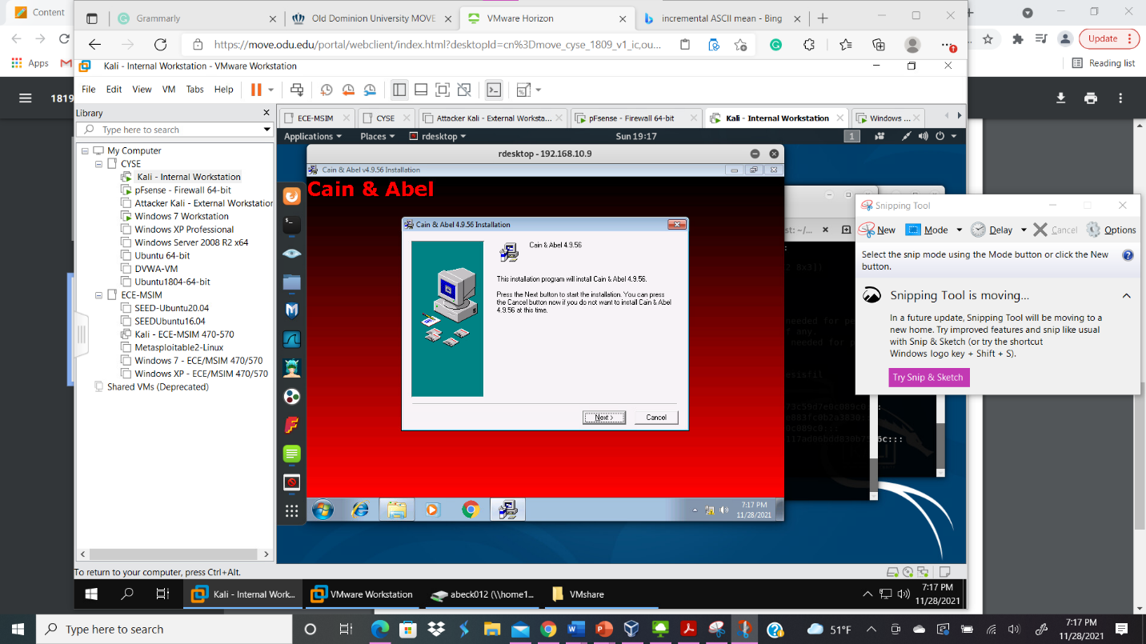
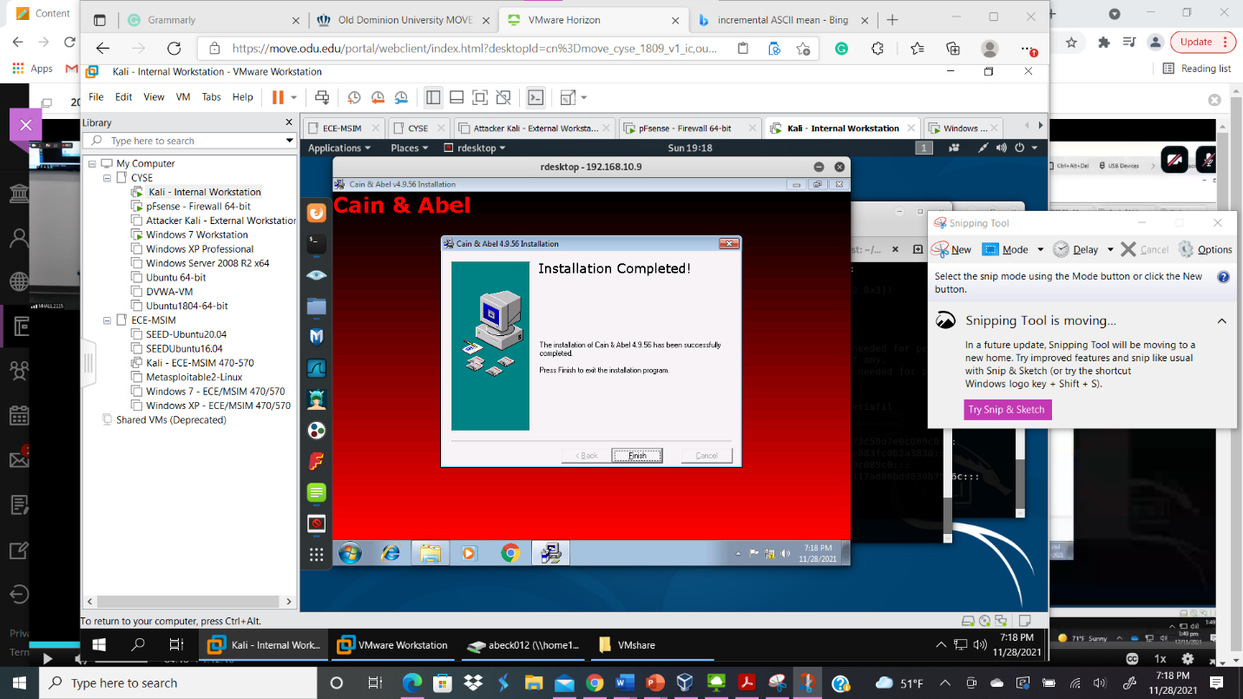
Your explanation goes here. For example:
I installed the password cracking tool, Cain and Abel in the remote desktop by clicking on ca_setup in the c drive.
- You need to implement BOTH brute force attack and dictionary attack to crack the accounts you created in the previous step. You should leave the password cracker run for at least 10 minutes. (no need to crack all the passwords). How many passwords have been cracked?
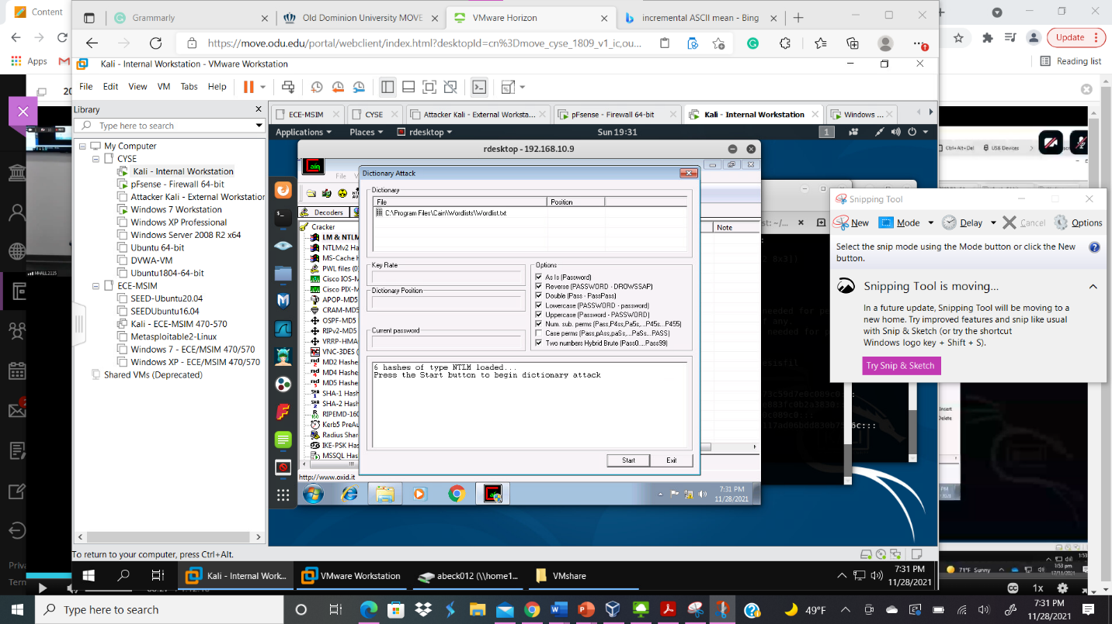
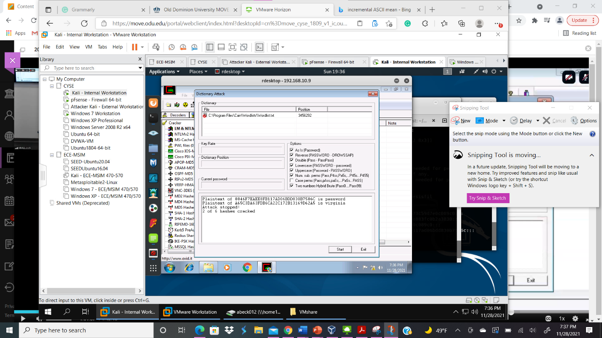
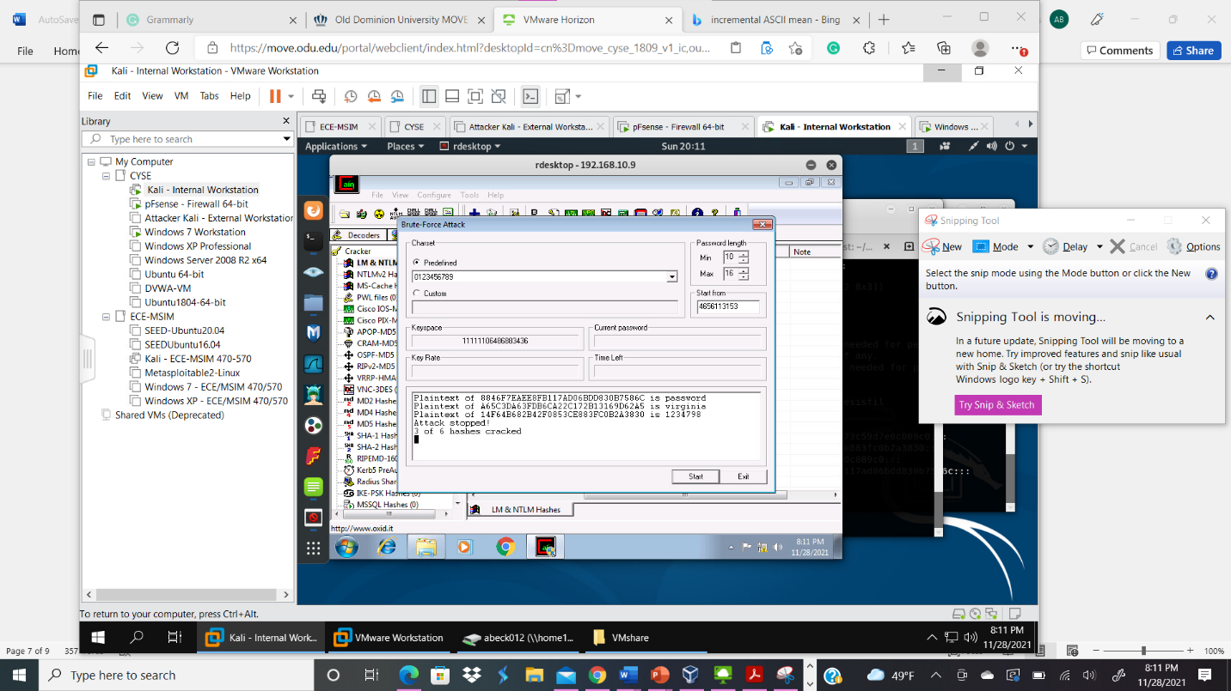
Your explanation goes here. For example:
Once I opened the password cracking tool Cain and Abel in the remote desktop, I utilized the cracker LM & NTLM Hashes. Next, I highlighted all the password hashes from all windows users and started a dictionary attack with the NTLM hashes; then, I inserted a simple wordlist that I could use to crack some of the hashes. I was only able to crack two hashes, password and virginia with the default wordlist. Next, I utilized brute-force attack for the hashes from windows with the NTLM hashes; I chose 0-9 and my password length 10-16. As a result, I was able to have three out of the six hashes cracked which were password, virginia, and 1234798.
Task C
- Find and use the proper format in John the ripper to crack the following MD5 hashes. Show your steps and results.
• 5f4dcc3b5aa765d61d8327deb882cf99
• 63a9f0ea7bb98050796b649e85481845
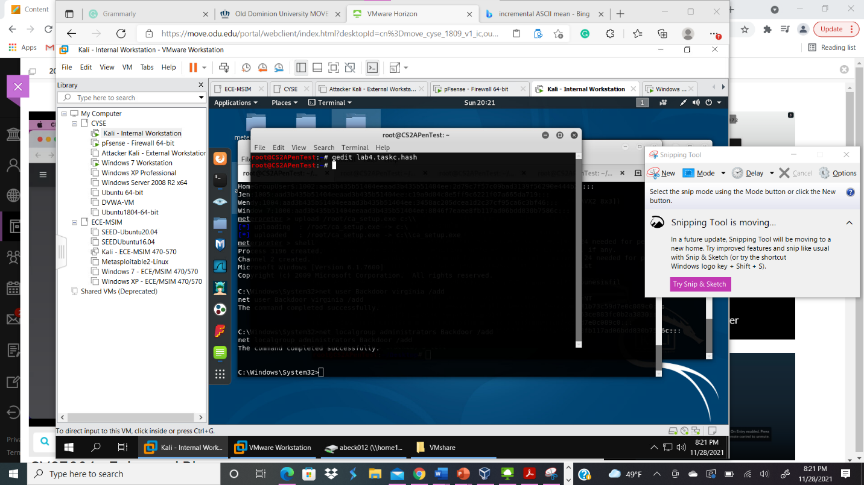
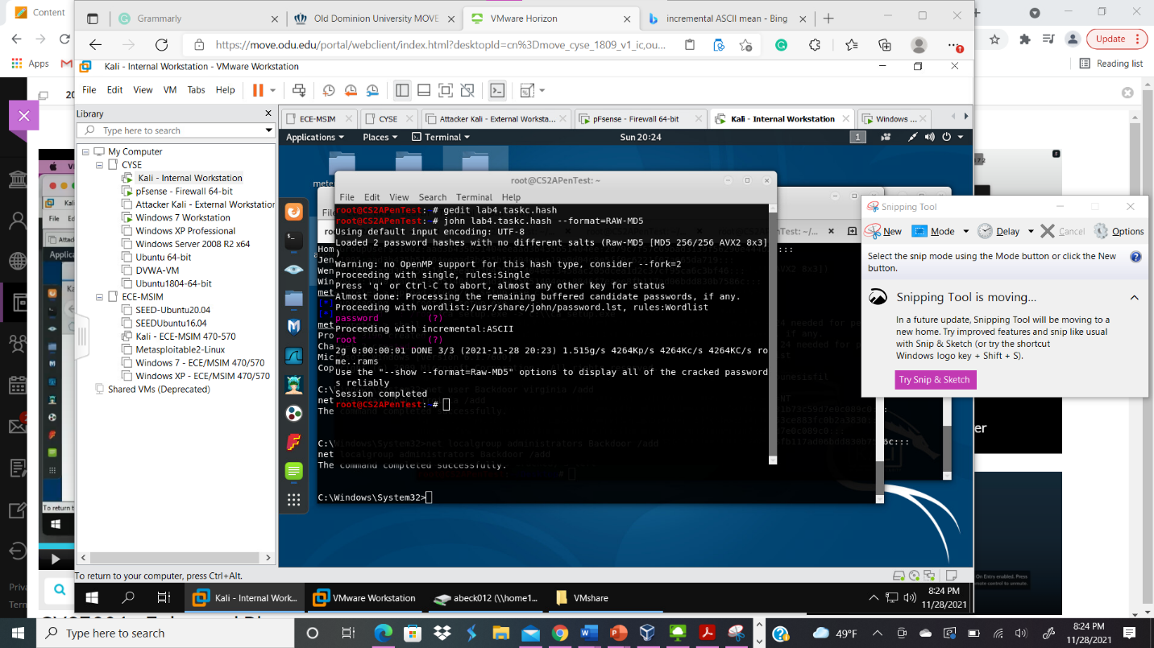
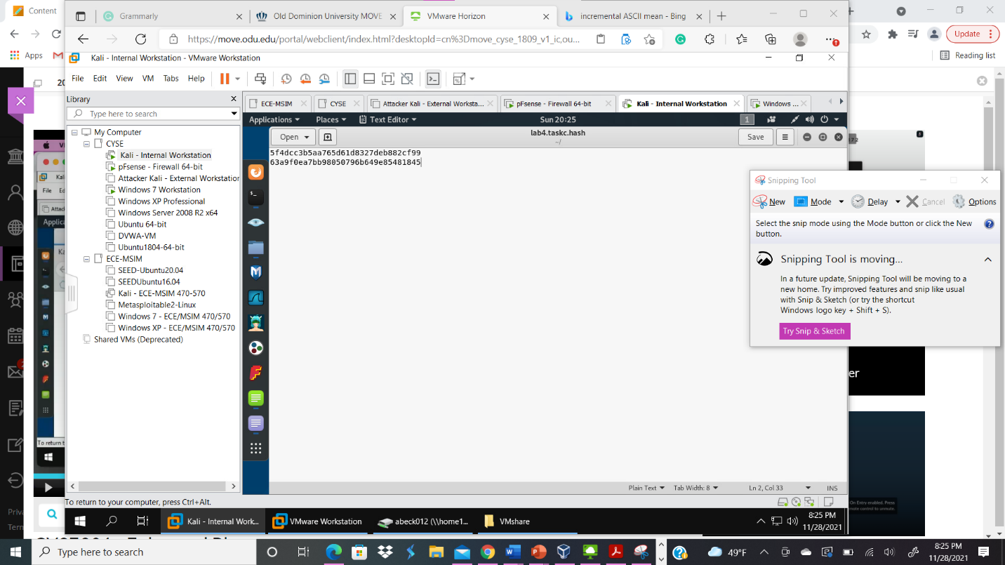
Your explanation goes here. For example:
In order to crack the MD5 hashes in John the ripper, I utilize the command gedit lab4.taskc.hash in order to put the two hashes in the lab4.taskc.hash hash file. In order to run the password cracker, John the Ripper I typed the command john lab4.taskc.hash –Format=RAW-MD5. I was able to see that the hash was decrypted to the words password and root, which is highlighted in fuchsia above.

