Old Dominion University
CYSE 270 Linux System for Cybersecurity
Assignment #12 advanced network configurations

Alysia Beckles
01127384

Below is the snippet of a sample lab report.
Task A
- . In the virtual box setting, connect two VMs in the same internal network, “internal_{UIN}”. Replace {UIN} with your real UIN?
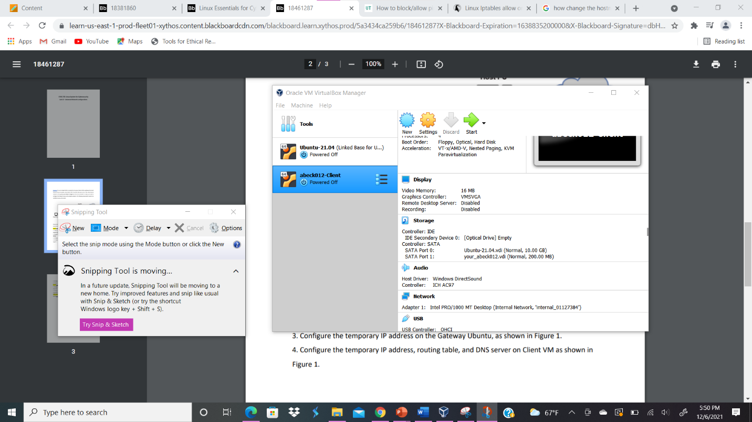
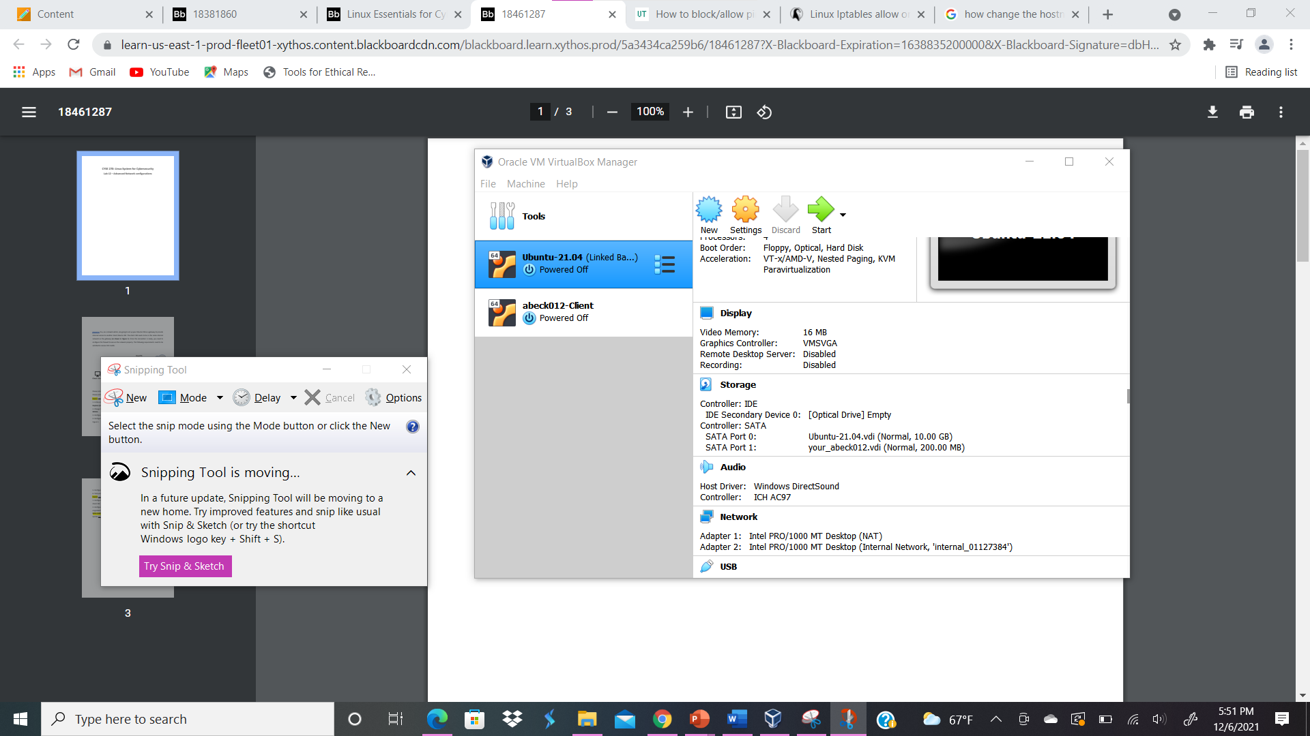
Your explanation goes here. For example:
In order to create the client VM, I cloned the Ubuntu- 21.04 and changed the policy to generate new MAC addresses for all network adapters. Then I went to the network tab under settings and configured adapter 2 to the internal network, and named it internal_01127384 for Ubuntu. Sor the abeck012-Client I went under the network tab and configured adapter 1 to the same configurations as Ubuntu’s adapter 2’s network configurations.
- Change the hostname of the Client VM to “{MIDAS}-Client.” Replace {MIDAS} with your real MIDAS?
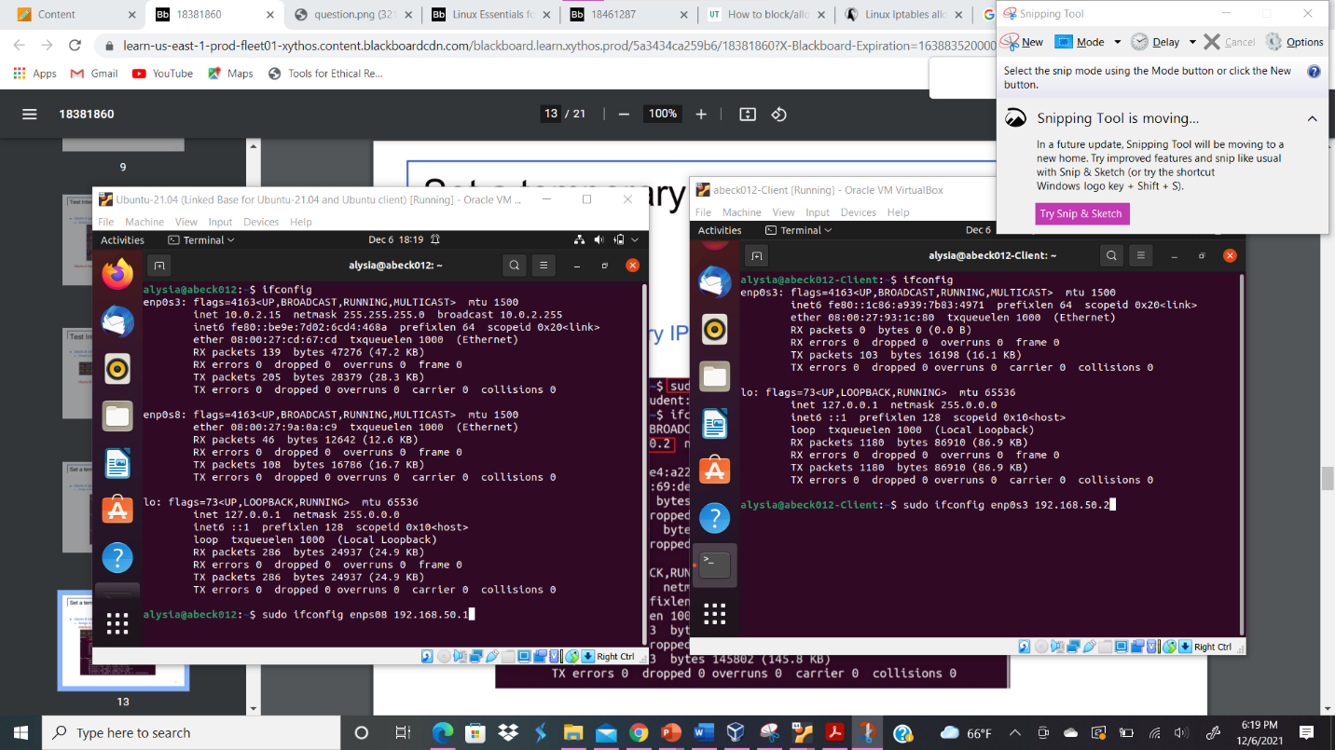
Your explanation goes here. For example:
In order to change the hostname of the Client VM, I typed the command sudo -I gedit /etc/hostname and wrote abeck012-Client in the file.
- Configure the temporary IP address on the Gateway Ubuntu, as shown in Figure 1?

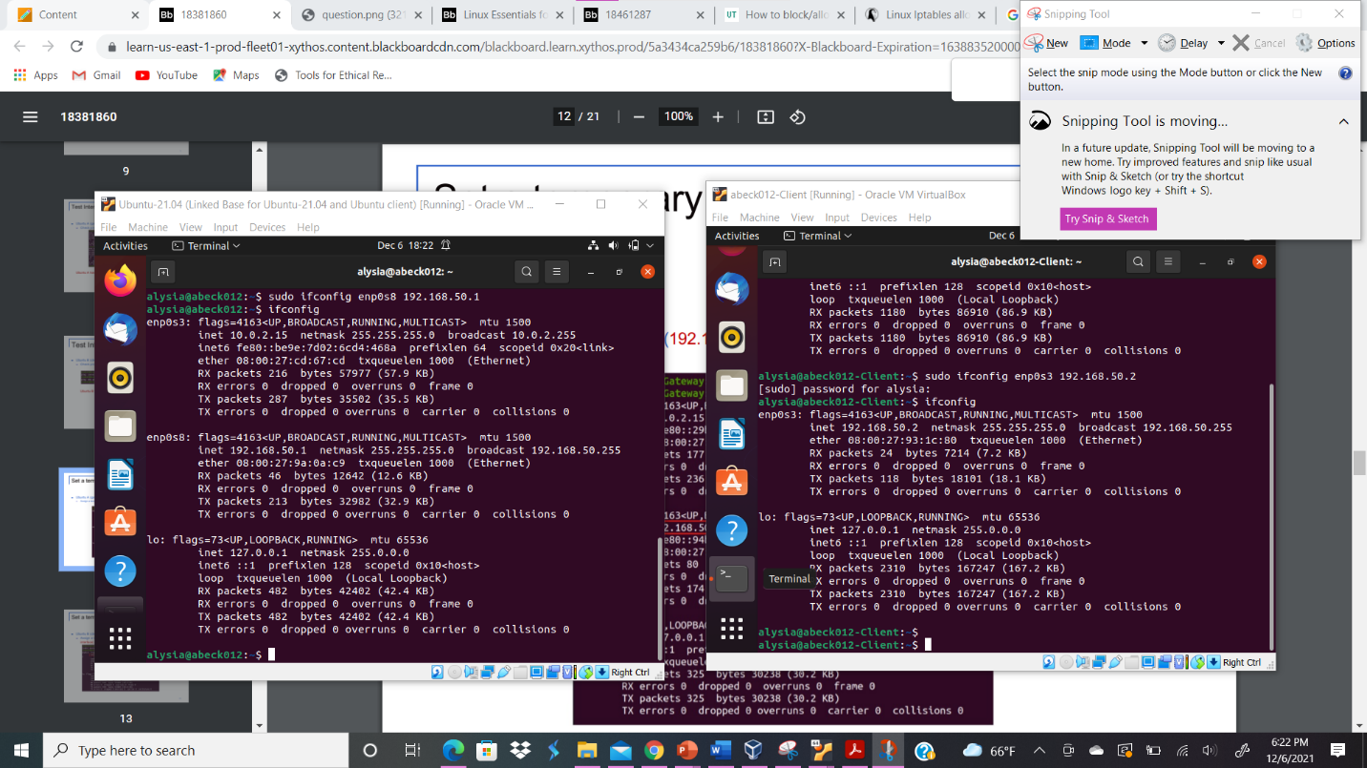
Your explanation goes here. For example:
In order to configure the temporary IP address on the Gateway Ubuntu, I typed the command sudo ifconfig enp0s8 192.168.50.1. Then, I typed the command ipconfig to check if the interface was assigned an IP address.
- Configure the temporary IP address, routing table, and DNS server on Client VM as shown in Figure 1?
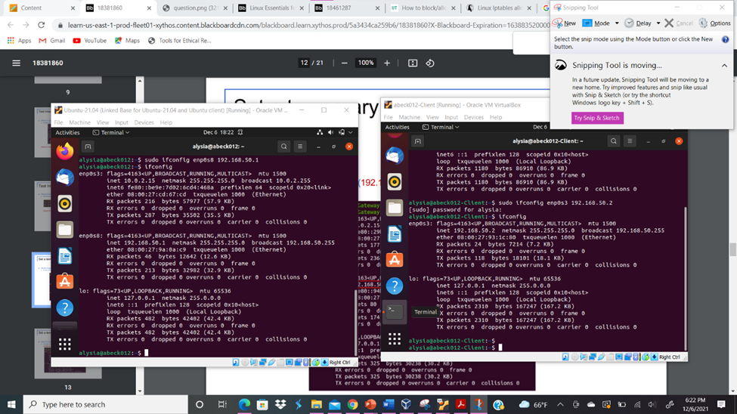
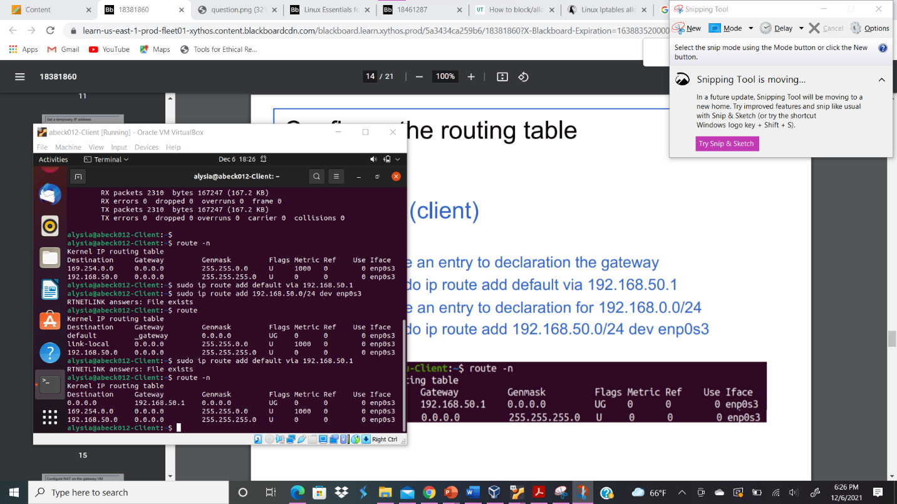
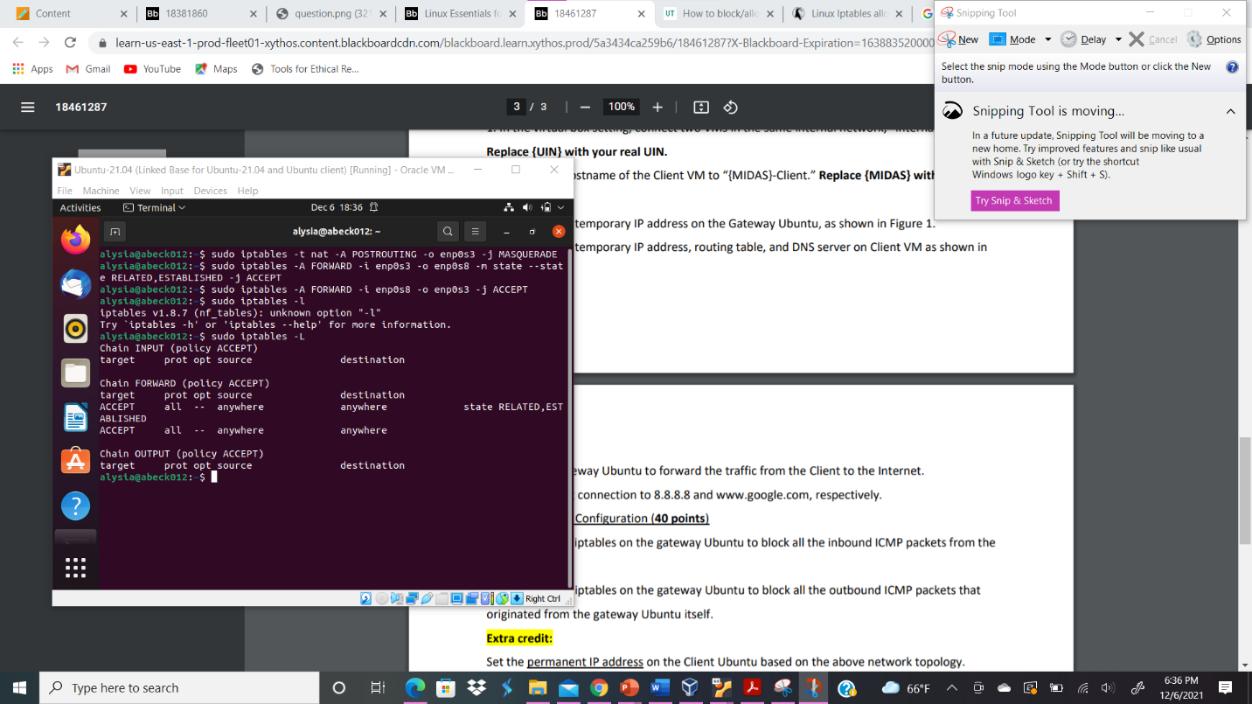
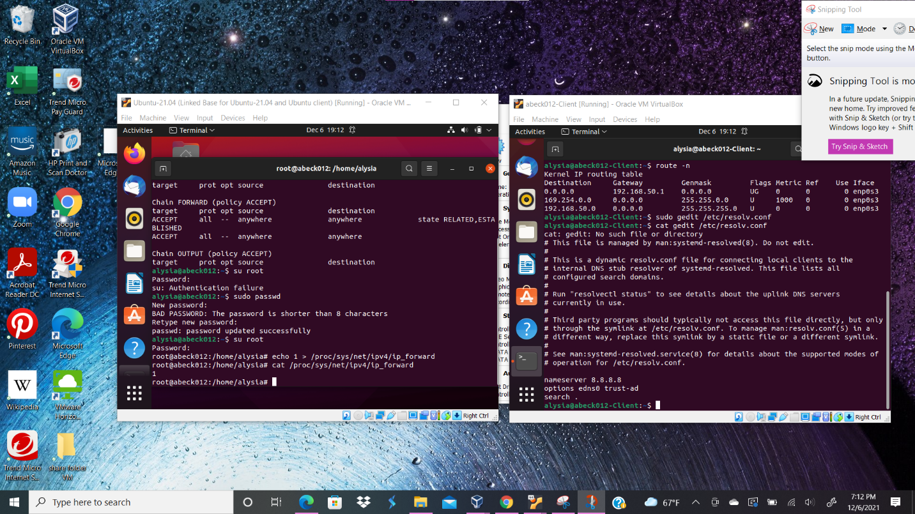
Your explanation goes here. For example:
In order to configure the temporary IP address on the abeck012-Client, I typed the command sudo ifconfig enp0s3 192.168.50.2. Then, I typed the command ipconfig to check if the interface was assigned an IP address. In order to configure the routing table, I typed the command route -n and to see the routing table. I see that there are some configurations put in place. I create an entry to declaration the gateway by typing sudo ip route add default via 192.168.50.1. Next, to configure the DNS server, I go under the Gateway Ubuntu and type the commands sudo iptables -t nat -A POSTROUTING -o enp0s3 -j MASQUERADE, sudo iptables -A FORWARD -i enp0s3 -o enp0s8 -m state --state RELATED,ESTABLISHED -j ACCEPT, and sudo iptables -A FORWARD -i enp0s8 -o enp0s3 -j ACCEPT to configure NAT. Next, I typed gedit /etc/resolv.conf to edit the nameserver to 8.8.8.8 on the abeck012-Client VM.
- Configure gateway Ubuntu to forward the traffic from the Client to the Internet.
Your explanation goes here. For example:
In order to configure Gateway Ubuntu to forward the traffic from the Client to the Internet, I to switch to the root user. I type the command sudo passwd for the root account in order to gain access to the account. Next I typed the command su root and typed the command echo 1 > /proc/sys/net/ipv4/ip_forward to enable traffic forwarding.
- Test your ping connection to 8.8.8.8 and www.google.com, respectively.
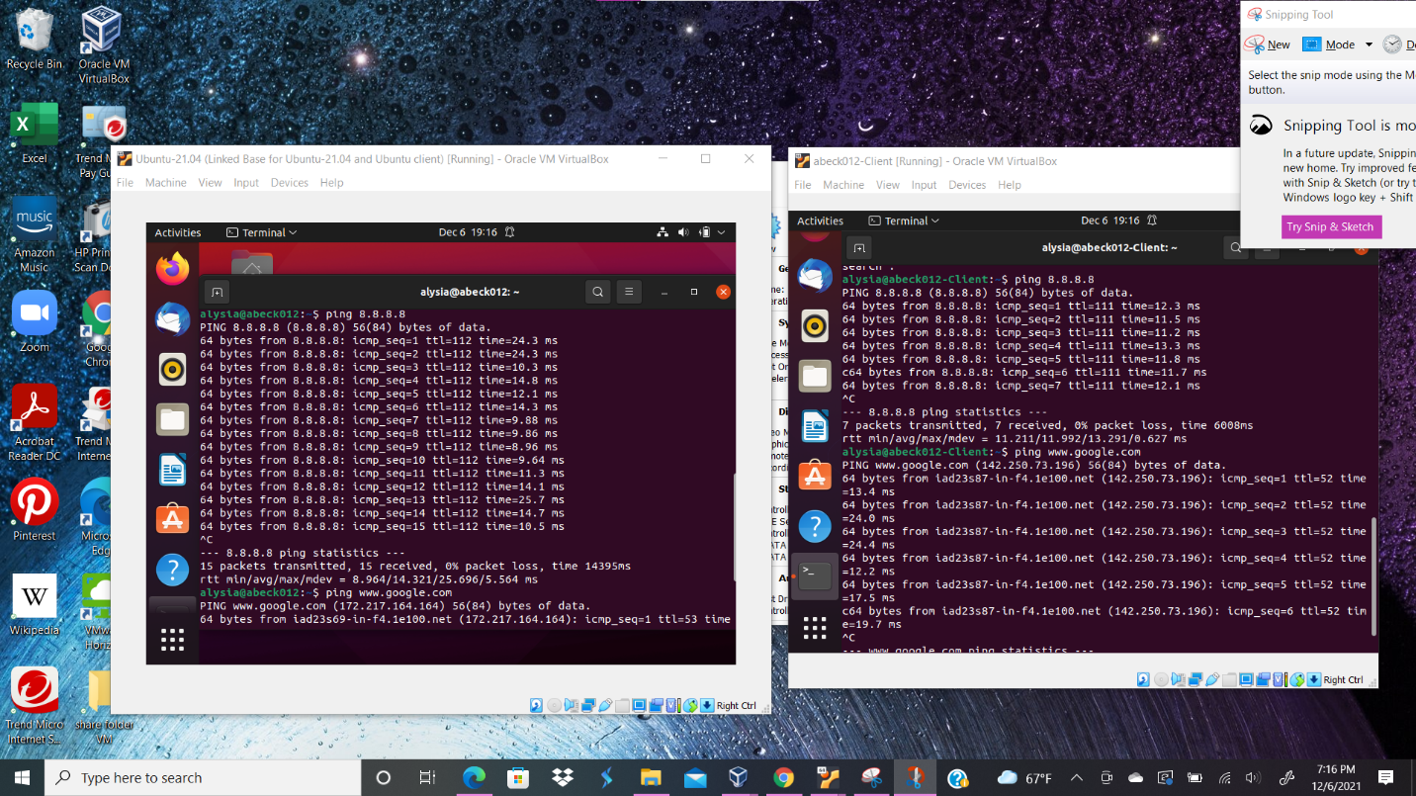
Your explanation goes here. For example:
After configuring the network, I was able to establish connections on the abeck012-Client VM and test it by utilizing the commands ping 8.8.8.8 and ping www.google.com.
Task B
- Configure the iptables on the gateway Ubuntu to block all the inbound ICMP packets from the Client VM.
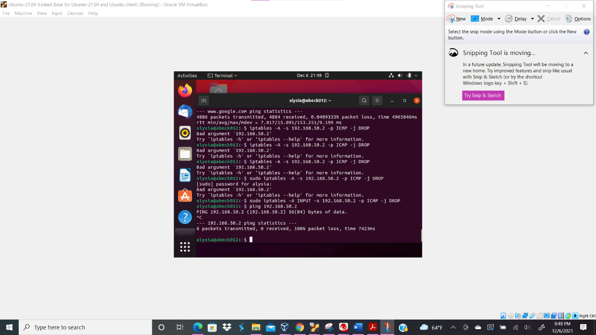
Your explanation goes here. For example:
I configured the iptables on the gateway Ubuntu to block all the inbound ICMP packets from the Client VM by typing the command iptables -A INPUT -s 192.168.50.2 -p ICMP -j DROP.
- Configure the iptables on the gateway Ubuntu to block all the outbound ICMP packets that originated from the gateway Ubuntu itself.
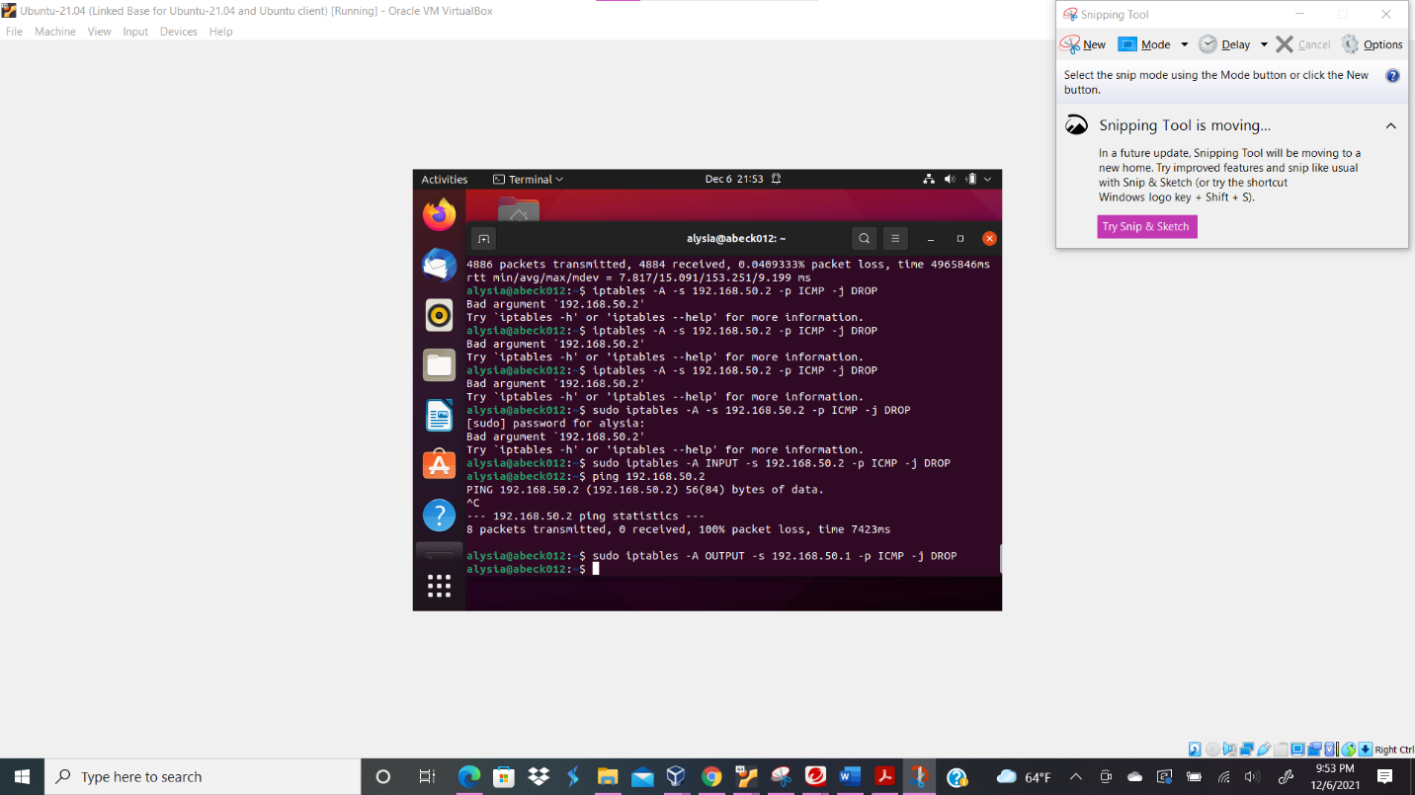
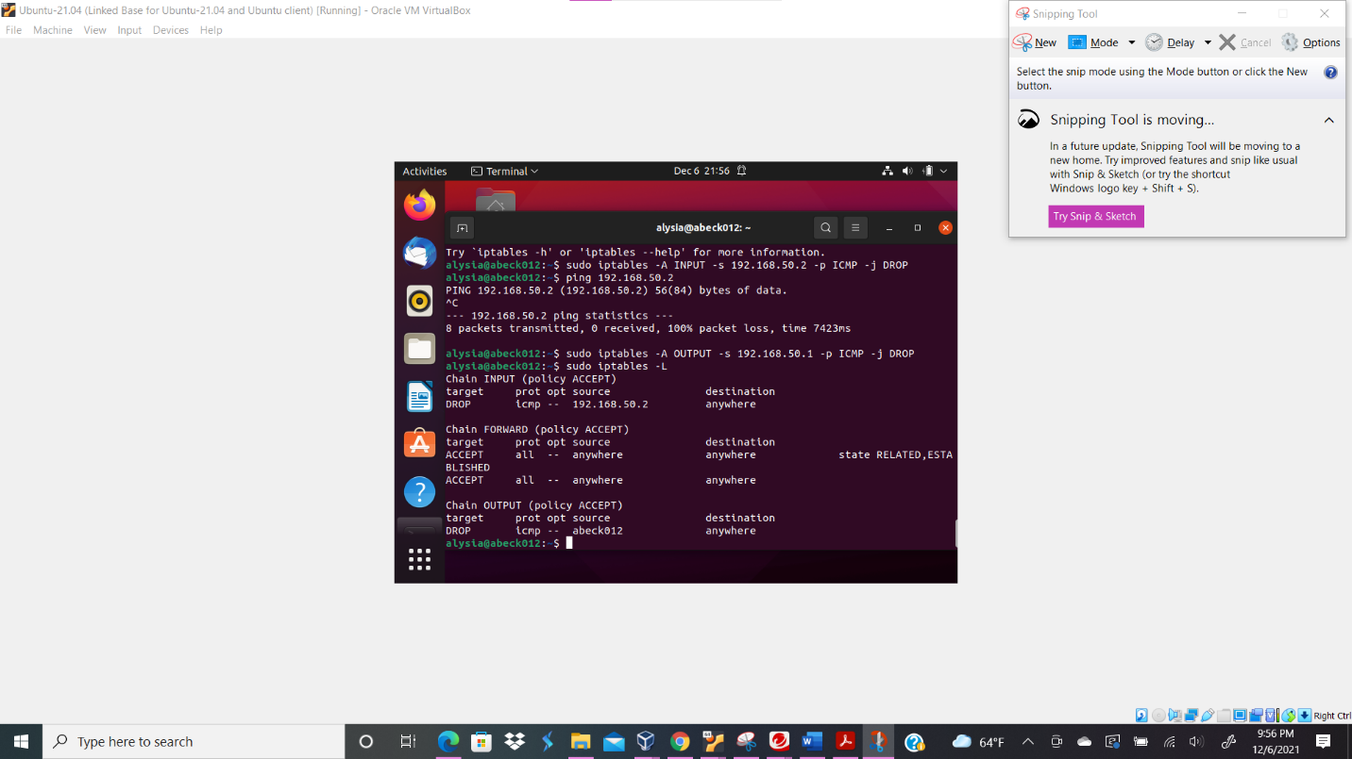
Your explanation goes here. For example:
I configured the iptables on the gateway Ubuntu to block all the outbound ICMP packets that originated from the gateway Ubuntu itself by typing the command iptables -A OUTPUT -s 192.168.50.1 -p ICMP -j DROP. Then I typed the command sudo iptables -L to see the IP rules.

