The Museum of Tolerance: The Start of a New Era of Thinking

To get the basics out of the way, the Museum of Tolerance (MOT) is located in Los Angeles, California. It opened in February of 1993 and has since then received five million visitors, with an average of 250,000 visitors annually. The museum is a “human rights laboratory and educational center dedicated to challenging visitors….to confront all forms of prejudice and discrimination in our world today.” In this day in age, especially the way this country has been behaving these past few years, we as a society need more of these museums readily available. People need to be held accountable for what they say and what they do, and they cannot change if they do not think what they are doing is wrong. The Museum of Tolerance and others like it are essentially a giant mirror, forcing visitors to look themselves in the face and determine if they like what they see.

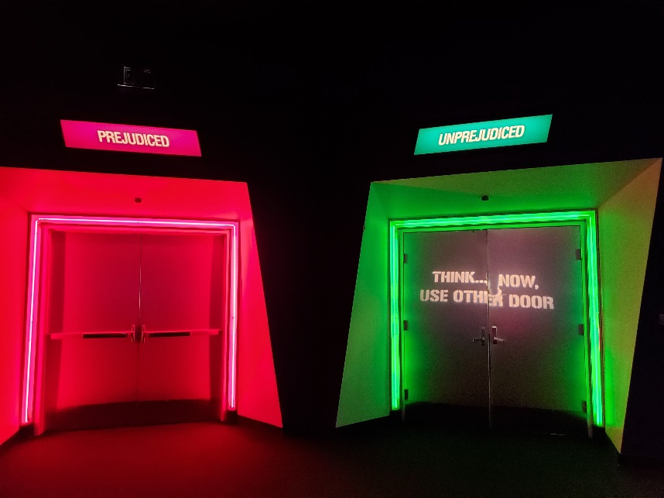 The MOT has five exhibits: Holocaust, Tolerancenter, Para Todos Los Niños, Finding Our Families Finding Ourselves, and Anne. For the sake of this paper, the focus will be on the Tolerancenter. Four of the seven displays showcased within the Tolerancenter exhibit will be highlighted in this paper.

The first display is actually the doors one must enter into the exhibit. Visitors have not entered into the exhibit, yet they are already forced to think critically about themselves. The goal to have visitors confront prejudice, even within themselves, was mastered beautifully and they hadn’t even walked through the doors yet. What makes this even more authentic, is that the UNPREJUDICED door is locked. If people had the chance to walk through the green door, the effect of the exhibit may not affect them as much. For instance, if someone were to whole-heartedly believe that they are unprejudiced, then the information that permeates throughout the exhibit, showing people how to fight back against prejudice and discrimination, would not allow these individuals to critically analyze themselves. Therefore, everyone must walk through the PREJUDICED door and by doing this, everyone is equal. Also, walking through the red door is not necessarily a bad thing. It is like a weight has been lifted off of one’s shoulders. Everyone is this world has a prejudice against something, not matter how hard they try not to have them. This way, walking through this door allows people to acknowledge their prejudices and try to overcome them by exploring the exhibit that lies behind those doors.

The second display is called GLOBALHATE.COM. This part of the exhibit is dedicated to how 21st century technological developments have spread digital terrorism. Upon walking up the display, one notices several computer terminals with a database of various types of hate platforms, such as hate music, hate games, hate propaganda, hate blogs, etc. During my visit, I spent most of my time researching the multitude of hate games that the database showcased. The following are a few games that struck a nerve and need to be discussed: “No Hope for Haiti, Ethnic Cleansing, and Salil al-Sawarem.” No Hope for Haiti is a video game that requires players to drop bombs on the island of Haiti. The more casualties, the more points a player receives. This game is meant to teach players that Haiti is a poor, worthless country and its citizens don’t deserve their lives. Unfortunately, this game has never been taken down due to the fact that I stumbled upon days before my class presentation on the topic. Many of the players in the discussion forums are incredibly racist and like to compare their high scores and death tolls.

The next game, “Ethnic Cleansing,” was created by a white supremacist group. Players in the game are to kill Black, Mexican, and Jewish characters. These characters are intentionally created to be as stereotypical and racist as possible. For example, black characters make monkey noises, Mexican characters wear sombreros, and Jewish characters are dressed as rabbis and scream, “Oy vey!” In order to win the game, players must kill the prime minister of Israel as he tries to dominate the world. It is unfortunate that people in this world feel so strongly about another race and religion that they create a video game to kill them. How do people come this conclusion? Were they raised this way? That still does not give people the right to spew such hate.

Lastly, the video game Salil al-Sawarem was created by ISIS to teach children how the battle the West. In the game, players are to kill policemen, military soldiers, and civilians. Upon a successful kill, the players’ character screams. “Allahu Akbar!” This game is supposed to facilitate the making of future terrorists for ISIS. Why on earth would one want to create a “How to be a terrorist 101” video game, especially for CHILDREN! It is horrid to see and interact with such hate-filled violence; it is absolutely repulsive. However, without people actively researching and documenting “hate video games” into a worldwide database, we would not even know they exist; I did not know it was such a thing before I came to this museum. It is a shame that these are out in the world, but then again we must learn from our mistakes, right?

The third part of the exhibit is called the Point of View Diner. In the corner, there is a replica of a 1950’s diner, filled with jukebox-looking computers. Visitors sit at a computer and they listen to several videos based on a different topic. Topics included bullying, drunk driving, and hate speech. Visitors listen to the video as the role of the bystander. At the end of each video, visitors complete a short survey asking if they agree or disagree with what happened in the video. The goal is to have visitors analyze their role as a bystander and if they will let hateful behavior go by or stand up for what it right. Bystander intervention is becoming better in our society, as I myself have seen people stop what they are doing on the street to help a woman being harassed by a man. However, other people usually just pull out their cell phone and record the incident rather than personally intervene. Also, another purpose of the POV diner is to have people reevaluate their own point of view and outlook on the world, hopefully changing it for the better.

Lastly, the final display for this paper is the Millennium Machine. This is an interactive tool to educate visitors on current human rights abuses that take place around the world. There are three categories of the Millennium Machine: exploitation of women, threat of terrorism, and refugees. For each category, visitors sit at a table and answer a few individual-based questions. Once that is completed, the screen will show a question for group discussion among the people at a table. The basis for group discussion is to engage visitors to come up with solutions for the given problem. By this, people can see that even though human rights violations exist in the world, they have the power to stop them. Although the solutions for human rights violations seem like they can only be solved by an international institution like the United Nations, this tool allows people to realize that it can take one person to make a difference, one person to bring about change.

To wrap up, the Museum of Tolerance is a one of a kind. With an emphasis on creating a better future without discrimination and prejudice, their goal is to teach its visitors how to claim personal responsibility for what goes on in the world around them. After all, if one does not try to stop hate, then hate will continue to fester and grow until it destroys everything in its path. The benefits of visiting this museum is that causes visitors to remove any narrow-focused lens that they may have upon entering. By showing examples of prejudice and videos of human rights abuses, they are exposed to the world around them that had been cut off due to their narrow mindedness. Another benefit goes hand in hand with the previous one - the ability to hear different opinion, perspectives, and ideas from other visitors that one may not share. That is how the world works; not everyone shares the same thought process. This is pertinent with the Millennium Machine. During the group discussion, people at the table can solve problems with various perspectives and ideas that they share. When great minds with different ideas come together, anything is possible.

The Museum of Tolerance has shown that we are starting a new era of thinking. We are beginning to think about the collective instead of the individual, a common characteristic of Western societies. We will no longer stand for human rights violations that have gone on for far too long. This museum is an inspiration for future human rights advocates. They may choose careers advocating for human rights and getting college degrees with a focus on how to end abuses. MOT has sparked a flame with the United States – several museums and educational center have opened around the country, focusing on educating the public on human rights. We will not keep quiet no more. This is just the beginning.