SPARQ Global

Backup Generator System

User Guide

Date 06/17/2020

Table of Contents & Introduction

Table of Contents
Section 1. Generator back up building control room 3
Section 2. Main Electrical/breaker room 4
Section 3. Generator 4
Section 4. Maintenance 4

Introduction:
The purpose of this guide is to familiarize employees with the use of generator backups in the event of power loss. SPARQ Global has on demand generator backups for the Data centers. The generator is installed in the rear of the build. The onsite generator requires little interaction and time from non-building managers. This guide’s purpose is to give an overview of the system and steps to remediate an emergency in the event a building manager is not available. As a modern backup generator, the system can automatically engage and prevent a loss of power in the event of city power loss.
This guide will include an overview of the system, photos of the system and contact information for repair and service of the system.

Section 1. Generator back up building control room

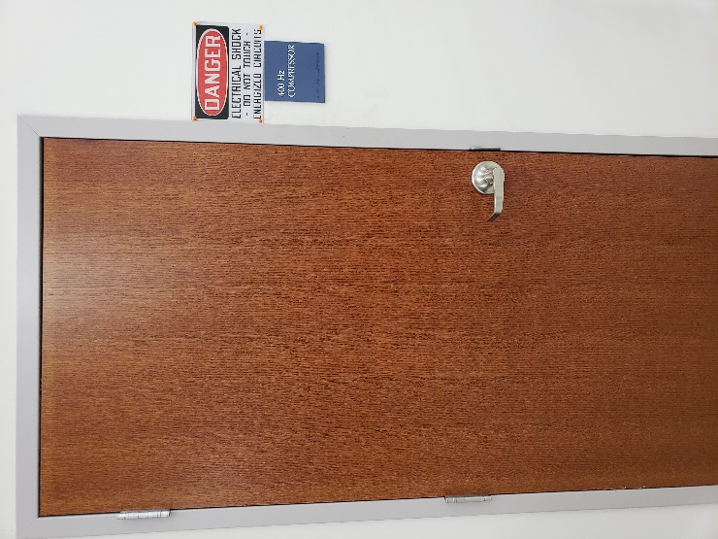
The Generator Control Room (GCR) houses the external control system, the power distribution system (PDU), the emergency cutoff to the grid and uninterrupted power supply. The GCR is unlocked and located under the SOC in the production floor, near the stairwell. The Door is not marked with a room number but has a blue plaque with 400 Hz Compressor on the outside.
Figure 1. Door to Backup generator control room and PDU.
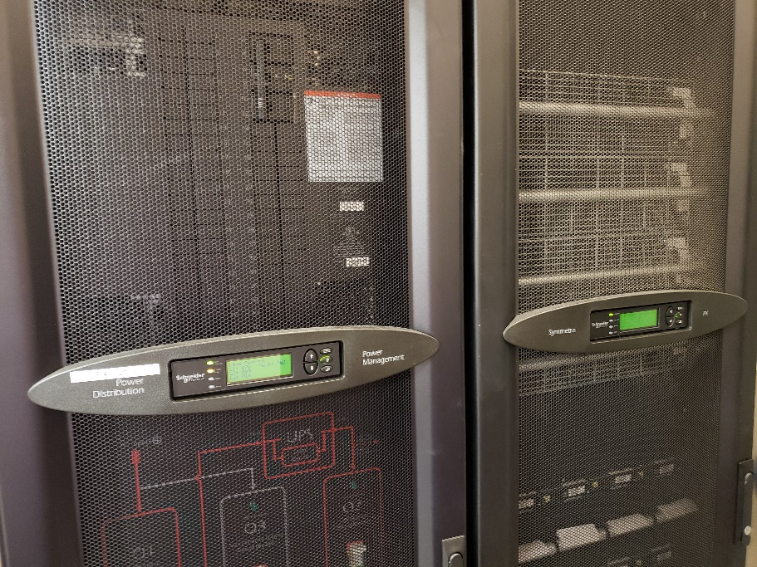
Figure 2. Power Distribution Unit.
The Power Distribution Unit is a building rated uninterrupted power supply that covers the moment power is lost to the generator taking over power production. The dual unit system is in the GCR on the left-hand side.

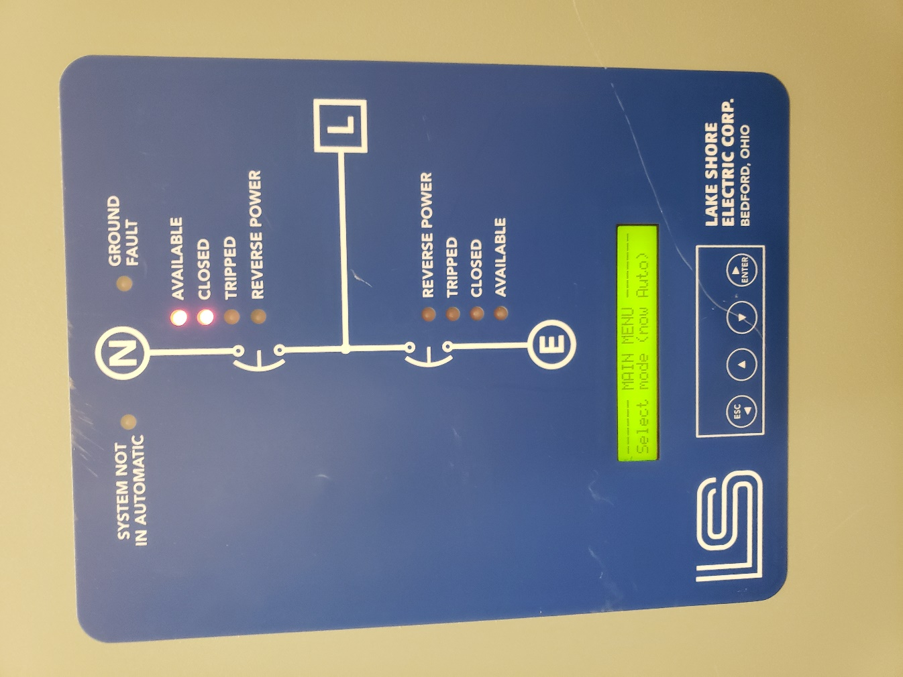
Figure 3. Generator external control panel.

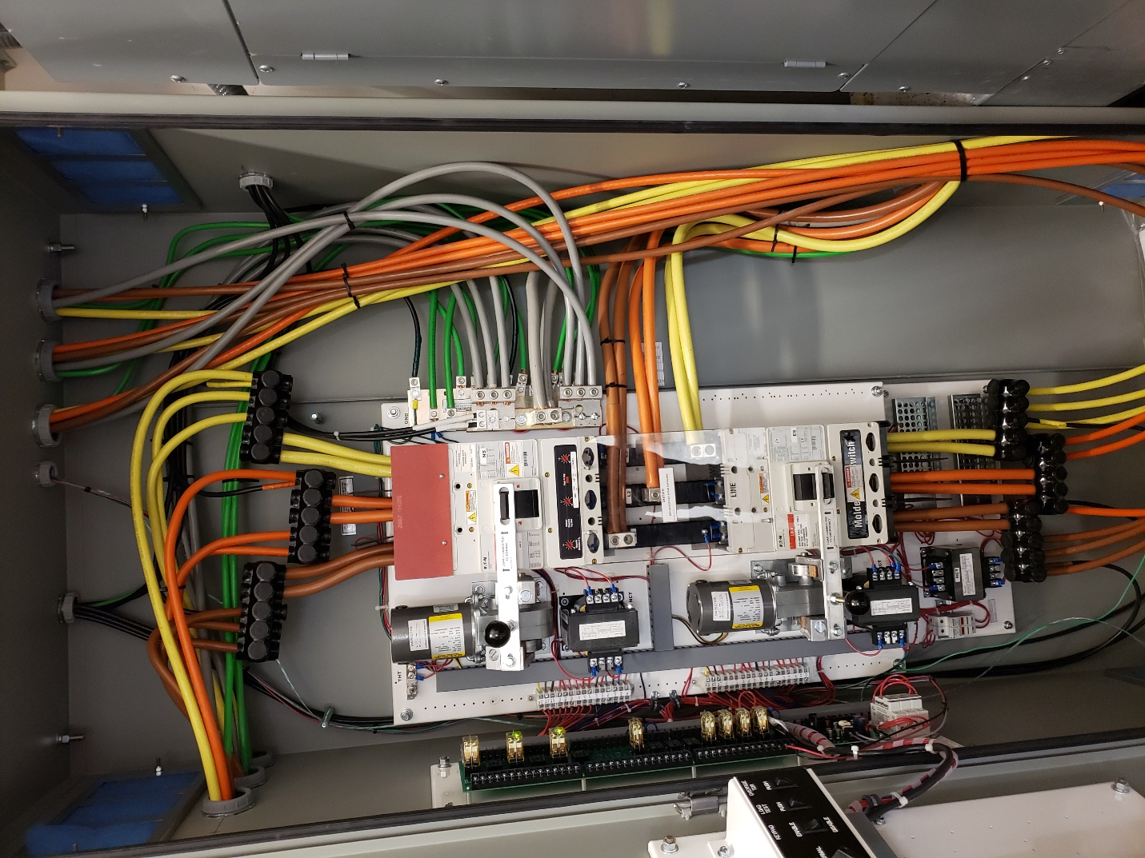

Figure 4. Interior of the External control panel.
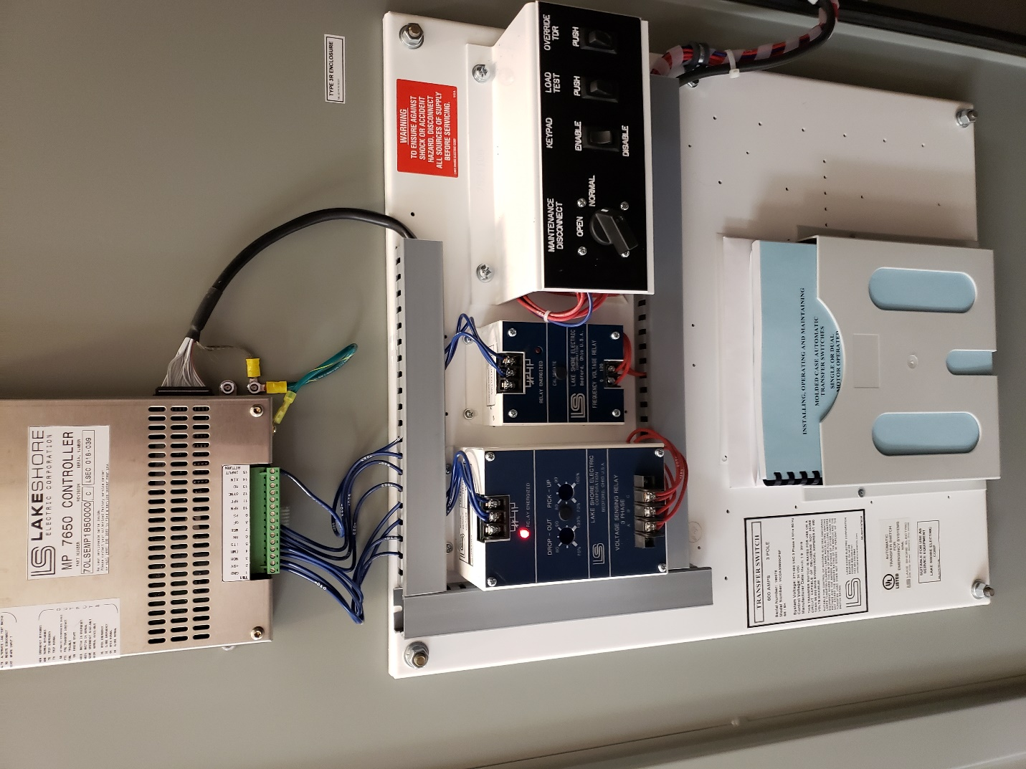
Figure 5. Inner Door panel of the External control panel *Note the blue operations manual housed on the door panel*

Section 2. Main Electrical/breaker room
The main electrical room is accessible from the exterior of the building only. The room is in the rear of the building next to the rear entrance. This room houses the circuit breakers for the whole of the building. In the event of an unsafe power overload the breakers will trip, temporarily cutting off power to the building. This is to prevent wiring from overheating and electronics being damaged by a power surge greater than their power rating.

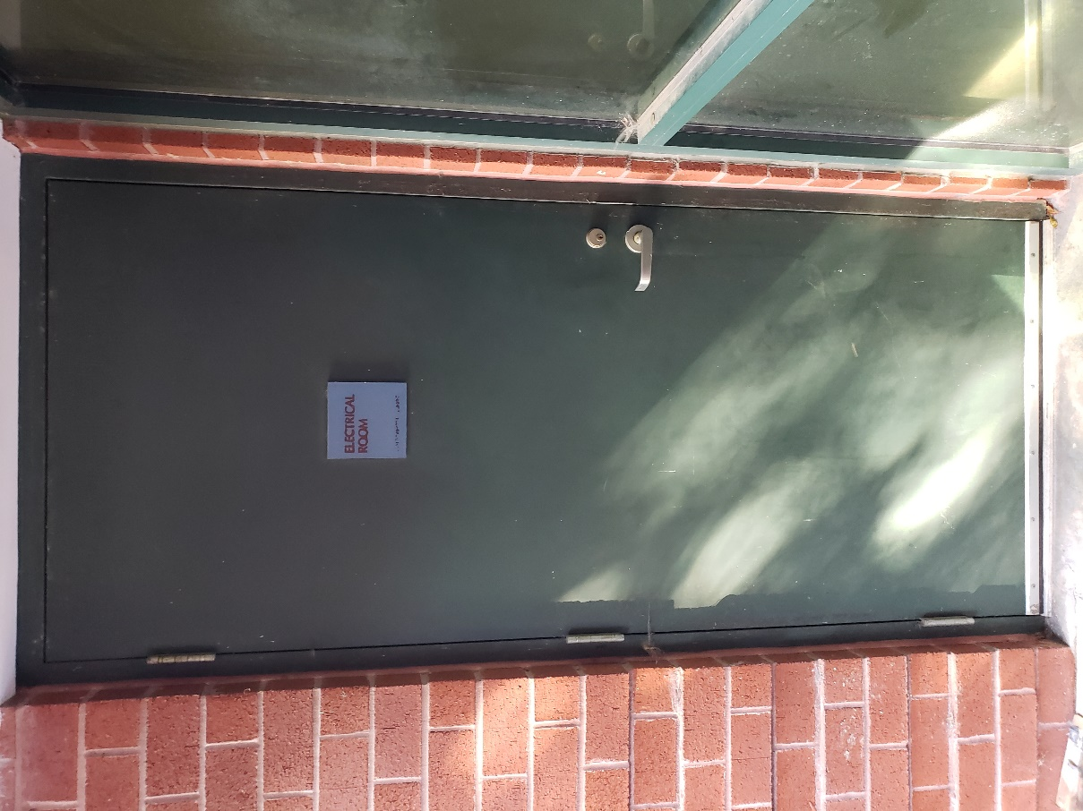
Figure 6. Door to the Main Electrical room.

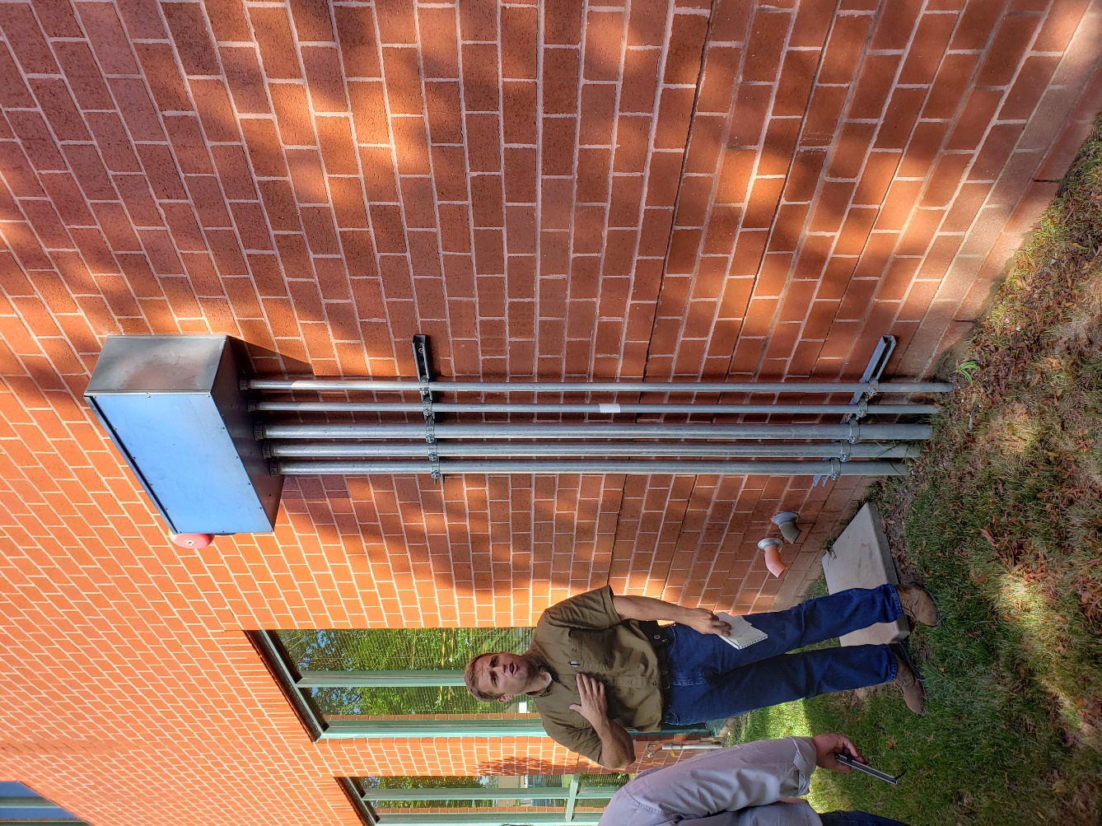
Figure 7. Power from generator to building electrical room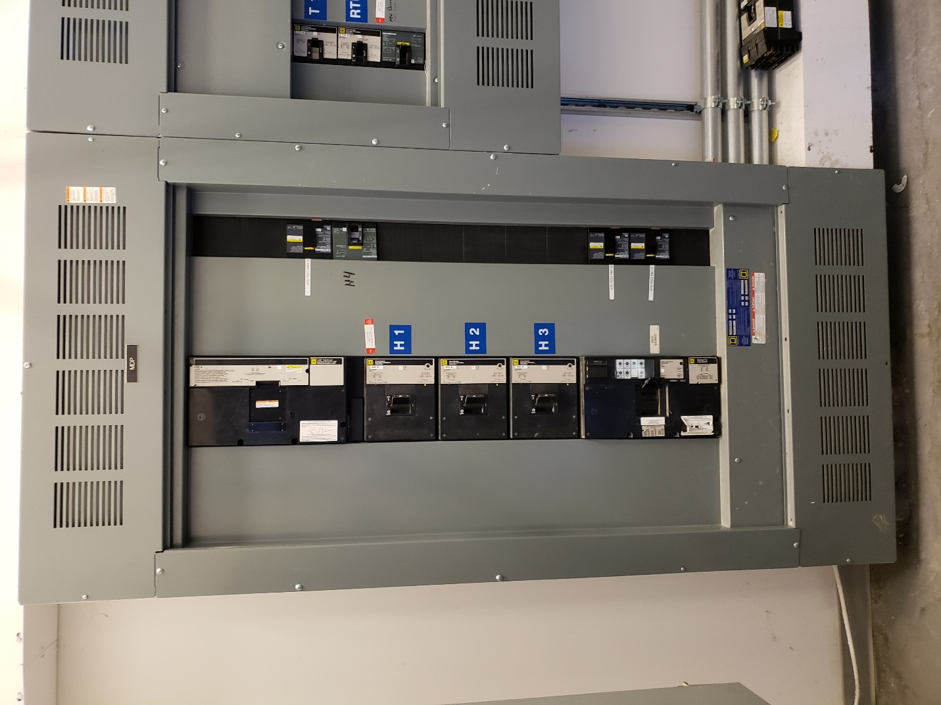
Figure 8. Example building Circuit panel.

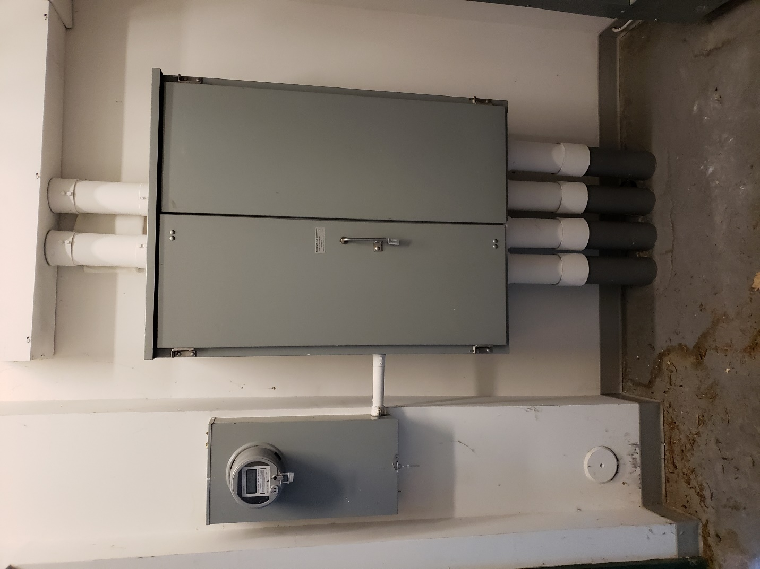
Figure 9. Interior of electrical room continued.
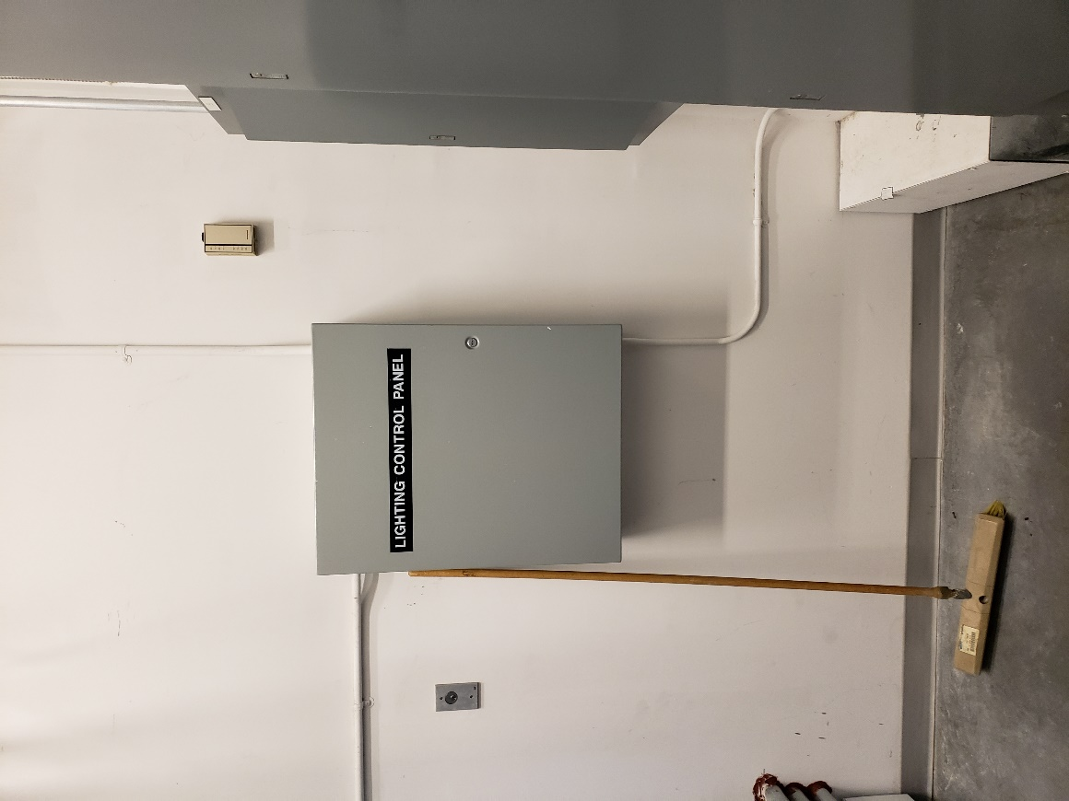
Figure 10. Interior of electrical room continued.

Section 3. Generator
SPARQ’s generator backup is a diesel fueled C-13 model, Caterpillar brand system. In addition to the external control panel located in the control room, the generator has an internal local control panel accessible through locked panels. Note the large red safety kill switch AKA “The Big Red Button”. In the event of an emergency the Big Red Button can be pressed to turn off the system. The generator has two kill switches: one mounted externally and accessible to all, and an internal kill switch accessible through a locked panel on the internal control panel.
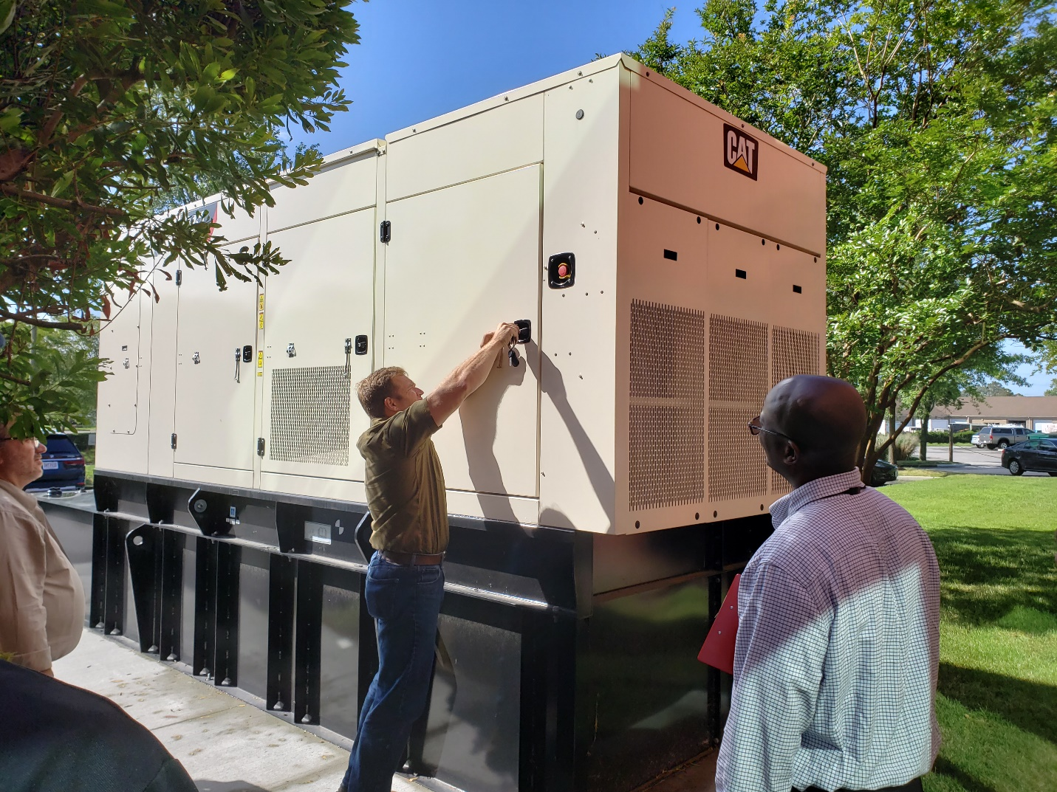
Figure 11. external image of the building back up generator. *Note the big red button on the exterior. *

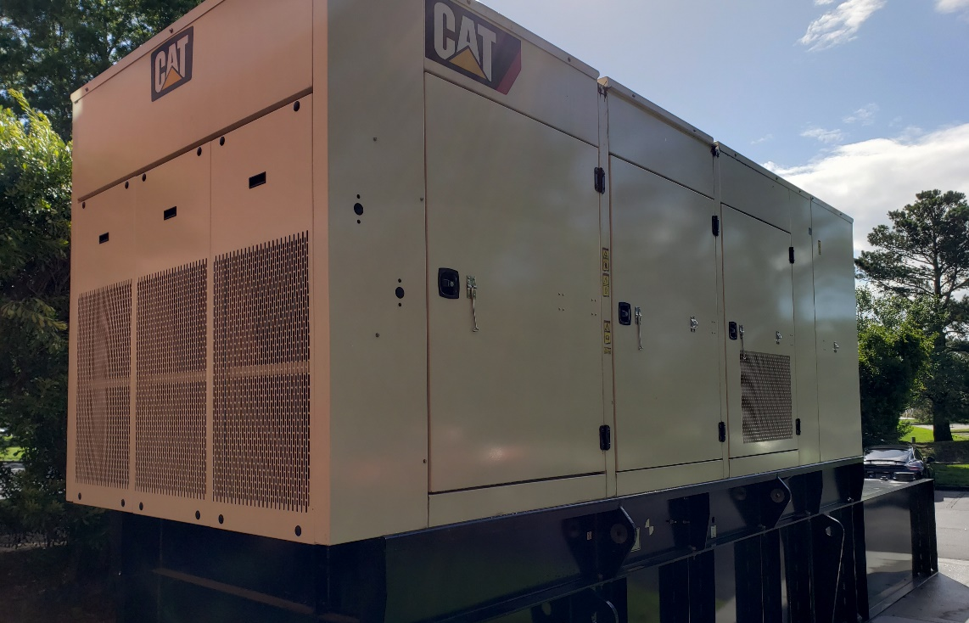
Figure 12. external image of generator continued.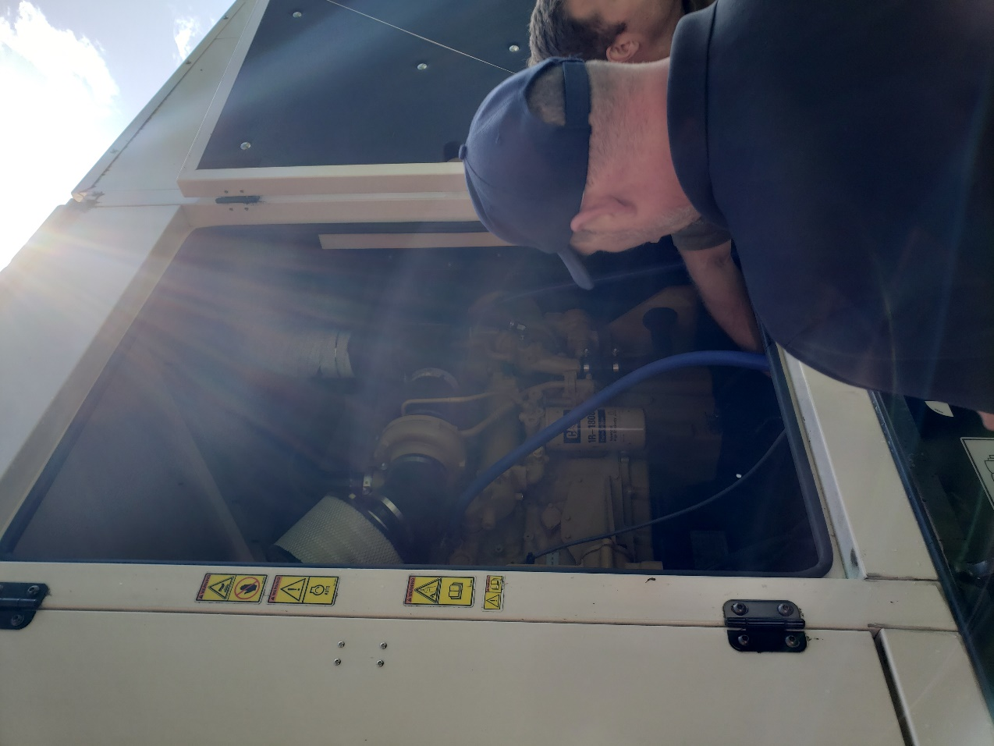
Figure 13. Opened service panel on generator observable are the Oil and Air filters.
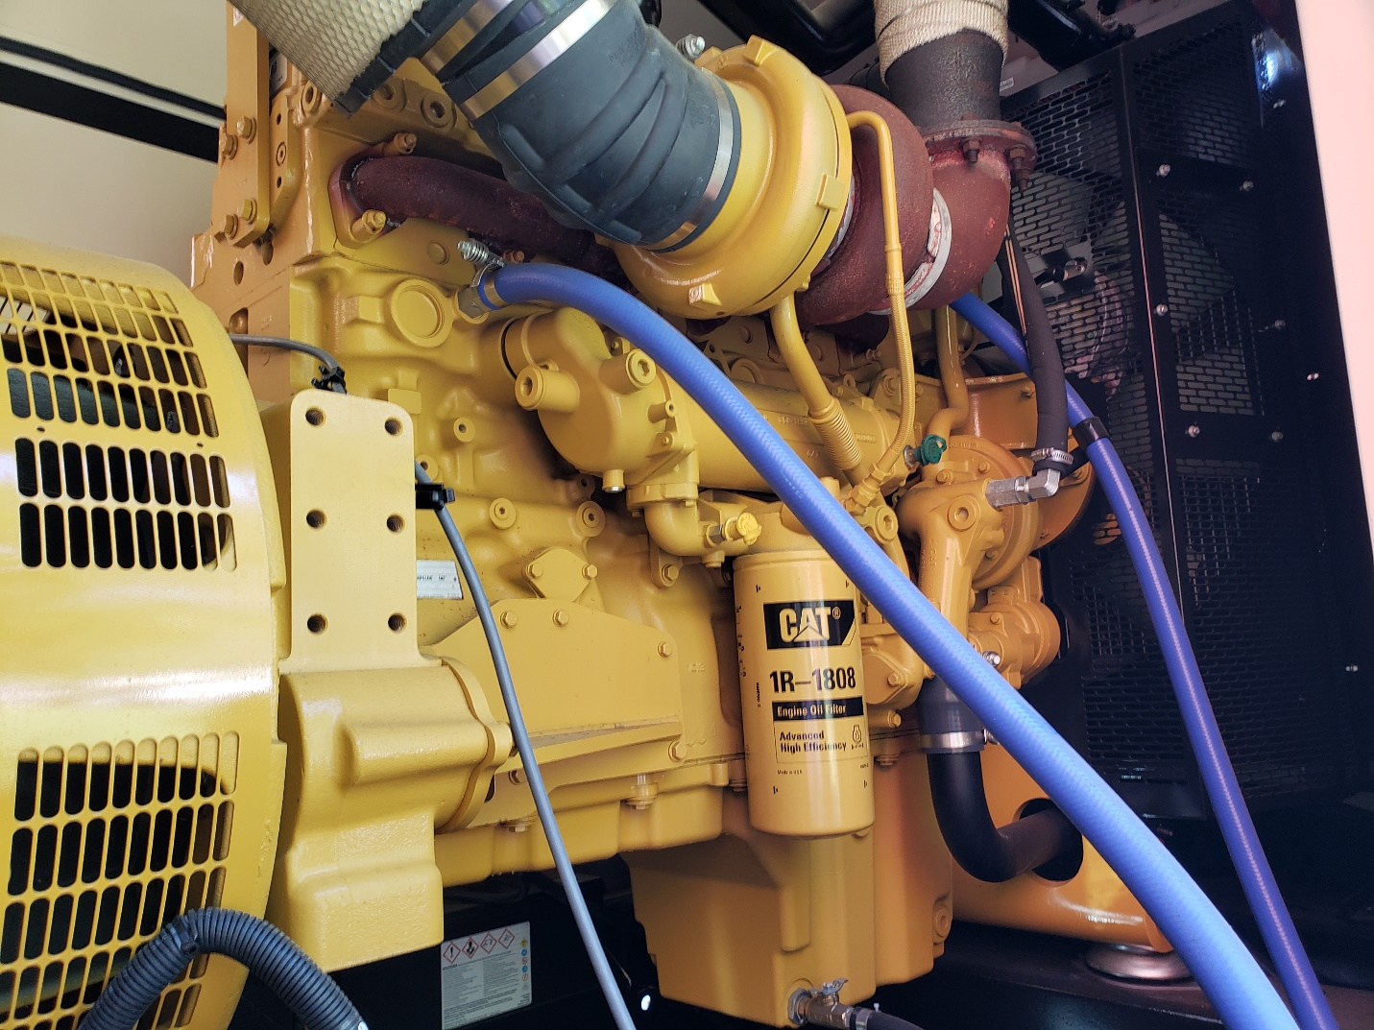
Figure 14. Detailed image of interior of service panel access.

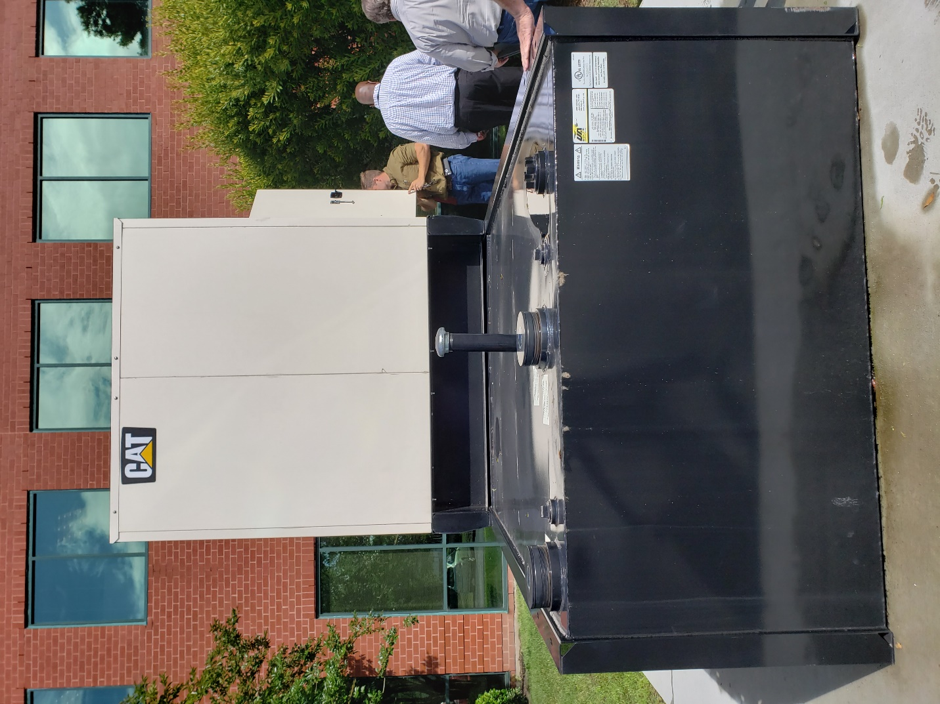
Figure 15. Diesel fuel tank for generator.

Section 4. Maintenance
Maintenance of the generator system is an ongoing and scheduled process. Your responsibility in ordering and scheduling supplies and maintenance is minimal. When the system was purchased a service-contract was agreed upon between SPARQ and Cater Machinery. Repairs and maintenance should be scheduled through them.
In addition to maintenance the system should be run on a scheduled basis to maintain lubrication and confirm the system is still in an operation status. This task will be scheduled and completed by the building manager or a designated employee. The current recommendation is to run the system for 1 hour monthly. Which will burn an estimated 3 gallons of diesel fuel.

Maintenance Contact info:
Fuel: Domestic Fuels, (757) 545-5100
Caterpillar Warranty service (exp xxxxxxx): Carter Machinery, 1-800-768-4300

