Task Four

Claude Stanley Hamlin, Jr.

Old Dominion University

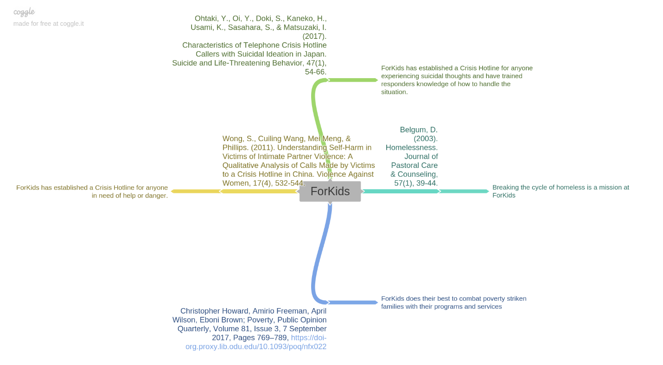

References

Belgum, D. (2003). Homelessness. Journal of Pastoral Care & Counseling, 57(1), 39-44.

Emeritus Director, David Belgum, Ph.D., sheds light on the different types of homeless individuals, causes of homelessness, the community’s response towards homelessness, and strategies and tips for those individuals providing assistance to those that are experiencing homelessness. Understanding the different types of homeless individuals helps society better understand how to assist and approach those experiencing homelessness.

Christopher Howard, Amirio Freeman, April Wilson, Eboni Brown; Poverty, Public Opinion Quarterly, Volume 81, Issue 3, 7 September 2017, Pages 769–789, <https://doi-org.proxy.lib.odu.edu/10.1093/poq/nfx022>

The Public Opinion Quarterly focuses on the government’s response American poverty along with how poverty can be diminished. Howard, Freeman, Wilson, and Brown all share ideologies, thoughts, statistics, and research that poverty is an ongoing problem within America. This peer-reviewed journal is centered around the past and present government efforts to slow down and ultimately eliminate poverty rates of families and children. Topics addressed include society’s perceptions and feelings concerning individuals that are less fortunate and in need of shelter. Poor individuals’ attitudes in regard to government officials’ assistance with poverty. Statistics included in the peer-reviewed article was how American society feels about poor individuals with those that are on public assistance, why does poverty occur, the correlation between poverty and work, wealthy individuals versus poor individuals in regard to race, and the correlation between African-Americans and government assistance. The way Americans feel about individuals within their community that are experiencing poverty is crucial in regard to what services those facing poverty need to move forward.

Ohtaki, Y., Oi, Y., Doki, S., Kaneko, H., Usami, K., Sasahara, S., & Matsuzaki, I. (2017).

Characteristics of Telephone Crisis Hotline Callers with Suicidal Ideation in Japan. Suicide and Life‐Threatening Behavior, 47(1), 54-66.

This article focuses on crisis hotline callers experiencing suicidal ideations within Japan and how it is handled along with all aspects regarding the individuals who have called. Incoming calls are either from those who have previously tried to kill themselves or experience suicidal ideations. The callers experiencing suicidal ideations are categorized by their problem and by how consequential is their ideation to better assist the caller. The calls of suicidal ideations received come from males and females of various ages, living settings, and occupations if any. Utilizing information about callers and their different backgrounds helps responders with forming more intuitive plans and techniques to suite the caller in a more efficient way for counselors. The article also states the type of methods used to gather the information of callers experiencing suicidal ideations within the study.

Wong, S., Cuiling Wang, Mei Meng, & Phillips. (2011). Understanding Self-Harm in Victims of Intimate Partner Violence: A Qualitative Analysis of Calls Made by Victims to a Crisis Hotline in China. Violence Against Women, 17(4), 532-544.

Wong, Wang, Meng, and Phillips examine and analyze twenty-six calls that came through on a crisis hotline within China. The text covers the type of calls ranging to the obstacles with providing services to callers and their unique situations. Majority of the crisis hotline callers experience anything from intimate partner violence to self-harm. Crisis hotline responders focus on what resources and services are best for that particular caller and the caller’s particular circumstance. The article highlights that women call the crisis hotline the most. Crisis hotline responders are trained to handle any situation properly, especially self-harm cases. The article highlights self-harm stemming from intimate partner violence. The article goes in-depth about self-harm behaviors and aspects. The characteristics of the callers are of importance when understanding what kind of individuals, the responder may encounter and how to best fit the caller’s needs. Crisis hotline responders provide mental health and psychological services to their callers.