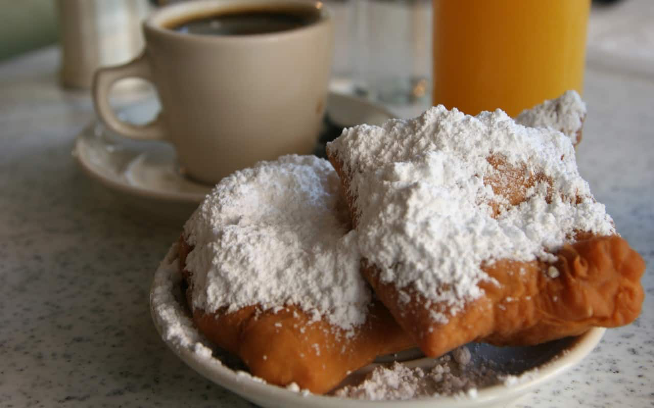

There are a lot of deserts that have french origins that are enjoyed by many New Orleans residence. But there is only one that has as much infamy as the beignets, these pastries are a staple of new orleans. Beignets are another reminder of New orleans french colony past.