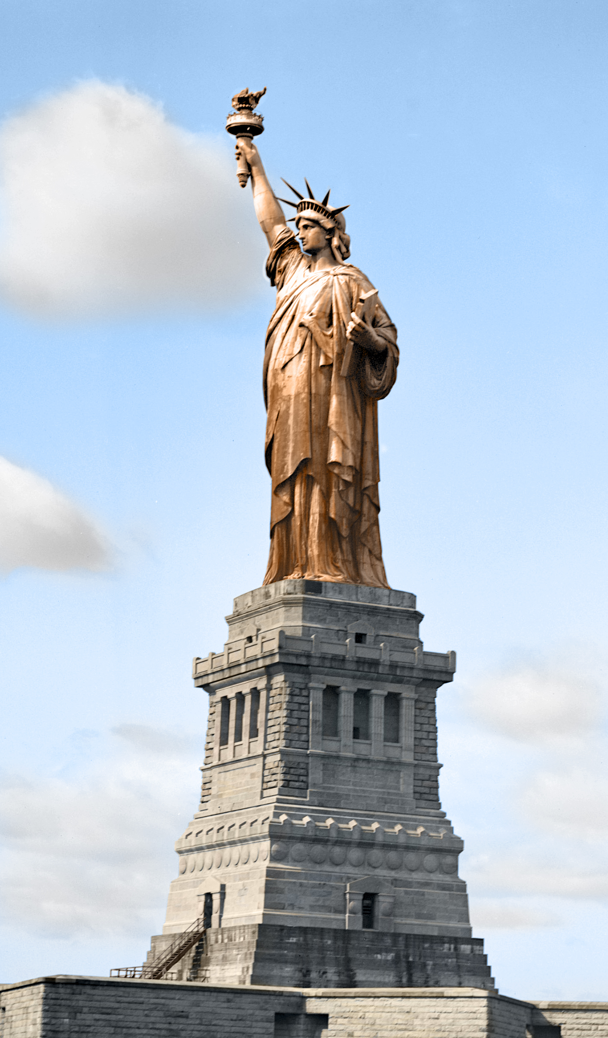The statue of liberty is usually perceived as an American wonder but people forget that is the french who gifted this statue to america. The french gifted the united states this wonder after the revolutionary war due to both countries being allies during this war. This statue was also not always the green color, it was originally a copper color but the exposure to oxygen and weather it gained the color we know today.