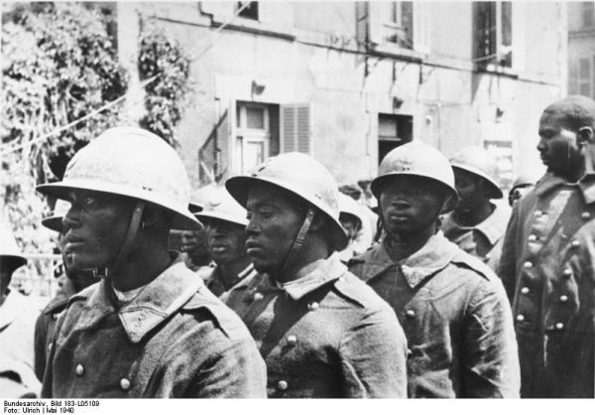

Not many people know that during world war two the french army had an all african division of soldiers. Not many of them saw combat due to them being seen as lesser beings and were usually assigned to sanitary positions. The squads that did see combat were praised for their bravery and combat prowess. I recently watched WWII in color and there was a segment that talked about the valiantness and bravery of all of the french divisions during the war before the fall and occupation of france.