|  |  |  |  |  |
| --- | --- | --- | --- | --- |
| |  |  | | --- | --- | | Always tired?  Never enough time in the day? |  | |  |  | |
| **SOUNDS LIKE YOU NEED TO GET A SUBSCRIPTION TO VERB MAGAZINE ASAP!** |

# How can a subscription to VERB help you?

Our annual magazine has a list of over 500 verbs that can be used to develop time management skills, improve physical fitness, and increase overall productivity.



**GET MOTIVATED**

VERB magazine has articles written by experts on time management and organization skills. Stop wasting time and make a plan with VERB today. PLAN, ORGANIZE, DEVELOP, CREATE, ACHIEVE, PRIORITIZE, STRATEGIZE, ESTABLISH, MANAGE, DEFINE



**GET MOVING**

VERB magazine has workout programs and action verbs to help you get in the best shape of your life. Stop making excuses, get moving, and get VERB today. WALK, RUN, LIFT, JUMP, KICK, PUSH, PULL, STRETCH, SWIM, CLIMB, PLAY.

Stop wasting your precious time and start taking action with

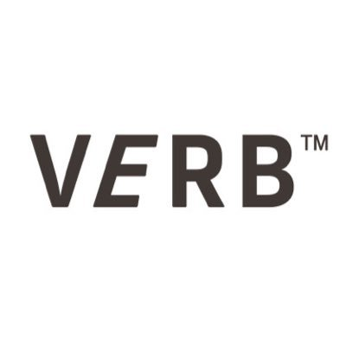

ORDER NOW to receive a complimentary water bottle with the verb logo on the front. VERB subscription is priced at 24.99 USD annually. Monthly subscription price subject to change based on membership status and type of subscription purchased. For additional details on VERB magazine, visit our website at www. VERB magazine .com or call the customer service phone number 1-800-GOT-VERB.