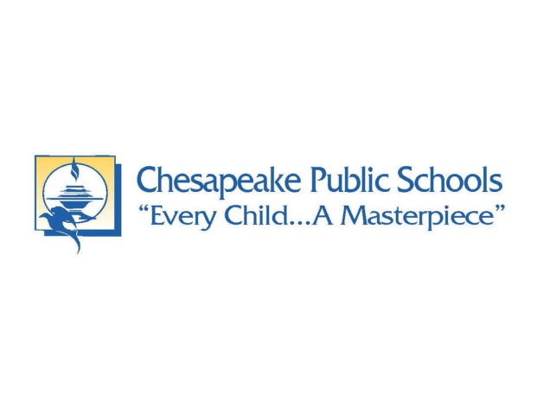

1354 River Birch Rd, Chesapeake, VA 23322

(757) 260-4600 www.riverrunelementary.edu

River Run Elementary School

April 15, 2018

Dear Parents and Administration,

As a parent, you have a powerful role in supporting the health and education of your child. Parent engagement means school staff and parents working together to improve health and learning of children. With the help of engaged parents, our school system will be able to guide our students through school and create a healthy school environment.

When parents become actively involved in their child's school, he or she is benefited. Students with actively involved parents perform better academically, make healthier choices, behave better in the classroom, and create strong social skills.

School food directly affects students' health and learning habits. By offering healthy school breakfasts and lunches, students are able to focus on their education, which is the mission of all schools. It has been proven by numerous studies that improved nutrition leads to better academic performance and an increased attention span.

Parents, please join us on Tuesday, May 1, 2018 at 6:00 pm to watch a short PowerPoint presentation on the benefits of incorporating healthier lunch and snack alternatives into our school. During this presentation, our administration will inform all parents of school nutrition programs, healthy lunch and snack alternatives, the benefits of increased water consumption, and the positive effects on academic performance.

I look forward to educating all parents on how important it is to introduce a healthy lifestyle in our school.

Thank you for your time. It is greatly appreciated.

Principal Johnson

Works Cited

"Healthy Schools." *Centers for Disease Control and Prevention,* Centers for Disease Control and Prevention, 9 Mar. 2018, www.cdc.gov/healthyschools/parentengagement/parentsforhealthyschools.htm

"School Food." *Healthy Schools Campaign,* 2018, www.healthyschoolscampaign.org/food/.