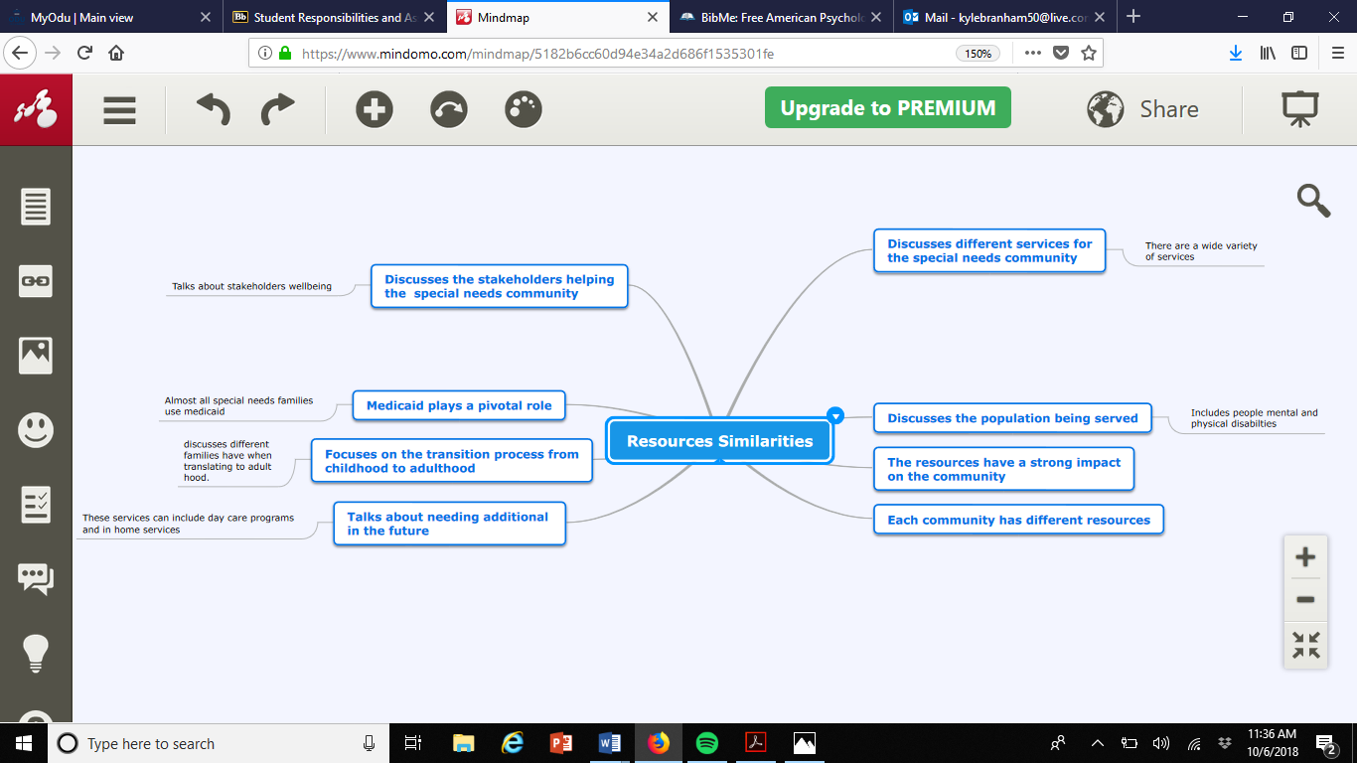

Had to take a picture instead of copying and pasting because the website required me to pay.

References

Hamdani, Y., Proulx, M., Kingsnorth, S., Lindsay, S., Maxwell, J., Colantonio, A., … Bayley,

M. (2014). The LIFEspan model of transitional rehabilitative care for youth with disabilities: Healthcare professionals’ perspectives on service delivery. Journal of Pediatric Rehabilitation Medicine, 7(1), 79–91. <https://doi-org.proxy.lib.odu.edu/10.3233/PRM-140271>

Zhou, H., Roberts, P., Dhaliwal, S., & Della, P. (2016). Transitioning adolescent and young

adults with chronic disease and/or disabilities from paediatric to adult care services

an integrative review. Journal of Clinical Nursing, 25(21/22), 3113–3130. https://doi-

org.proxy.lib.odu.edu/10.1111/jocn.13326

Herron-Foster, B. J., & Bustos, J. J. (2014). Special Needs: Caring for the Older Adult with

Down Syndrome. MEDSURG Nursing, 23(4), 225–237. Retrieved from <http://proxy.lib.odu.edu/login?url=http://search.ebscohost.com/login.aspx?direct=true&db=a9h&AN=97632126&site=ehost-live&scope=site>

Mcmanus, M. A., Pollack, L. R., Cooley, W. C., Mcallister, J. W., Lotstein, D., Strickland, B., &

Mann, M. Y. (2013). Current Status of Transition Preparation Among Youth With

Special Needs in the United States. Pediatrics, 131(6), 1090–1097. <https://doi-org.proxy.lib.odu.edu/10.1542/peds.2012-3050>

Friedman, C. (2016). Day Habilitation Services for People With Intellectual and

Developmental Disabilities in Medicaid Home and Community-Based Services Waivers.

Research & Practice for Persons with Severe Disabilities, 41(4), 244–255. https://doi-

org.proxy.lib.odu.edu/10.1177/1540796916664337