Summer 2017 Internship Work Report

Jazmin Carmon

01037402

jcarm001@odu.edu

BIOL 368/32021

1. Position Information

I served as an intern for the Summer Research Internship for Minority Students at Marshall University Joan C. Edwards School of Medicine. In this position, I worked under my mentor, Dr. Yanling Yan, Assistant Professor at the Departments of Clinical & Translational Sciences, Biomedical Sciences. Dr. Yan is currently carrying out research on Reactive Oxygen Species (ROS) and Cardiotonic Steroids-Mediated Na/K-ATPase signaling in kidney and cardiovascular disease.

Her long-term goal is to implement translational clinical research and develop personalized patient management. It has been found that normotensive recipients of a renal graft from a genetically hypertensive donor develop hypertension. Furthermore, in genetically hypertensive rats a bilateral nephrectomy accompanied with the transplantation of a kidney from a normotensive donor has been shown to decrease blood pressure. The lab is interested in identifying the role of the kidney in this mechanism. Dr. Yan and her colleagues have reported a novel mechanism by which cardiotonic steroids (CTS) mediated- Na/K- ATPase/Src/reactive oxygen species (ROS) signaling regulates renal sodium handling and blood pressure. She documented this mechanism in *Sprague Dawley Rat and Dahl Salt Resistant (R) Rat Fed a High Salt Diet*. Her current research is to focus on the role of ROS and impaired renal sodium excretion in obesity-hypertension in terms of Na/K-ATPase signaling. I carried out a study to further analyze her findings.

The research that I performed involves studying the effect of the inflammatory cytokine, Interleukin-6, on the Na/K-ATPase signaling. This in vivo study is carried out by using TALLYHO/JngJ (TH) mice and C57 BL/6J (B6) mice. The TallyHo mice are genetically engineered to have obesity and Type II diabetes. The B6 mice are the wild-type control. The mice were fed a high salt diet to encourage inflammation and hypertension. The TallyHo mice were expected to be more sensitive to salt in terms of blood pressure, compared with the B6 mice.

1. Duties/Responsibilities

During my summer research, I joined the laboratory and began working with medical students, graduate students, post-doctoral fellows, as well as faculty. My first days at the lab were spent perfecting basic lab skills. In order to properly perform the duties of the lab my pipetting skills needed to be enhanced. I learned how to set the pipet and obtain the ideal amount of solution as well as how to transfer the liquid. For example, to make sure that I was pipetting the correct amount of solution Dr. Yan instructed me to pipet distilled water into a weigh plate and measure the weight of the contents. I completed this action using 10 uL, 20 uL, 100 uL, and 1000 uL pipets. I pipetted the distilled water ten times each then plotted the measurements on Excel. After, I used the program to calculate the standard deviation and error.

Once I became comfortable with pipetting, I began performing protein assays. I made standard solutions of proteins. The standards were 0 uL, .125 uL, .25 uL, .5 uL, 1 uL, and 2 uL. I learned how to use a SpectraMax machine, which reads my proteins to determine the reliability of my standards. This method enhanced my ability to read graphs and analyze the saturation of solutions. Later, I pipetted proteins that were taken from mice and rat kidneys and compared the saturation to my standards. This was the beginning foundation of my experiment.

Further into my internship, I learned how to perform Western Blots. The initial Western Blots that I prepared were my loading control to allow for comparison for my high salt diet studies. I, again, analyzed rat and mouse kidney proteins. The pictures of the blots, showing the right loading control for my experiment, were saved for later use.

Throughout my learning process I underwent training in animal use, toxicology, biosafety, chemical safety, radiation, rDNA, and responsible conduct of research. I passed these sessions and learned how to conduct myself in a professional lab setting. The training that was necessary for my internship as well as the beginners’ methods taught to me during the first weeks showed me the high level of responsibility needed to work in a lab.

After my training, I was allowed to work on my own. This showed me to take pride in my work and remember that an incorrect action could put myself or others in danger. More precisely, it could put my research and my mentor’s research in jeopardy.

The most tedious responsibility was caring for the mice. When I finished my animal training I was allowed to touch the TallyHo and B6 mice. My first dealings with the mice involved tagging their ears and obtaining their individual body weights. I had never handled a mouse before and the initial experience was shocking. However, I handled it well. This brings me to the only enhancement that I have for the program. I believe that the interns should have a virtual or visual experience with animals before they work with them, so that they are not overwhelmed. My mentor was my biggest aid throughout this experience and provided me with more knowledge about caring for the mice than the training.

1. Progression

Since my initial employment, I have been expected to handle more tasks. When I first began, I would perform one of my instructed tasks a day. Now, I am trusted to complete multiple tasks a day. I also have more complex tasks that require more precision such as monitoring the blood pressure and blood sugar of the mice. Recently, I aided my mentor in taking blood from the mice and observed the hematocrit count of the mice blood. This experience was the most difficult because it is possible for a mouse to bleed out and the experimenter must be weary.

Even though some tasks were arduous, my workload raised my confidence and supported my career development. I would not know that I could conquer these tasks if they had not been expected of me.

1. Academic Relevance

A problem that occurred during my internship involved determining which loading control to use to normalize the protein detected. Loading controls were used to ensure the reliability of my data when comparing expression of a protein in different samples. A Western Blot had to be made three times before the protein could be properly viewed. This did not work so we had to strip the membrane using an acetic acid-NaOH-TBS-T sequence. After, we tried to use GAPDH (Glyceraldehyde-3-Phosphate Dehydrogenase). GAPDH made the extraction appear muddy due to signal saturation. Also, there were some changes in GADPH protein levels between B6 and TH mice. Finally, my mentor and I went back to our initial test and identified that tubulin would be the best loading control to view the protein. We, again, stripped the membrane and applied tubulin. Films of the membrane were developed and the protein chain was read successfully.

The major impact of identifying the proper loading control was allowing the procedure to be repeatable. Further testing will be needed to identify the constructs within the Na/K-ATPase signaling. Once my experiment concludes and the kidney tissue is extracted from my mice, I will have a reliable buffer to map the protein.

My internship at Marshall University Joan C. Edwards School of Medicine has increased my knowledge of the biomedical processes within the bodies of animals. In my core classes I have received an overview of these mechanisms. Now, I have been provided with an in-depth study. Moreover, when I am undergoing a biological course there is often not enough time to provide backing and details about the necessity of certain procedures. For example, I have viewed the completion of electrophoresis several times, but I had never carried it out by myself and analyzed the molecular weights of proteins. This opportunity has enhanced my understanding of my coursework and provided me with the backing I need to excel in my major.

1. Future Projections

The career options that can stem from my internship are becoming a biomedical scientist, forensic scientist, physician, physician assistant, or other healthcare and science professions. My primary interest in obtaining this internship was to fortify my backing to work in healthcare. The training that is necessary to gain a career in this field is an undergraduate degree, followed by graduate or medical school. One must also successfully finish all training associated with working with the organism and conditions within his or her field such as biohazards.

Furthermore, I wanted to familiarize myself with the lab setting to determine where my knowledge would be best fit. I hope to obtain an M.D. and a Ph. D in the future. My internship put these aspirations into perspective. Previously, my search for a career in the medical field consisted of shadowing and attending the career fairs offered at Old Dominion University. As I near the end of my undergraduate schooling, it is imperative to invest myself in hands on learning.

1. Conclusion

Overall, I feel that my internship benefitted my development as a Biology, Pre-Med student. Serving as an intern at Marshall University Joan C. Edwards School of Medicine allowed me to look deeper into the background of medicine. I would recommend this internship to anyone who is seeking a career in the sciences. I believe that working physically among like-minded students and professionals enhances growth. This internship has empowered me. I hope that others gain the same fulfillment.

1. Beneficial Suggestions

The only beneficial suggestion that I have for the Summer Research Internship for Minority Students is to require more time with our mentors. As science students, we tend to forget that we need to relax. The ideal mentor should teach his or her intern to excel professionally as well as mentally and emotionally. My mentor, Dr. Yanling Yan, instilled this philosophy throughout my time at Marshall. I am thankful for the support and guidance that she gave me. The other interns were not as lucky. I have been informed that spending time with a mentee is not a requirement. Additional time with an intern has the potential to aid his or her progression while completing any internship.

1. Photos

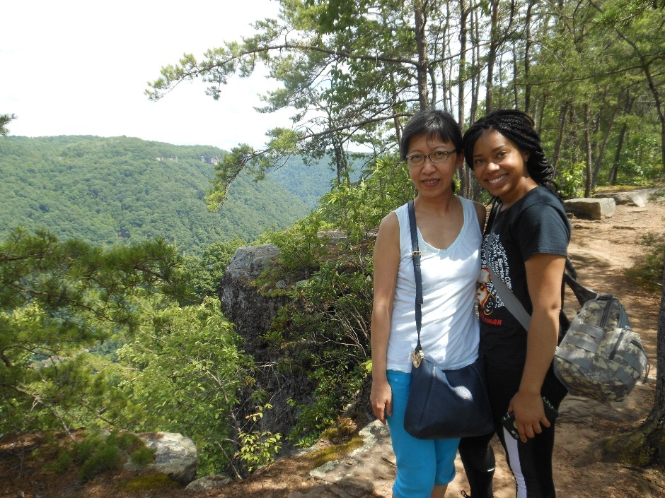

This photo was taken at the top of Long Head Point Trail on a hiking trip with Dr. Yan at The New River Gorge.

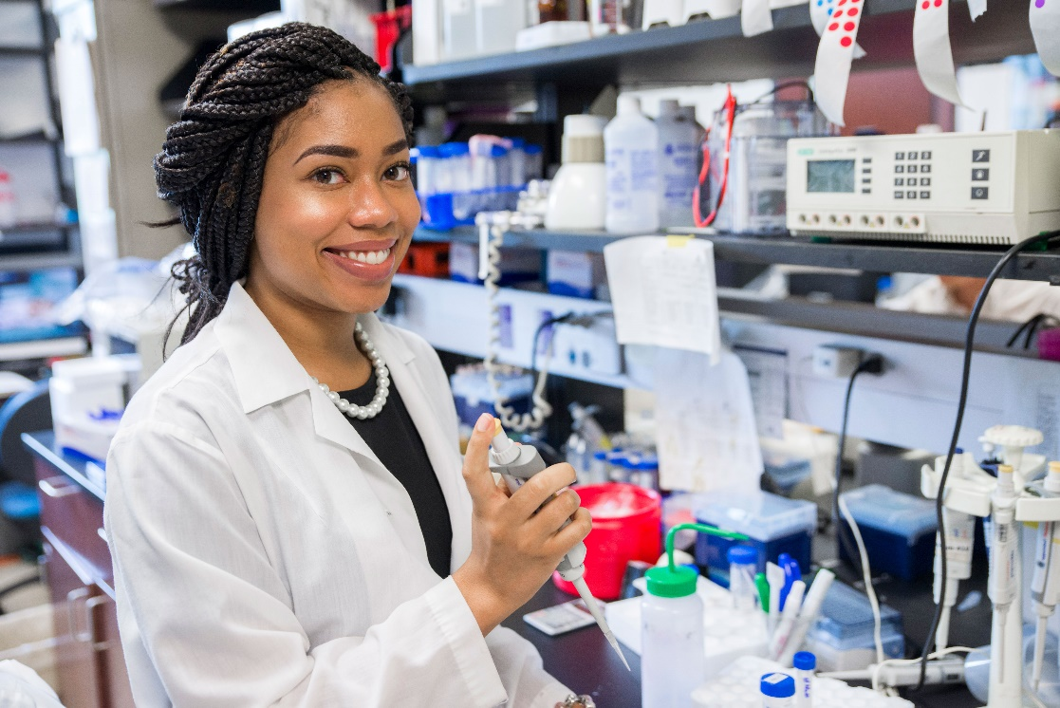

Here I am pictured working in the lab in the Biomedical Sciences Building on the campus of Marshall University.