Writing assignment #3: Summary

The article named, “A gene-environment induced epigenetic program initiates tumorigenesis” is a study of gene-environment interaction to dictate early neoplastic commitment. Researchers also provide evidence of the interplay between genetics and environmental cues in cancer initiation. If we understood how tumor form, and how damaged tissue promotes cancer, we could easily come up with strategies to prevent, detect, and intercepts these tumors.
One of many forms of damage carcinogenesis is pancreatic ductal adenocarcinoma which associates with KRAS mutation. KRAS mutation exists in 95 percent of pancreatic cancer patients, but scientists still wonder how it can derail the wound healing process. It is lethal cancer but lacks therapies. They explain pancreatitis is associated with damaged tissue and KRAs mutation will increase the chance of neoplastic and pancreatic cancer.
According to the authors, the pancreas makes enzymes used to break down food. However, pancreas and tissues will be damaged if these enzymes release in the wrong place. The pancreas can repair itself. The cells in this damage will stop producing digestion enzymes, but produce them in a different form. They will return to work when the problem has been solved. In another scenario, if these damaged cells carry the KRAS gene, they would not be healing and returning to normal.
Damage cells in KRAS mutation can be turned on and off, and become cancerous cells by the change of chromatin. A part of the chromosome that is supposed to be open is closed. Otherwise, the part that is supposed to be closed is opened. That led to these damaged cells confuses about their genetic instruction. This process of cancer-associated chromatin happens very quickly, about 48 hours of tissue damage to link to cancer factors. Researchers use genomic techniques and innovative mouse models to discern damage tissue synergizes with genetic change to prevent early-stage pancreatic cancer.
First, scientists use mouse models to incorporate a pancreas and doxycycline to correct elements associated with fate specifying genes. They disrupt the epigenetic program of stromal cells that effect directly to pancreatic epithelial cell fate. Second, they discover distinct epigenetic requirements for the resolution of metaplasia and link Brd 4 function. Third, they test IL-33 to find out the effect of tissue damage by intraperitoneal of the mouse. They come up with IL-33 as the element that affects gene-environment interaction in the early stage of cancer. They state, “…suggest a chromatin-mediated amplification mechanism whereby tissue damage mediators unleash and enforce oncogene-dependent gene expression.” (page 8).
For the method, they target in GFP link Brd 4-shRNAs, KC-shRen ESC control clone. The result shows, mouse and their progeny was authenticated by genomic PCR by a common Colla primer. The figure below shows, chromatin dynamics during pancreatic regeneration and early neoplasia.
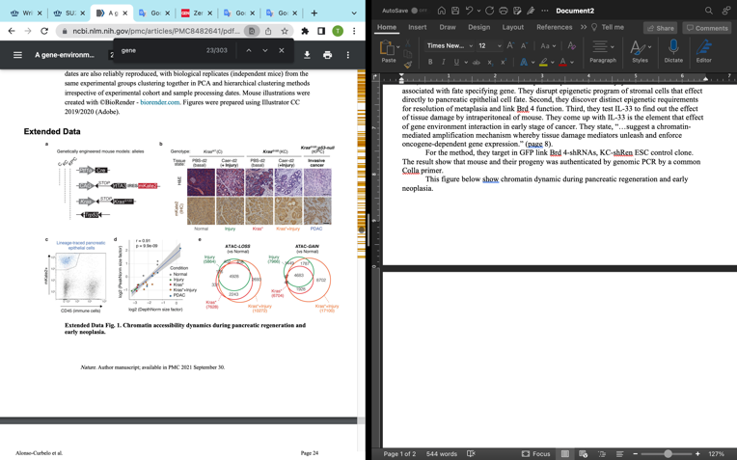
This research is very important because scientists can now prevent cancer development by activating a gene that becomes inappropriately turned on. They believe that they need both mutation genes and damaged tissues to discover this epigenetic program. It means cancer will not occur if KRAS mutation and damaged tissue are present separately. The author state, “Intriguingly, KRAS gene mutations are only weakly oncogenic but potently cooperate with signals emanating from tissue damage and the resulting inflammation (pancreatitis) to initiate the disease.”(page 2) In the future, scientists can use this gene to mark the early sign of cancer.

Citation:

Alonso-Curbelo, D. et al. A gene-environment induced epigenetic program initiates tumorigenesis. Nature 590, 642-648 (2021).

