**Michelle Corcoran**

HMSV 440W: Professor Lewis

November 29, 2021

I am currently a student in the Human Service program at Old Dominion University and have recently completed a course in Program Development, Implementation, and Funding. This course proved to be challenging as it did not primarily focus on skills that I will use in my career while working directly with clients in the field as all of my other Human Service related classes that I have taken have, but more so on the implementations and procedures that are incorporated and used in the environments that I will be working in. Some of my experiences and thoughts about completing tasks for this class are listed below:

* I had forgotten about how useful the University Library can be in finding relevant information for research topics, and had also forgotten how easy it is to get off track when researching topics while using the library due to some of the interesting articles that can be found there on so many topics. <https://www.odu.edu/library>
* I have not taken a writing intensive course in a while and considering the feedback that I received on some of my assignments, I do need to continue practicing writing in APA format. Though my mistakes were small, I am grateful that they were pointed out to me so that I can avoid them in the future (Not all professors do that, as I have been making the same small mistakes for quite some time now).
* The [MindMap assignment](https://learn-us-east-1-prod-fleet01-xythos.content.blackboardcdn.com/blackboard.learn.xythos.prod/5a3434ca259b6/1228217?X-Blackboard-Expiration=1638284400000&X-Blackboard-Signature=DIuvUui2OOSUhFpS6b2eM6%2F%2Fp8mAYND%2FbmUQ%2BB9J2cU%3D&X-Blackboard-Client-Id=131304&response-cache-control=private%2C%20max-age%3D21600&response-content-disposition=inline%3B%20filename%2A%3DUTF-8%27%27Task%25204%2520Create%2520A%2520Mindmap.pdf&response-content-type=application%2Fpdf&X-Amz-Security-Token=IQoJb3JpZ2luX2VjECMaCXVzLWVhc3QtMSJHMEUCIQD%2F9RUwrd7hxhPBQjm2A0wRwp4SWeI99tGdmuED8hwitwIgBka8FsGxZ3SN4NxlVHbX7UUkByNjK4pphmv1AggvQjgqgwQI6%2F%2F%2F%2F%2F%2F%2F%2F%2F%2F%2FARAAGgw1NTY5MDM4NjEzNjEiDJoYZUUGw0OW6PBrICrXA1WQXPYmrJiCtKJrWaUM2kZFpOTUY61KdBK5tDrzIOXjwbFoCvZYii2qmr3WLETn6%2FrjNfWSWwQzyQoS6pOrBO7tRyabKpY4EcjxG6L4xP2fE%2F87l0k7ni6qA96SI7tFbdGQj3lsf9dKY8XX4KuneiVWUEWAg6huU19wsOTTppdtFhSZhZP17PCiWMmjrBxHoAgGA1swppdMi9lI5uKJISQINiOT168dPMMCZSDCU6AM9HCgVkiOinR8l0mbIz6jke9%2BigrEw02Blp0GxLpdj7BYwaAIXi0kpXFv9YbgN4QKL5c0mUEvpXCfOu2KFEiNoU%2FBtp0m0kuIXMYoZD47HGY789o%2F7mzx1H6jnvdxjSzsVDvmB36u48ncLami%2F4yShc5JXvbJaJi3BQNOPIS7SywSg97s2BN7KZszvRg1odUvUDHqmSJz3OE%2BTjUDfGdn1WRmHeu3H%2BUdtvPSotAWPzCD2d0rxXSY9MWRQHt5XFJdxsrQcGJkMYr%2FHGHJMiWqKNQDusxmI33%2BayRAQazhOGUfgN8%2F4R63YgKGjqTYZqRcJYfldjFS7zeBhsSWaNwLigYnqf5QPTp5R8BX9vzQOZwLufziHuoygDv6kcgprfYdbH%2BnZyvnHzDj8peNBjqlAfUJWpEXdludlBYcI0pKfbX38KqlMTImLbvASRzqBsJo0D8YmwIjcC2bnhSSTI6h34%2FFAc%2BMYNRaFK3bojt%2BwkcsA9lbp26HuyHwAVO%2BXqEGm1BHH0KLc%2BVz75igmzDsUprzdlpW4GSSSa2roOgalJlf7FTh6hsLfpje7bBNBXLyYy15zoECr%2FTLeTfxXehZnPn988fgjzrBmjo%2BbSjRqRXo6EzbAw%3D%3D&X-Amz-Algorithm=AWS4-HMAC-SHA256&X-Amz-Date=20211130T090000Z&X-Amz-SignedHeaders=host&X-Amz-Expires=21600&X-Amz-Credential=ASIAYDKQORRY7RQHZNKH%2F20211130%2Fus-east-1%2Fs3%2Faws4_request&X-Amz-Signature=b3d7add2bbf86e34bf807590d052596b141d50cc1856bb0dd1d620fa25dccde9) was a bit difficult for me because the information that we were to include in the project was not typically information that I would include in my brainstorming, However, when I overcame the confusion, I was able to see how effective the MindMap was for finding and utilizing sources that all provided relevant information that was connected to use in our own research.
* I found the peer reviews helpful, as feedback is always appreciated and it’s generally helpful for me to collaborate with others to help stimulate new ideas.

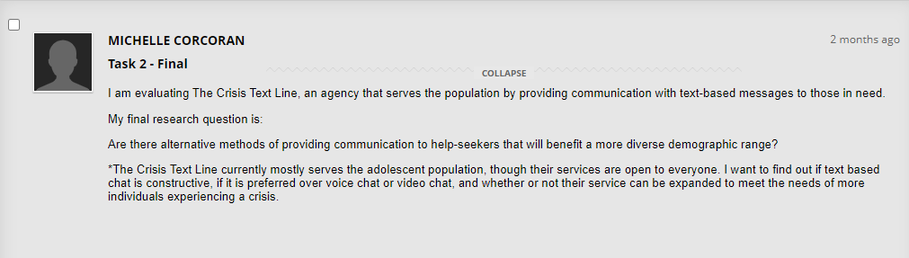

* For the evaluation project, we were given the option to choose an agency of our choice, one provided, or to use a hypothetical agency. I chose to evaluate the Crisis Text Line ([https://www.crisistextline.org](https://www.crisistextline.org/)) and I am glad that I made that choice. The evaluation process was difficult and I was not able to carry out the evaluation as a formal evaluation would have been because those that help to provide services for the organization are located all over the United States and most of the textline’s services take place over an online platform with clients who are, for the most part, anonymous. I do feel that I was able to use the information that I have learned in the class to produce an evaluation strategy within my means that could provide me with information that was relevant to my research questions, but with the understanding that during a formal evaluation, my strategy would not necessarily be considered reliable because I was not meeting with stakeholders face-to-face.
* I now have a better understanding as to why it is vital to identify and work with the stakeholders during an evaluation. I also understand that while everyone’s needs may not be able to be fully met, it is still paramount to discover and consider the needs of all stakeholders so that an agreeable beneficial resolution can be determined.
* This course has provided insight as to what I might want to consider when making a decision for the type of agency or organization that I will want to work for in the future. These considerations include (but are not limited to) working for an organization that is flexible, open to feedback, and susceptible to change if it could benefit the clients, the staff, and the community.
* At my current place of work, I am occasionally required to monitor new implementations and I think that completing this class has helped me to better some of the skills that I already possessed, helped me to develop a few new ones, and I feel that the content learned in this class can certainly be used in my future professions, even if I am not specifically evaluating a program or agency.

Overall, I feel that the evidence of what I have learned can be found in my E-Portfolio, more specifically in the tasks that I have completed (<https://sites.wp.odu.edu/mcorcoranhmsv440w>), as well as in the content listed here in this reflection letter. I was familiar with some, but very little content presented to me at the beginning of this course and that was a bit overwhelming for me, but I feel that as I continued reading the textbook, looking over materials provided, and worked on the assignments that all aided and led up to the final project, I was able to effectively grasp the content in this course and will be able to use that information in my future endeavors.