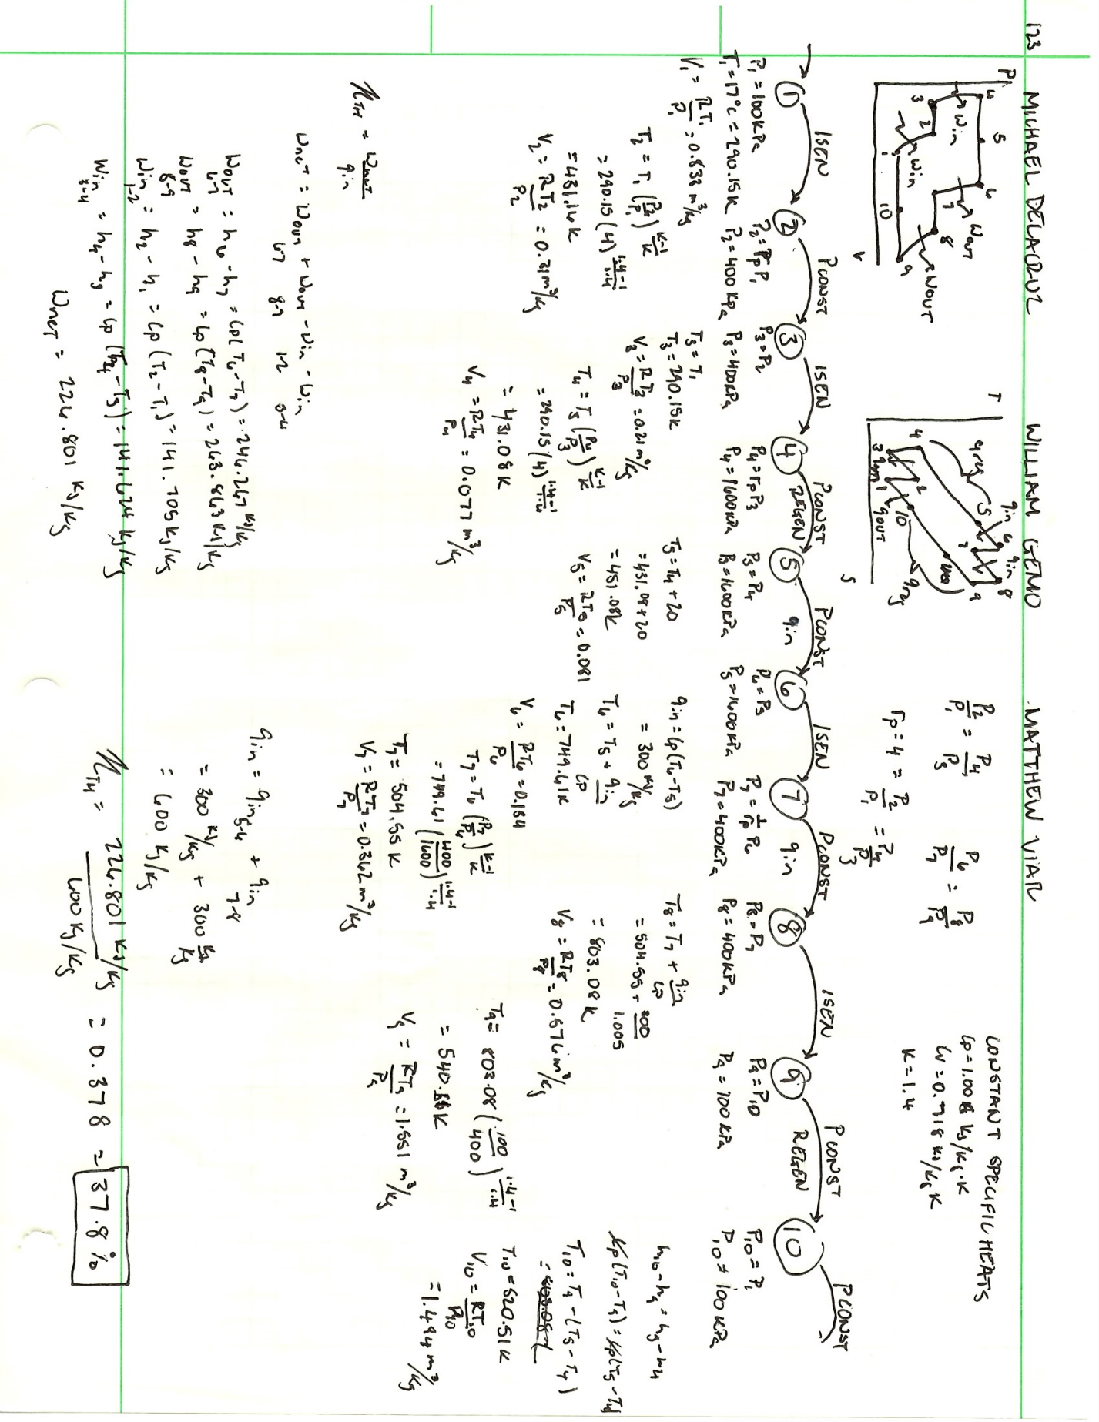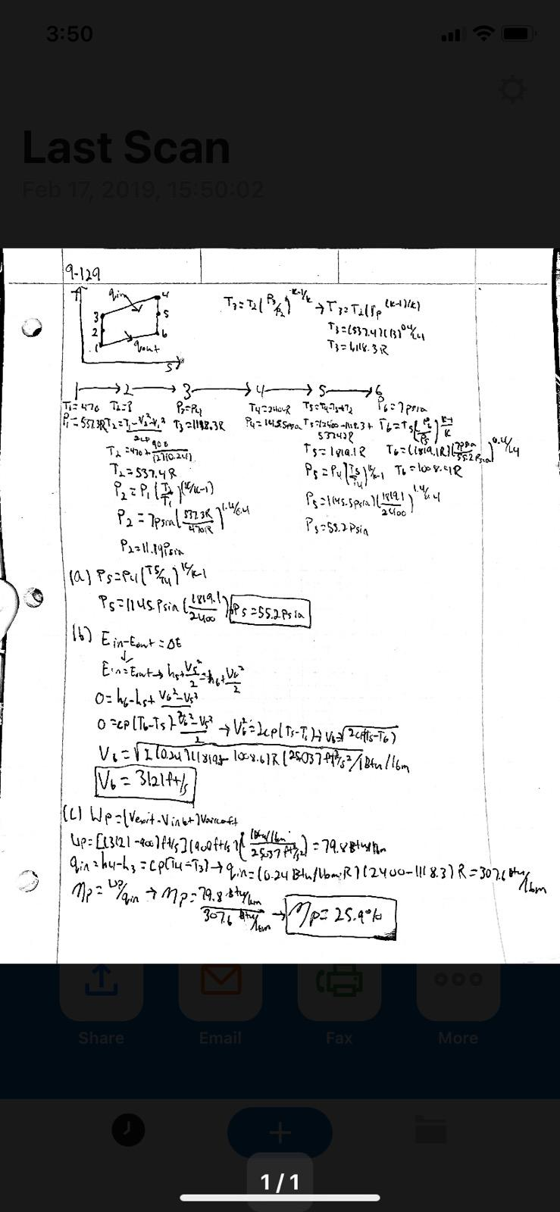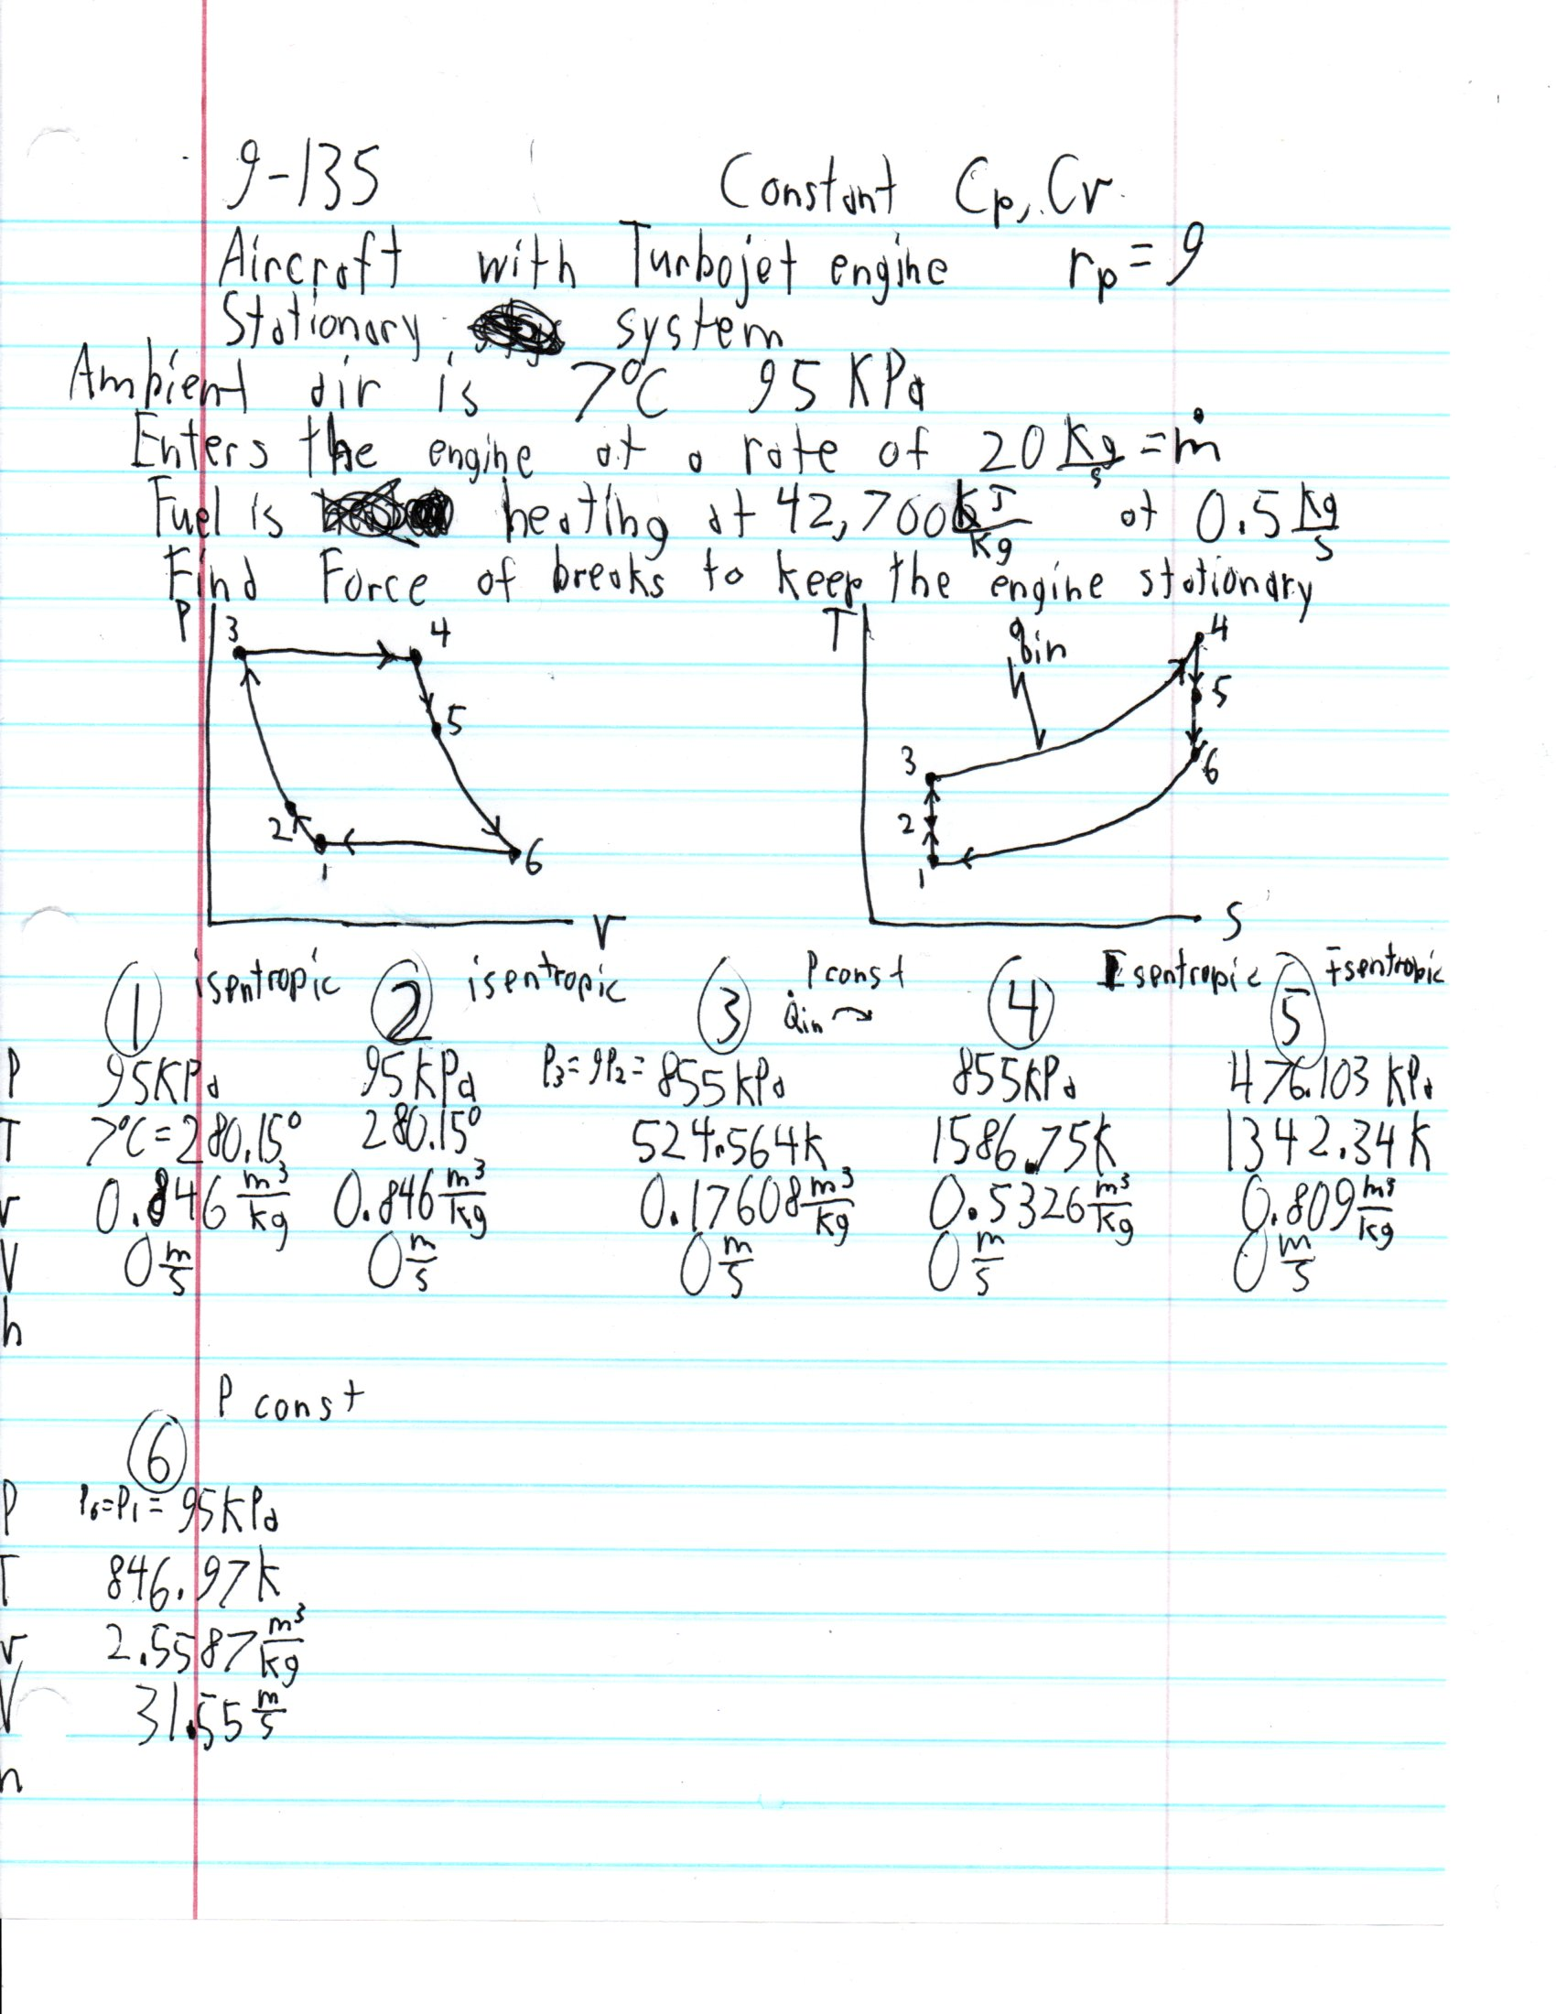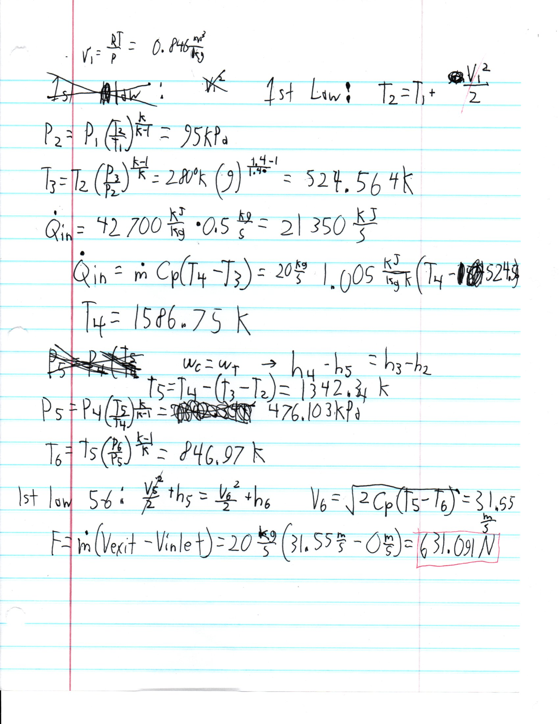

HW 1.4 review comments

-Not all states were found on the problems.
-Did not include the P-v diagrams on all the problems
-T-s diagrams are included
-All problems were solved

