Amanda Shepperd, Blackstock, Ambrose Collaborative 5th grade Unit

South Boston Elementary School

Plagiarism and Source Citing

Knowledge of Learners:

Of the seven elementary schools in the Halifax County Public School system, South Boston Elementary is the largest with a total student population of approximately 670, 52 faculty members, one principal and one assistant principal for the 2018-2019 school year. The school houses grades Kindergarten through fifth grade and has a student teacher ratio of approximately 22:1 in grades Kindergarten through third grade and 25:1 in grades fourth and fifth. The population of students is diverse with 55% of the students being Black, 34% White, 5% Hispanic, 5% bi-racial and 1% Asian. Other subgroups include the gifted students, students with disabilities and students that are economically disadvantaged. 12% of the student body is considered gifted, 12.5% have been identified as students with disabilities, and 3.5% of students are English language learners. Because of the number of students that are identified as economically disadvantaged in the community, the school can take advantage of the Community Eligibility Provision, a program under the No Kid Hungry campaign run by the Share Our Strength nonprofit organization. The school uses federal money to provide free breakfast and lunch to all students in qualifying school districts. Therefore, the school is considered 100% economically disadvantaged.

The school is on a six-day rotation for resource classes and come to the library for 45 minutes once every six days. I am the only librarian for the school and do not have an assistant. The school has two instructional coaches, one for kindergarten through second and one for third through fifth.

Accommodations:

There are 135 students among the five classes in fifth grade. 12 students participate in the pull-out gifted program and 10 students have IEP’s and require specifically designed instruction. According to the teachers, 18 students are reading under their grade level, 94 are reading on grade level, and 23 are reading above grade level.

At the beginning of the school year, I created my seating charts grouping students in groups of four for the 8 tables in the library. Higher leveled readers, lower leveled readers and grade leveled readers are mixed evenly among the tables. Most group work is completed by table. A variety of differentiated learning strategies are used throughout the year. For the following three lessons, students will remain in their assigned groups.

Unit Title: Copy Right, Fair Use, and Citing Sources

Brief Description:

Three collaborative lessons will be given to all 5th grade classes to assist with their upcoming state projects. For this project, students will choose two written resources and three online resources to complete the project. During the lessons in the library, the students will learn about plagiarism, copyright, and citing sources to appropriately complete their projects.

Instructional and Research Skills Methodology:

Even though the collaborative unit is spread over three 45-minute class periods, 15 minutes at the beginning of each class is designated to book check out. Therefore, approximately 30 minutes each class period is allotted for each lesson. Discussion will be used to introduce plagiarism and copy right; direct instruction will be used to learn how to cite their sources and syndicate group work will be used to create an example bibliography for the students to use when creating their source page for their research papers. The instructional methods meet all six AASL standards:  inquire, include, collaborate, curate, explore, and engage. They also access the following learning domains:  cognitive, affective, psycho-motor, and developmental.

Primary Goal and Objective:

The three lessons are all centered around SOL’s and AASL Standards:

USII.1 The student will demonstrate skills for historical thinking, geographical analysis, economic decision making, and responsible citizenship by identifying the rights and responsibilities of citizenship and the ethical use of material or intellectual property.

VI.A.1.2.3. – Learners follow ethical and legal guidelines for gathering and using information by responsibly applying information, technology, and media to learning. Understanding the ethical use of information, technology, and media. Evaluating information for accuracy, validity, social and cultural context, and appropriateness for need.

VI.B.1.2. – Leaners use valid information reasoned conclusions to make ethical decisions in the creation of knowledge by ethically using and reproducing others work. Acknowledged authorship and demonstrating respect for the intellectual property of others.

Approximate Time Required:

The students will begin their state project in the classroom. I pulled all of the specific state non-fiction books from my shelves and two sets of encyclopedias and placed them on a rolling cart for the teachers to use in the classroom. The students will use those written resources and their Chrome books to look up their websites.

During their library times, we will cover the three lessons on plagiarism and copy right. Each of the three lessons will be approximately 30 minutes. When complete, I will provide the teachers with the bibliography examples that the students created so that they may use them in the classroom to create their own bibliography pages for their papers.

Lesson Plans:

Three lesson plans attached separately

Instructional Delivery and Assessment:

The pre and post-test is attached separately

I will assess student learning by using the pre and post-test scores. The example bibliography pages that they create and refer to while creating their research projects will also be used as evidence of their knowledge of plagiarism and copy right.

Student Work Sample:

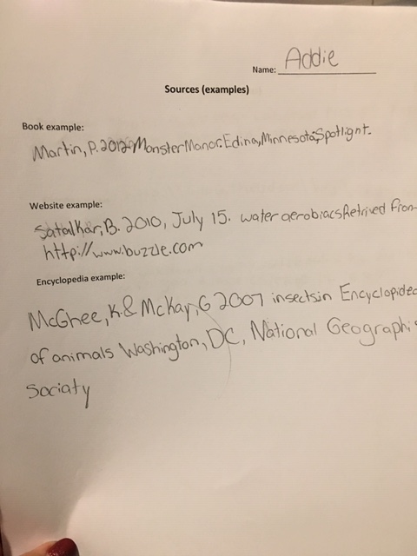

Meeting Minutes and planning log:

October 1- email sent to 5th grade teachers to determine if there is a project that I can assist with.

October 2- Ambrose and Blackstock came to me in the library after school to ask about helping with the student’s state projects that will be completed by the end of the second nine weeks. Set up meeting time to discuss details.

October 4- Meeting at 3:15 in 5th grade pod to collaborate about the state project and come up with lesson ideas. During the library classes, I will help the students learn to cite their sources for their projects. This is a time that I can cover the AASL Library Standards that teach safe, legal, and ethical ways of creating and sharing information. Lessons will begin during the 6-day rotation that begins on October 17th. I will have the students source example pages that they create to Ambrose and Blackstock by November 8th. I will pull the non-fiction state books that are in the library, and a set of encyclopedias for the students to use in their classrooms. They can be put on a rolling cart and kept in the 5th grade pod until their projects are complete.

October 18- Meeting after faculty meeting to discuss new dates due to 5 missed days because of Hurricane Michael. New start date for lessons will be October 24 with source page examples given to teachers by Thanksgiving break. This still allows the students enough time to finish their projects by the end of the second nine weeks.

Reflection:

The beginning of this year as the new librarian has been very challenging when it comes to collaboration with the teachers at South Boston Elementary. They are very friendly and welcoming, but they are not used to a collaborative relationship with their librarian nor are they used to utilizing the materials in the library for lessons. The previous librarian did not encourage collaboration and was not very helpful with providing teachers with materials. Because of the size of the school, each grade level has their own pod and tend to work within those pods. This also creates a barrier that I’ve been trying to overcome. Therefore, it has taken a lot of extra effort to create these new relationships. It’s been easier with some grades than with others.

I have worked collaboratively with the 5th grade teachers several times so far this year. This group of teachers are very open to any extra help and are always eager to collaborate. I am hoping that the other grade levels will see this and will be more open to collaborate as the year progresses. I also have activities that I plan to do at the beginning of next school year to better advocate for collaborative relationships with the teachers.

As far as this collaboration unit, I am very pleased with the way the unit went. I feel the students learned a great deal about plagiarism, copy right and citing their sources for their state projects. Hopefully this will be helpful to them in the future as they continue to need to cite their sources for future projects. Missing two weeks due to two separate hurricane systems created challenges for timing but I still feel the students learned what we needed them to learn for their projects.

Video Overview:

<https://share.icloud.com/photos/0sOtYQnfjP7x1x-HgKkxyWfdA>