**Age Is Just A Number Reader’s Guide**

Tiffany Allen

Library and Information Studies Program, Old Dominion University

LIBS 647: Reading and Literature for Adult Library Patrons

Dr. Amelia Anderson

July 17, 2022

The targeted audience for this Reader’s Guide is seniors or older adults. This group is aged 70 and older, who may or may not be coping with a loss of independence. I have personal reasons for creating this list for this age group. I was a caretaker to an elderly aunt for many years and visited her a lot when she went into a nursing home. I spent time around that age group, enjoyed them, and currently love helping the senior patrons who frequent my library. That age group faces a lot of challenges, some of which I saw firsthand, and reading could help them cope or escape from the realities for a little while yet also show them that their life can begin again despite their age.

In the United States, libraries are experiencing an upsurge in their use by senior citizens (Ahlvers, 2006, p. 305). However, there are impediments to use by seniors including they may have given up driving, their ability to hold a book maybe limited, their physical mobility maybe limited, and their vision maybe impaired, whether that is partial or complete (Ahlvers, 2006, p. 305). However, reading provides many benefits to the senior population including some research suggesting that it can help to prevent dementia (Merga, 2017, p. 147). The activity also provides other benefits including mental stimulation (Merga, 2017, p. 151), escape from surroundings and from self for improved mental health (Merga, 2017, p. 151), relaxation (Merga, 2017, p. 151), help from loneliness by providing friendship (Merga, 2017, p. 152 and Luvt & Swee Ann, 2011, p. 205), and a boost to creativity (Merga, 2017, p. 153). Older adults are often craving human contact and the library maybe their only source (Ahlvers, 2006, p. 306). Lifelong needs can be met by reading and it can help with coming to terms with the aging process (Luvt & Swee Ann, 2011, p. 205). So, there are both impediments to and benefits from seniors using the library.

The question becomes as far as what to include on a reading list targeting that population. Bestsellers seem to be a staple (Ahlvers, 2006, p. 308 and Luvt & Swee Ann, 2011, p. 205). Also, popular with this demographic are mysteries and thrillers, biographies, popular narrative history, romance novels, crafts, personal favorites from childhood, and TV tie-ins (Robertson, 2006, p. 24 and Hebert & Huwiele, 2022, p. 5) Bestsellers and mysteries do top out the preferences in fiction while biographies and bestsellers top out preferences in non-fiction, (Herbert & Huwiele, 2022, p. 12). Ahlvers found that “older adult customers still tend to request no profanity, nice characters, and lack of gory description as elements that appeal to them” (2006, p. 308). Topics identified as practical for seniors include crafts, gardening, health and drug treatments, mental fitness and memory, exercise programs (including general fitness, yoga, stretching, and fall prevention), personal finance (including living on a fixed income), pet care, wills and estates, and wisdom/humanitarian (Robertson, 2006, p. 24). Large print can be helpful to seniors who do not see as well as they used to and findings by Herbert and Huwiele indicate they “want what everybody else wants” (2022, p. 13).

The book list should have either all titles available in print, ebook, large-type and audiobook (both CD and available in eaudiobook form) or a mix of the mediums presented. The idea is to help with some of the impediments to a senior using the library like vision loss and diminished capacity to hold a book. This book list features older adults in mysteries, humorous/literary fiction, and biographies that are not traditional ways seniors are presented. The idea is to entertain while also showing them active seniors who have adventures and learn things about life, love, and family along the way. Depending on the success of this book list, other book lists can be created with similar books that feature older protagonists doing all sorts of activities. Some of these novels are the start of a series featuring the same older protagonists. Book lists can also be formed on the practical subjects suggested for seniors depending on how well this book lists meets the needs of its demographic.

Age Is Just A Number Book List

Backman, F. (2014 July 15). *A Man Called Ove*. Atria Books.

This New York Times Bestseller is a humorous tale about a curmudgeon, Ove, and the family who moves in next door. Ove struggles with finding a purpose for his life after his wife dies, and he is forced to retire. He continually sets about to commit suicide but is always interrupted or thinks the better of it. Through his interactions with the family that moved in next door, he does find a purpose to his life. This book, while dealing with a serious subject, presents life in a funny turn of events and this can be helpful to seniors dealing with similar life experiences. It also can help show there is a purpose to life after the known is gone, something that seniors often must deal with.

Cannon, J. (2018, August 7). *Three Things About Elsie*. Scribner.

This is a cozy mystery where 84-year-old Florence has fallen, but it is the thoughts about her friend Elsie that consume her while she awaits rescue and the secret about Elsie that she wonders if it is going to come out now. Florence also presents a fear that she will be moved from her present home to a nursing home. Falls are a very real fear for seniors as is being moved into a nursing home whether be it from home or from a senior or assisted living facility. Both fears are present in this novel. The mystery is what is the third secret about Elsie and who is Gabriel Price, the new resident, who resembles someone Florence knows is dead. Mysteries are popular with this demographic and this one features an all too real protagonist dealing with things they might be as well.

Davis, B. (2015, February 2). *Lost and Found*. Dutton.

Humorous tale about a seven-year-old, Millie, abandoned by her mother at a department store. Her mother is dealing with grief over Millie’s father’s death. Millie teams up with 82-year-old Agatha, who has not left her house since her husband died, and 87-year-old Karl, who escaped from a nursing home. Karl also lost his wife. The three embark on a trip across Australia to find the child’s mother. This novel addresses some serious topics about loss and loneliness as both seniors have lost their spouses as has Millie’s mother with wit and zippy dialogue while taking the characters on a wild ride. Both older protagonists are dealing with grief in different ways and finding each other so late in life. The humor may help a senior who is dealing with loss find some ways to cope.

Hobbs, V. (2005, Feb 18). *Call It a Gift*. University of Nevada Press.

77-year-old Jeronimo and 82-year-old Emily meet over a checked-out library book leading to the romance of a lifetime between an unlikely pair who must overcome obstacles to be together. Romance is not only for the young, and this book shows that when Jeronimo accosts the woman, Emily, who just checked out the book he wanted. He has met the love of his life, who cannot be more different than he. They elope but must deal with their responsibilities and with family along with confronting prejudices. This is a romance among the senior set and may remind them that it can happen at any age. Romances are popular reads among seniors as well.

Ingelman-Sundberg, C. (2016, July 12). *The Little Old Lady Who Broke All the Rules*. Turtleback Books.

Martha, 79, and her group of four friends form the League of Pensioners rebelling against their retirement home cutting corners, the rules, and then turn to white collar robbery, trying to stay one step ahead of the authorities. Though outlandish in the hijinks, this novel features seniors who are frustrated and decide to take things into their own hands. Considering that this demographic maybe dealing with a loss of independence, reading about seniors who try to take some independence back maybe cathartic for them. This is the first book of a three-book series.

Jonasson, J. (2012, September 11). *The 100-Year-Old-Man Who Climbed Out the Window and Disappeared*. Hachette Books.

This 100-year-old is not excited about his celebration at the nursing home for turning 100 and heads out on an adventure featuring criminals, money, and an elephant while he reflects on his life along the way. Again, this is a 100-year-old man in fairly good health who escapes his nursing home and has adventures, something that could be cathartic for seniors confronting both a loss of independence and a fear that death is approaching. This novel also has Allan’s life recollected in a way where he meets a lot of world leaders, and reading about history maybe popular as the reader recollects on these leaders as well. The book has been compared to *Forest Gump* in that part of the plot. There are a lot of escapades both in the past and in the present, again hopefully making seniors who read it see a little inspiration in someone who has not stopped living their life just because they aged. There is a sequel to this book.

Osman, R. (2021, August 3). *The Thursday Murder Club: A Novel*. Penguin.

A mystery set in a retirement village where four friends meet weekly to discuss unsolved crimes but suddenly find themselves with a case. This not only is a mystery but one where senior citizens are the sleuths. Mystery is popular among the senior demographic, and this tale of four older citizens playing detective in race against the police to solve a crime should be entertaining as well as showing that seniors can have a purpose. It also deals with loss as one of the four original members who met to talk unsolved crimes is now in a coma, and new beginnings as it starts with the new person coming into the group. Starting over is always a challenging idea for any set of the population and one seniors must face in their latter years. This is the start of a three book (to date) series.

Riesman, A. (2022, March 1). *True Believer:* *The Rise and Fall of Stan Lee.* Crown.

This biography is a Hugo Award finalist. It explores whether Stan Lee was who he seemed to be or whether he perpetuated fraud. Lee started creating comics relatively late in life, 39, and achieved most of his fame in his later years with the popularity of the Marvel movies. The author of the book did over 150 interviews and looked at many pages of private documents. He explores the ownership and creation of Marvel properties and whether Stan Lee was the one who did so. Licensing and copyright were murky in those early days of comic books. As Lee’s popularity soared after the Marvel movies became hot properties, relatively late in in his life, this should be of interest to seniors. Also, biographies seem to be a popular read among that demographic.

Thorogood, R. (2021, January 7). *The Marlow Murder Club*. HQ.

This cozy mystery features an impossible crime with a 77-year-old sleuth who teams up with a dog walker and the wife of a vicar to investigate the crime. Judith Potts is happy with her life at 77. It is an interesting idea to present to seniors who might read this book. When her neighbor is killed, Judith embarks on a mission to solve the crime and ropes in Beck Stirling, a vicar’s wife, and Suzie Harris, a dog walker. They are an unlikely trio but manage to stay one step ahead of the police on the case. A mystery that shows a senior doing something besides crosswords should be an interesting read for a senior looking to do more with their life. There are two books in the series to date, this one being the first.

Williams, M., Williams, K. and Williams, J. (2005, September 1). *One Last Dance: It’s Never Too Late to Fall in Love*. Calliope Press.

Finding love at any age happens in this story with 79-year-old Dixie and 89-year-old Morgan, despite a disastrous first meeting and then an agreement to become roommates. Their business arrangement strengthens their relationship as they combat illness, a scandal, and an accident while dealing with an intruder. The couple also deals with their pasts that continue to haunt them. This romance of two unlikely senior citizens would be good at showing that romance does not end when you get older. In some cases, it just begins. Romances are of course popular with the senior demographic.

Wolterstorff, R. (2016, June 14). *Grandma Moses: American Modern*. Skira Rizzoli.

This biography looks at the artist’s paintings and her autobiography to re-examine her role as an artist who defined modernist’s art in the latter years of her life. This biography seeks to examine her life in the context of being a definer of the culture of modernist. Grandma Moses did not pick up a paint brush until she was 78 and did so because she could not embroider anymore due to painful arthritis. Yet, she became an art phenomenon and was prolific over the course of the next three decades. Seniors prefer biographies, and this one should bring about a message that it is never too late to make a change and do what you want to do. The story of Grandma Moses is inspiring because she lost the ability to do what she liked to do but found something else that she excelled at. Starting over is hard for any age group, but seniors may find themselves having to do that so anything that can help them see it can be done might be a good read.

Displays in the library will have the posters (examples following the Reference section in this paper) and book displays of the books mentioned on this list with them. These same posters can be put online and in other sections of the library on the walls to advertise the book list. Bookmarks can be printed with scaled down versions of the posters and a few books from the list (different on each one). These along with the book lists can also be distributed in outreach at senior citizen communities. The book list will have printed versions (both regular and large type), be on the website, and available for download at the library’s website. As the program is advertised, a team-up between tweens/teen and seniors can be put into place. These groups can read the books on the list to a senior and then they can have a book discussion. This would give tweens/teens some volunteer hours, the opportunity to interact with an older adult, and to share with that population. This would not only be utilizing the Age Is Just a Number Book List but would be giving senior citizens companionship, help if they cannot hold a book or read due to vision issues, and give them mental stimulation.

**References**

Ahlvers, A. (2006). Older adults and readers' advisory. *Reference & User Services Quarterly*, *45*(4), 305-312.

Hebert, H.S. & Huwiele, C. (2022). Adult large print collections in the United States: An exploratory survey. *Journal of Librarianship and Information Science*, *54*(1), 3-15.

Luvt, B. & Swee Ann, H. (2011). Reading, the library and the elderly: A Singapore case study. *Journal of Librarianship and Information Science*, *43*(4), 204-212.

Merga, M. K. (2017). What motivates avid readers to maintain a regular reading habit in adulthood? *The Australian Journal of Language and Literacy*, *40*(2), 146-156.

Robertson, G. (2006). Leisure reading for seniors: Sorting out tastes and topics. *Feliciter*, 52*(1*), 24-26.

Vista Winds Retirement Community. (2022). 55 funny and inspirational quotes about aging. <https://vistawindsretirement.com/quotes-about-aging/>

Age is just a number



“You can’t help getting older, but you don’t have to get old.” – George Burns

Get the **Age Is Just a Number Book List**

available on our website ([www.blahblah.com](http://www.blahblah.com)) and print copies available

Age is just a number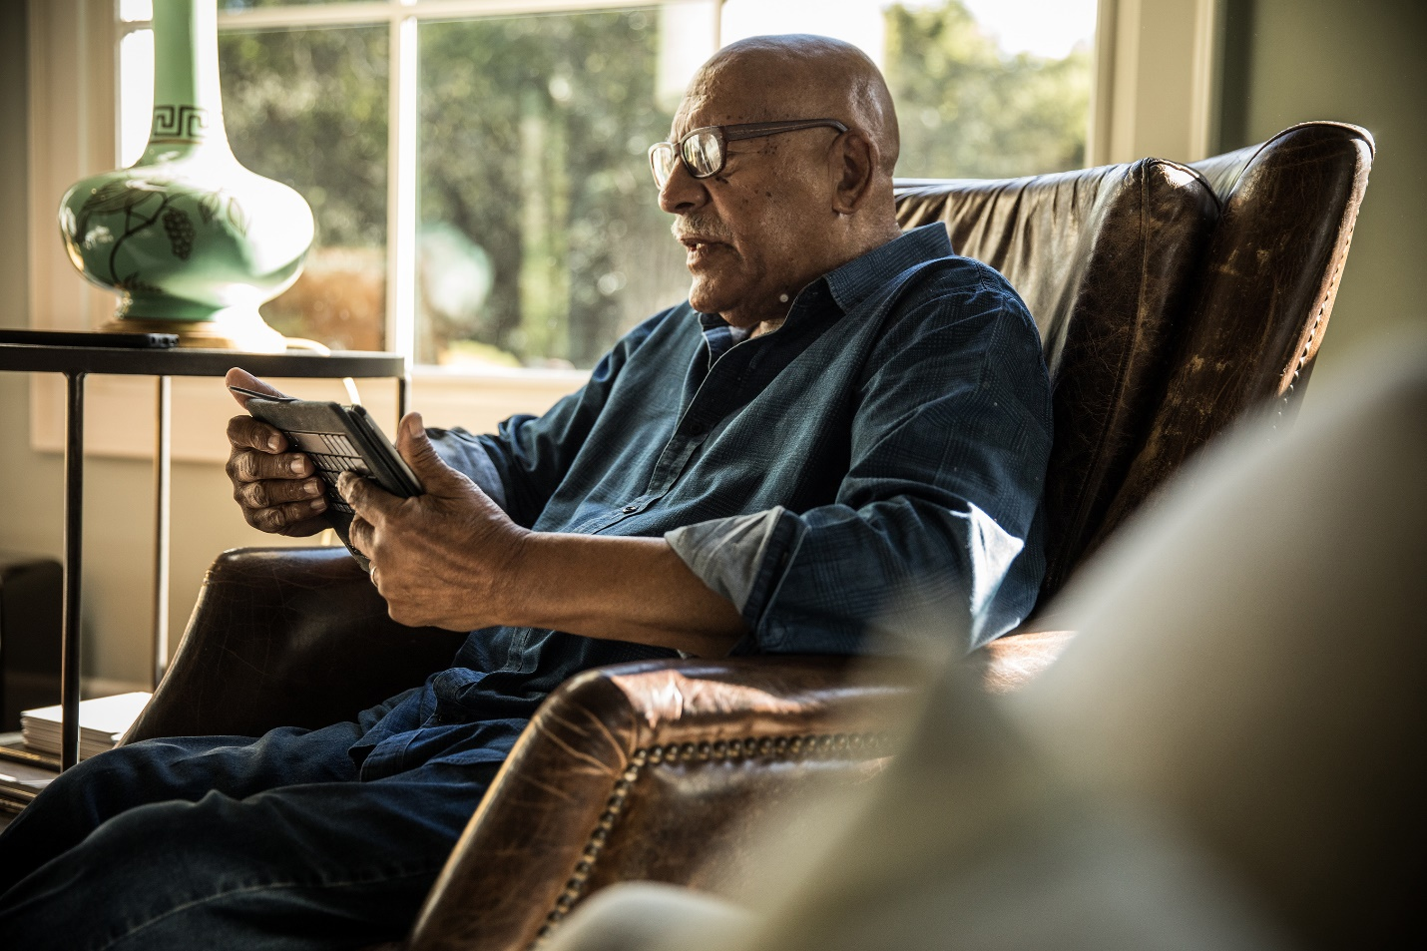

“The longer I live the more beautiful life becomes.” – Frank Lloyd Wright

Get the **Age Is Just a Number Book List**

available on our website ([www.blahblah.com](http://www.blahblah.com)) and print copies available

Age is just a number

“Old age is an excellent time for outrage. My goal is to say or do at least one outrageous thing every week.” -Maggie Kuhn

Get the **Age Is Just a Number Book List**

available on our website ([www.blahblah.com](http://www.blahblah.com)) and print copies available

Age is just a number

“Anyone who keeps the ability to see beauty never grows old.” – Franz Kafka

Get the **Age Is Just a Number Book List**

available on our website ([www.blahblah.com](http://www.blahblah.com)) and print copies available

Age is just a number

“Those who love deeply never grow old, they may die of old age, but they die young.” – Ben Franklin

Get the **Age Is Just a Number Book List**

available on our website ([www.blahblah.com](http://www.blahblah.com)) and print copies available

Age is just a number

“Wrinkles should merely indicate where smiles have been.” – Mark Twain

Get the **Age Is Just a Number Book List**

available on our website ([www.blahblah.com](http://www.blahblah.com)) and print copies available

Age is just a number

“In the end it’s not the years in your life that count. It’s the life in your years.” – Abraham Lincoln

Get the **Age Is Just a Number Book List**

available on our website ([www.blahblah.com](http://www.blahblah.com)) and print copies available

Age is just a number

“Age is not how old you are but how many years of fun you’ve had.” – Matt Maldre

Get the **Age Is Just a Number Book List**

available on our website ([www.blahblah.com](http://www.blahblah.com)) and print copies available

Age is just a number

“The best tunes are played on the oldest fiddles.” – Ralph Waldo Emerson

Get the **Age Is Just a Number Book List**

available on our website ([www.blahblah.com](http://www.blahblah.com)) and print copies available

Age is just a number



“You don’t stop laughing when you grow old. You grow old when you stop laughing.” – George Bernard Shaw

Get the **Age Is Just a Number Book List**

available on our website ([www.blahblah.com](http://www.blahblah.com)) and print copies available

Age is just a number



“We don’t grow older, we grow riper.” – Pablo Picasso

Get the **Age Is Just a Number Book List**

available on our website ([www.blahblah.com](http://www.blahblah.com)) and print copies available

Age is just a number

“Growing old is mandatory, but growing up is optional.” – Walt Disney

Get the **Age Is Just a Number Book List**

available on our website ([www.blahblah.com](http://www.blahblah.com)) and print copies available