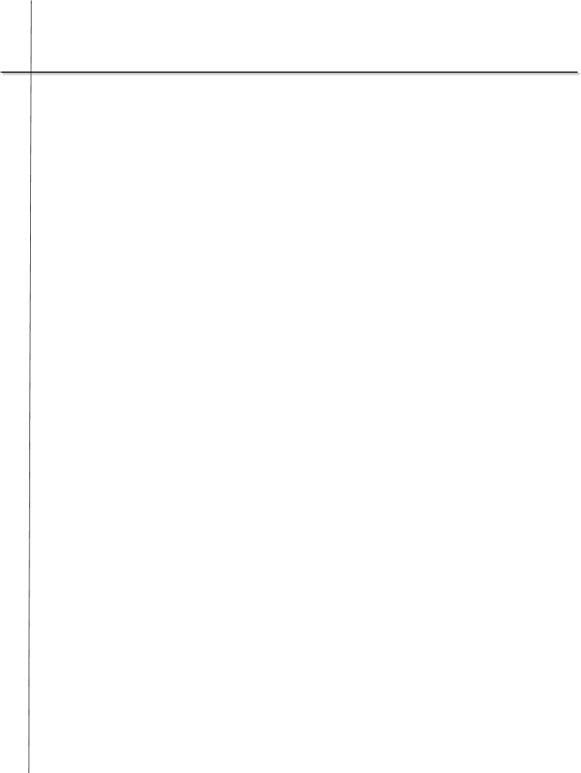**MyKayla K. Moore**

**MyKayla K. Moore**

**Portsmouth, Virginia 23702**

**Career Objective:**To seek an education oriented towards obtaining a career that will benefit society and the job market. Furthermore, to maximize my computer skills while allowing my interpersonal and leadership skills to transpire into the real world.

**Relevant Skills:**Participated in after school activities such as Robotics, Cyber Security, FBLA, Young Life, Project Search and CHROME club. Attended Leadership Conferences. Public Speaking, Telephone Customer Service, Note-taking, Teaching and Research Skills. Proficient knowledge and experience using the following Computer Software - Microsoft Word, Excel, and PowerPoint, Some Human Service Skills, Unix Programming, Code::Blocks, C++, and Cyber Security Knowledge.

**Education:**I. C. Norcom High School, Portsmouth, Virginia – 12th Grade Honor Roll/Dual Enrollment Student.

Tidewater Community College, Portsmouth, Virginia – First College Program.

Old Dominion University, Norfolk, Virginia – Junior Class

# Work Experience:

# Human Service Practitioner, Montego Bay, Jamaica

# March 08, 2019 to March 16, 2019

Duties: Acting as a human service practitioner to develop increased self-worth, self-awareness, and self-love in the teens. I also worked to encourage the girls with human service skills learned during the semester. The student served, learned, and grew while developing well needed intrapersonal and interpersonal skills as well as gained international human service skills from studying abroad which can holistically be used within the workplace, community, or home. Additionally, I attained cultural awareness, exposure, and diversity.

**References Furnished Upon Request.**