Steps 1, 2, 3, 4, 5
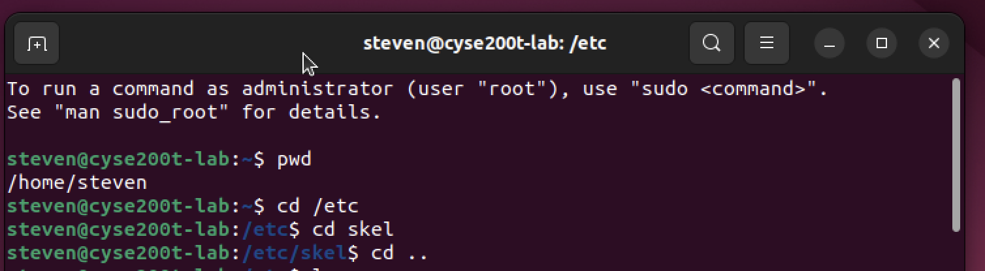

Steps 2, 3, 4, 5, 6
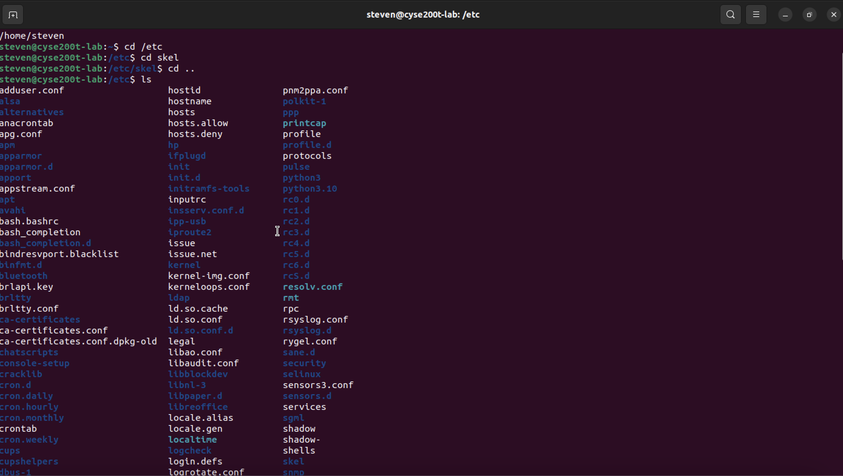

Steps 7
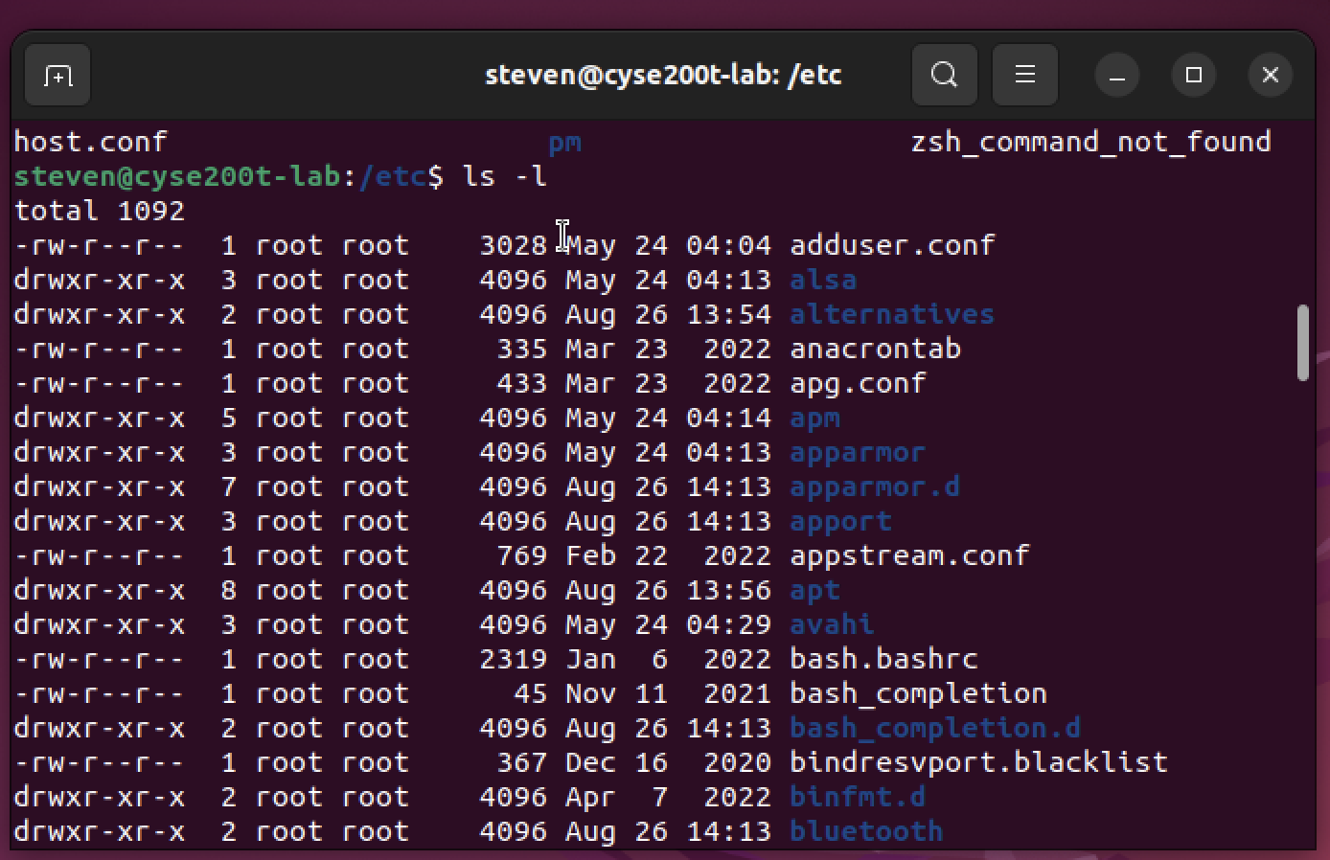

Steps 8
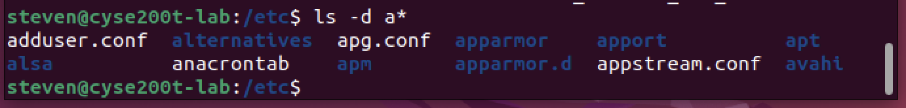

Steps 9


Steps 10


Steps 11,12,13


Steps 14

Steps 15


Steps 16,17,18,19,20
