References

Hardacker, C. T. RN, Rubinstein, B. K. MA. LSW., Hotton, A. PhD. MPH., Houlberg, M.
MD.,(2013). Adding silver to the rainbow: The development of the nurses' health education
about LGBT elders (HEALE) cultural competency curriculum. Retrieved from:
https://onlinelibrary wiley-com.proxy.lib.odu.edu/doi/full/10.1111/jonm.12125
Jann, J. T., Edmiston, E. K., & Ehrenfeld, J. M. (2015). IMPORTANT CONSIDERATIONS FOR
ADDRESSING LGBT HEALTH CARE COMPETENCY. American Journal of Public
Health, 105(11), 1. Retrieved from: http://proxy.lib.odu.edu/login?url=https://search-
proquest-com.proxy.lib.odu.edu/docview/1723086093?accountid=12967
Mayer, K., Applebaum, J., Rogers, T., Lo, W., & al, e. (2001). The evolution of the Fenway
community health model. American Journal of Public Health, 91(6), 892-4. Retrieved
from:
http://proxy.lib.odu.edu/login?url=https://searchproquestcom.proxy.lib.odu.edu/docview/2
15100497?accountid=12967
Morabia, Alfredo,M.D., PhD. (2017). Sexual orientation question kept in NSOAAP:
"government at its best". American Journal of Public Health, 107(11), 1692-1693.
Retrieved from: http:// dx.doi.org.proxy.lib.odu.edu/10.2105/AJPH.2017.304075
Moravek M.B. Gender-affirming hormone therapy for transgender men. Clinical Obstetrics and
Gynecology, Volume 61, 2018
Coggle. Retrieved February 18, 2019, from website: https://coggle.it/?lang=en-US

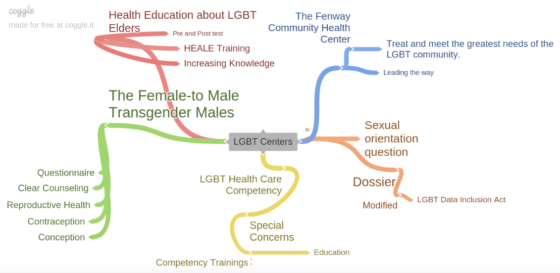
My articles were all related to the educating, care, and concerns of the LGBT Community. The articles relate to my agency that I am evaluating because the LGBT Life Center focuses on the needs and concerns of the LGBT community.

