Homework 1.1 for Rebecca Sopher

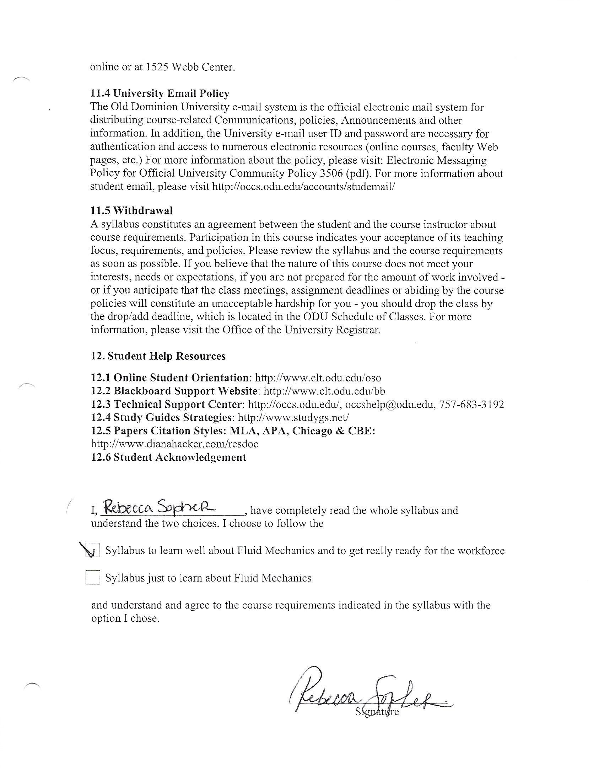

The following pictures are the water heater and the plumbing for the kitchen sink. I didn’t pass very many other systems this week when I had an opportunity to take pictures, unfortunately.

