Verbs | 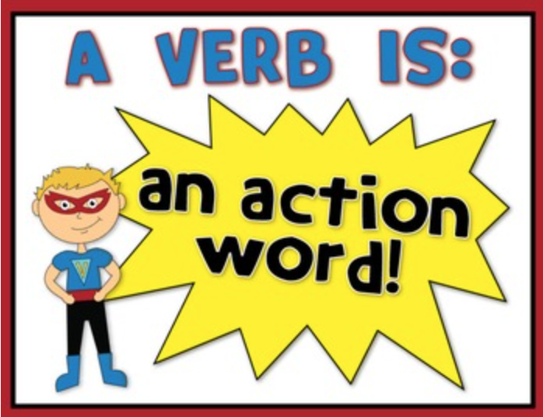
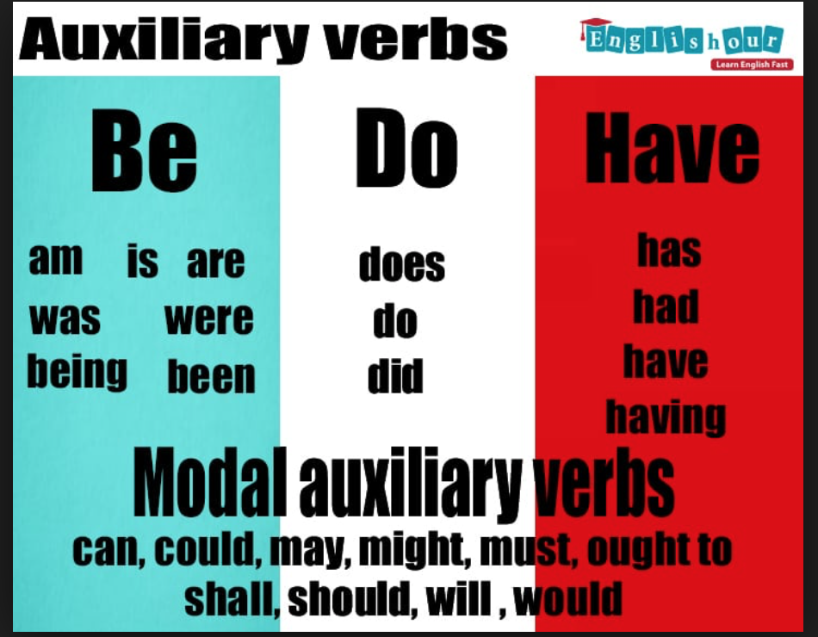 | 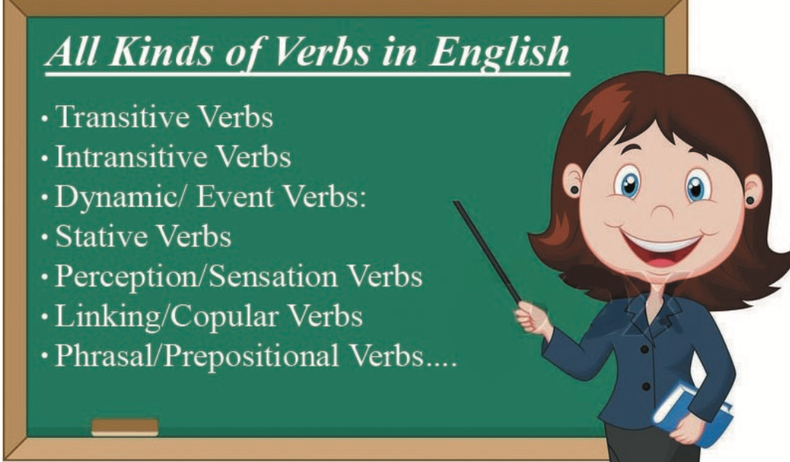

  - Why Verbs??
Without verbs, language would not exist. There are many types of verbs but the ones we will focus on are: main verbs, auxiliary verbs, and modal verbs.

Verbs
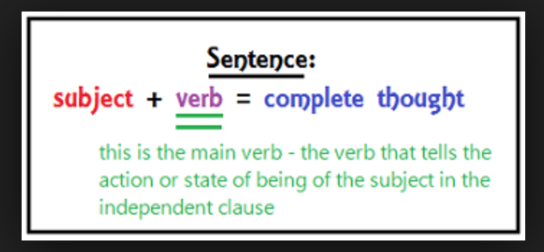
Main Verbs
- also called the lexical verb or the principal verb.
- refers to the important verb in the sentence (typically shows the action or state of being of the subject)
- stands alone, or can be used with a auxillary verb (helping verb)

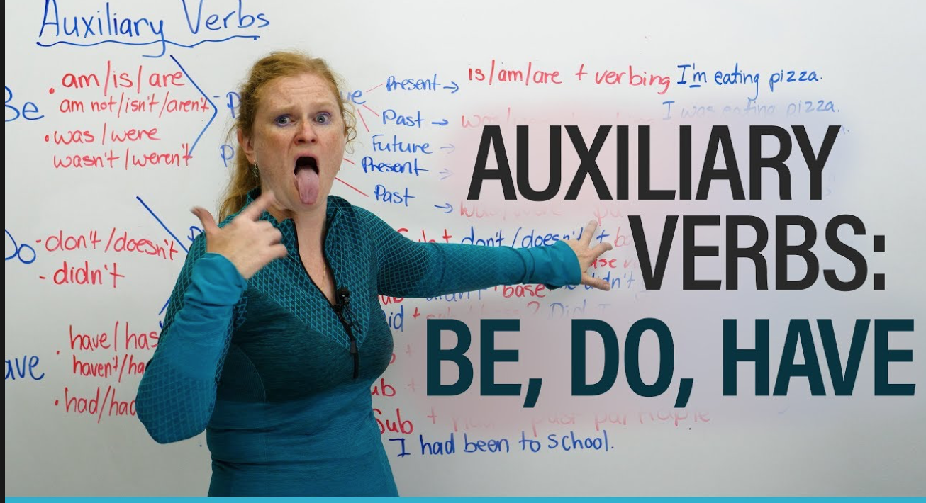
Auxiliary Verbs
- Also called helping verbs
- Used together with a main verb
- Shows verb’s tense or to form a negative or question.
- Most common auxiliary verbs: have, be, and do.

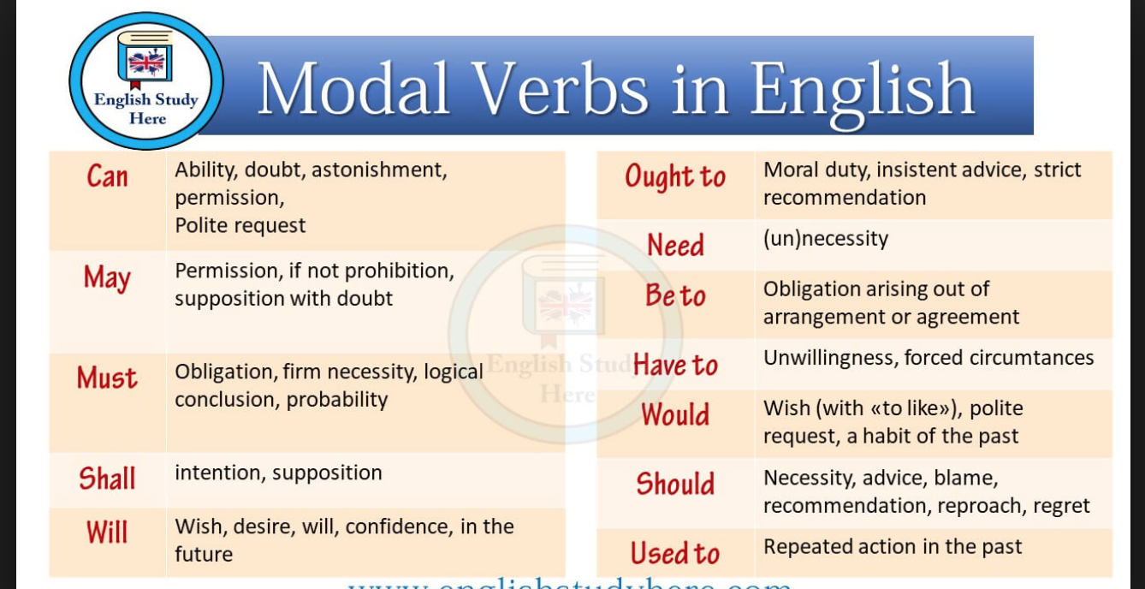

Modal Verbs
- include can, must, may, might, will, would, should
- express ability, obligation, or possibility
- does not change spelling

