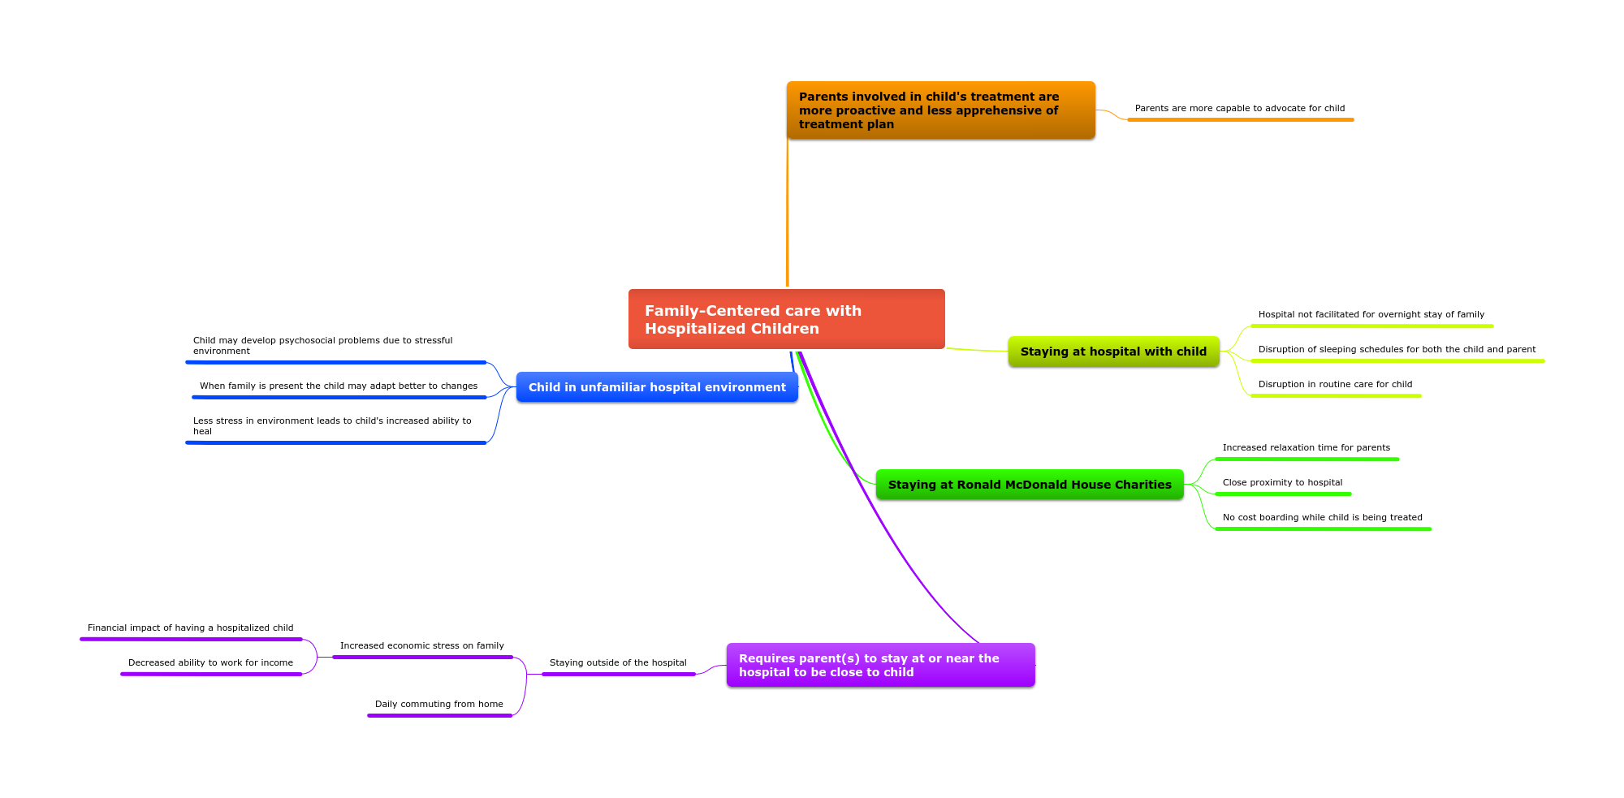
The four articles I used for my mindmap are all based on family-centered treatment for children. Family-centered treatment requires family involvement in the child’s treatment on a regular basis. It helps to alleviate some of the stress that a child may experience due to treatment in unfamiliar surroundings. The theory around this style of treatment states that if a child’s stress levels are reduced then they are more capable to heal quickly. A parent also may become a better patient advocate for their child as they become involved in the child’s treatment. Most hospitals do not provide overnight accommodations for family members especially for extended periods. Some families find that they must find accommodations outside of the hospital but in close-proximity of the hospital to be near to their child. Having separate sleeping arrangements may even be beneficial for the child and parent. It helps to promote less interruptions in sleeping patterns for both. The economic stress of having a child in treatment is common in most cases. There is also a need for parents to take time from work to be with his/her child during treatment. It may also increase economic strain. Some parents rent or pay for hotel accommodations on top of the other financial stressors in order to be near their child during treatment. The Ronald McDonald House Charity does not require parents to pay for accommodations in the charity house if they qualify.
Works Cited
Shields, L., & Zhou, H. Family-centered care for the hospitalized children aged 0-12 years: A
systematic review of quasi-experimental studies. Volume 9- Issue 16- p 1-18.
Doi: 10.11124/jbisrir-2011-341

Lanta, P., Hohman, K., & Hutchings, V. Family centered care and children with serious health
needs: A review of the conceptual and empirical literature for Ronald McDonald House
Charities. p 1-32. Retrieved at: pdfs.semanticscholar.org

Franck, L., Ferguson, S., Fryda, S., & Rubin, N. The child and family hospital experience: Is it
influenced by family accommodation? p 1-18. Doi: 10.1177/1077558715579667

Bellou, P., & Gerogianni, K. The contribution of family in the care of patient in the hospital.
Health Science Journal p 1-5. Retrieved at: www.hsj.gr/medicine

