**How to Annotate a Map**

**Goal:** Create a map to provide information about at least 5 place locations your students must know.

**Navigate** to arcgis.com. Sign in Username: Southside_institute; **Password:** geography1.

**Step 1: Create a Map Notes Layer**

1. From the Add button select the last entry, Add Map Notes.

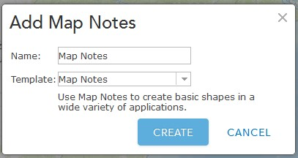

1. Click CREATE. You have just created an editable layer to which you can add your information to your map*.*
2. Next you will rename the Map Notes layer, *Important locations* or another suitable title.
3. Click the three dots (called Map Options) under the layer’s name.
4. Select Rename and type in the new name.
5. Click OK

**Step 2: Save your map**

1. Save AS the map in YOUR FOLDER. (Only use Save As the first time you save a map.)
2. Add your initials to the tags and some descriptive words about the message of the map.
3. Click SAVE MAP. Make sure the map is going to your folder.
4. Saving time varies.

**Step 3: Adding Data to the Map**

1. Use the search window on the map to locate one of the places on your list.



The program tries to help you out with the **Add to Map Notes** option. Use the dropdown and choose your map notes layer.

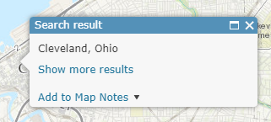If you do not do so, you will have multiple map notes layers and that will cause problems.

You also do not get your choice of pins.

Instead manually enter the Map Notes locations.

1. Click the pin in the left window, then click on the location on the map.
2. Notice the Edit pencil is now depressed.
3. Click on a location on the map and the Edit window opens.
4. Add a Title.
5. 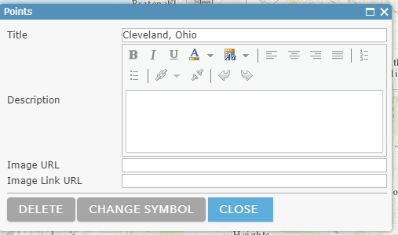Add some text descriptive of the significance of the location.
6. CLOSE attaches the map note to the map. Only saving the map records the changes. lick close.

**Step 4: Retrieving Images**

Before we can add an image, we need to retrieve one from the Internet. ArcGIS online readily supports links to images ending in .jpeg, .gif, and .png. You need to capture the image’s URL. Wikipedia images work best because most of them are either in the public domain or shared through the Creative Commons. Government sites, such as the Library of Congress, offer access to many copyright free images. Just because an image is on the Internet doesn’t mean it isn’t copyrighted. You use those at the risk of a cease and desist order as well as royalty fees.

1. Open a new tab in the browser.
2. 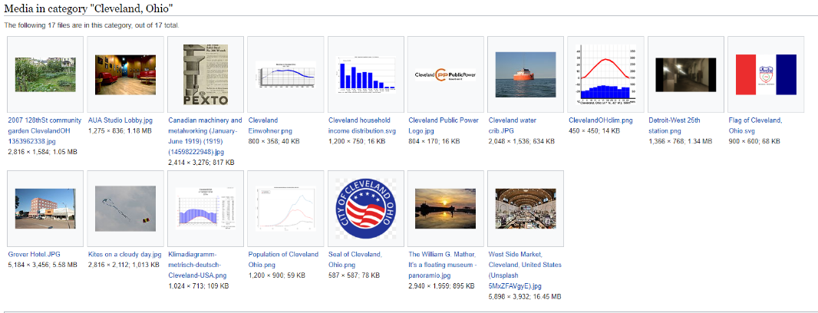Type in the name of the topic, e.g. Cleveland. Hit enter. Note I did not choose the Images option. Could also search for Cleveland and Wikimedia.
3. Click on a image. I chose:

<https://commons.wikimedia.org/wiki/Category:Cleveland,_Ohio#/media/File:The_William_G._Mather,_It%27s_a_floating_museum_-_panoramio.jpg> (**NO, this is not the URL you want**)

1. At the bottom of the page, there is a More details button. Literally do so, it is hyperlinked.
2. [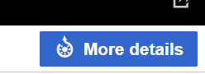](https://commons.wikimedia.org/wiki/File:The_William_G._Mather,_It's_a_floating_museum_-_panoramio.jpg)How you can scroll down to read about attribution if required and copyright status.
3. You can also select the size of the image. (**NO you are not done yet**)
4. Select a size 320 ish is good for pop-ups. The image then opens.
5. Now you can capture its URL.
6. [https://upload.wikimedia.org/wikipedia/commons/thumb/b/be/The_William_G._Mather%2C_It%27s_a_floating_museum_-_panoramio.jpg/320px-The_William_G._Mather%2C_It%27s_a_floating_museum_-_panoramio.jpg](https://upload.wikimedia.org/wikipedia/commons/thumb/b/be/The_William_G._Mather%2C_It%27s_a_floating_museum_-_panoramio.jpg/320px-The_William_G._Mather%2C_It%27s_a_floating_museum_-_panoramio.jpgL)
7. This URL is what you paste on the top line of the Map Note dialog box.

**How do I get back to the Map Note dialog box after I have closed it?**

1. If the Edit pencil is still depressed, turn off the Edit icon (pencil) by clicking on it.

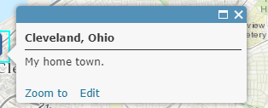

1. Click the word Edit and the Map Note dialog box opens again.
2. 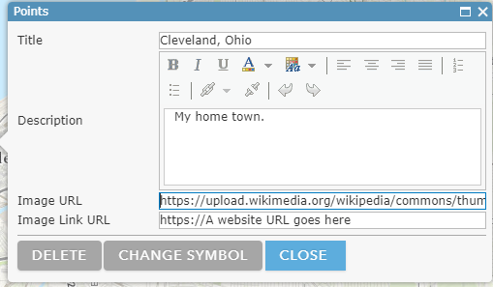When you paste the image URL be sure to remove the https:// that is already in the box.
3. The bottom line is designed for a link to a Website that opens when the image is clicked.

**Step 5: Test your Map Note**

1. To test your Map Note, make sure the pencil is not depressed.
2. Click on the pushpin and your map note should open..
3. Click CLOSE to attach the Map Note to the map. Remember to save as often as you are willing to lose your work.

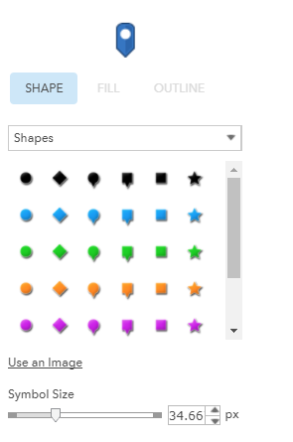**Step 6: Change Map Note symbols**.

With the Map Note open select, CHANGE SYMBOL. Explore the wide variety of options from the dropdown.

**Can I use this Map Note layer with other maps and accounts?**

**YES.**

1. Select the three dots under the layer in the Contents window.
2. Select Save layer.
3. 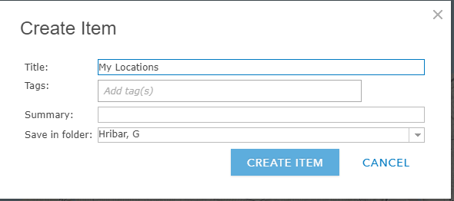The create Item box opens.
4. Fill out the information.
5. CREATE Item.
6. 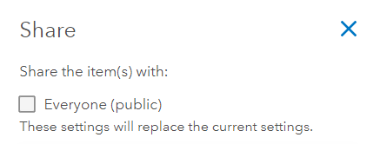Go to your folder and find the layer.
7. Share the layer with Everyone. OK.
8. New Map.
9. 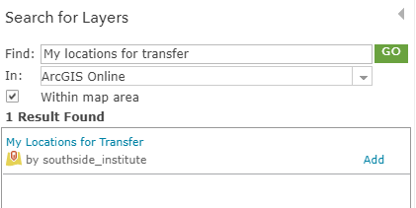From within the Map select Search for Layer. Add to the map.

*How could this technique be used?*