**How to retrieve a GeoInquiry™ map**

1. Go to [Geoinquiries™ page](http://education.maps.arcgis.com/home/group.html?id=39505ed571d646c8b66ecccadbc386e4#overview) and select a subject.
2. Open the lesson the link on the pdf. You may need to copy the link in your browser.



1. Open the map.
2. Capture the map ID, <http://www.arcgis.com/home/webmap/viewer.html?webmap=cdf8bbbaad574525b5d1c3227ece7fea>
3. Go to <http://arcgis.com>
4. Log into your account with your credentials. (School org or public account) user name: Southside_Institute, password: geography1
5. Go to the home page or the gallery. Paste the map id into the search box and select map from the options.

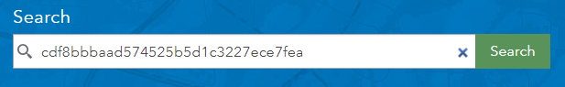

1. Open the map.
2. Choose Save As to save in the account. Remove the word copy, customize the tags. Write a summary.
3. You can now make modifications to the map. Don’t forget to save after making changes.

**How to Create a Presentation**

A presentation showcases various locations and layers within a single saved map. A presentation can be made from any map that has layers.

1. Select a map. Map searches are conducted from home or the gallery, not the map itself.
2. Save a copy to your folder.
3. Click CREATE PRESENTATION from the upper right map window.
4. Click Add to add a slide.



1. Give the slide a Title which will appear on the map.

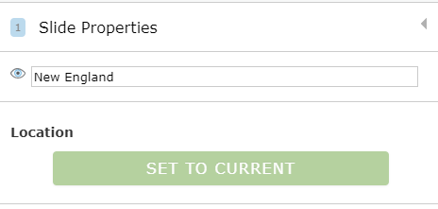

**SAVE OFTEN (unless you enjoy redoing your work)**

1. Zoom into the desired area of the map, click SET TO CURRENT.
2. Select the layer/s you want to feature.
3. 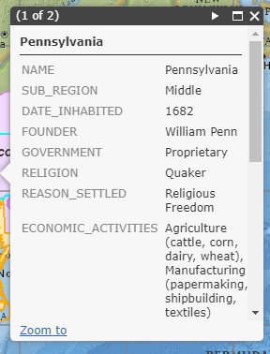Change the Basemap if desired.

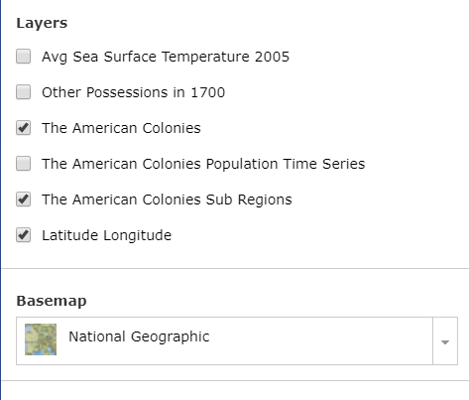

1. Make a pop-up visible when the layer is displayed.
2. Open the popup, and check Include open pop-up in presentation.
3. 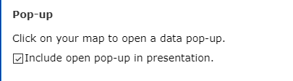Click the Save Icon.
4. Click **Play t**o view the presentation. Use options to have the presentation play automatically when opened.
5. The SLIDE LIST provides access to the slides and opportunity to change the order or delete them.
6. Any changes in the map will automatically be updated in the presentation.

If the map prompts you about saving the map, you need to hit the save button. OK, just doesn’t do it.

**Sharing your presentation**

Way 1

* Open the presentation by clicking play.
* Then, capture the URL when the presentation opens.

<http://www.arcgis.com/apps/presentation/index.html?webmap=a28226dcd54f4e808d7f0adc2632e439&slide=1>

* Note the word presentation appears in the URL.

Way 2

* Presentations are stored with the map.
* Go to My Content.

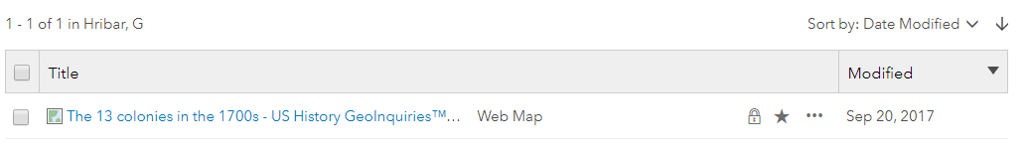

1. Click the title of the map.
2. 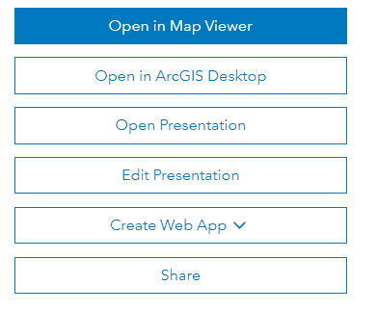When the Item Details page opens, check the Share button. The presentation **must be shared** for others to view it.
3. Then, select Open Presentation.
4. Capture the URL and provide that to the viewers.

*How could presentations be used in your teaching?*

Check out: Create Presentations from ESRI’s ArcGIS Online Help at <https://doc.arcgis.com/en/arcgis-online/create-maps/create-presentations.htm>

Want to edit the presentation?

Use the edit button from the Item Details page or

Open the map and in the upper right select

Check out a World History I example at

<http://vga.maps.arcgis.com/apps/presentation/index.html?webmap=1bda057ffebd42ed8ef4e18911d0d5c6&slide=1>