**Recommended Settings for Organizational Accounts**

***General Tab***

Add an organizational description and a logo.

Contact us should be set to the main org admin.

***Home Page Tab***

Select or upload a background image. Recommended size is 960 pixels wide and 180 pixels tall.

Featured Content is set to the group with Map Portal in its name.

This group controls what is shown on the org’s front page.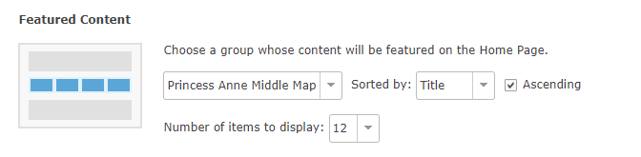

***Gallery Tab***

Gallery is set to the group with the Map Portal in its name.

This group controls what maps and apps are shown in the Gallery.

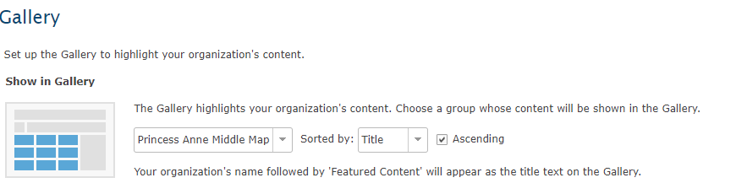

***Map Tab***

Keep defaults. Map is set to open in the United States.

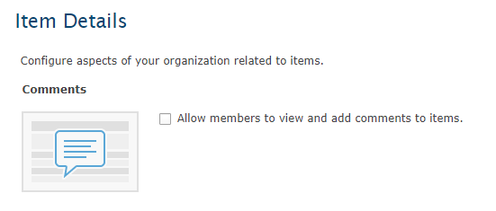***Item Details Tag***

Unless you want the students to provide comments on each other’s maps, deselect the Allow members to view and add comments to items.

***Groups Tab***

Controls which content is shown in the Gallery. Of note here is the ESRI Featured Groups. Keep what is there and add more if you wish.

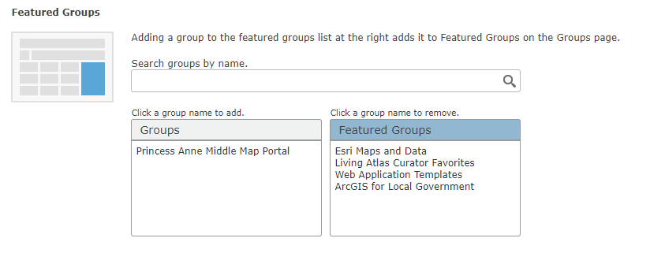

***Utility Services***

Keep the defaults.

***Roles Tab***

Teacher Limited aka TeacherL

Rationale: To prevent teachers from accidentially consuming credits.

Teachers assign members to their classes and have the right to reassign ownership of a product. This is useful when doing collaborative assignments, the “keeper of the map” can be temporarily reassigned.

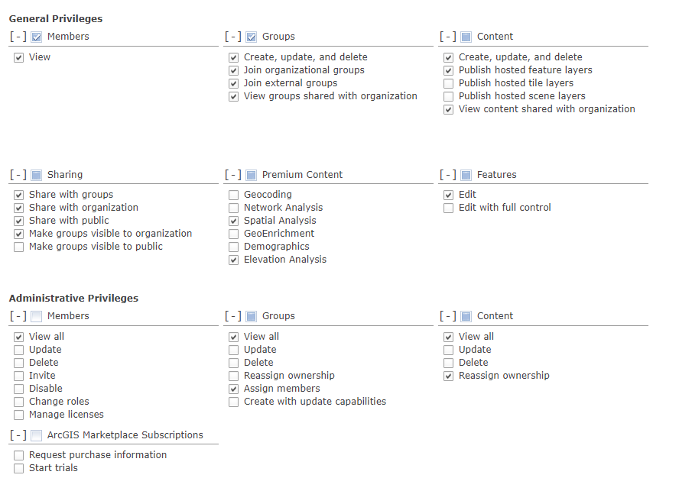

If there is a need to publish a csv by location, e.g., state, country,address,

Make sure the geocoding option is turned on. Best to locate places by lat,long.

**Student Limited aka Student L**

In order to preserve the sheltered environment in the org. Students should not be able to create groups or join external groups. Rights for hosting tile and scene layers are limited. “Expensive” credits operations are also controlled.

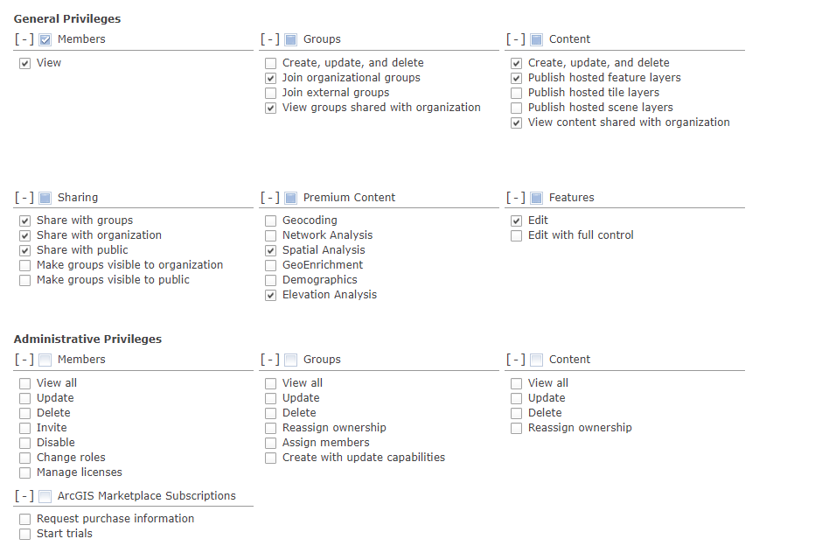

If there is a need to publish a csv by location, e.g., state, country,address,

Make sure the geocoding option is turned on. Best to locate places by lat, long.

**Marketplace Tab**

No changes.

**Credits Tab**

Enable credit budgeting tools.

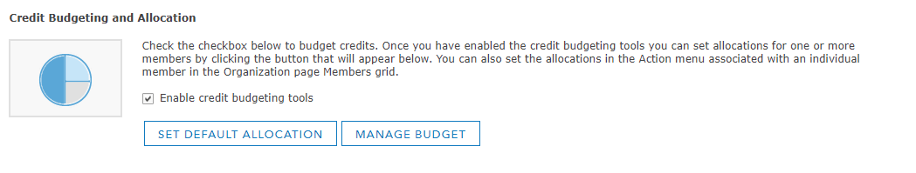Set the default to 5. The number of credits can always be increased.

What are credits and how much do different operations cost?

* [ArcGIS Online Credits](http://www.esri.com/software/arcgis/arcgisonline/credits) (short version)
* [Read all about ArcGIS credits](http://doc.arcgis.com/en/arcgis-online/reference/credits.htm) (long version).

**Security Tab**

Students can only access the maps on the org’s map portal or gallery without being logged in if anonymous access is allowed.

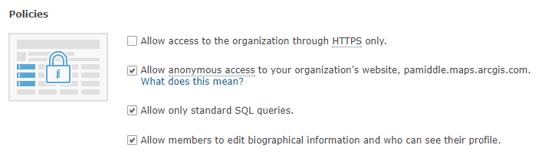

Experiment with the last item for allowing members to edit biographical information and who can see their profite.

Sharing and Searching

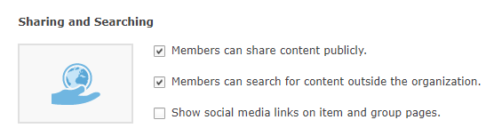

Uncheck the social media links. Leave the ability to share publicly. The portal is public, but the roles control the ability to share content publicly.

Accept the defaults for the rest of the items in this section.

Enable ESRI access is not needed for the organization’s users. That provides links to other resources they do not need yet.

Want to know more about org management?

Learn ArcGIS course lesson: [Set up an ArcGIS Online Organization](https://learn.arcgis.com/en/projects/set-up-an-arcgis-organization/)