**Adding data to a map from a spreadsheet**

Location field is latitude and longitude. Remember locations in the western hemisphere have a negative number as do locations in the southern hemisphere.

***Step 1: Prepare the data***

1. Download the file UNcities_dta_multp or US cities through time from Fall 2017 Day 2 from <http://sites.wp.odu.edu/MapsRUS> to your desktop.
2. Open the file.
3. How is it organized?
4. Save the file as a .csv

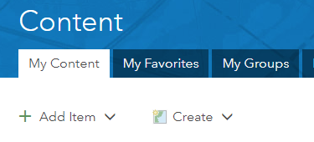***Step 2: Publish a feature layer***

1. Go to <http://arcgis.com>.
2. Log into your school’s organizational account with your org credentials.
3. Click the Content Tab.
4. Go to My Content.
5. Click Add Item, from my computer.
6. Choose the csv file you just downloaded. Fill out the tags.

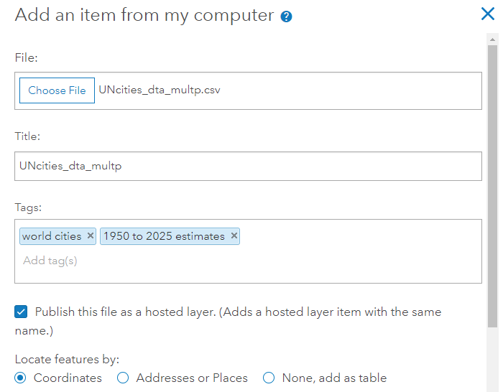

1. 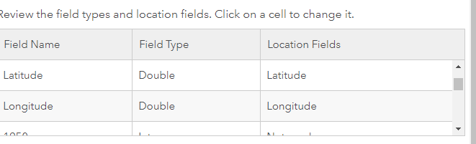Make sure latitude and longitude are selected as the Location fields. You may need to scroll through the attributes to find the fields.
2. Click Add Item.
3. The computer will add the data to the cloud and create a feature layer.

***Step 3: Change style aka symbolize the data***

1. Who is the item shared with?
2. The layer opens in the map and Smart mapping takes over.
3. What did it choose to symbolize the map by?
4. In the choose an attribute to show select Cyclone risk.
5. 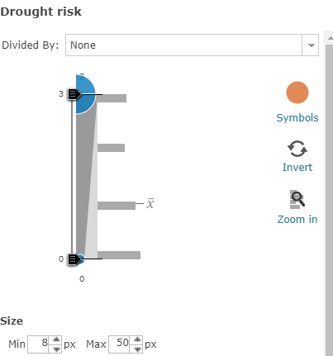Click on Options and you can change the color of the symbol. Click OK.
6. Change the attributes to show the other risks, drought; earthquakes, volcano, landslide.
7. Click on a point, where is the data for the popup coming from?

Just in case the layer doesn’t open symbolized.

1. 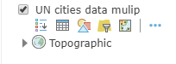Click on the layer’s name to see what tools are available.
2. Select the geometric shapes icon known as Change Style.
3. Select an attribute.
4. Select a method.
5. Let Smart mapping choose.
6. Experiment with the Heat Map option.

SAVE the map. Every map in the org should have a unique name. Add your initials to the title. Fill out the tags.

**New tool with the September upgrade**

Click the 3 dots next to the tools. How do you get the tools to show?

From the menu that opens, select Clustering.

Use the slider to see the effects on the representation of the data.

***Add a layer to the map***

1. Click the yellow Add Button and select Search for Layers***.***

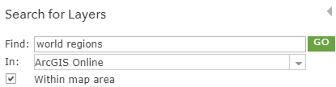

1. 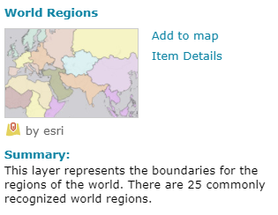Search for world regions.
2. Scroll down until you find the layer by esri.
3. Click on the layer’s name to find out more.
4. If it were subscription or premium content, the card would include that information.
5. Select add to map.
6. DONE ADDING LAYERS at the bottom of the column.



1. Change the style to show location only.
2. Map ignoring you? Check the clustering setting.

***Use the Filter***

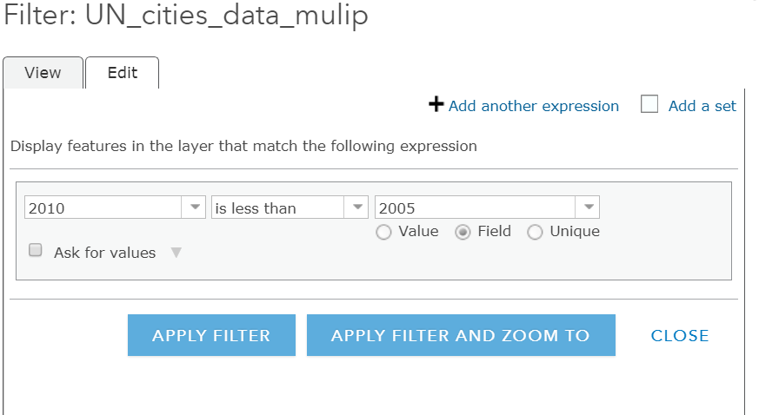Use a filter to find out which cities lost population between 2010 and 2005.

1. Click the filter icon.
2. Set up the filter as shown to the left.
3. Click APPLY FILTER.
4. Open the Table.
5. How many cities lost population?

In what region are they located?

**Adding layers**

**United States History**

* Regions_SOL7 (gchribar_kempsodc)
* Physical regions _US )vbcpsgis
* rivers_us (gchribarZ_KLMGC)
* popuscities (gchribar_KLMGC)

**AP Human World Geography**

* densities5 (vgagis)
* world_demo_2015 (vgagis)
* MAJOR_CITIES (vgagis)
* MajorCitiesGlobal (MappingOurWord)
* world cities 3 (vgagis) 52 cities
* world regions (esri)

**World History**

* Major Empires (University_of_Minnesota)
* Mesopotamia (araymond_ardms)
* Top 10 cities 100CE (cagersmehl)
* Top 10 cites1000CE (cagersmehl)
* Top 10 cities 1500CE (cagersmehl)
* Top 10 cities 1900
* Top 10 cities 2000
* World Cities with Populations (Kathryn_Keranen_LearnArcGIS)