**Adding data to a map from a spreadsheet**

Location field is latitude and longitude. Remember locations in the western hemisphere have a negative number as do locations in the southern hemisphere.

***Step 1: Prepare the data***

1. Download the file vacitypophis or BUOY data from Fall 2017 Day 2 from <http://sites.wp.odu.edu/MapsRUS> to your desktop.
2. Open the file.
3. How is it organized?
4. Save the file as a .csv

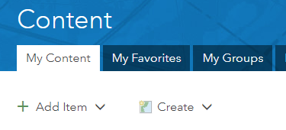***Step 2: Publish a feature layer***

1. Go to <http://arcgis.com>.
2. Log into your school’s organizational account with your org credentials.
3. Click the Content Tab.
4. Go to My Content.
5. Click Add Item, from my computer.
6. Choose the csv file you just downloaded. Fill out the tags. Be sure to add vacitypophis as a tag.

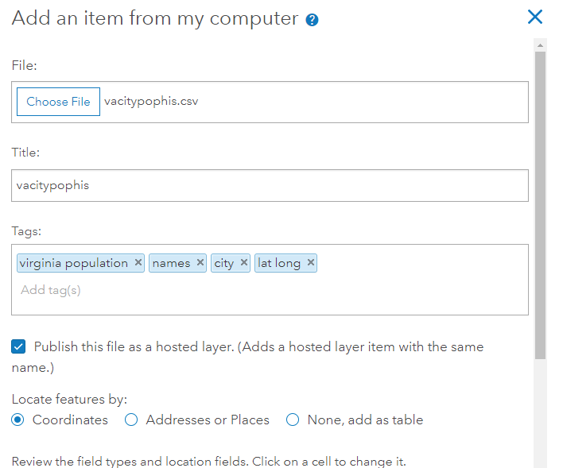

1. 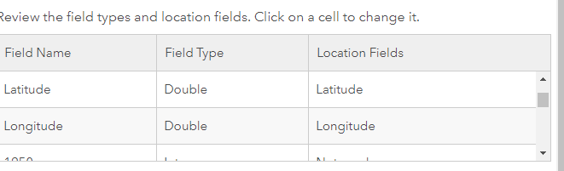Make sure latitude and longitude are selected as the Location fields. You may need to scroll through the attributes to find the fields.
2. Click Add Item.
3. The computer will add the data to the cloud and create a feature layer.

Open the feature layer in Map Viewer

***Step 3: Change style aka symbolize the data***

1. Who is the item shared with?
2. The layer opens in the map and Smart mapping takes over.
3. Which attribute did the computer use for symbology?
4. In the “choose an attribute to show” select 1790.
5. 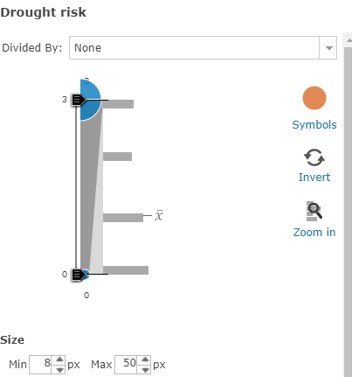Click on Options and you can change the color of the symbol. Click OK.
6. Click on a point, where is the data for the popup coming from?
7. Change style back to 2010 as an attribute.

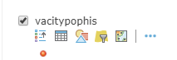Just in case the layer doesn’t open symbolized.

1. Click on the layer’s name to see what tools are available.
2. Select the geometric shapes icon known as Change Style.
3. Select an attribute.
4. Select a method.
5. Let Smart mapping choose.
6. Experiment with the Heat Map option.

SAVE the map. Every map in the org should have a unique name. Add your initials to the title. Fill out the tags.

**New tool with the September upgrade**

Click the 3 dots next to the tools. How do you get the tools to show?

From the menu that opens, select Clustering.

Use the slider to see the effects on the representation of the data.

***Add a layer to the map***

1. Click the yellow Add Button and select Search for Layers***.***

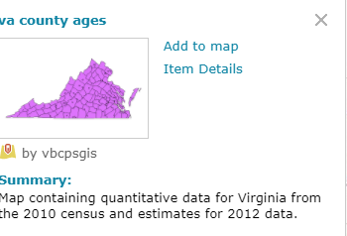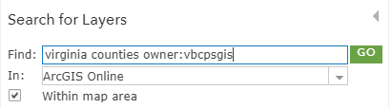

1. Search for virginia counties? How many results?
2. Narrow the search by adding owner:vbcpsgis.
3. Select va_county_ages by vbcpsgis.
4. Click on the layer’s name to find out more.
5. If it were subscription or premium content, the card would include that information.
6. Select add to map.
7. DONE ADDING LAYERS at the bottom of the column.



1. Change style to show population 2010.
2. Map ignoring you? Check the clustering setting.
3. What happened to the cities? Look at the order in the Contents window. Points should be on top of polygons.
4. Use the three horitzontal dots on the left to drag the layer up (requires coordination) or click the layer 3 dots and select move up (much easier)

Seeing dots?

1. 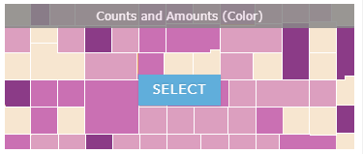Select the option in change style for Counts and Amounts (Color)
2. Click on Options to change the color and set the transparency.

***Use the Filter***

Use a filter to find out which cities lost population between 2000 and 2010.

1. Click the filter icon.
2. 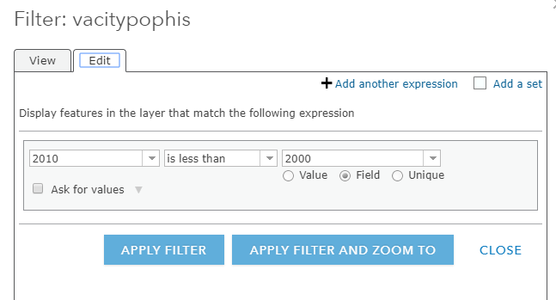Set up the filter as shown to the left.
3. Click APPLY FILTER.
4. Open the Table.
5. How many cities lost population?

Where are they located?

Extra Extra skill: Add a line chart for city population through time to the pop-up

These pop-ups will come from the table rather than the Map Notes we did last time.

1. 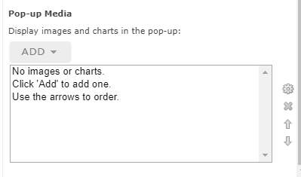Remove the filter.
2. Click the three horizontal dots next to the layer’s name.
3. Click Configure pop-up.
4. Find Pop-up Media at the bottom of the panel.
5. Select Add Line Chart
6. Configure the line chart.
7. Title: City Population Through Time
8. Caption: Mouse over for exact values
9. 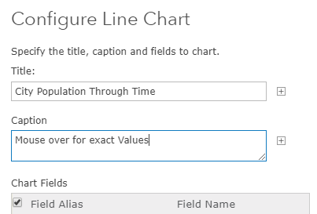Check the uppermost box Field Alias to select the years.
10. 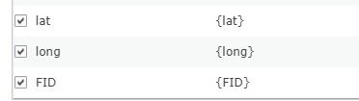Scroll down the list and and uncheck lat, long,FID. (FID is an index the computer gave for each of the features aka cities)
11. Click OK,
12. Test the Pop-Up. Scroll down to the bottom to see the chart that you created.

**Virginia Studies**

* virginia_regions (vgagis)
* Exploring Virginia regions map notes (vgagis) or (gchribar_kempsodc)
* Virginia_Rivers_Manor_Streams (vgagis)
* Watersheds_va (vgagis)
* Storm_Drain_Marker_Layers (Virginia_Johnson)
* watershed_by_river (vgagis)Physical regions _US )vbcpsgis
* watersheds_va (vbcpsgis)
* Captain John Smith trail (Story Maps)

**Chesapeake Bay**

* kk_bay (kkoffice)densities5 (vgagis)
* Restoration indicator for Oyster Restoriation Tributaries (fitch.any_EPA)
* watershed bworld_demo_2015 (vgagis)
* OysterRestoriation_CBF_GIS
* CBF Education – Water Quality

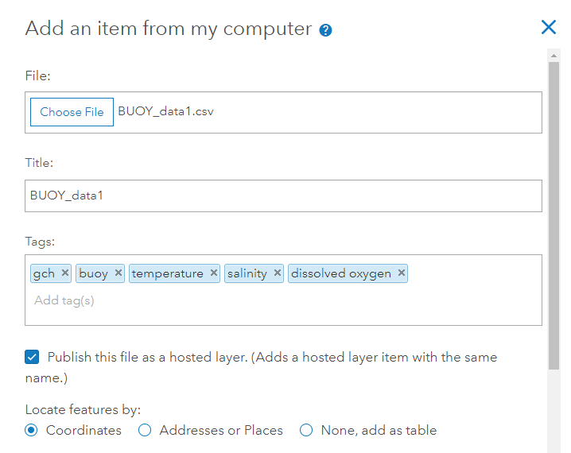

1. Check that lat and long are location fields.
2. Open in Map Viewer
3. Change style by an attribute for a given date.

SWT = sea water temperature

DO = dissolved oxygen

CL = Chorophyll

SWS = sea water salinity

Data source: <https://cbexapp.noaa.gov/>

Search for and add layer kk_bay by kkoffice.

See the other exercise for detailed steps.