**Adding data to a map from a spreadsheet**

Location field is latitude and longitude. Remember locations in the western hemisphere have a negative number as do locations in the southern hemisphere.

***Step 1: Prepare the data***

1. Download the spreadsheet for World Cities from 2017 Day 2 from <http://sites.wp.odu.edu/MapsRUS> to your desktop or google drive or let it go to downloads.
2. Open the file.
3. How is it organized?
4. Save the file as a .csv.

***Step 2: Publish a feature layer*** 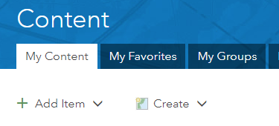

1. Go to <http://arcgis.com>.
2. Log into your school’s organizational account with your org credentials.
3. Click the Content Tab.
4. Go to My Content.
5. Click Add Item, from my computer.
6. Choose the csv file you just downloaded. Fill out the tags.

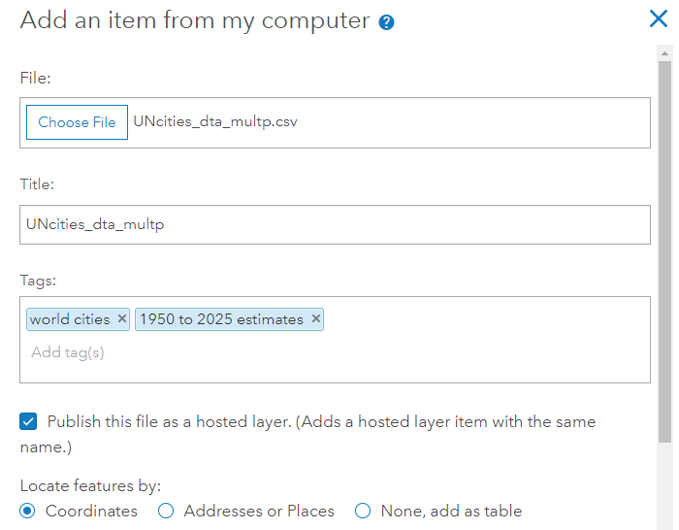

1. 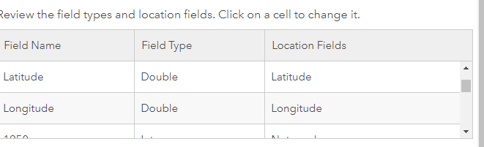Make sure latitude and longitude are selected as the Location fields. You may need to scroll through the attributes to find the fields.
2. Click Add Item.
3. The computer will add the data to the cloud and create a feature layer.

***Step 3: Change style aka symbolize the data***

1. Who is the item shared with?
2. The layer opens in the map and Smart mapping takes over.
3. What did it choose to symbolize the map by?
4. In the choose an attribute to show select Cyclone risk.
5. Click on Options and you can change the color of the symbol. Click OK.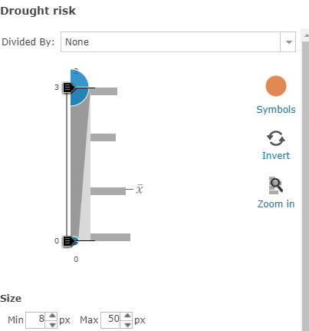
6. Change the attributes to show the other risks, drought; earthquakes, volcano, landslide.
7. Click on a point, where is the data for the popup coming from?

Just in case the layer doesn’t open symbolized.

1. Click on the layer’s name to see what tools are available. 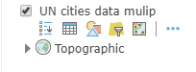
2. Select the geometric shapes icon known as Change Style.
3. Select an attribute.
4. Select a method.
5. Let Smart mapping choose.
6. Experiment with the Heat Map option.

SAVE the map. Every map in the org should have a unique name. Add your initials to the title. Fill out the tags.

**New tool with the September upgrade**

Click the 3 dots next to the tools. How do you get the tools to show?

From the menu that opens, select Clustering.

Use the slider to see the effects on the representation of the data.

***Add a layer to the map***

1. Click the yellow Add Button and select Search for Layers***.***

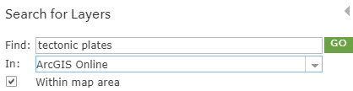

1. Search for tectonic plates.
2. 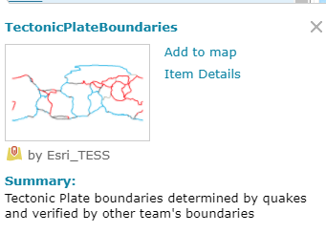Too many. Try a new search for owner:Esri_TESS. (the producer of the geoinquiry layers)
3. Select TectonicPlateBoundaries by Esri_TESS.
4. Click on the layer’s name to find out more.
5. If it were subscription or premium content, the card would include that information.
6. Want more info, check out the Item Details.
7. Select add to map.
8. DONE ADDING LAYERS at the bottom of the column.



1. Change the style to show location only.

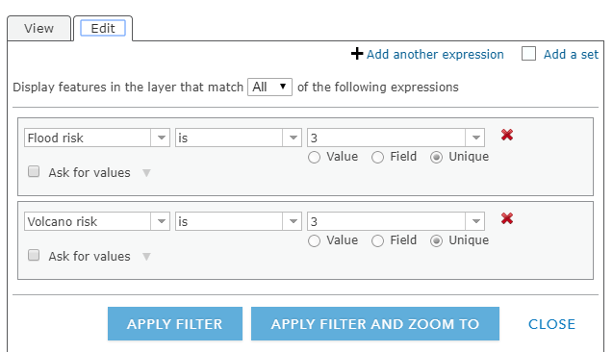***Use the Filter***

Use a filter to find out which cities are most vulnerable to a disaster. The map maker used a scale of 1 to 3 with 3 being the worst. Select two or more disaster variables.

1. Click the filter icon.
2. Set up the filter as shown to the right.
3. Click APPLY FILTER.
4. Open the Table.
5. Which cities are the most vulnerable?
6. On what tectonic plate are they located?

**Chesapeake Buoy Data Spreadsheets**

1. 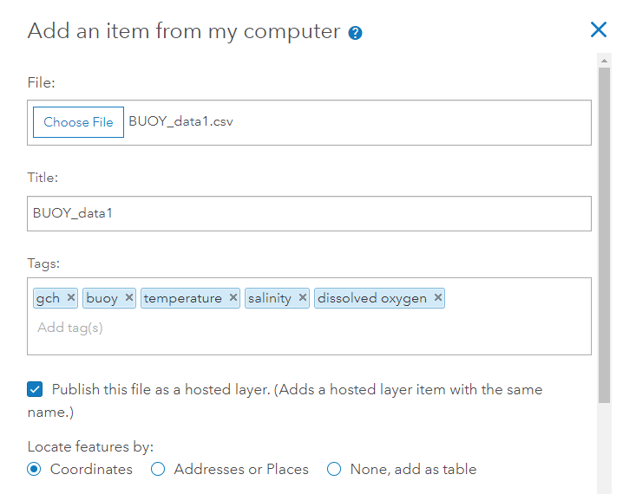Check that lat and long are location fields.
2. Open in Map Viewer
3. Change style by an attribute for a given date.

**SWT** = sea water temperature

**DO** = dissolved oxygen

**CL** = Chorophyll

**SWS** = sea water salinity

Data source: <https://cbexapp.noaa.gov/>

Search for and add layer kk_bay by kkoffice.

See the other exercise for detailed step

**Add a chart**

Add a line chart to show one of the variables through time in the pop-up

These pop-ups will come from the table rather than the Map Notes we did last time.

1. 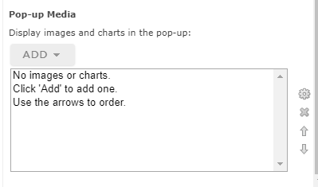Remove the filter if needed.
2. Click the three horizontal dots next to the layer’s name.
3. Click Configure pop-up.
4. Find Pop-up Media at the bottom of the panel.
5. Select Add Line Chart
6. Configure the line chart.

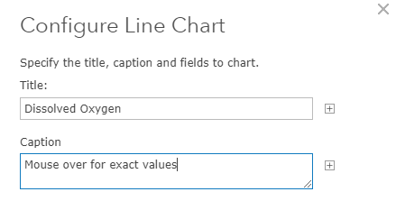

1. Title: Sea Water Salinity
2. Caption: Mouse over for exact values
3. Check the uppermost box Field Alias to deselect the data.
4. Check the dissolved oxygen data.
5. Make sure that lat, long, FID. (FID is an index the computer) remain unchecked.
6. 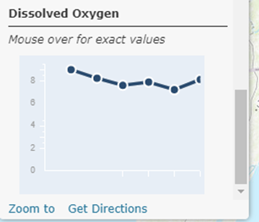Click OK,
7. Test the Pop-Up. Scroll down to the bottom to see the chart that you created.

**Compare two variables**

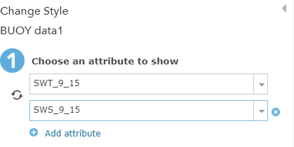Compare SWT and another variable of interest.

1. Change Style icon.
2. Select Add attribute. Good idea to have them for the same day.
3. Smart Mapping takes over and suggests Color & Size.
4. What relationships can be uncovered with the representation of the data?

**Add recent earthquake data from USGS**

Data from a downloaded .csv can be added directly to ArcGIS Online. Unless the data are published, there will be no filter.

Navigate to Earthquake Hazards Program—Spreadsheet Format. <https://earthquake.usgs.gov/earthquakes/feed/v1.0/csv.php>

1. Suggest Past 7 days and M4.5+
2. 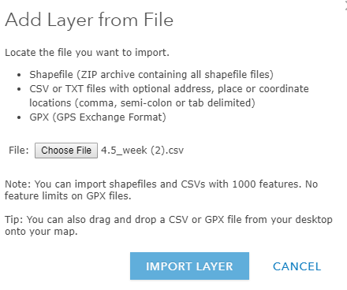The data downloads
3. Select some options for time and magnitude.
4. Open the spreadsheet.
5. Keep the lat and long fields,
6. Decide which other fields can be deleted.
7. Save the spreadsheet.
8. Go to ArcGIS Online.
9. Add Data.
10. Select Add Layer from File.
11. Select file you just edited.
12. IMPORT Layer.
13. Symbolize data.

There is no Filter unless you choose to publish the layer as we did previously.