Student Login Procedure
Be sure you have a master list of student usernames and initial passwords.
- Students navigate to http://arcgis.com.
- Once the students log in they are prompted to change the password
Options—keep the same password with an underscore removed or let kids set their own. BE SURE YOU HAVE THE PASSWORD ON FILE as it will soon be forgotten. I use a notecard for each student with username and password. I keep them on file, so when a student forgets, I can just hand him or her the card.
- A dialog box for changing the password appears. Before students type their new password, have them write it down. Then have the students type in the new password. Consider having them use their google credential passwords.
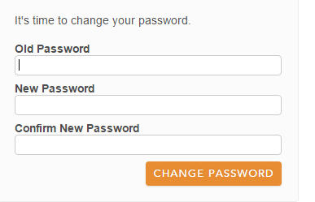
- A dialog box for security question opens.
- Select OK.
Consider having a standard security question—where were you born with the answer virginia beach. Best to use no caps.
That way the teacher of record can change the password if needed. The requests for new passwords will come to your email.
- Make sure to check that the profile is only shared with the organization.
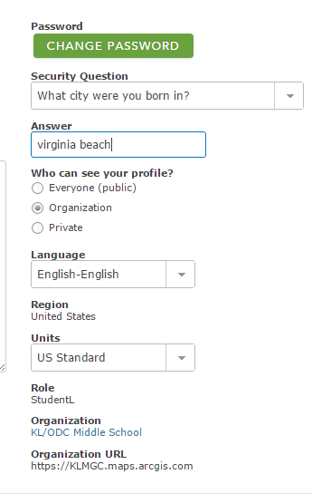

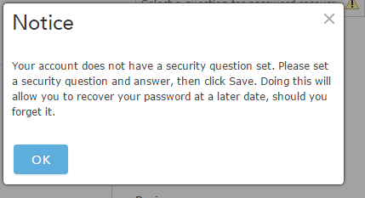

Decide if you want a bio image and profile. I vote NO,

Students sometimes click the CHANGE PASSWORD button.
They should not as they have already changed their passwords.

