Add Teachers to your School’s Organization Account
- From the top menu select organization
- Then Invite Members
- Choose the second option.
- Add members and notify them by email. Only use this method for the teachers.
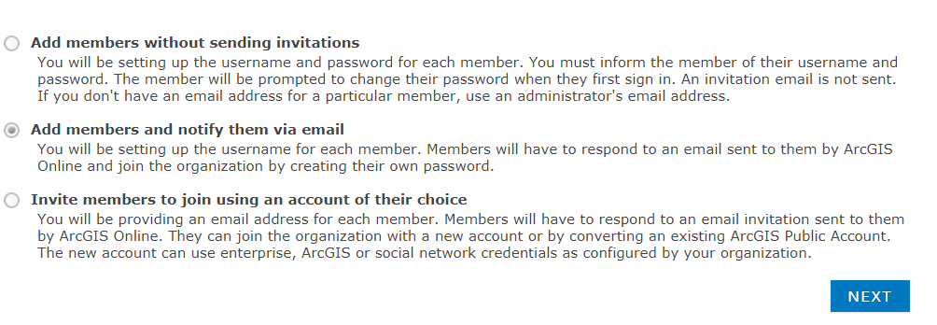
Click NEXT

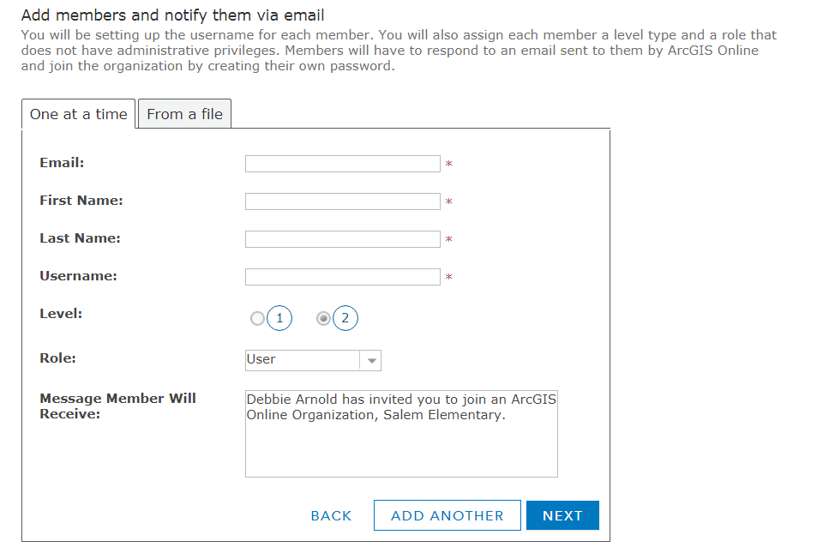
- Fill out the form. Be sure to double check the email.
- The user name is usually the teacher name followed by your org short name. Decide if you want to use first initial instead of the whole name.
NEXT
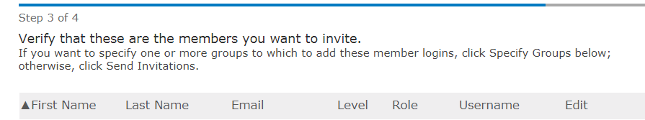

- Double check the information you have entered.
- click SEND INVITATIONS.
Once the teacher has logged in you can adjust their role. Recommend the TeacherL, that I have set up in your account.

