**Collaborative Mapping**

Students can research and enter data on the same class map via an editable feature service. Sample

http://vga.maps.arcgis.com/home/webmap/viewer.html?webmap=c81c3744fb8241cbaec6b547e61d143c

1. Set up a spreadsheet with the fields that you want students to use for data entry.

Field know-how

* String = words
* Integer = number
* Small integer
* Single
* Double = number with decimals
* No spaces in the header names. Make the field names professional & presentable.
* Be sure to have a location field, preferably lat, long
* Save the spread sheet as a .csv.
* Enter some “dummy” information, which can be deleted after the feature service is added to a map.

1. Publish the spreadsheet.
2. Log into org account.

* My Content, Add Item. Fill out tags, etc.
* 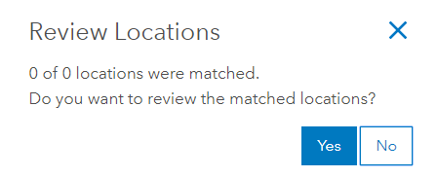Make sure Locate features by addresses or places is checked.
* Make sure location fields are set, e.g., city, state.
* Numbers? Make sure Field Type type is not String.
* Click Add Item and publishing begins.
* Choose NO.

1. Document the feature service. (title, tags)
2. Customize the feature service.
   * 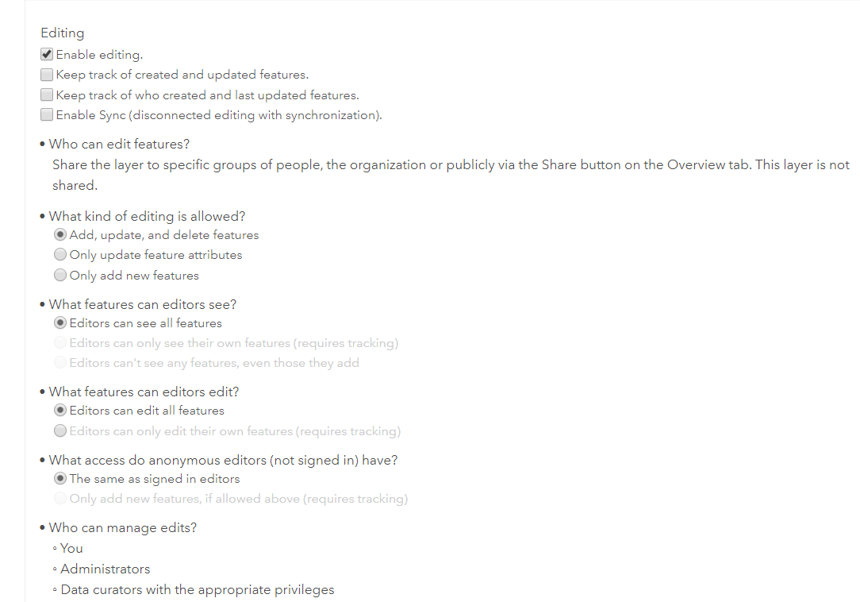Share with everyone.
   * Settings Tab
   * Delete protection a good idea.
   * Feature Layer (hosted ) Settings.
   * Check Enable editing; more options appear.
   * Export data—yes for a spreadsheet export that could be saved and added to another map.
3. SAVE.
4. Adding feature service to a map.

* Back to Overview Tab.
* Open in Map Viewer dragdown-Add to new Map.
* Center the map on the region of interest.
* Use Change Style to change the symbol. Be sure it is set on location only.
* Save the Map—blank as it may be. Fill out tags, etc.
* Share the map with everyone. Provide the URL to the users.

1. Test it out

* Click Edit.
* DELETE.
* Click the Edit pencil. Add a new pin. You can add an image to the pop-up.

The map that collected the data is fully filterable and can be symbolized to show a specific attribute. The map will automatically update as new data are added.