**Story Map Tour Options**

Creating A Story Map Tour

A story map tour provides a way to tell a story using photos, yours or from the Internet. Location of photo, captions, and photos showcase a topic.

Option 1: From a .csv

Add images from prepared .csv. Go to Groups and download photo_story.csv. Make a new story tour map, this time selecting the Import Tour data from a CSV file.

1. From My Content, select Create.
2. Select App, Using a Template.
3. 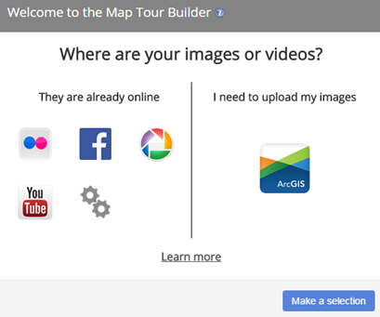On page 5 select Story Map Tour. Click Next.
4. Give your Story Map Tour a title, tags, and summary. Click DONE.
5. Select settings icon (cogs).
6. Select Import Tour Data from a .csv file.
7. Click Import.

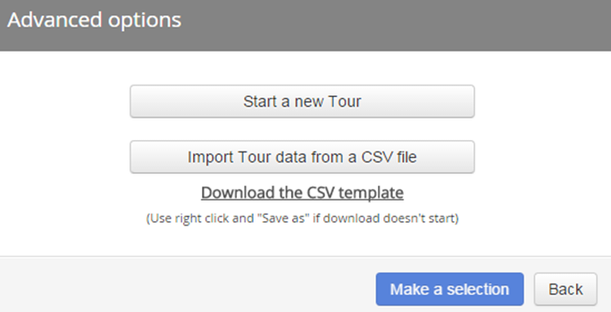

Use the pencil icons and this menu  to edit as needed. Edit as needed.

Examine settings to see what other options are available. Save the Tour and Share with the Chesapeake Workshop group.

Option 2: Manual (Add images one by one and select their location on the map)

Create a word document with three to five images for your Map Tour. Be sure to the URL for the image ends in jpg, png or another graphics format.

1. From My Content, select Create.
2. Select App, Using a Template
3. From page 5, select Story Map tour.
4. 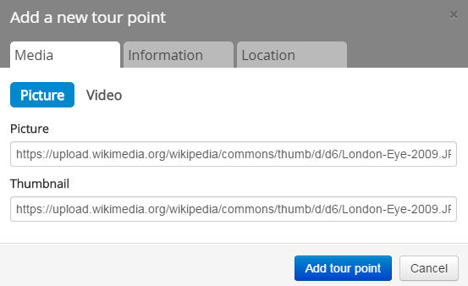Add title, tags summary, done.
5. Select settings icon (cogs).
6. Select Start a New Tour.
7. Click Add from the Menu on the Map.
8. Add an image URL in both lines, picture and thumbnail.  
   The URLS may be identical or different sizes of the same image.
9. Fill out the information for the other tabs—Information, Location. (Use the map’s search function.)
10. When tabs complete, click Add Tour Point.

Use Flickr for storage of photos.

Set up a Flickr account.Log in.

1. Click on You.
2. Cloud icon in upper right.
3. Choose photos and videos to upload to your photstream.
4. The add a description.
5. Add to albums.
6. Then make sure to go to blue button and Upload the photo.

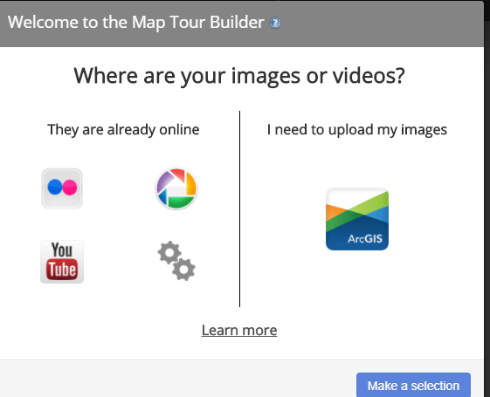From Content.

Select Create. App from Template.

Select Story Map Tour.

Add title and tags.

Select the two dot Flickr icon.

Enter your Flickr user name.

Click Look up.

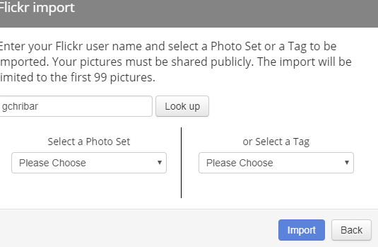

Your Albums are available in the drag down under Select a Photo Set.

Select Import and set a location for the image.

See Flickr documentation on how to turn on the geotagged locations in the app,.