**Creating Watersheds**

***Calculating Watersheds***

Must be logged into an organizational account.

Be sure to share your layers

1. Create a new map. Title it ICW_9a_yourlast name
2. Add the hydrography layer. For now it needs to be added via Add Layer from Web, ArcGIS Server. Type in the following address.
3. Add a Map Notes layer with the name of the river as the title.
4. Place a point near the river’s mouth to mark the end of the watershed.
5. Use the **measure** tool to get a rough estimate of the distance from the tributaries to the pin just placed.
6. Click the layer’s title. Select the Analysis button.
7. Select: Find Locations, Create Watersheds.

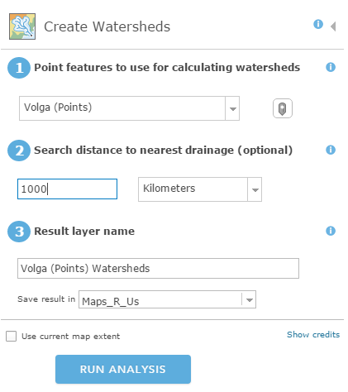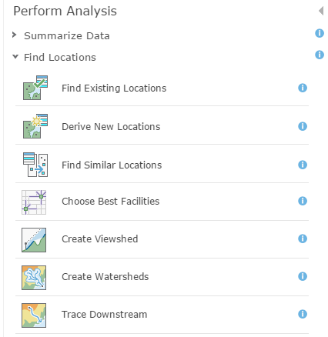

Fill out the parameters for the search

1. Select the correct point layer, add the distance value.
2. Change the unit of measurement.
3. Rename the layer with your initials at the tail. Every file in the org must have a unique name.
4. Uncheck current map extent.
5. Click show credits for the “price” of the operation.
6. 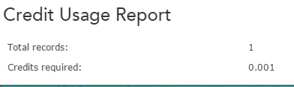Click RUN ANALYSIS.

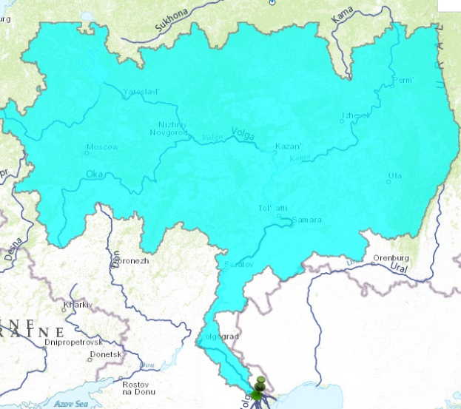**Results**

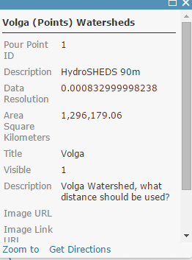

* Looks like most of the tributaries were captured.
* Pop-up has lots of information.
* Use Configure Pop-up from the 3 dots to select which fields to show.
* What was the cell size from the aerial photo?

Data are not authoritative because of the varying levels of resolution and scale of the map. But the procedure does provide a good approximation. If performing calculations in a use the hydrography tools from desktop and a map projected to state plane or UTM zone of the site.

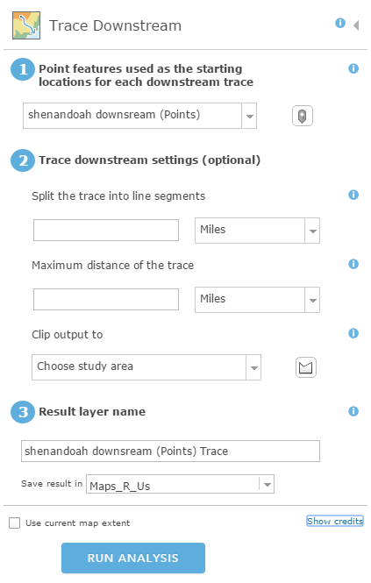**Trace downstream**

1. Perform this analysis on the same map as the watershed.
2. Add a Map Note
3. Select Analysis
4. Uncheck use current map extent
5. Gives the length of the downstream path

*Convert between measurement units*

Can perform calculations on layers that you own. As you created the downstream trace you can calculate.

1. Add a column to the table. Select calculate and set up the formula.
2. Field to use is Analysis length.
3. Miles to kilometers—multiply by 1.609344
4. Kilometers to miles—multiply by .6213711922
5. Save your map.

**Using Scene to illustrate topography**

Use your *developer account* for this segment of the assignment. Be sure to share the scene with the GEOG_425 group.

A 3 D model of three volcanoes, mountain peaks

1. Go to Scene from the top menu.
2. Search for the volcano or city by name at the spy glass in the upper right.
3. Change the basemap to Imagery.
4. Use the plus sign to zoom in.
5. Click the four headed arrow to turn it on change the aspect of the image to 3D
6. Click on the map to rotate the view. Use the circular icon with arrow to rotate the view.
7. The arrow points north to reorient the map.
8. Click Slides, Capture Slide from the top left.
9. Give the slide a name.
10. .Add slide Click done. Save scene.
11. View Item details.
12. Share the scene with GEOG_425, as ICW_9b_yourlast name.

FYI, you can link a scene in a in a Story Map Journal or a Story Map Series

Add a slide to one of the apps you have created previously.

1. Open the finished scene.
2. Click on the slide image at the bottom.
3. Click the share icon from the list of icons in the upper right, third from top.
4. Copy the short link to the scene.
5. Use that link in the he story map journal as a web page.

**Create a 3D Data Visualization App**

Maps cannot be added to the Scene, only layers. The data must have numerical values.

The layer must be a feature service not a feature layer in order to have its own URL.

1. Open the Major Cities of the World through Time Web Map which is shared with the GEOG_425 group. Three dots, show item details.
2. Get the URL for the city_pop and copy it. That layer is shared with GEOG_425.
3. Create a Web Scene using that layer. Save the Scene. Name the scene ICW_9c._yourlastname. Fill out tags and info as needed. Return to My Content.
4. My Content, Create, App from Template. Select 3D Data Visualization App.
5. From the configuration menus, select the scene you just created.
6. Add a title and choose colors under General.
7. Accept the defaults for Visualization.
8. Go Back to My Content and View the APP.