**How to create an Elevation App in ArcGIS Online**

<http://vga.maps.arcgis.com/apps/Profile/index.html?appid=484f28efb7ef42e2a21ad6a067b8c158>

1. Log into your school’s org account.
2. Create a map or find a map and save a copy to your account. Hint, Virginia Regions. Remember to find the map in the gallery.
3. Be sure to add for elevation app somewhere in the title.
4. Change basemap to ocean, shows rivers and rivers well and is rather simple.
5. Save map.
6. From the share button on the map select CREATE APP.
7. Search for elevation and select Elevation Profile.

**Set the options**

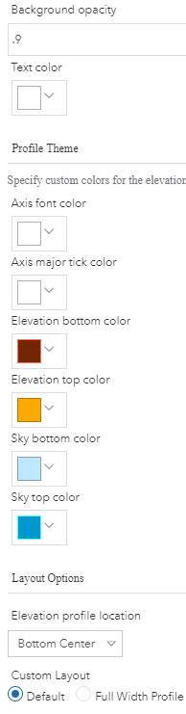*General*

* Select Web Map—you have already attached the app to the map.
* Title: Elevation App for ----- fill in a grade or a topic
* Description: See how elevation changes across space.
* Splash screen: provide a place to give directions for the users before they can use the app.

Splash screen title: To create a profile

Splash screen content text:

1. Click the pencil.
2. Draw a line on the map.
3. Click the graph icon.
4. View the profile.

Splash screen button text: Got it!

* SAVE provides a preview.

*Theme tab—*adjust color and appearance. Try these settings.

* Background opacity—number between .1 and .9
* Elevation bottom color: dark brown
* Elevation top color: lighter brown/orange.
* Sky top color: darker blue
* Sky button color: lighter blue
* Elevation profile location: Bottom Center
* Custom layout: accept default.

*Options tab*

* Accept default

*Elevation Profile tab*

* Select measurement units, miles or kilometers
* Select Display draw tool.

*Search tab*

* Enable search tool.
* Students can then add a name of the location to the search box.
* Accept Esri World Geocode as the search tool.

Click **Launch** to view. Try it out.

Click Close on the configure page to return to the item details page.

Be sure to share with everyone so students can use the app without being logged in.

Fill out the item details page.

Caution, profiles appear different from the direction they are drawn. These both show the coastal plain. Which is from east to west?

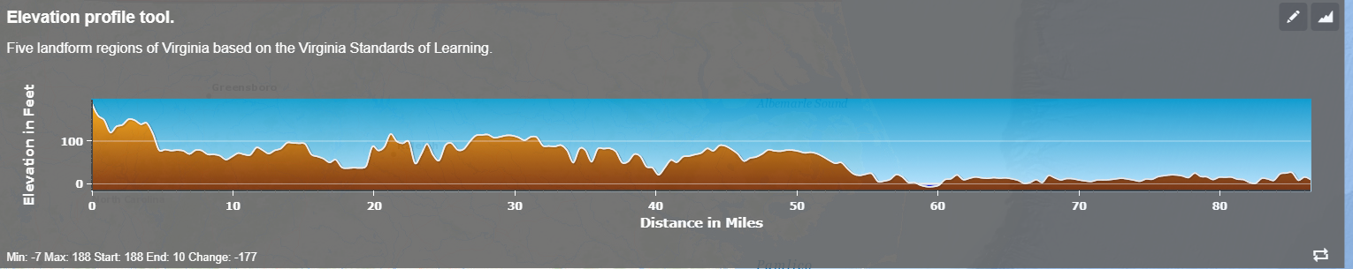

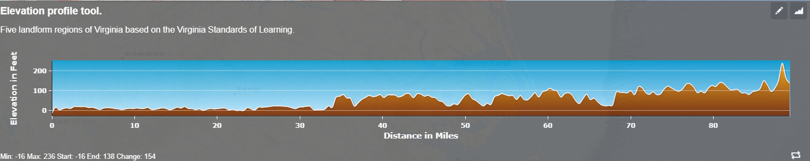

If you want students to measure between cities, it may be a good idea to have the basemap toggle on. (Options tab)

Experiment with other basemaps.

Changes in the map are reflected in the app. Also use a new saved map to create the app. Good idea to put the title of the app in the map’s title and tags.

How can you use this app in your curriculum?