**Scene and Story Maps**

**Using Scene to illustrate topography**

Why use scene?

* Show data on a model of the globe.
* Capture topography for a place in past and present.

Log in to your organizational account. Be sure to share the scene with the org or publicly if you want the students to view the scene without being logged in.

A 3 D model of three volcanoes, mountain peaks

1. Go to Scene from the top menu on the Home page.
2. Select New Scene. A globe opens.
3. Change the basemap to Imagery.
4. Search for a geographic location such as a volcano, country, or city by name in the Search box at the upper right.
5. Use the plus sign to zoom in.
6. Click the four-headed arrow to and tilt the map to show 3D.
7. Use the circular icon with arrow to rotate the view and move the map.
8. The arrow points north to reorient the map.
9. Click Slides, Capture Slide from the top left.
10. Add slide Click done. Save scene.
11. Give the slide a name.
12. Add additional slides.
13. View Item details., fill out title and tags
14. Share the scene.

**Create A Story Map Journal**

1. The Map  *Sample*: aabae8e2379442e5b3a8f961081e9802

* Use an already-made map. GeoInquiries have plenty of them.
* Remember the procedure. Find a GeoInquiry Map, capture its map id.
* Log into your org account.
* Go to the Gallery and enter the map id in the search box. Make sure you are searching outside of your org.
* Save the map to your account.
* Examine the map for possibilities for your story, layers, different symbology. Any changes you make to the map will automatically be shown in the app.

1. Make the APP

* Click Share
* Share with your org.
* CREATE WEB APP in lower right.
* Look at all of the possibilities. Type Story Map Journal in the Search Box.
* Select story map journal
* CREATE WEB APP. This time the button is blue.
* Add a summary and additional tags if needed.

1. Customize the app
   1. Accept the default for side panel. Click Start.
   2. 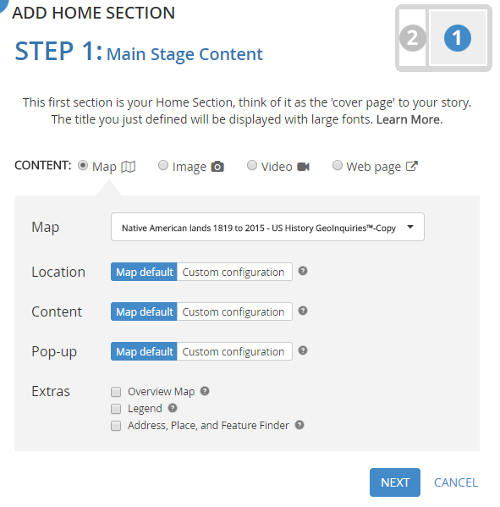Change the title of the app.
   3. The Main Stage and Side Panel appear.
   4. Select a map. The one you attached to the app should be listed in the drop down.
   5. Decide whether or not you want the legend to show. Check the box.
2. Remember making the presentation where you set where the map would zoom to, which layers to use, whether or not the pop-up is open when the map loads. These options are controlled through the Custom configuration menu.

You can add an image a video, or another web app to the main stage or the side panel. Add Section just as you added slides to the presentation.

Try one of each option.

Image: *Sample:* https://upload.wikimedia.org/wikipedia/commons/2/28/Hampton_Institute_-_geography.jpg

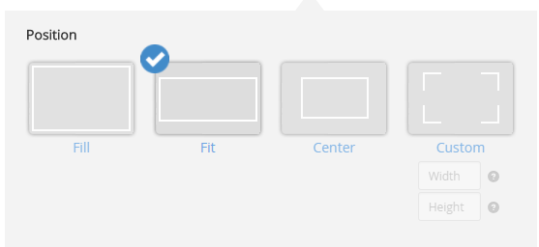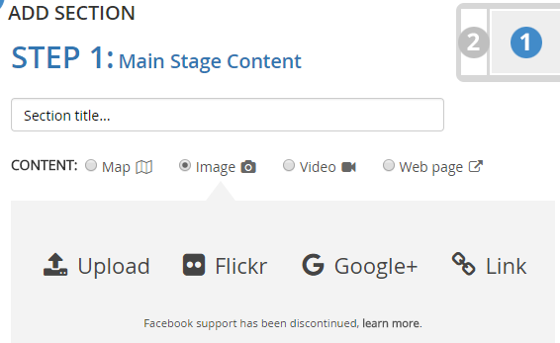Handout for using your own pictures from Flickr is included in <http://sites.wp.odu.edu/MapsRUs>. That would be the recommended option. Upload if by a great number of people costs credits for storage space.

Choose fit for the Position option.

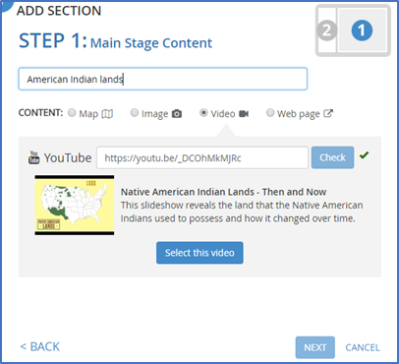Video

Video must be hosted at Vimeo or YouTube.

If using a video Check and then select video.

*Sample:* https://youtu.be/_DCOhMkMJRc

Web Page

Use the entire URL. Works best when page ends in html.

*Sample:* https://www.aimovement.org/

SAVE as you go along.

Sample Story Maps

American Expansionism: <http://klmgc.maps.arcgis.com/apps/MapJournal/index.html?appid=513adbbd518a4912b30b0d56e543ce18>

Where do I belong? A story map quiz?

<http://klmgc.maps.arcgis.com/apps/MapJournal/index.html?appid=513adbbd518a4912b30b0d56e543ce18>

Add a Scene to your Story Map *Sample*: http://arcg.is/PvyTG

Add a slide to one of the apps you have created previously.

1. Open the finished scene.
2. Click on the slide image at the bottom.
3. Click the share icon from the list of icons in the upper right, third from top.
4. You could copy the short link to the scene. But instead open the app and copy the long URL.
5. Use that link in the story map journal as a web page.

Extras

You can use a URL parameter to go directly to a scene, &ui=min#3

That directs the computer to minimize the user interface and go to slide 3,

<http://vga.maps.arcgis.com/home/webscene/viewer.html?webscene=45cd654a197a4784ad6c350428b0ca4c&ui=min#3>

**This and That**

If you know the name of a story map, you can search for it and then from its item details page select share with a group in your org.