**Story Maps and More**

Independence Middle School

April 23, 2018

Use **Google Chrome** for the best results.

**Examples of Story Maps**

1. Story Map Journal

[Rise of American Expansionism](http://klmgc.maps.arcgis.com/apps/MapJournal/index.html?appid=513adbbd518a4912b30b0d56e543ce18)

[Library of Congress Project](https://vga.maps.arcgis.com/apps/MapJournal/index.html?appid=6be6aee9efde4eb59ecd874a7d5ab632)

1. Story Map Tour

[The United States in 1840](http://klmgc.maps.arcgis.com/apps/MapTour/index.html?appid=d38768d20f3c4cdda80102f7217607ab)

[American Indian Culture Regions](https://klmgc.maps.arcgis.com/apps/MapTour/index.html?appid=ee2c1350538547068c9e785cfa894ddf) (login to that org required)

Recommended search places

* Website: https;//sites.wp.odu.edu/MapsRUs
* Search in <https://vbcpsgis.maps.arcgis.com>
* Search in <https://vgagis.maps.arcgis.com>
* Search the Gallery within your org for apps and ready-made maps.

Be sure to change the search area to include ArcGIS Online

**Step 1: Find a map**

1. Go to <https://arcgis.com>
2. Search for maps

*Search for All About George*

1. From the Item Details page, select Open in Map Viewer.

**Step 2: Log in**

After opening the map

In the upper right Sign In with your log-in credentials.

Tips: First time you will be prompted to change the password. Password must have at least eight characters one of which is a number.

You can use the same password for multiple accounts.

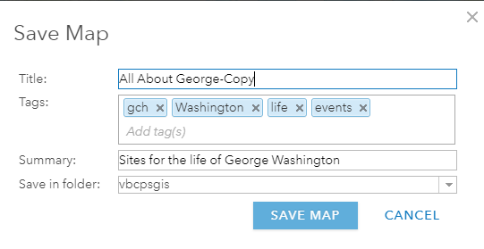**Step 3: Save the map to your account**

1. Select Save As from the top menu.
2. Replace the word copy with your initials.
3. Add your initials to the tag, take mine out.
4. Consider adding the full name of the map to the tags.
5. Note it is saved in your account.

**SAVE MAP**

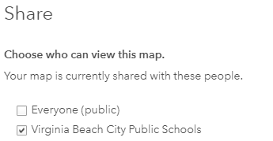**Step 4: Share the map**

With the map open, select Share from the top menu.

Share with your org.

That means the viewer must have a log-in to the account in which the app is hosted.

If made public, can be viewed with just the URL.

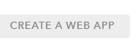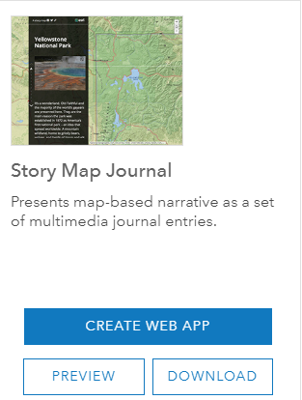**Step 5:** Create the App

1. Click CREATE WEB APP.

Oddles of possibilities,

1. From the Configurable Apps Tab
2. Select Build a Story Map
3. Select Story Map Journal. (green)
4. CREATE WEB APP
5. Double check title and tags
6. Good idea to add Story Map Journal to the title
7. Computer will generate an app for you

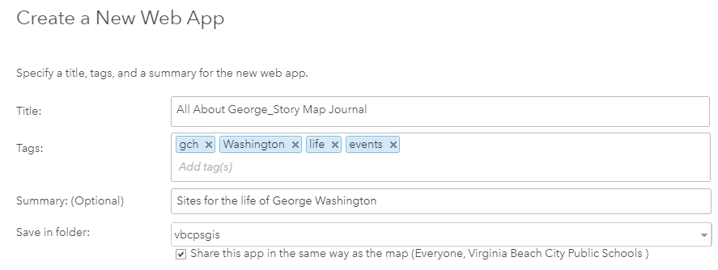

1. Once the app opens, select Side Panel or Floating Panel
2. Click START.

**Step 6: Add information to the Story Map**

1. One more chance to change the title, this time take out story map journal and your initials.
2. Click the right arrow. SAVE.
3. 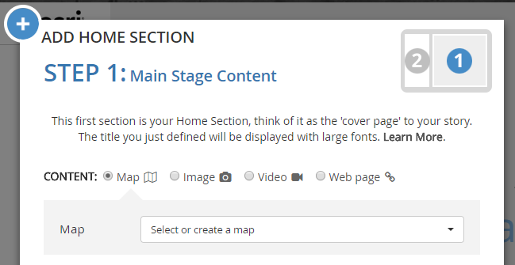Select Map.

*All About George should be the first choice in the dropdown.*

1. Click Next*.*
2. Add text

*This Story Map will examine key locations and events in the life of George Washington, our country’s first president.*

1. ADD.

Note the first slide is preset and adopts the title of your story map.

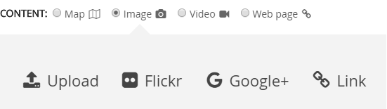**ADD Section--imag.**

1. Must give the section a title

*Boyhood home.*

1. Select Image.
2. Select Link.
3. Add URL for image.

<https://upload.wikimedia.org/wikipedia/commons/thumb/2/2e/George_Washington%27s_birthplace_%281856_engraving%29.jpg/486px-George_Washington%27s_birthplace_%281856_engraving%29.jpg>

1. NEXT, Add Text

*George was born in Westmoreland County, Virginia.*

1. Picture is too big.
2. Go to the edit pencil. Main Stage tab and select fit or center, SAVE. (saves the change, but not the app)

SAVE the story map in the upper right.

**Add an image to the side panel.**

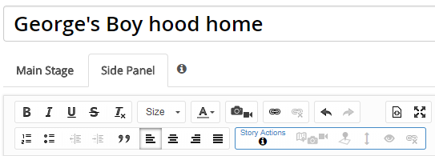

1. Add the text.

*George grew up to look like this.*

1. Click below the text to place the image.
2. Click the camera icon.
3. Use the following link

<https://upload.wikimedia.org/wikipedia/commons/thumb/b/b6/Gilbert_Stuart_Williamstown_Portrait_of_George_Washington.jpg/394px-Gilbert_Stuart_Williamstown_Portrait_of_George_Washington.jpg>

1. APPLY, SAVE.

**Tips for retrieving images**

1. Wikipedia and Wikimedia images are copyright free for the most part.
2. Conduct a Google Search for images.
3. Select Tools.
4. Select Usage rights.
5. Select for non-commercial use.
6. Images supported are jpg, gif, png

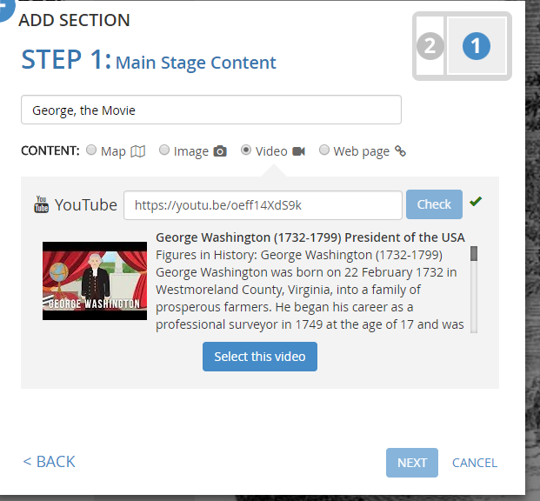**Add Section--Video**

Only YouTube movies are supported

1. Add the link. Then select check.
2. Then Select this video

<https://youtu.be/oeff14XdS9k> or

<https://www.youtube.com/watch?v=oeff14XdS9k>

1. Have to add text or the ADD button does not light.

*What historical events did George Washington influence?*

Too big? Center is a good choice here

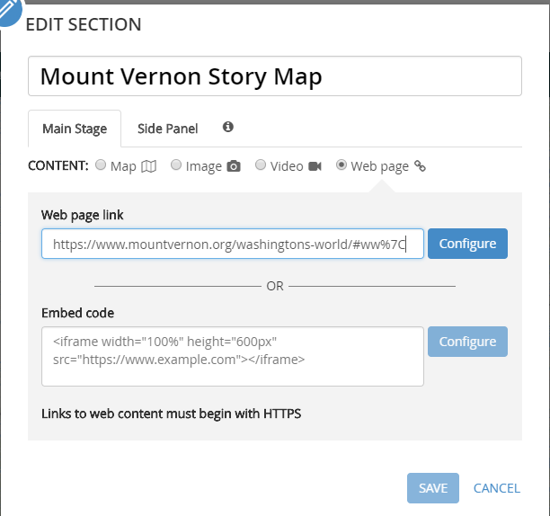

**Add Section – a Story Map** to the story map

Main Stage

Title Mount Vernon Story Map

1. Select Web page.
2. Enter URL

<http://www.mountvernon.org/washingtons-world/#ww%7C>

1. Configure.
2. Make sure the link begins with https. You will see why soon.

Side Panel text

*This story map shows key areas George Washington visited.*

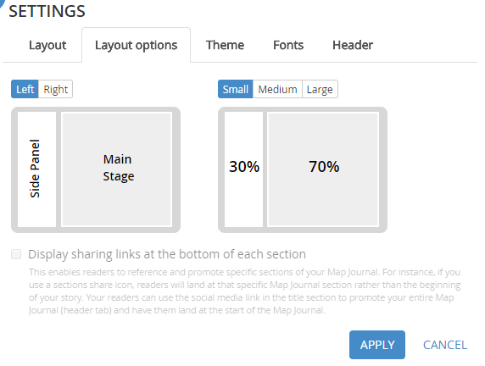Have you saved recently.

**Appearance**

1. From Settings
2. Select Layout options.
3. Select a smaller side panel Apply

Where is this story map stored? How can you find it again?

It is in your content. Where is my content?

**My Stories**

When signed into the account, click the waffle next to the left of your name and select My Stories.

Checks your story map for errors.

Try it out.

Can also launch a story map from that area.

**Tutorials**

<https://storymaps.arcgis.com/en/how-to/>

<https://storymaps.arcgis.com/en/app-list/map-journal/tutorial/> (story map journal)

**Story Map Tour**

Upgraded interface.

Features images and video and short text.

For images select the cog, locate the image, add a title and caption, add the link in media as both a picture and thumbnail.

Click Add Tour Point. and then add the image URL, locate the image, include a caption, and title for the image. Until all three tabs are filled out, you will receive and error message.

Under settings there are three types

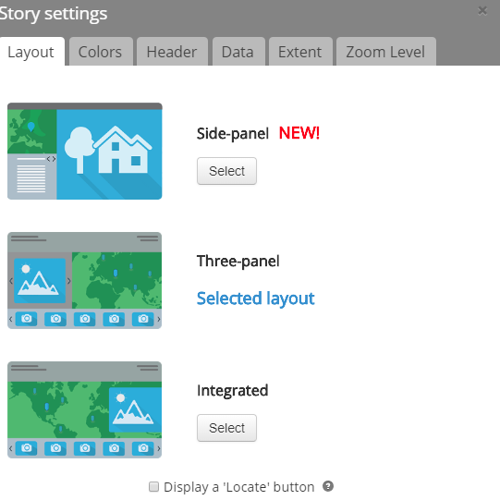How to make the map zoom to locations.

Under Settings select

Extent to draw a box around the area of interest.

Zoom Level, select a number from the down arrow on the menu.

The zoom will not be visible on the first slide. For the example I chose 12.

<https://storymaps.arcgis.com/en/app-list/map-tour/tutorial/> (story map tour)