**How To Make a Collaborative Map**

Goal to create an empty editable feature service in which students without being logged in can enter information into a shared map.

1. Log into ArcGIS Online org account. Must have publisher privileges.
2. Select Developer from the waffle next to sign in.
3. Select Dashboard.
4. Select New Layer.
5. 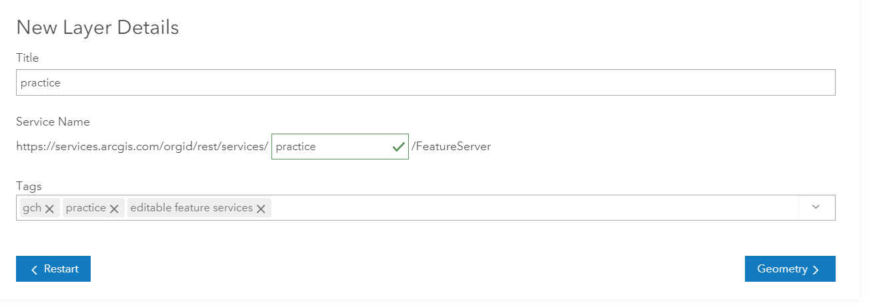Create an empty layer—add names, tags
6. Select Geometry. Use points. And leve the spatial reference aka projection field alone.

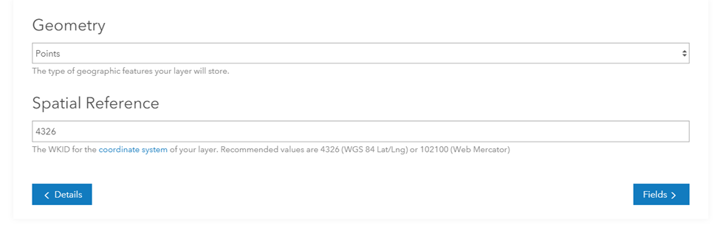

You will next set up the fields for data entry. The fields are usually abbreviated and can have no spaces, but the alias can be in normal English.

Types of fields

* String
* Integer
* Double
* Date

A domain allows for drop-down words. To set the categories, select Coded Values. Click Add Field when

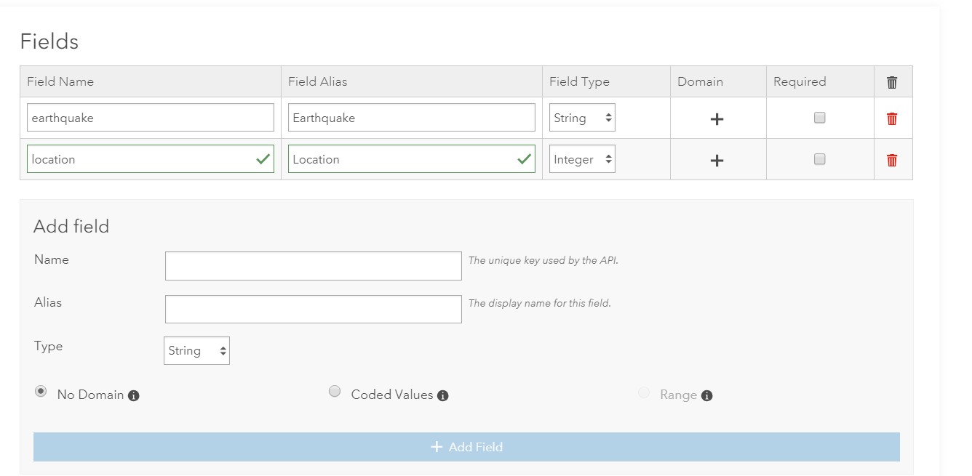Famous Earthquakes or Famous Americans

Possible fields

Name, Date, Location, Tidbit, Type, Description

Attached images is the defaut. Uncheck it.

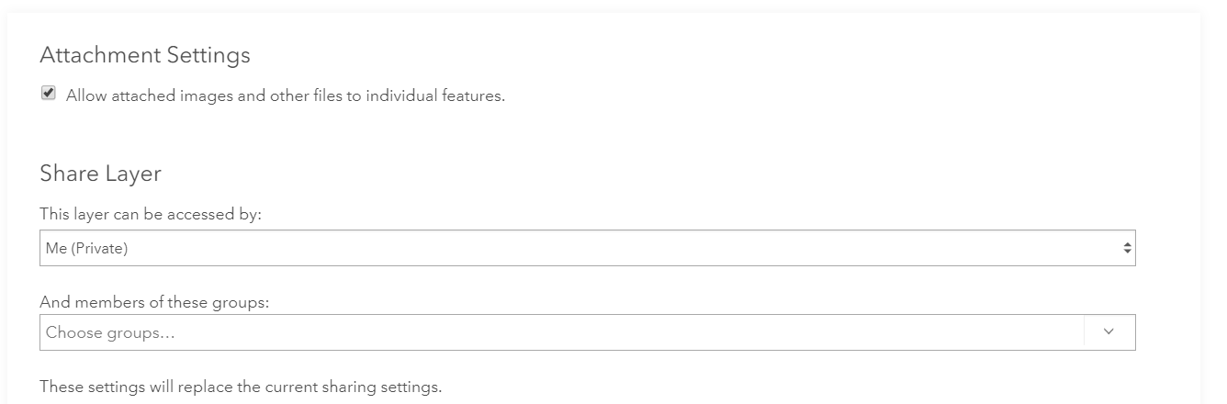

Sharing will determine who can view and use the layer. If you want no log in the layer must be public. Your org must be configured for anonymous access.

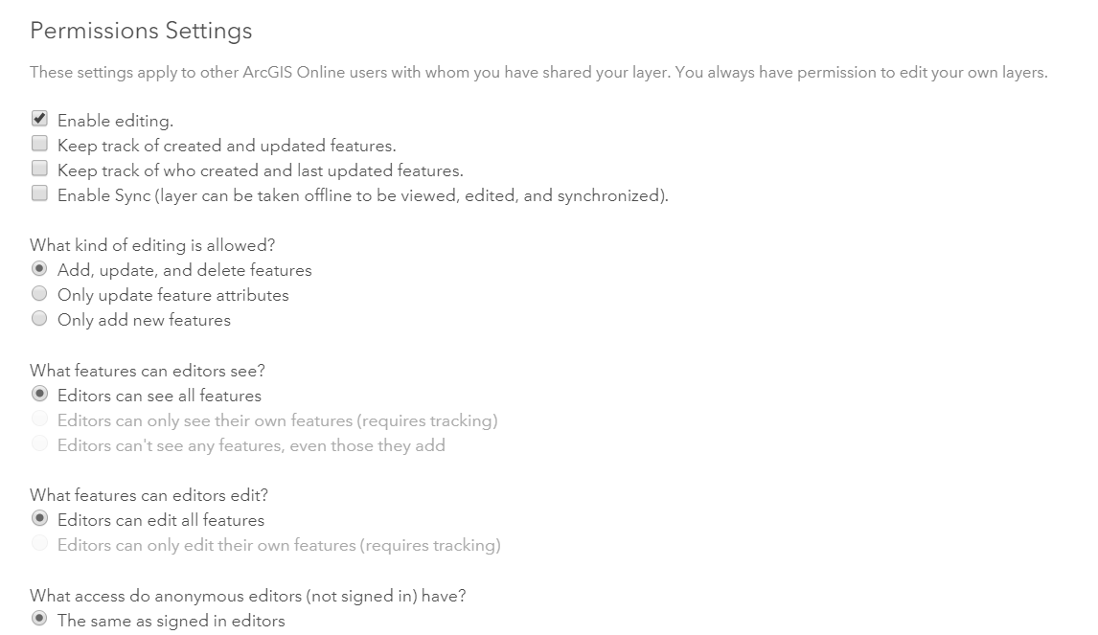

Click Create Layer and a layer is published to the Esri Cloud.

To be used the layer needs to be connected to a map.

1. Open your layer in Map Viewer.
2. Save the map.
3. Share the map.

Be sure the layer is shared with everyone and you have filled out the data for the layers.

Name of sample: reqwq.