**Creating a Layer from a Spreadsheet**

Creating a layer from a csv provides a filter for the data.

1. Log into ArcGIS Online org account. Must have publisher privileges.
2. Select Developer from the waffle next to sign in.
3. Select Dashboard.
4. Select Import Data.
5. Select the file: shapefile, csv, GEO JSON, or Geodatabase into the Drop File Here box.



**Note** you can change the name in the URL to something more meaningful.

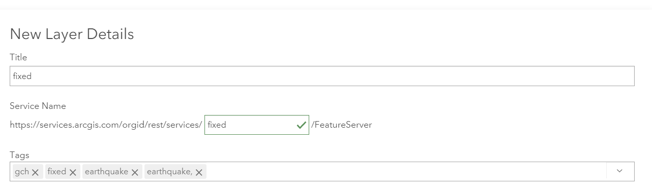

Make sure the location field correspond to the fields in the spreadshseet.

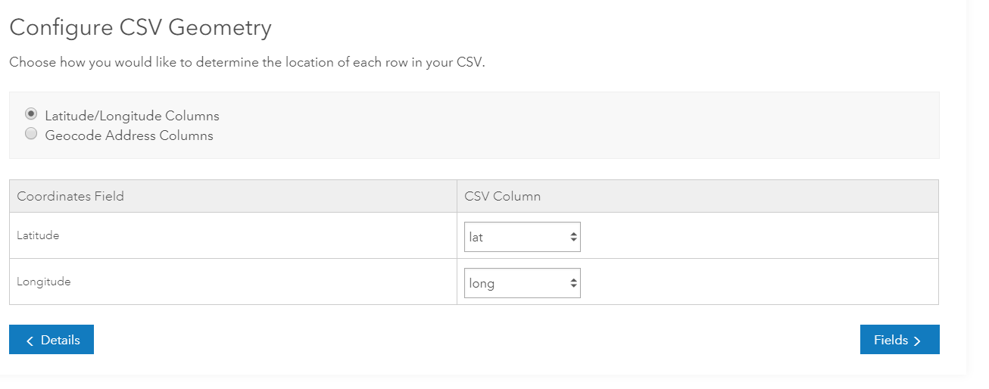

Set the field type.

* String is words
* URL would be the link to your images.
* Integer is a single number.
* Double has decimals. Lat/Long as they are decimal degrees should be double.

**NOTE:** Make sure percents without the percent sign in your csv are classified as double.

*Settings*

Fill out tags and sharing options.

Share only with the ODU org

Group: GEOG 300 TR or GEOG 300T

Enable editing is good so that you can update the data on the map in case of errors.

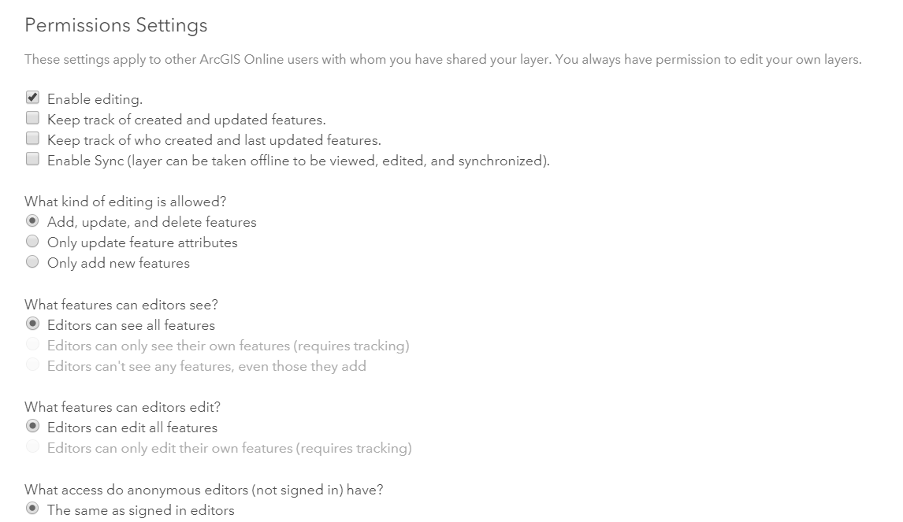

Click CREATE LAYER. Layer is published to the ESRI cloud.

A new screen opens with more options. How many tabs do you have?

Select open in map viewer and save the layer to a map.

The layer you created can be added to any map. Look at item details and fill out the information about the layer. You should now have five tabs. Explore the function of each.

You can add the images for your points to the spreadsheet. The field could be added at a later time because you own the layer.