**How to Annotate a Map**

**GOOGLE CHROME Works BEST**

**Task 1:** Adding data to a collaborative map that is hosted in the ESRI Cloud.

**Step 1:** Access the map—no log in required

Type or paste in the browser: <https://arcg.is/01LubL>

**Step 2**: Collect data (Research on Internet).

**Name (first last)**  Thomas Jefferson

**Birth City** Shadwell, Virginia

**Birth Country** British Colony

**Accomplishment** Author of the Declaration of Independence

**Field of Work** Politics

**Birth Year** 1743

**Death Year**  1826

**Life Span** 83

**Image**

**Website**

**Step 3: Adding Data to the Map**



1. Type the name of the location in the search box in the upper right. .
2. Click the Edit Pencil to activate it
3. When active, it is underlined.
4. Click on the location and a data entry box should open. Add the data.
5. Click close to save the data to the map. (as the data are stored in the cloud no need to save the map yet.)

**Step 4: Retrieving Images**

Before we can add an image, we need to retrieve one from the Internet. ArcGIS online readily supports links to images ending in .jpeg, .gif, and .png. You need to capture the **image’s URL.** Wikipedia images work best because most of them are either in the public domain or shared through the Creative Commons. Government sites, such as the Library of Congress, offer access to many copyright free images. Just because an image is on the Internet doesn’t mean it isn’t copyrighted. You use those at the risk of a cease and desist order as well as royalty fees.

1. Open a new tab in the browser.
2. In Google, search for the person and then select images.
3. Select Tools. Then Usage rights, Labeled for noncommercial reuse.
4. Avoid sites with .com or pixabay. Org, .gov , wikimedia are good choices for copyright-free images.
5. Right click and select Copy Image **address.**
6. Select the Edit pencil to turn it off.
7. Click on the pin to test your pop-up

When the “class” has finished adding information to the map, each individual will save a copy.

**Task 2: Saving a Map**

1. Select a basemap that appeals to you.
2. Save AS the map in YOUR FOLDER. (**Only use Save As** the first time you save a map.)
3. Add your initials to the tags and some descriptive words about the message of the map.
4. Click SAVE MAP.
5. Saving time varies.

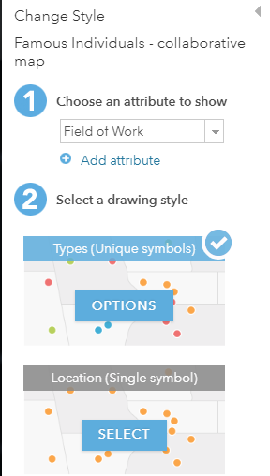**Task 3: Change Style**

Map data can be symbolized to help the map tell a story.

Different symbols are used for numerical and categorical data. Depending on the attribute chosen various styles will appear.

*Symbolize by Field of Work attribute*

1. *.*Select Change Style icons (geometric shapes the layer’s name.)
2. Step 1, select an attribute—Field of Work.
3. Step 2: select a drawing style, Type s (Unique Symbol).
4. Click the options button on the drawing style you have chosen.

*Change Style for Life Span*

1. Make a copy of the layer.
2. Click the layer name, three horizontal dots.
3. Select copy. Where was the copy added?
4. Select the 3 dots next to the layer’s name and select Rename.
5. Type Life Span as the new layer name.
6. Select the Change Style icon.
7. Step 1, select Life Span as the attribute.
8. Step 2, Drawing style--Smart mapping takes over and suggest Counts and Amounts Size.
9. Change colors using the OPTIONS bar.

Copy the layer and experiment with

*Style with Heat map*

*Style with Clustering*

**Task 4: Explore a GeoInquiry**

Log out as geoinquiries are designed to be used without a log in.

Select a GeoInquiry and follow the directions.

**Task 5: Presentations**

A presentation is a collection of different views for one map. A presentation is attached to a map. Works best when a map with multiple layers and pop-ups is used.

View a presentation

1. From the Search box on the arcgis.com page type owner:Finals_TWPS and select Maps from Item Types.
2. maps
3. Select Great Migration-edited.
4. Click the title of the map to open the item details page.
5. Open Presentation.

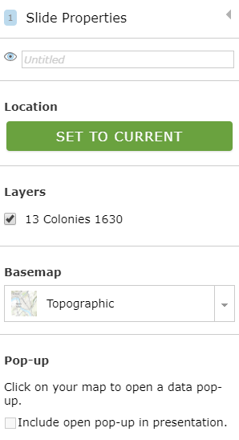

**Create a presentation**

1. Log in.
2. Find the collaborative map in your My Content and open or a GeoInquiry Map.
3. Save to your account. Modify tags as necessary. Save.
4. With the map open, select Create Presentation in the upper right-hand corner.
5. Click Add to add a slide.
6. Give the slide a title.
7. Set a location on the map.
8. Click SET to CURRENT to save that location.
9. Select the layers you want to use.
10. Select a basemap.
11. Decide whether or not to include an open pop-up.
12. Click save in the top menu.

Add another slide. Save and then view.

Help document:

<https://doc.arcgis.com/en/arcgis-online/create-maps/create-presentations.htm>

**Task 6: Story Map**

1. Go to Content > Select Create >. Select App Using a Template > Select Building a Story Map, Story Map Journal.
2. CREATE WEB APP.
3. Fill out title and tags.
4. Select a Side Panel.
5. Assign Main Stage and Side Panel Content.
6. Choices are map, image, video (you tube or flickr) or a web page.
7. You cannot go on to a new slide until there is main stage content, title, and text. Click Add and tehn editi.
8. Remember to SAVE periodically.

Help document: <https://storymaps.arcgis.com/en/app-list/map-journal/tutorial/>