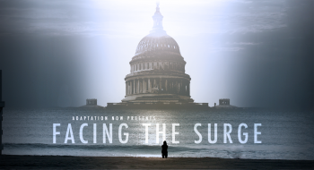

Old Dominion University will be hosting a screening of Facing the Surge, a documentary on sea level rise and climate change filmed here in Norfolk on Wednesday, September 28 at 7 pm at the ODU theater on Hampton Boulevard.

Facing the Surge documents the tangible costs of sea level rise for the people of Norfolk, Virginia. Norfolk is home to the largest naval base in the country and to thousands of hardworking Americans struggling to adapt to the rising tides and an uncertain future. The town has registered 16 inches of sea level rise since 1930. But Facing the Surge is not a film about loss and inaction. It tells the stories of citizens from across the United States as they step forward to raise awareness and push the government to pursue real solutions.

This film will be followed by a panel discussion featuring Dr. Wie Yusuf, ODU Resilience Collaborative, Ron Villanueva, delegate from Virginia Beach and many of the people featured in the film.

The film is the first documentary short by Adaptation Now, a crowdfunded project created to share the stories of communities as they face the leading edge of climate change. The project started with the goal of broadening the climate change conversation beyond the existing environmental movement. It operates with the fervent belief that stories have the potential to shift public opinion and create a groundswell foundation for political change.

Register for the film here: https://odu.co1.qualtrics.com/SE/?SID=SV_0xn1kiJQu7xL58V

Check out the film trailer here: http://www.adaptationnow.com/

