Daily Deposits

short line

Continuing Education Division  
June: 2024

# Daily Drop Off Deposit Guide:

1. Daily deposits will be sent out via email from [*noreply@Xenegrade.com*](mailto:noreply@Xenegrade.com)around midnight
   1. *Daily deposits* come from XenoGrade
   2. Deposits could be sent out a few seconds later
   3. Deposits will show up as attachments to the email
   4. Attached to the email should be: *Katrina V, Greg F, Robert D and Olivia J.* 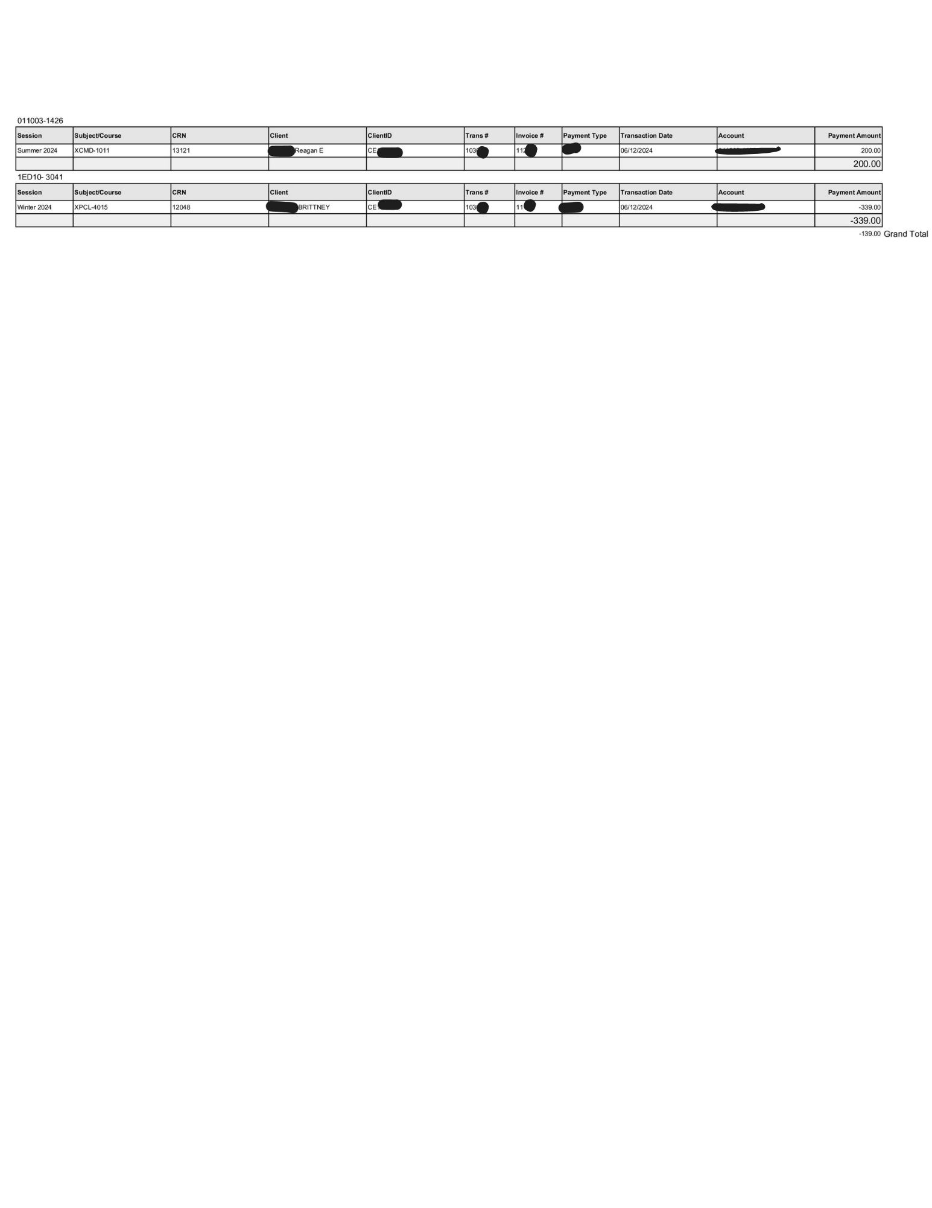
2. Once you click on the attachments linked to the email, the deposits will look like the image below:( Sensitive info. has been blocked)

# 

# TouchNet Account Login

1. When the homepage appears, select the *phone* option for authenticator type, the *first* option on the login screen.

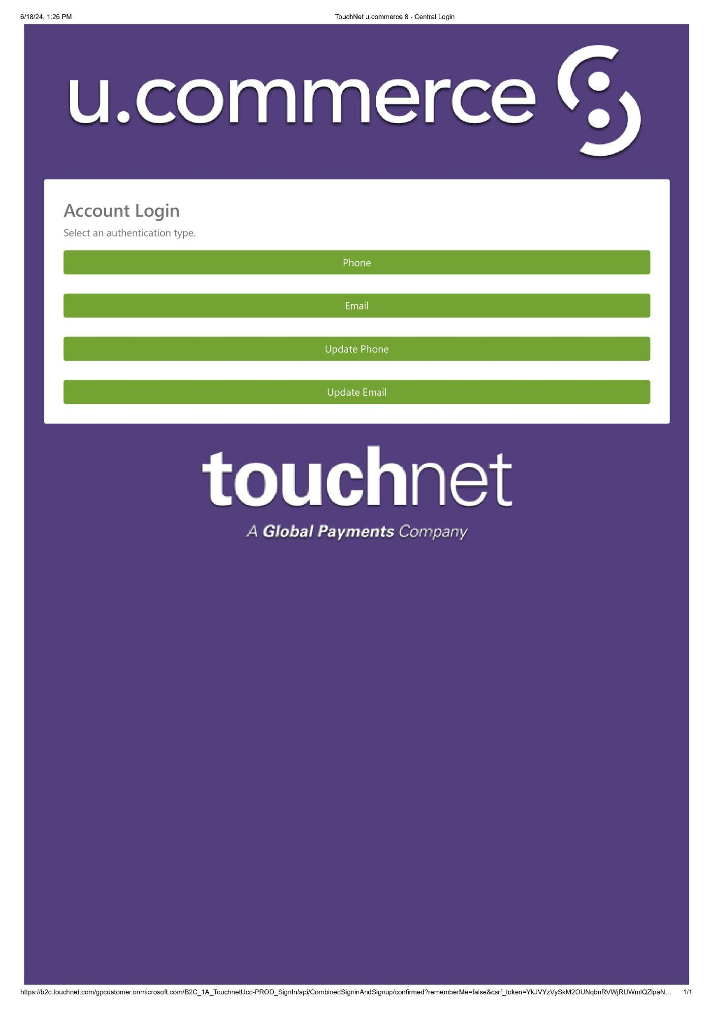

B. Once you have selected the phone option, the next screen will appear and the option to call or send a code to the phone number on file will appear. Select what works best.

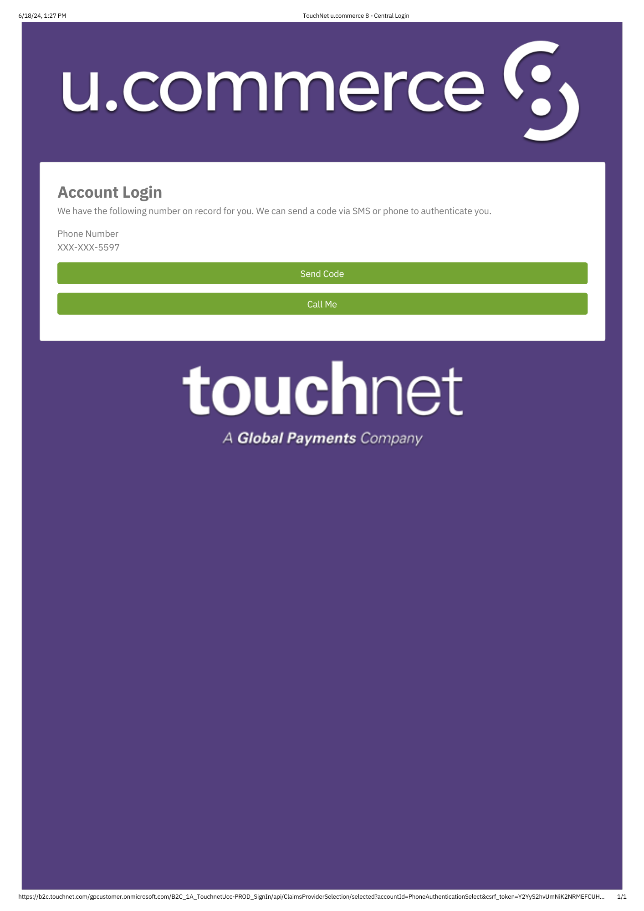

# 

# 

# 

# 

# C. Once the code choice is selected, a code will be sent and now will be able to enter the code sent from touchnet. If no code is received, the option to resend the code will be available.

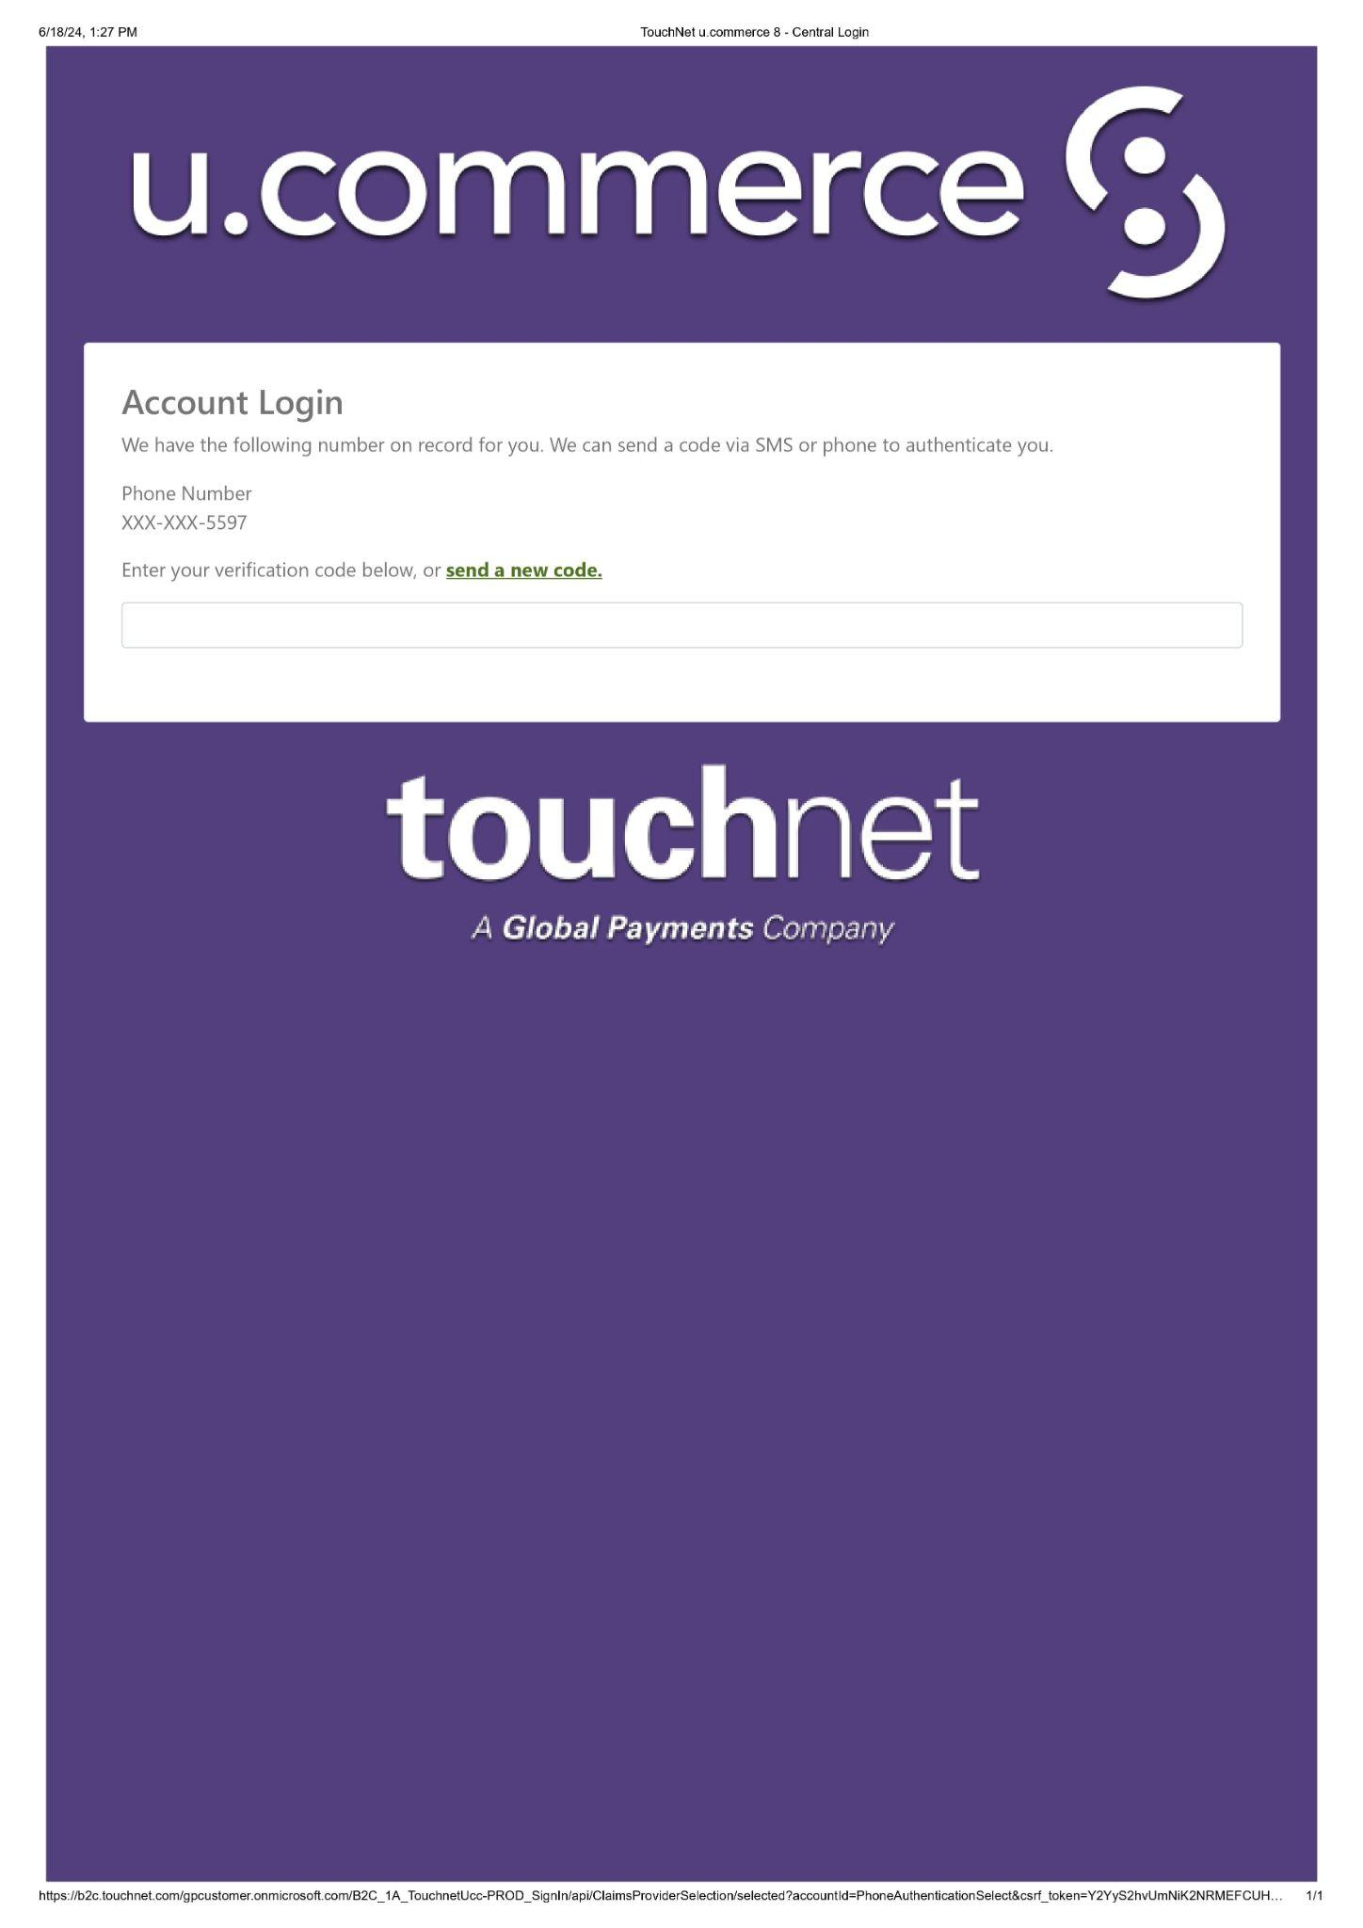

# D. Once logged into touchnet the Banner production systems screen will appear: Select “*TouchNet”* as highlighted below

# 

# 

# 

# 

# 

# 

# 

# 

1. Once *Touchnet* is selected, a dashboard will appear.
   * 1. Select *“Applications”*
     2. Under the *“Payment Type”* select *“Credit Card”*
     3. Select *“Batch settlement”* and *“Batch details”* under the *“report”* section to the right of the *“payment type section”.*
   1. *Batch reports* come from “TouchNet”
      1. Begin Dates:
         1. *Starts the day before* the specific report lookup
         2. Time should start at *00:00* & end at *23:59*
         3. The time should be *exactly 24 hours from start to end*

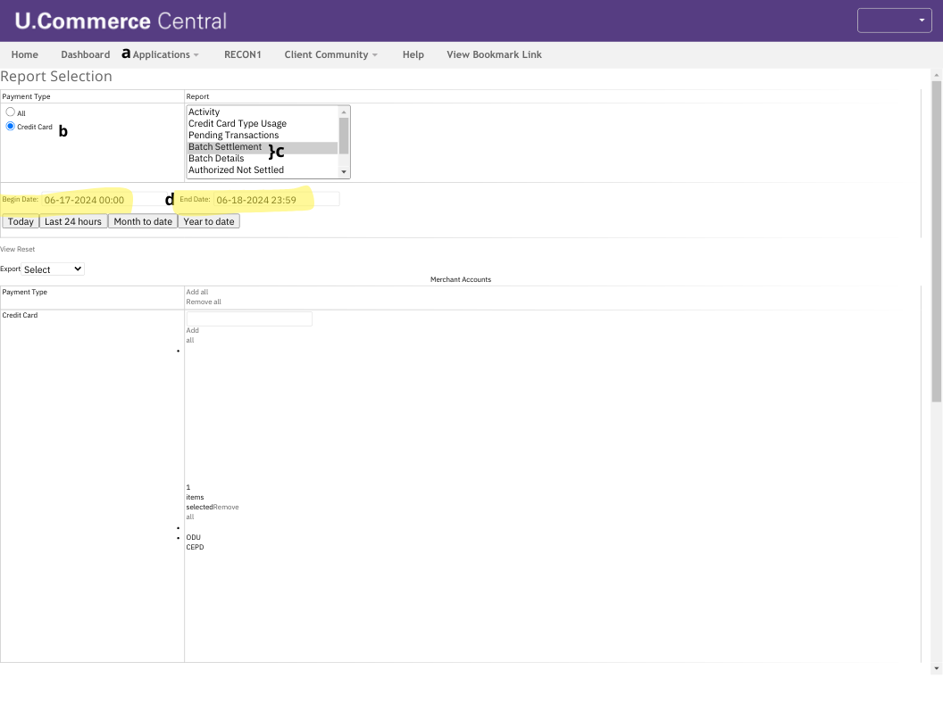

Settlement Reports

# Once the report information has been submitted, the *“Credit Card Batch Settlement Report”* and the *“CC Batch Detail Report”* will appear as below.

# 

# 

# 

# 

# 

# 

# 

# 

# **Final: Saving Documents**

All documents will need to be saved to the computer drive before emailing.

* 1. Save the reports to the *“COPD Shared Drive”*
  2. Add the fiscal year, the Xenograde and the accounts receivable report

***Organize Documents:***

* 1. Create a folder named with the date of deposit.
  2. Add the following to the folder:
     1. Xeno report
     2. Batch detail report
     3. Batch settlement report

Attach the folder containing all the above documents.

* + 1. Include a copy of the cashier's receipt(below)
    2. Send the email to the Cashier’s office.

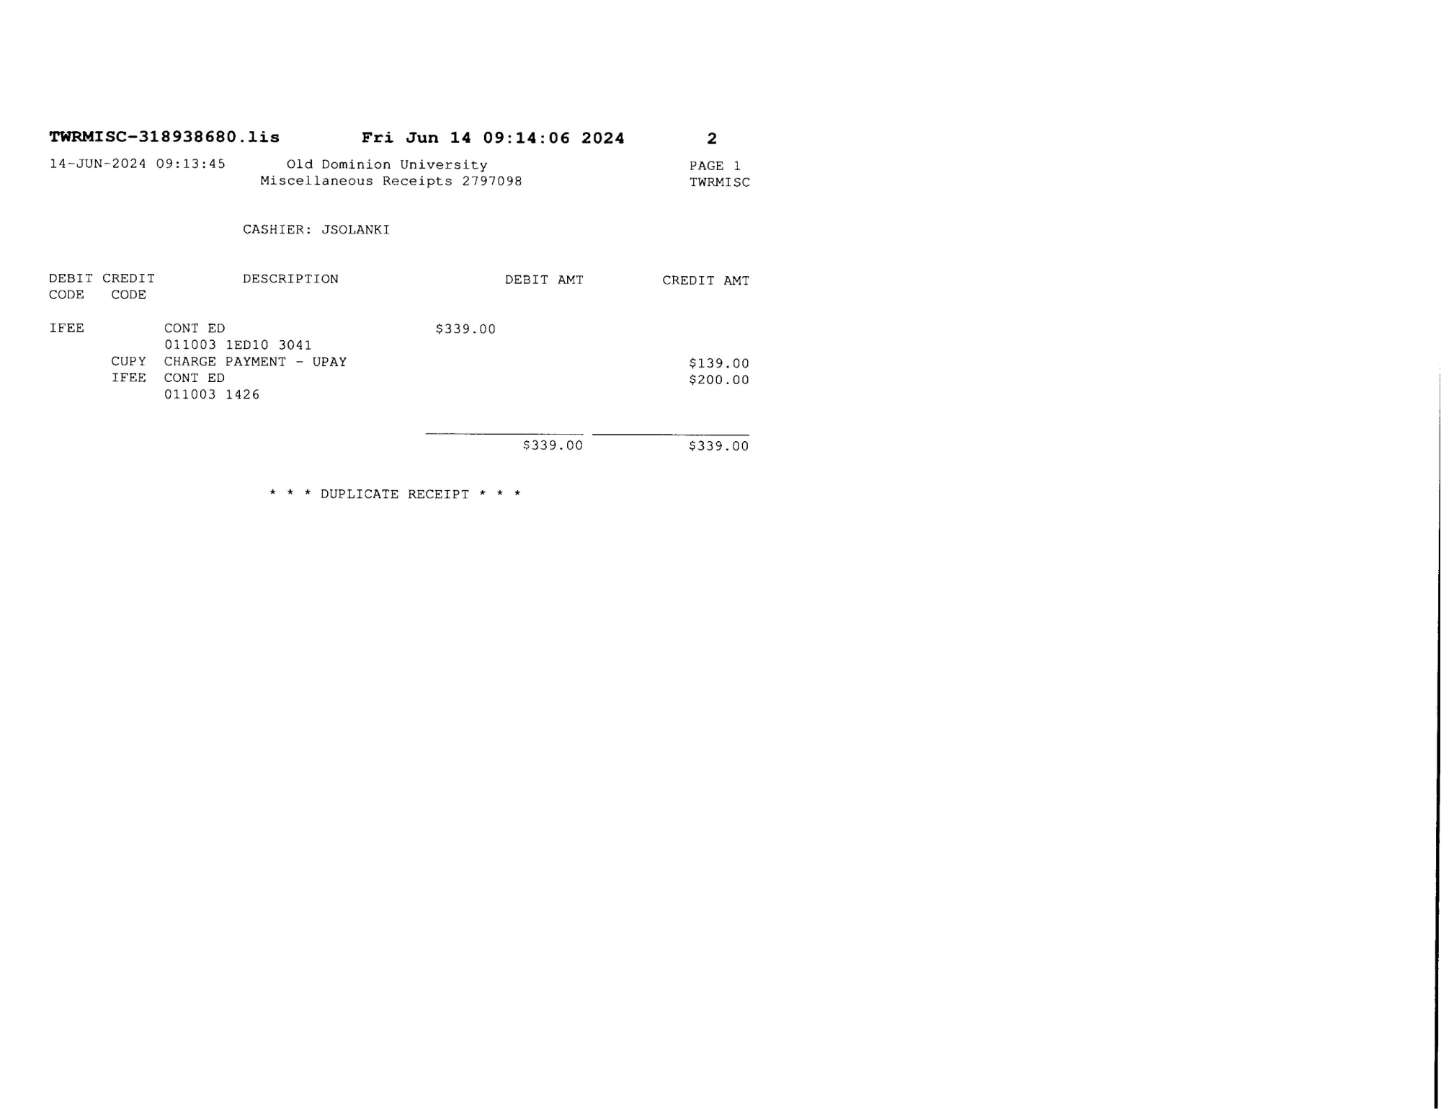

### 

### 

### 

### 

### 

### 

### 

### 

### ***Xeno and Touchnet Cheat Sheet***

**Overview**

* **Xeno Deposits**: Automated email-based deposit system.
* **Touchnet**: Independent financial application.

**Interactions Between Xeno and Touchnet**

* Occasionally, these applications may conflict with each other.
* To ensure accuracy, the grand total amount from Xeno must match the settlement report total from Touchnet.

**Touchnet Batch Reports**

* **Types of Reports**:
  + **Credit Card Batch Settlement**
  + **Credit Card Batch Detail**
* Both types of reports are essential for financial tracking and reconciliation.

**Drop Deposit Guidelines**

* Payments should be made using Visa, Mastercard, or similar credit cards.
* Client IDs: Begin with 2 letters followed by 6 numbers.

**Batch Report**

* **Batch Number**: Unique identifier for each batch.
* **Batch Status**: Indicates the current status of the batch.
* Both are traceable