Old Dominion University
CYSE 450: Ethical Hacking and Penetration Testing

Lab 3: Active Reconnaissance and Vulnerability Scanning

Question 1: Active Scanning
- T1: Using both host and dig commands, demonstrate whether the host sdf.org is live or not. Attach screenshots showing the results. 4 points
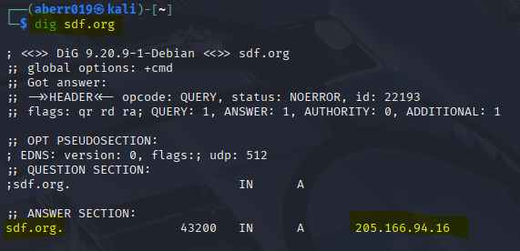
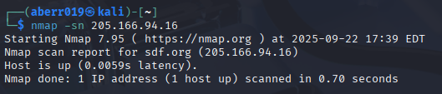
- T2: Perform DNS enumeration using dnsenum command for the host sdf.org. Check whether the zone transfer is possible. Provide necessary screenshots. 4 points

Zone transfer is not possible.
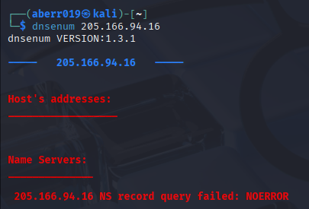
- T3: Perform both ICMP Sweep and TCP Sweep for the host sdf.org using NMAP. Use the option --reason to show the details and disable the arp-ping. Attach screenshots
showing the results.
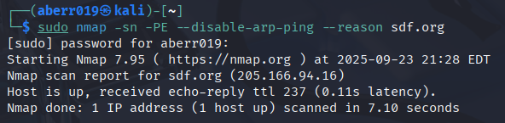
- T4: Perform port scanning to determine all open ports and corresponding running services for the host sdf.org. Attach screenshots showing the results.
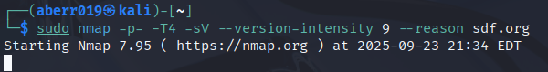
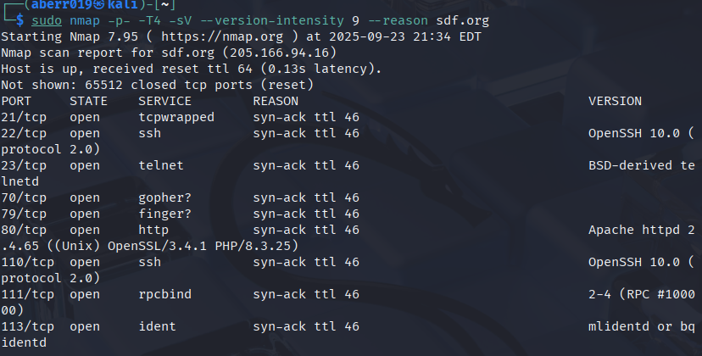
Question 2: Vulnerability Scanning
- T1: Using NSE scripts, determine all known vulnerabilities present in the host sdf.org.
Attach a screenshot showing your command and the results you got.
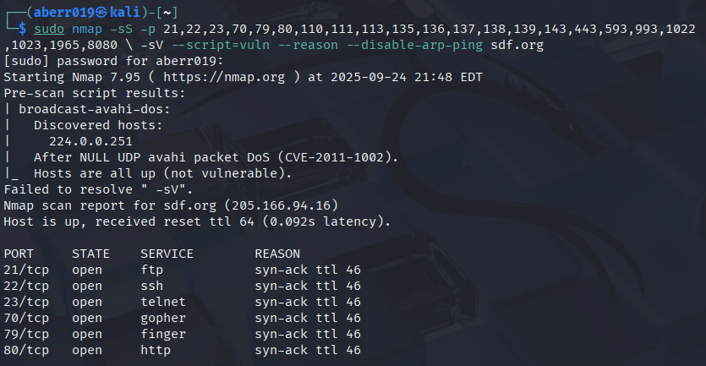
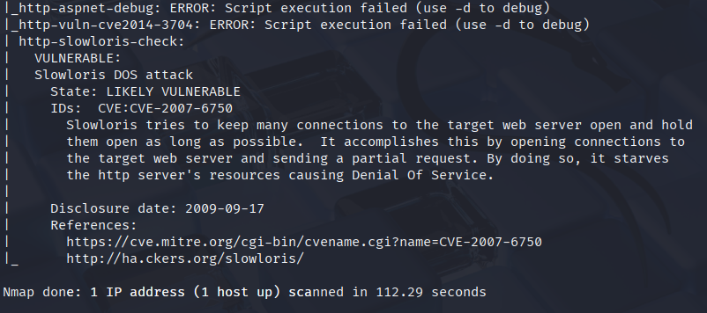
- T2: Perform a brute force attack on sdf.org. You can choose any script from the followings: ftp-brute, snmp-brute, http-brute, and oracle-brute. Attach screenshots showing your command and the results you received. 5 points
