Cyberviolence: The Growing Cybercrime Challenge

Executive Summary
- Cyberviolence refers to the use of computer systems and online platforms to cause, facilitate, or threaten harm, whether physical, psychological, sexual, or economic, to individuals.
- Offenses include (but are not limited to) cyberstalking, harassment, doxing, non‐consensual image sharing (revenge porn), and sextortion.
- With increased digital activity, especially during periods like the COVID-19 pandemic, reports of online abuse and violence have also increased.
- Law enforcement, digital service providers, and victim support groups face jurisdictional, technological, and legislative challenges during their attempts to address cyberviolence.
- Coordinated responses involving government, industry, and the general population is critical to increasing awareness, updating legal frameworks, and for protecting rights in the growing cyber domain.
Introduction
Cyberviolence is a form of cybercrime that uses technology to commit, facilitate, or threaten acts of violence against individuals. More specifically, cyberviolence is defined as “the violent impact of the cyber activities of another upon an individual or social grouping.” (Graham & Smith, 2024).
This crime is committed in several ways. For example, perpetrators may use social media or various messaging apps to send threatening messages, share sensitive images without consent or publish personal information, also known as “doxing”, to intimidate individuals. In some cases, the perpetrators maintain anonymity to continuously target victims, amplifying the psychological effects of their crimes.
The activities discussed violate individual rights and have real, offline consequences. Victims may experience severe emotional distress, social isolation, or even physical violence because of online abuse. Understanding how perpetrators commit these crimes and the impact their actions have is crucial for organizations, ranging from law enforcement agencies to technology companies, to develop effective deterrents in the cyber domain as technology continues to evolve.
Current Trends
Over time, cyberviolence has quickly proved itself to be a significant concern for society. While this cybercrime includes a wide range of harmful behavior, current and historical data showcases the following insights:
- During the COVID-19 pandemic, lockdowns led to an increase in internet usage by 40–100% in various regions. This trend was paralleled by increased reports of cyber harassment and abuse. Various cyberbullying hotlines and organizations reported an 81% increase in reports made after the pandemic (Parker, 2020).
- Women are more vulnerable to cyberviolence. Reports indicate that around 38% of women worldwide have experienced some form of online abuse, and that nearly 50% of girls face more online harassment than what’s experiences in physical, public spaces (Dauletova & Hyeonsoo, 2021). These statistics highlight that as we become more digitally connected, gender-based violence is transferred and exemplified onto our online environments.
- Extended exposure to cyberviolence has been linked to depression, anxiety, and other mental health issues. Victims may also experience economic harm, such as losing a job or being financially exploited, when their personal information is exploited or damage to their reputation affects their lives.
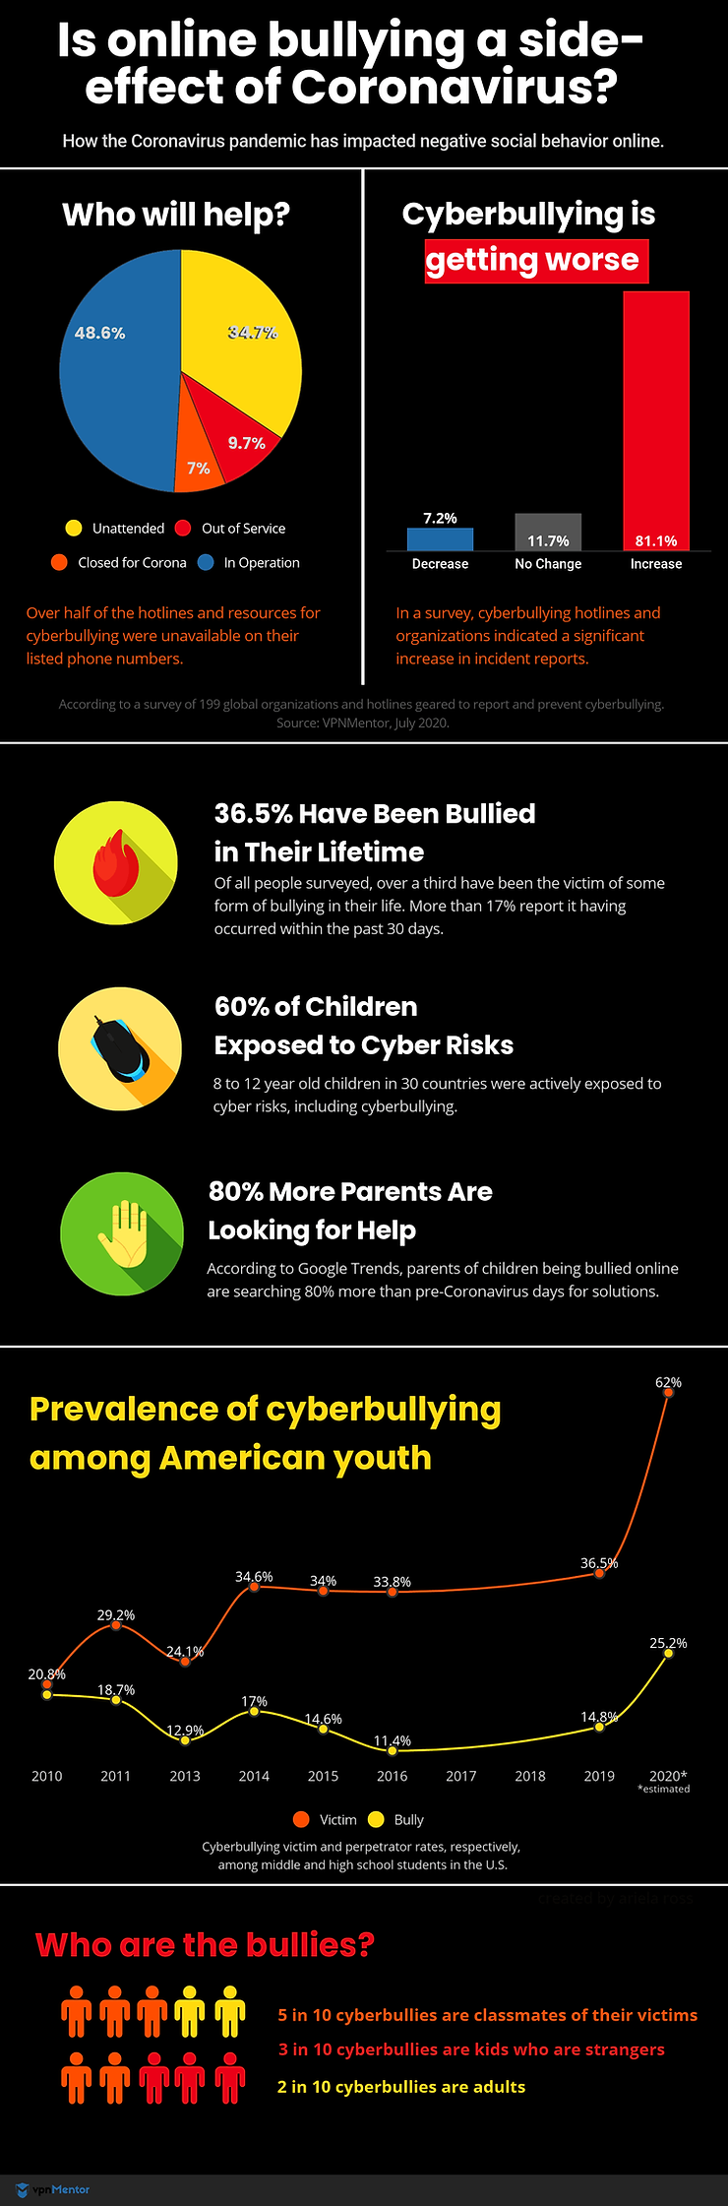

Emerging Challenges
Cyberviolence is not entirely new. Early forms included email-based harassment and cyberbullying. However, the introduction of social media and numerous messaging apps also introduced new means perpetrators can operate in increasingly complex ways. Modern offenders can organize widespread disinformation campaigns or use a deepfake (a video, image, etc. in which a person’s face, body, or voice has been digitally altered so that they appear to be someone else) generator technology to generate explicit content.
Another major hurdle when addressing cyberviolence is how difficult it is to apply traditional legal frameworks to the relatively new, digital cyber domain. Jurisdictional conflicts, anonymity within online platforms, and outdated laws all create complications for law enforcement organizations. This makes effectively prosecuting cases of cyberviolence extremely difficult.
Statistics
Statistic | Figure/Value
Percentage of women globally experiencing online abuse | 38%
Increase in internet usage during lockdown periods | 50–70%
Reported increase in online abuse incidents in some regions | Up to 65%
Girls experiencing more online harassment than street harassment | 50%
Proportion of women reporting at least one form of cyber violence | Approximately 1 in 10 women

Party Challenges and Strategies
Party | Challenges | Potential Strategies
Law Enforcement | Jurisdictional boundaries; Anonymity of criminals | Enhance international cooperation and update legal frameworks to reflect current technology.
Digital Service Providers | Detecting and mitigating harmful content | Develop robust reporting systems; collaborate with authorities and invest in advanced filtering solutions.
Victim Support Organizations | Underreporting and stigma; Lack of specialized services | Launch public awareness campaigns and offer tailored support services, including mental health and legal aid.
Governments and Policymakers | Outdated legal frameworks | Update domestic laws, align with international standards (e.g., the Budapest Convention), and fund new research initiatives.

Moving Forward
The data and trends discussed above emphasis the need for a coordinated, multifaceted response to cyberviolence. Moving forward, several considerations and actions arise for each of these entities.
The global nature of cyberviolence demands international cooperation. Law enforcement must be up to date with technological tools and training to track and prosecute criminals whose crimes extend beyond borders. Updated legal frameworks that are inclusive to technological language will be critical as laws need to be adaptable to evolving forms of digital abuse, avoiding outdated definitions.
Government agencies can also support research initiatives to gain a better understanding of the evolving tactics studied in cybercriminals. Policies based on data can help bridge the gap between digital advancement and legal enforcement. This helps ensure that victims receive justice even as the cyber domain continues evolving.
Social media companies play a large role in the prevention and mitigation of cyberviolence. These organizations should shift to algorithms that detect and flag harmful content quickly. Beyond social media, service providers must establish effective and clear reporting procedures and work with law enforcement to help trace cyberviolence incidents.
Individuals affected by cyberviolence will often face challenges that extend beyond immediate safety concerns. Mental health support, legal assistance, and advocacy are all necessary components of assistance victims should have readily available to them. Organizations should also work to reduce the stigma associated with reporting cyberviolence and ensure that victims have access to comprehensive care. Public awareness campaigns can also help educate individuals about the risks and the resources associated with cyberviolence and its victims.

Glossary
Cyberviolence: The use of computer systems and the internet to commit acts that cause, facilitate, or threaten physical, sexual, psychological, or economic harm. This includes activities such as cyberstalking, harassment, and non-consensual distribution of private information.
Deepfake: A video, image, etc. in which a person’s face, body, or voice has been digitally altered so that they appear to be someone else, typically used maliciously or to spread false information.
Doxing: The practice of researching and publishing private or sensitive information about an individual on the internet without their consent, often with the intent to intimidate or cause harm.

References
Graham, R. S., & Smith, '. K. (2024). Cybercrime and Digital Deviance (2nd ed.). Taylor & Francis. https://bookshelf.vitalsource.com/books/9781040011218
Parker, Rachel. “Cyberbullying in the Age of Covid-19.” Cyberwise, Cyberwise, 20 Oct. 2020, www.cyberwise.org/post/2020-special-report-cyberbullying-in-the-age-of-covid-19.
Dauletova, Umutai, and Hyeonsoo Jeon. “Cyberviolence Disempowers Women and Girls and Threatens Their Fundamental Rights.” UNDP, 25 Nov. 2021, www.undp.org/eurasia/blog/cyberviolence-disempowers-women-and-girls-and-threatens-their-fundamental-rights.

