Chore Incentive Python Project

CYSE 250

Instructor

Hind AlDabagh

By Adam Haas

This program is an interactive game built to help incentivize my two children, 9 years old and 5 years old, to complete various chores each week without being asked. It tracks their progress and offers a reward once enough chores have been completed. This Python project has been created and written with an Intel(R) Core(TM) i7-4770 CPU @ 3.40GHz computer and is operating on the Windows 10 Pro operating system, using Python Version 3.11 and Visual Studio Code. This project was created to demonstrate knowledge of Python code using loops, functions, lists, dictionaries, and socket programing. This program uses a server that runs in the background managing the score levels and prize winnings of the users. The client program is the program used for interface inputting chore completion and offering rewards when goals are reached. The server and client programs regularly communicate recording work completed, prize awards, and total scores.

This project is structured to help our family by encouraging self-motivation to earn future rewards. The children enter their name which coincides with a text file tracks their scores. The program updates and records to the text file as chores are manually logged into the client program as seen in Figure 1.1 and then sent to the server program in Figure 1.2.

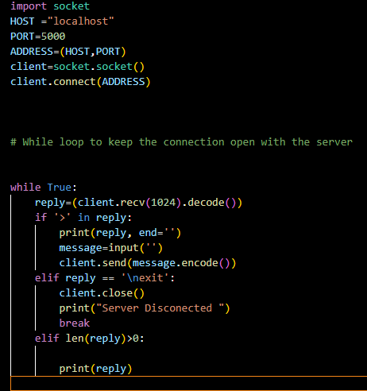

Figure 1.1

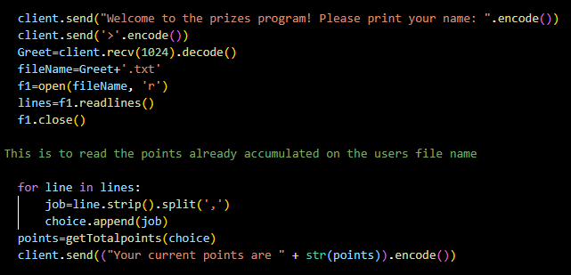

Figure 1.2

The chore options are set up together with the prize options in a dictionary named Choices. Each item in the dictionary contains a list that contains a tuple. The program differentiates between chores and prizes based on their value, choices are a positive number, while prizes are negative numbers. The choices can be observed in Figure 1.3 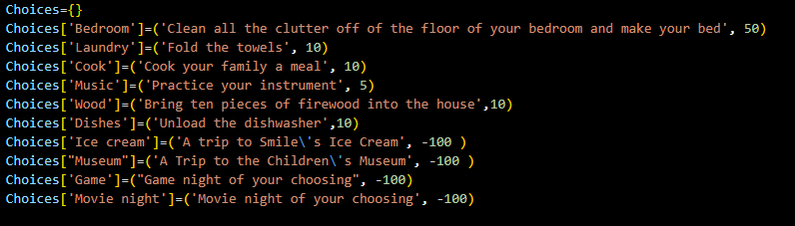

Figure 1.3

The program reads each child's text file to know whether they have enough points for a prize. If enough points are available for a prize, they are prompted to pick one, otherwise they are prompted to keep doing chores. This can be observed on the client’s terminal in Figure 1.4.

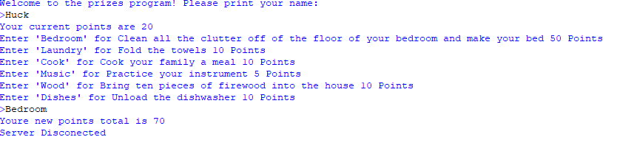

Figure 1.4

This selection and check can be observed through the If, Else statements and For Loops in Figure 1.5. It displays on the client computer when users log on to see what options they have for entry.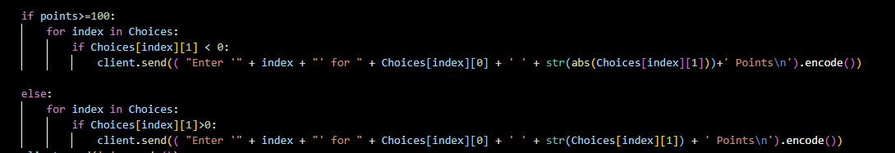

Figure 1.5

If the user memorizes the name of the prizes a check is in place to prevent them from selecting a prize before they have enough points as seen in Figure 1.6. 

Figure 1.6

Once the user responds to the server that a chore was completed it disconnects and is ready to be relaunched for more chores or prize submissions. This program has a function created that automatically combines the earned points with previously awarded points called **getTotalpoints** as seen in Figure 1.7. It was important to make this as its own function since this calculation is made more than once in the program.

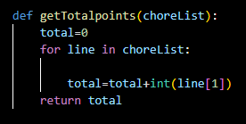

Figure 1.7

Once the predetermined goal value is reached by a user a message is printed on the client computer. “Great job you have earned enough points for a prize. Please log back in to select a prize. The code for this can be observed in Figure 1.8 and once the user logs back in the terminal display of the client can be viewed in Figure 1.9. 

Figure 1.8

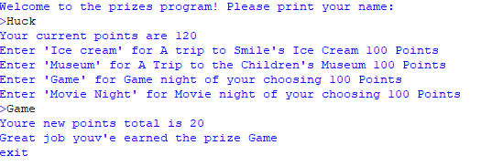

Figure 1.9

Each user has a text file labeled with their name to track their progress and hold the information for future access and record. This can be seen in Figure 1.10 where the user Huck has completed a variety of chores and has selected a prize.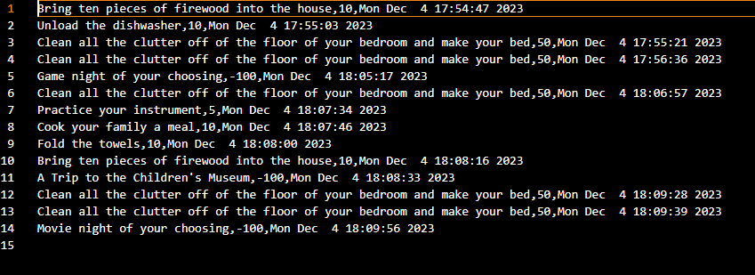

Figure 1.10

A separate text file is used to hold just prize data so the administrator is not challenged by reading all completed work and prizes to find out what rewards need to be paid out. This can be observed in Figure 1.11.

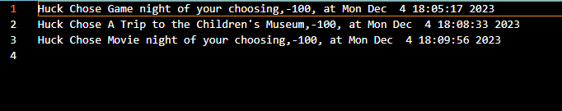

Figure 1.11

This program uses a variety of Python coding techniques like loops, functions, lists, dictionaries, and socket programming to demonstrate my coding knowledge and understanding. The problem solved with this program creates a solution to a challenge that our family regularly faces by helping provide motivation for completion of chores by our children. It does this by requiring their self-motivated work and rewarding them with prizes.