In this assignment, you will act as an hackker to iden7fy the vulnerabili7es in the LAN network and a defender to apply proper countermeasures. You need to provide a screenshot for each task below.
Task A: Sword - Network Scanning (20+ 20 = 40 points)
Power on the listed VMs and complete the following steps from the External Kali (you can use either nmap or zenmap to complete the assignment)
- External Kali
- pfSense
- Ubuntu
- Windows Server 2022
Make sure you didn’t add/delete any firewall policy before conInuing. 1. Use Nmap to profile the basic informa7on about the subnet topology (including open ports informa7on, opera7on systems, etc.) You need to get the service and backend soLware informa7on associated with each opening port in each VM.

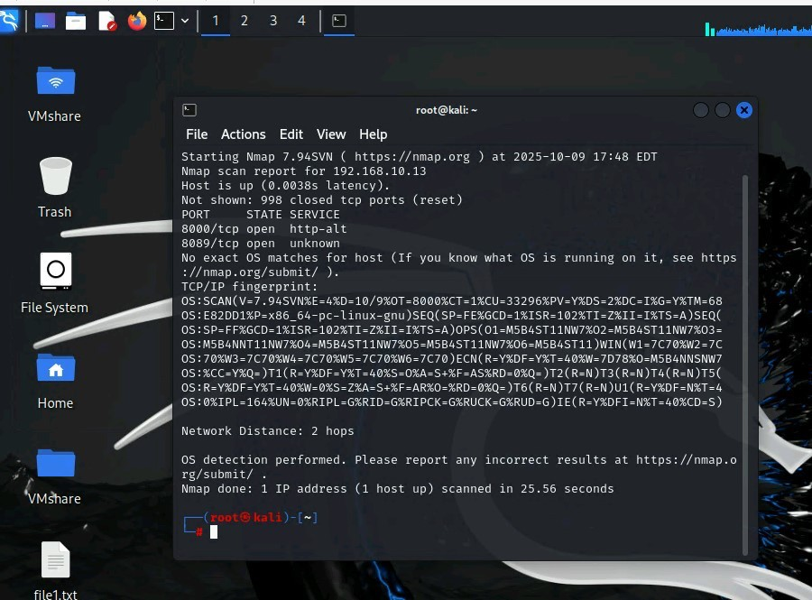

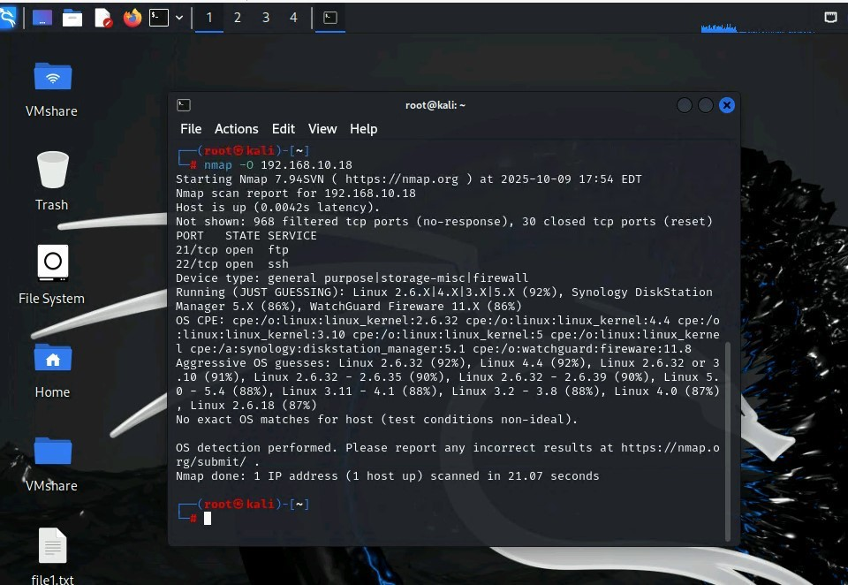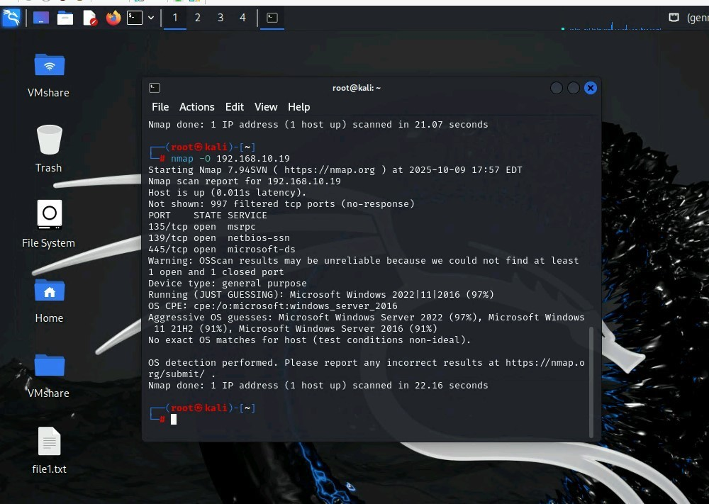

2. Run Wireshark in Internal Kali VM while External Kali is scanning the network. Discuss the traffic pa3ern you observed. What do you find? Please write a 200-word essay to discuss your findings.
Wireshark is showing that it is receiving mul7ple protocols such as ICMP, TCP, and UDP. Wireshark is detec7ng that the machine is trying to connect to the firewall but it is not receiving anything and geWng DNS. There are lso mul7ple reports of ARP which means address resolu7on protocol which means it is trying to find the IP address.

Task B: Shield – Protect your network with a firewall (10 + 10+ 20 + 20 = 60 points)
In order to receive full credits, you need to fill the table (add more rows if needed), implement the firewall rule(s), show me the screenshot of your firewall table, and verify the results. 1. Configure the pfSense firewall rule to block the ICMP traffic from External Kali to Ubuntu VM.
Rule # | Interface | Ac7on | Source IP | Des7na7on IP | Protocol (port # if appliable)
1 | WAN | Block | 192.168.217.3 | 192.168.10.18 | ICMP
[Add the screenshot here]
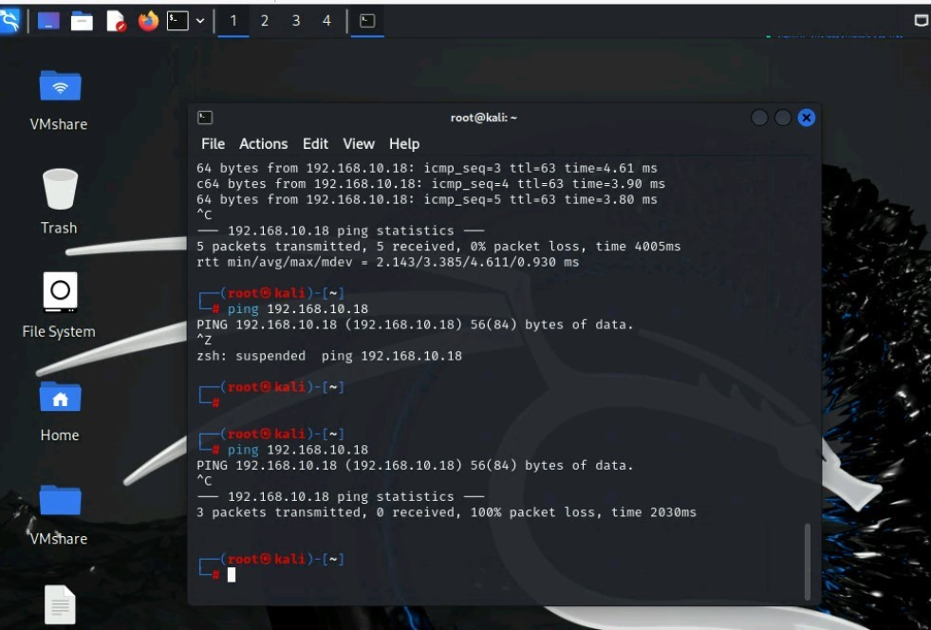

- Clear the previous firewall policies and configure the pfSense firewall to block all ICMP traffic from External Kali to the LAN side.
Rule # | Interface | Ac7on | Source IP | Des7na7on IP | Protocol (port # if appliable)
2 | LAN | Block | 192.168.217.3 | 192.168.10.18 | ICMP

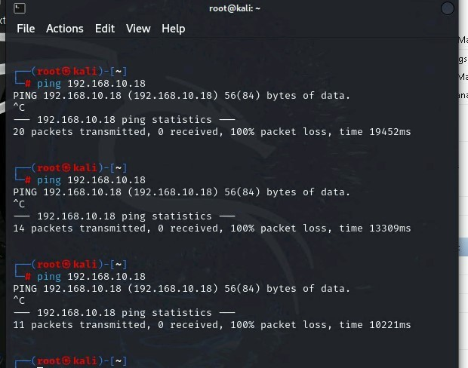
- Clear the previous firewall policies and configure the pfSense firewall to block ALL traffic from External Kali to the LAN side, except for the FTP protocol towards Ubuntu.
Rule # | Interface | Ac7on | Source IP | Des7na7on IP | Protocol (port # if appliable)
3 | LAN | Block | 192.168.217.3 | 192.168.10.18 | 21

