Squamous cell carcinoma is skin cancer that develops in the middle and outer layer of skin. This kind of
cancer can typically be avoided by wearing sunscreen and making sure not to spend too much time in
the sun. While many are slow growing the development of keratoses, new areas of skin with darker
pigmentation, can have potential to become malignant (Springer, 1988). It can be difficult to spot
squamous cell carcinoma, sometimes being mistaken for freckles or moles, as they can vary in size,
shape, and color. Squamous cell carcinoma is highly treatable, especially when caught in the early
stages. There are several treatment options, if it is possible, getting the affected area surgically removed
has been shown to be the best method so far (Webb, 2009). While the idea of searching your body for
any new freckles or moles it is important to remember that they will usually form in areas that are
subject to more exposure to the solar radiation.
Collagens type I, II, and III are units of a sequence of amino acids. Collagen III is a type of fibrillar collagen
that consists of a singular helical alpha chain, which is quite different from the majority of collagens
(Nielsen, 2016). This collagen is secreted by the fibroblasts and other similar cells, it is used as a
structure that keeps tissues and cells connected to each other. It is also an important factor in the
extracellular matrix of skin and various internal organs (Liu, 1997). Experiments run on mice has shown
that collagen III is an important part for fibrillogenesis of collagen I that can be found in many organs.
Collagen III has also been shown to be able to aid in keeping cancer cells dormant for an extended
period of time, with possible methods of treatment revolving around this collagen type being studied.
Hopefully in the future scientists will develop a method that uses the levels of collagen III found in the
body to anticipate and treat cancers before they develop into life threatening diseases.
Drawing 1 of Collagen III
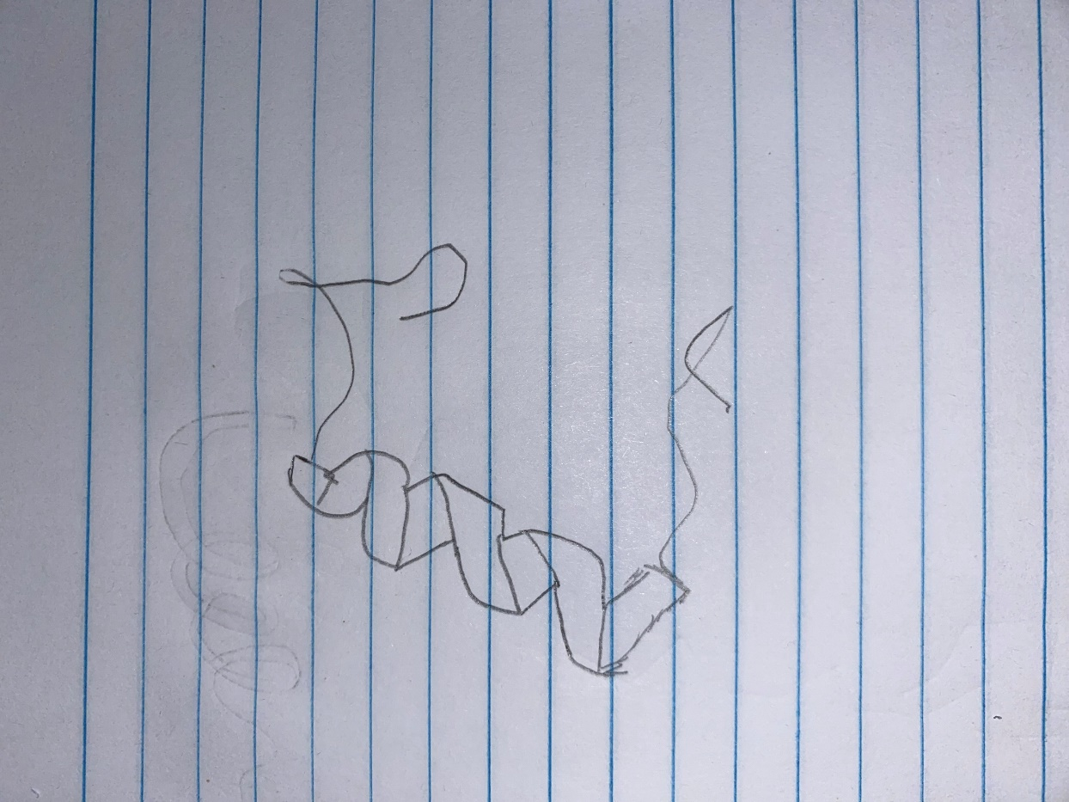
Drawing 2 of Collagen III

According to my research there is a relationship between collagen III and cancer. Simply the collagen has
been shown to sustaining and even inducing the dormancy of cancer cells throughout the whole body.
Collagen III is found in high numbers in the initial stages of life, when the body is growing and
developing. However, an increase in the creation of type I and type III collagens can serve as a possible
route for cancer cells to use as a pathway to penetrate surrounding tissues (Kauppila, 1999). Collagen III
levels have also been shown as a way to test for tumor fibrosis, should collagen III levels rise higher than
normal then there is an increased risk of developing fibrosis (Kauppila, 1999). Fibrosis is a first step for some cancers to develop, but the development of a regular method of testing collagen III levels can lead
to earlier detection of many cancers.
When observing dormant and proliferative tumor cell lines they show their distinctive contrast in the extracellular matrix (ECM). Using structured and aligned ECM, proliferative cells display organization and patterns, meanwhile, dormant cells showcase a more disorganized and chaotic arrangement. This difference is more easily seen when examining colorized images that shows how the linearity is particularly prominent. This truly drives home the difference between dormant and active cell lines. Because an increase in color indicates irregularity in the ECM components, this allows for an easy visual indication of the chaos that is inherent in dormant cell lines while the more organized of the proliferate ECM are mainly monochromatic.
The cell cycle is a necessary part of all biological beings, however, there are several differences between the cell cycle of a single cell vs a metastatic tumor. Normally the cell cycle follows the normal flow of G1, S, G2, and M which is indicative of single cells. Unfortunately, because cancer cells are abnormal, they do not die off after the cells have reached their usefulness and continue to multiply despite being full of mutations and different gene expressions. This means that in the cell cycle of a metastatic tumor, it has diverted from its normal functions and controls. This means that these cells grow and divide uncontrollably as well as migrate throughout the body to settle and grow throughout the body.
Collagen III is an important type of collagen that acts as the structure for tissues and cells in living beings. Researchers discovered the collagen III can start and continuously sustain the dormancy of cancer cells while preventing the spread of cancer through the rest of the body. Between single cells and metastases, single cells have been found to have more collagen III. This illustrates that the metastases are much more likely to be active, multiplying, and going through the cell cycle. According to the bar graph shown solitary cells have close to 1000 collagen III intensity per field while the micrometastases have nearly half that amount.
Incidentally, collagen III also has an effect on tumor size when it is uses the proliferative T-HEp3 cell line. Because collagen III can keep cancer cells in dormancy, it causes the tumor to not grow as quickly and with fewer cells. This experiment resulted in a much smaller tumor with fewer cells when the tumors were injected with collagen III. When compared the T-HEp3 controls grew faster and larger than the T-Hep3 with collagen III. This causes the control T-HEp3 to be considered the active cells while the tumor with the Collagen III is more likely to be dormant.
Through experimentation researchers were able to definitively prove that collagen III does have a major effect on the growth of metastases. According to the data from the figures shown in the video, collagen III was able to successfully demonstrate that it is able to reduce the number of cells going through S/G2 phases. When comparing the graph of the tumor volume vs the days the difference between the growth rates is profound to the point of clearly illustrating the profound influence that collagen III has on impeding the expansion of micrometastases. This proves that collagen III plays a pivotal role on the progression and growth of metastases.
In conclusion, this paper illustrates the pivotal role that collagen III has in influencing the growth and spread of cancer cells within the body. Because of its integral part in detection, cancer cell dormancy, and potential treatment, collagen III has proved to be a crucial factor in human understanding and possible control of the progression of various cancers.
References
Schwartz, R.A. (1988). Squamous Cell Carcinoma. In: Skin Cancer. (New York, NY: Springer) pp. 36-37
Webb, J.L., Burns, R.E., Brown, H.M., LeRoy, B.E., and Kosarek, C.E. (2009). Squamous cell carcinoma.
Europe PMC, https://europepmc.org/article/med/19412903
Nielsen, M.J., and Karsdal M.A. (2016). Chapter 3- Type III Collagen. In Biochemistry of Collagens,
Laminins and Elastin Structure, Function and Biomarkers, M.A. Karsdal, ed. (Academic Press) pp. 21-30
Liu, X., Wu, H., Byrne, M., Krane, S., Jaenisch, R. (1999). Type III collagen is crucial for collagen I
fibrillogenesis and for normal cardiovascular development. Proceedings of the National Academy of
Sciences vol 94(5), 1852-1856.
Kauppila, S., Stenbäck, F., Risteli, J., Jukkola, A., and Risteli, L. (1999). Aberrant type I and type III collagen
gene expression in human breast cancer in vivo. Journal of Pathology vol 186, 262-268.

