**The Effects of Prolonged Exposure to Elevated CO2 Levels on Marine Fish Behavior and Lifecycle**

Alex Howell

School of Biology, Old Dominion University

BIOL 405W: Biology Seminar

Dr. Christopher Osgood

February 17, 2025

**Abstract:**

Rising atmospheric carbon dioxide (CO₂) levels are not only accelerating climate change but are also driving ocean acidification, a process that lowers seawater pH and disrupts marine ecosystems. This paper investigates the effects of prolonged CO₂ exposure on marine fish behavior, physiology, and lifecycle, highlighting the broader ecological implications. Ocean acidification alters water chemistry by reducing carbonate ion availability, which is essential for calcifying organisms like corals and shellfish. These foundational changes ripple through marine food webs, impacting fish species directly and indirectly. Behavioral studies show effects such as increased boldness, impaired predator response, and disrupted foraging. While recent analyses suggest that earlier findings may have overstated some behavioral impacts, consistent evidence remains for sensory impairments, including reduced hearing and smell, which hinder survival and reproduction. In addition to behavioral and sensory changes, physiological stress from acidification can affect growth and metabolism. These impacts are compounded by shifts in migration patterns and ecosystem structures, especially in coral reef habitats. Acidification may even slow the movement of tropical species into temperate zones, altering community dynamics and food web interactions. Despite these challenges, some fish populations demonstrate resilience. Studies at natural CO₂ seeps reveal adaptive traits and genetic changes, suggesting certain species may acclimate to acidified conditions. Predictive models support these findings by forecasting potential ecological outcomes, aiding in conservation planning. Understanding species-specific responses to acidification is essential for predicting future marine biodiversity, managing fisheries, and maintaining ocean health in a rapidly changing world.

**Introduction:**

The rising levels of carbon dioxide (CO2) found in the Earth’s atmosphere have been affecting climate change for many years, which is in turn affecting the water chemistry of oceans. This rise in dissolved CO2 lowers the pH of the water leading to ocean acidification, causing an intense effect on marine life due to the shift in environmental conditions. In particular, fishes and their behavior, life cycles, and physiology can be influenced by continuous exposure to elevated levels of dissolved CO2. Various studies have illustrated the effects on sea life including impaired senses, disruption of migration routes, and even fish development. While there are species that are struggling in the changing environments, there are certain species that have been able to adapt, leading scientists to research how and why they are able to adapt so readily. The ability to understand why these changes are so crucial for scientists to predict the cascading effects of ocean acidification on global food security, marine biodiversity, and fisheries. This research article explores the long-term effects that rising levels of CO2 have on marine fish behavior, lifestyles, and even lifecycles by illustrating the larger ecological and economic implications of the changing environment.

**Content Area:**

**Mechanisms of Ocean Acidification and Its Ecological Impact:**

The rising levels of carbon dioxide (CO2) in the atmosphere are affecting climate change across the globe, including affecting the water chemistry of the world’s oceans. As the seawater absorbs the CO2 carbonic acid is formed which lowers the overall pH of the ocean, this process is called ocean acidification. From the records of past research, it is a known fact that the ocean had maintained a relatively stable pH around 8.1, however, recent studies indicate that this has already dropped 0.1 units with projections predicting another 0.3-0.4 units dropped by turn of the 22nd century. This may not seem like a noticeable drop but keep in mind that each point on the pH scale represents a difference of ten times the strength, so a drop from 6 to 5 makes an acid ten times stronger than it was originally. This increase in acidification implies a significant shift for marine ecosystems. One major concern is the reduction in the availability of carbonate ions, which are essential in the creation and formation of skeletons and shells of organisms such as plankton, corals, and mollusks, which are made from calcium carbonate. A reduction in population for these species has the ability to cause dramatic ripples effects throughout marine food webs. The research presented by Mandal and Baag (2022) emphasizes that the chemical shifts in the ocean affect marine life from broad ecosystem structures such as trophic dynamics and biodiversity to molecular processes like gene expression. Additionally, Mandal et al. (2022) presents a mathematical model that provides insights and predictions on how these observed changes have the ability to disrupt the survival of marine species, potentially aiding future environmental management and conservation efforts.

**Behavioral Changes in Marine Fishes:**

Early studies on the behavioral impact of ocean acidification have illuminated some consequences with alarming impacts, including altered foraging habits, increased boldness, and impaired predator detection, which can lead to higher mortality rates. Initially, these changes were thought to be connected to a disruption in the function of neurotransmitters in fish brains, caused by elevated CO2 levels. Laboratory experiments, such as those conducted by Radford et al. (2021), have shown that exposure to elevated CO₂ concentrations significantly impairs auditory processing in fish, affecting their ability to detect predators and navigate complex reef environments. In these controlled lab settings, fish demonstrated reduced startle responses and altered swimming patterns in response to auditory cues.

In another experiment, Spatafora et al. (2022) studied the Mediterranean anemone goby (*Gobius incognitus*) in laboratory tanks with chronically elevated CO₂ levels. Their findings revealed limited behavioral changes compared to control groups, suggesting a species-specific tolerance. The controlled lab setup allowed researchers to isolate CO₂ as a variable, ensuring that observed behaviors—such as refuge-seeking and response to unusual objects—were directly influenced by acidified conditions.

Unfortunately, these results have been called into question due to recent meta-analyses. Clements et al. (2022) introduced the idea of a “decline effect,” noting that some of the strongest reported behavioral impacts in early studies may have been overstated. Their meta-analysis advocates for ongoing testing using improved methodologies and larger sample sizes. Despite the variety in results and findings, there is strong evidence that implies sensory impairments, like diminished olfactory capabilities and hearing that persist in more recent studies with more refined and modern processes and techniques (Radford et al., 2021).

While these impairments may not manifest as obvious changes in behavior but still affect reproductive success and survival. This conflicting data emphasizes the complex effects that elevated CO2 levels may have on marine fish behavior and the importance of flexible and variable, long-term research projects. It also highlights the necessity for long-term and species-specific laboratory research to truly understand how elevated CO₂ affects marine organisms.

**Shifts in Ecosystem Dynamics and Migration Patterns:**

Climate stressors such as warming create a compound effect on marine ecosystems which is amplified by ocean acidification. One of the biggest consequences of ocean acidification is the disruption migratory patterns of marine species, in particular a process called “tropicalization.” This process illustrates how tropical fishes move into more temperate waters as a result of their original habitats becoming uninhabitable for them. However, research conducted by Coni et al. (2021) suggests that the rising acidification of marine ecosystems could possibly inhibit this type of migration due to the decline of coral reefs and changing community structures. These changes in structure impact the availability of habitats, limiting successes of migratory species in establishing a more permanent residence in these areas. Incidentally, these disruptions cause a cascade effect throughout the food web, forever altering community makeups, predator-prey relationships, and the overall function of the ecosystem. Understanding the research of Hill and Hoogenboom (2022) emphasizes that the degradation of coral reefs leads to a loss in habitats that are essential for reef-dwelling fish which reduces the capability of supporting their original species diversity. The combination of acidification and warming in our oceans presents a complex threat to marine fishes’ ecological roles and spatial distribution.

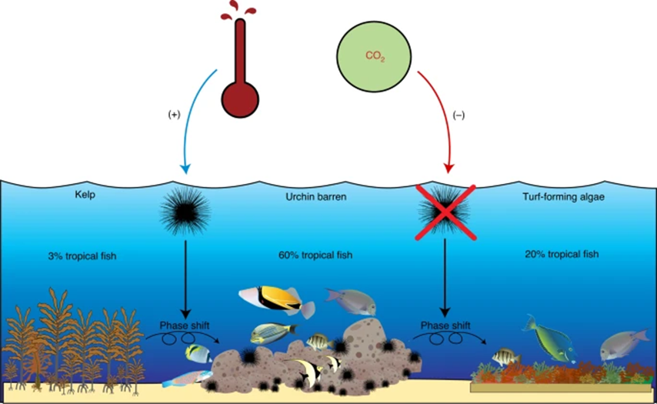

Fig. 1: Schematic depicting the potential direct, indirect, negative, and positive effects of ocean warming and ocean acidification on sea urchin-induced habitat phase shifts and the cascading effects on species richness of range-extending tropical fishes in temperate ecosystems.

(Coni et al., 2021)

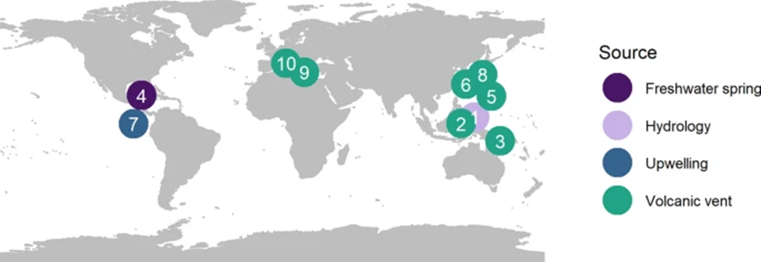

Fig. 2: This figure indicates the location of the ten naturally acidified sites with associated corals which are observed in this study, ordered by smallest to largest decrease in coral cover. 1- Rock Island Bays, Palau; 2- North Sulawesi and Maluku Provinces, Indonesia; 3- Dobu, Esa’Ala and Upa-Upasina, Papua New Guinea (PNG); 4- Puerto Morelos, Mesoamerica; 5- Maug, Commonwealth of Northern Mariana Islands (CNMI); 6- Iwotorishima, Japan; 7- Galapagos, Eastern Tropical Pacific (ETP); 8- Shikine, Japan; 9- Panarea, Italy; 10- Ishia, Italy. These areas are used to observe general impacts on reef health and structure that affects marine fish species.

(Hill et al., 2022)

**Sensory and Physiological Disruptions in Marine Fishes:**

Like terrestrial organisms, marine fish rely on their senses to navigate their environment, locate prey, communicate, and avoid predators. The rising levels of dissolved CO2 have shown researchers that the sensory systems for fish like hearing and smell have been impaired. These impairments have been shown to have substantial ecological impacts, especially when the behaviors are not immediately observable.

Radford et al. (2021) documented these effects by conducting controlled laboratory experiments that exposed juvenile reef fish to elevated CO₂ levels consistent with projected end-of-century ocean conditions. They used auditory playback of predator sounds and ambient reef noise in tank settings, measuring the fishes’ behavioral responses such as freezing, avoidance, or increased movement. Compared to control groups, the acidified groups displayed significantly reduced responsiveness to acoustic cues, indicating compromised hearing and increased vulnerability to predators.

Additionally, Suresh et al. (2023) examined molecular responses by analyzing the brain transcriptomes (gene expression profiles) of gobies living in natural CO₂ seep environments. These gobies, exposed to elevated CO₂ over multiple generations, showed changes in the expression of genes related to neurological function, stress response, and metabolism. This genomic evidence suggested that extended exposure to high acidification alters neural pathways, potentially explaining observed behavioral and sensory impairments.

Physiological effects were also documented by monitoring respiration rates, metabolic efficiency, and growth patterns under varying CO₂ conditions. For instance, studies cited by Mandal et al. (2022) used laboratory simulations to demonstrate that fish in acidified tanks had increased metabolic costs, which can reduce energy available for growth and reproduction. These combined methods—from behavioral observation in lab tanks to genomic profiling and metabolic assays—paint a clearer picture of how ocean acidification affects marine fish beyond surface-level behavior. They also emphasize the importance of integrating both short-term lab studies and long-term environmental monitoring to fully understand the scope of acidification's effects.

**Adaptation and Resilience of Marine Fish Species:**

Despite the negative impacts of ocean acidification, there are some populations of fish that illustrate promising indicators of adaptation to their changing environments. The discovery of natural CO2 seeps, which are cracks in the earth’s crust that allow for the gas to leak out in mass, where fish populations are exposed to higher concentrations of CO2 over multiple generations. The research provided by Petit-Marty et al. (2021) indicates that some species that reside in these types of environments show particular traits indicative of adaptation that help mitigate the effects that ocean acidification has on marine organisms. For example, analysis on the brain transcriptomes, which are equivalent to gene expression profiles, of gobies residing in areas with CO2 seeps uncovered particular molecular changes that are linked to acclimation (Suresh et al., 2023). The presence of these genetic adaptations indicates that some species of marine fish have the ability to adapt to the conditions of ocean acidification at a biological level. Likewise, Spatafora et al, (2022) discussed the behavioral changes observed in other fish species and how they were limited in populations of Mediterranean gobies that resided in areas with CO2 seeps, which further supports the idea that particular species can tolerate increased acidity. These results allow researchers to find a potential path towards resilience for species, although the course and time it takes for adaptation may have a wide variety depending on the ecosystem and species.

**Long-Term Ecological Implications and Predictive Modeling:**

In the long-term, the impacts of ocean acidification on the biodiversity of marine organisms remain deeply concerning and uncertain. To better understand and potentially predict the impacts of ocean acidification, researchers have developed mathematical models to simulate the responses the ecosystem will have to the rising CO2 levels. The model proposed by Mandal et al. (2022) predicts the potential changes in marine fish populations and their dynamics as well as their interactions with other species. Models like this are essential for fisheries and marine conservation efforts by allowing them to prepare ecological shifts before they reach their tipping points. Research presented by Timmer et al. (2021) indicates that overall richness of species remained reasonably stable in coral reefs despite the shift in cryptobiota due to ocean acidification and warming. These findings are indicative of a possible ecological resilience, in particular areas with diverse communities paired with a high capacity for adaptation. In the end, the future for marine fish populations under the effects of ocean acidification depends on a combination of the adaptive responses of individual communities and species and environmental stressors.

**Conclusion:**

With the continuing rise in atmospheric CO₂ levels, ocean acidification remains one of the most significant threats to marine ecosystems. This process begins at the chemical level, altering seawater pH and resulting in widespread impacts that ripple through marine food webs—from coral reef degradation to behavioral and physiological disruptions in fish.

Recent advancements in laboratory experimentation have shed clearer light on the scope of these disruptions. Controlled tank studies have confirmed impairments in predator detection, foraging, and auditory processing under elevated CO₂ conditions, while transcriptomic analyses of fish from natural CO₂ seep sites reveal underlying molecular adaptations. These lab-based methods provide robust, repeatable frameworks for observing subtle changes in sensory systems and physiological stress responses, strengthening our understanding of acidification’s impact on marine life.

Although initial research may have overstated some behavioral consequences, updated methodologies confirm that many species still face considerable risks. Yet, amidst these challenges, evidence of acclimation—particularly in species dwelling near natural CO₂ seeps—offers hope. These fish display adaptive gene expressions and reduced behavioral sensitivity to acidified conditions, suggesting that resilience is possible in some populations.

Looking forward, the integration of experimental data, molecular biology, and ecological modeling will be essential for predicting how different species respond to long-term acidification. This knowledge is critical for developing targeted conservation strategies, managing sustainable fisheries, and safeguarding marine biodiversity in an era of rapid environmental change.

Annotated Bibliography

Baag, S., & Mandal, S. (2022). Combined effects of ocean warming and acidification on marine fish and shellfish: A molecule to ecosystem perspective. Science of the Total Environment, 802, 149807.

The comprehensive overview of the authors illustrates the effects of ocean warming and acidification on many biological levels of marine fishes and shellfish, a popular food choice for many marine species, through the smallest molecular changes to shifting entire ecosystems. Focusing on the rising levels of CO2 and the impact on fish survival, behavior, and physiology allows the reader to understand the ecological consequences through the use of critical thinking. This particular study is valuable because it allows for predicting long term effects of high levels of CO2 on marine fishes and biodiversity.

Clements, J. C., Sundin, J., Clark, T. D., & Jutfelt, F. (2022). Meta-analysis reveals an extreme “decline effect” in the impacts of ocean acidification on fish behavior. PLoS biology, 20(2), e3001511.

The revelation of a “decline effect” that is shown in this meta-analysis indicates that the initial studies on fish behavior and ocean acidification may have been overestimating their impacts. This paper questions previous claims of drastic behavior changes in marine fishes caused by high CO2 levels by analyzing numerous data sets. It emphasizes the importance of reviewing older research with more modern methods, allowing for refinement of the predictions of the impact of ocean acidification on marine fish behavior. This article also allows the audience to view a different perspective on this long thought issue with the ocean ecosystem.

Coni, E. O., Nagelkerken, I., Ferreira, C. M., Connell, S. D., & Booth, D. J. (2021). Ocean acidification may slow the pace of tropicalization of temperate fish communities. Nature Climate Change, 11(3), 249-256.

This article explores the predicted effects of ocean acidification on the migration of tropical fishes into more temperate climates, called tropicalization. The authors suggest that higher CO2 levels may affect species migration patterns and interactions by altering the structure of the community as a whole. This allows the reader to understand how crucial these dynamic predictions on the shifting distributions of fish species due to climate change are. The inclusion of an incredibly useful illustration depicting the positive and negative effects of oceanic acidification will further assist in the audience’s understanding of the study.

Hill, T. S., & Hoogenboom, M. O. (2022). The indirect effects of ocean acidification on corals and coral communities. Coral Reefs, 41(6), 1557-1583.

While this paper focuses on corals, it emphasizes indirect effects of rising CO2 levels on coral reef ecosystems as a whole, which are treasure troves of many marine fishes. By illustrating the impact of reef health and structure on marine fishes that rely on this particular ecosystem for shelter and food the authors give me a vast amount of important building blocks for my paper. This information is crucial for evaluating the effects of ocean acidification on many marine species including numerous species of fishes. There is also a figure depicting the location of 10 naturally acidified sites across the planet where there is measurable loss of coral cover in coral reefs due to ocean acidification that would be incredibly helpful for my presentation.

Mandal, S., Islam, M. S., Biswas, M. H. A., & Akter, S. (2022). A mathematical model applied to investigate the potential impact of global warming on marine ecosystems. Applied Mathematical Modelling, 101, 19-37.

Through the use of mathematical modeling, this study interprets and predicts various impacts of the rising levels of dissolved CO2, causing ocean acidification, on marine ecosystems. By using quantifying analysis to illustrate the potential disruptions in species survival rates and food webs, this paper illustrates the possibility of population decline or adaptation for marine fishes. The mathematical approach of this paper is an important tool in the process of conservation planning as well as management of sustainable fisheries.

Petit‐Marty, N., Nagelkerken, I., Connell, S. D., & Schunter, C. (2021). Natural CO2 seeps reveal adaptive potential to ocean acidification in fish. Evolutionary Applications, 14(7), 1794-1806.

The research in this paper focuses on natural CO2 seeps and the fish populations that call them home, allowing for insightful understanding of marine fishes’ ability to adapt to acidic environmental conditions. It also provides evidence of possible paths of evolution that would allow certain fishes to live and thrive in high CO2 environments. These remarkable scientific contributions allow the reader to understand the flexibility and resilience of marine fishes for potential changes in oceanic environments.

Radford, C. A., Collins, S. P., Munday, P. L., & Parsons, D. (2021). Ocean acidification effects on fish hearing. Proceedings of the Royal Society B, 288(1946), 20202754.

The investigation on the effects of ocean acidification, focusing on fishes’ sense of hearing, which is done in this paper depicts the changes found in sensory function involving predator avoidance, navigation, and communication. It focuses on possible interferences in fish survival and behavior due to reduced auditory processing. These views are essential for understanding the unseen but potentially dangerous consequences of rising ocean acidification on marine fishes.

Spatafora, D., Cattano, C., Aglieri, G., Quattrocchi, F., Turco, G., Quartararo, G., ... & Milazzo, M. (2022). Limited behavioural effects of ocean acidification on a Mediterranean anemone goby (Gobius incognitus) chronically exposed to elevated CO2 levels. Marine Environmental Research, 181, 105758.

This paper demonstrates the potential for marine fishes to acclimate to high CO2 levels by studying the Mediterranean anemone goby and the limited behavioral changes that were observed in their populations. This study is suggestive of the ability some marine fish species have to tolerate the rising acidification in their environments. It also emphasizes the importance of honing risk assessments for rising dissolved CO2 levels in marine biodiversity.

Suresh, S., Mirasole, A., Ravasi, T., Vizzini, S., & Schunter, C. (2023). Brain transcriptome of gobies inhabiting natural CO2 seeps reveal acclimation strategies to long‐term acidification. Evolutionary Applications, 16(7), 1345-1358.

Through the analysis of the brain transcriptome of goby populations that are found living in natural CO2 seeps, this paper illustrates changes in gene expression that are linked to extended acidification exposure. The provided molecular evidence demonstrates potential strategies for acclimation, thus assisting in the general understanding of the effects of the changing ocean chemistry and the biological adjustments of marine fishes. With the inclusion of maps and graphs that illustrate the studied environment and the scale of the affected areas, this analysis encourages the audience to employ critical thinking and comprehension.

Timmers, M. A., Jury, C. P., Vicente, J., Bahr, K. D., Webb, M. K., & Toonen, R. J. (2021). Biodiversity of coral reef cryptobiota shuffles but does not decline under the combined stressors of ocean warming and acidification. Proceedings of the National Academy of Sciences, 118(39), e2103275118.

With a focus on enigmatic organisms, this paper examines the effects of ocean warming and acidification on the biodiversity of coral reefs. Despite shifts in the composition of the observed species there is no discernable reduction in overall biodiversity. This implies that the populations of fishes that depend on these habitats are a perfect example of the effects of acclimation to the changing climate in marine ecosystems. Also used in this paper are several graphs that I intend to use for my own presentation that show the various reactions that observed species have to controlled, acidified, heated, and acidified heated environments.