Old Dominion University
CYSE 270 Linux System for Cybersecurity
Assignment #4 Group and User Accounts

01127384
Alysia Beckles

Below is the snippet of a sample lab report.
Task A
- Open a terminal window.
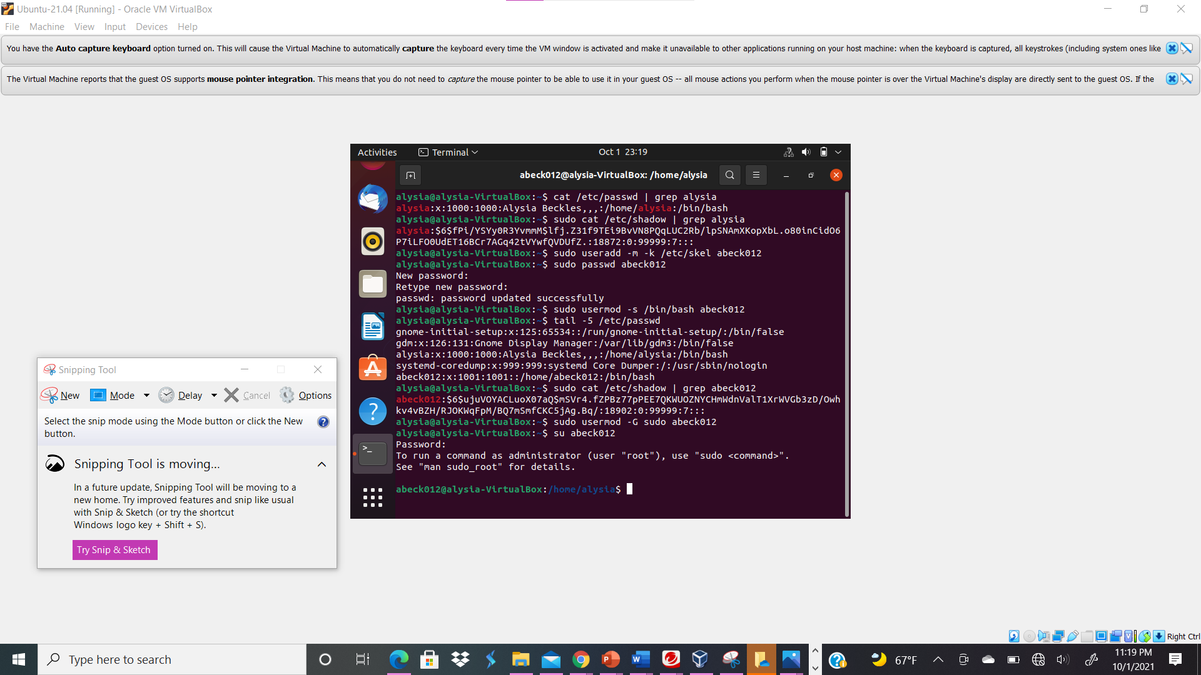
Your explanation goes here. For example:
I opened the terminal for Ubuntu.
- Execute the correct command to display user account information (including the login shell and home directory) for the current user using grep.
Your explanation goes here. For example:
In order for me to display user account information for the current user utilizing grep, I typed cat /etc/passwd | grep Alysia. Cat /etc/passwd shows all user information while grep command gets information from the user account.
- Execute the correct command to display user password information (including the encrypted password and password aging) for the current user using grep.
Your explanation goes here. For example:
I typed the command sudo cat /etc/shadow | grep Alysia in order to see the password information such as encrypted password and password aging; I can also see the current user.
- Create a new user named xxxxx and explicitly use options to create the home directory /home/xxxxx for this user.
Your explanation goes here. For example:
I utilized the command sudo useradd -m -k /etc/skel abeck012 to create a new user named after my MIDAS, and utilized options to create the home directory /home/abeck012 for my new abeck012 user. Useradd enables me to add users while /etc/skel allows me to contents of a specific directory is copied to the new user’s home directory. Also -m allows me to create a user’s home directory while -k enables me to override /etc/login.defs defaults.
- Set a password for the new user.
Your explanation goes here. For example:
I typed the command sudo passwd abeck012 in the terminal to create a password for my new user account.
- Set bash shell as the default login shell for the new user xxxxx, then verify the change.
Your explanation goes here. For example:
In order to set bash shell as the default login shell for the new user abeck012 I typed the command sudo usermod -s /bin/bash abeck012. To verify the change I typed tail -5 /etc/passwd to see the users at the end of the first five lines.
- Execute the correct command to display user password information (including the encrypted password and password aging) for the new user xxxxx using grep.
Your explanation goes here. For example:
I utilized the command sudo cat /etc/shadow | grep abeck012 to showcase user password information for my new user abeck012 using grep. Cat /etc/shadow command displays emcrypted passwords and password aging.
- Add the new user xxxxx to sudo group without overriding the existing group membership.
Your explanation goes here. For example:
In order to add the newuser abeck012 to the sudo group without overriding the existing group membership, I typed sudo usermod -G sudo abeck012; the -G prevents the command from completely replacing the sudo membership. -G enables abeck012 to join the sudo membership.
- Switch to the new user’s account, then continue Task B.
Your explanation goes here. For example:
In order to switch my user account from Alysia to abeck012, I typed su abeck012 in the terminal.
Task B
- Open a terminal window and determine the shell you are using.
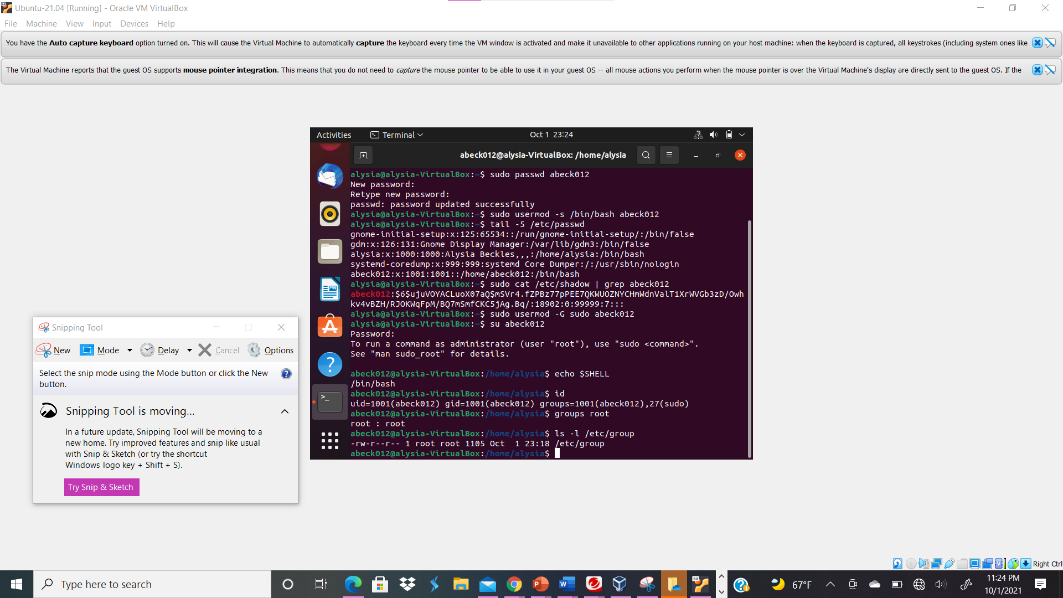
Your explanation goes here. For example:
I typed the command echo $SHELL to determine the shell that I was utilizing, which was /bin/bash.
- Display the current user’s ID and group membership.
Your explanation goes here. For example:
I typed the command id in the terminal in order to see the user’s ID and group membership. The UID, GID, and groups such as abeck012 and sudo listed.
- Display the group membership of the root account.
Your explanation goes here. For example:
I typed the command groups root in order to showcase the membership of the root account.
- . Run the correct command to determine the user owner and group owner of the /etc/group file.
Your explanation goes here. For example:
I typed the command ls -l /etc/group to see the user owner and group owner of the /etc/group file. It appears that the user/owner root had ownership of /etc/group.

- Create a new group named test and use your UIN as the GID.
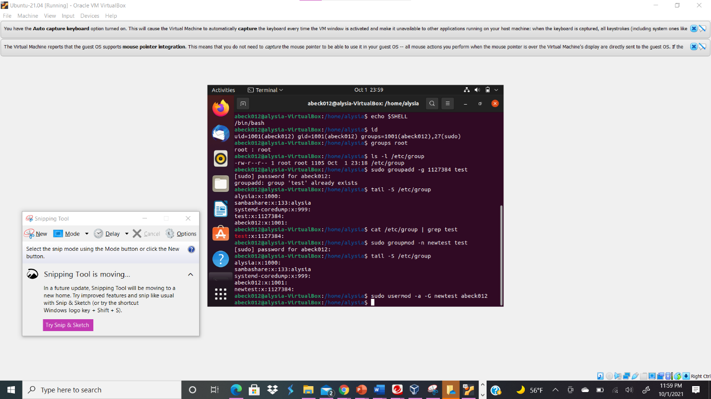
Your explanation goes here. For example:
I created the group test and changed the GID to my UIN by typing sudo groupadd -g 1127384 test in the terminal. The -g enables me to choose the GID to the test group.
- Display the group account information for the test group using grep.
Your explanation goes here. For example:
The command cat /etc/group | grep test enabled me to see the test group account information in the terminal.
- Change the group name of the test group to newtest.
Your explanation goes here. For example:
In order to change the group name from test to newtest, I typed the command sudo groupmod -n newtest test. -n enables me to change the group name.

- Add the current account (xxxxx) as a secondary member of the newtest group without overriding this user’s current group membership.
Your explanation goes here. For example:
I typed the command sudo usermod -a -G newtest abeck012 in order to append the new group to the user’s secondary group. -G is meant to not override the user’s current group membership while -a appends the command.
- Create a new file in the account’s home directory, then change the group owner to newtest.
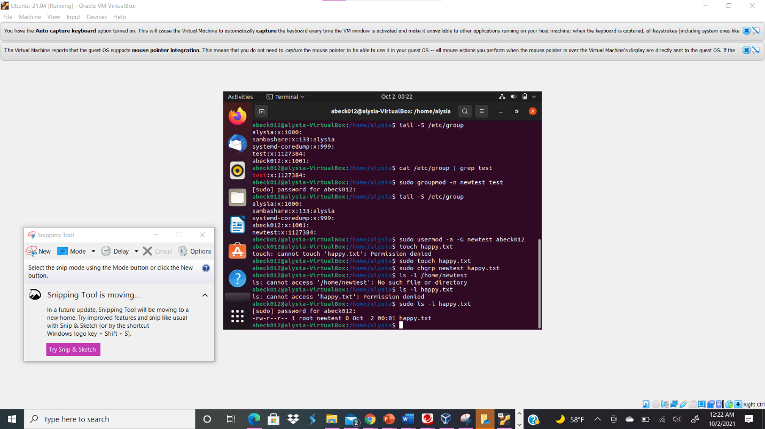
Your explanation goes here. For example:
I typed sudo touch happy.txt in the terminal in order to create a new file. The command sudo chgrp newtest happy.txt enabled me to change the group owner of the file to newtest. Therefore, the group newtest had ownership over the happy.txt.
- Display the user owner and group owner information.
Your explanation goes here. For example:
I typed the command ls -l happy.txt to see the user owner and group owner information; the group newtest had ownership of the happy.txt file.
- Delete the newtest group, then repeat the previous step. What do you find?
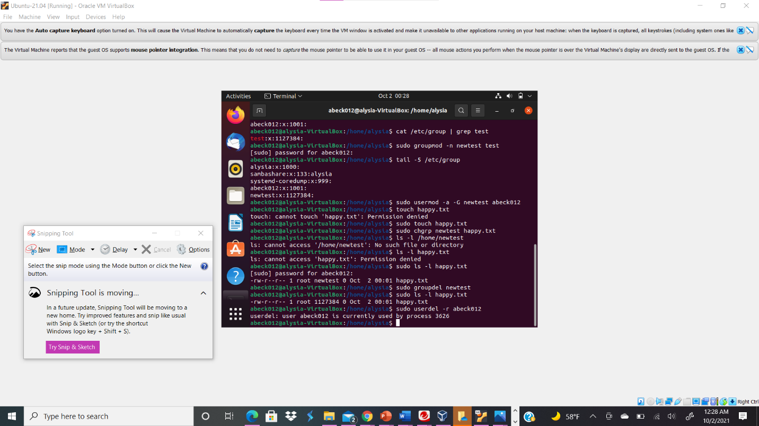
Your explanation goes here. For example:
I deleted the newtest group by typing sudo groupdel newtest. Then, I retyped ls -l happy.txt to see the the group newtest no longer had ownership of the file nor existed.

- Delete the user xxxxx along with the home directory using a single command.
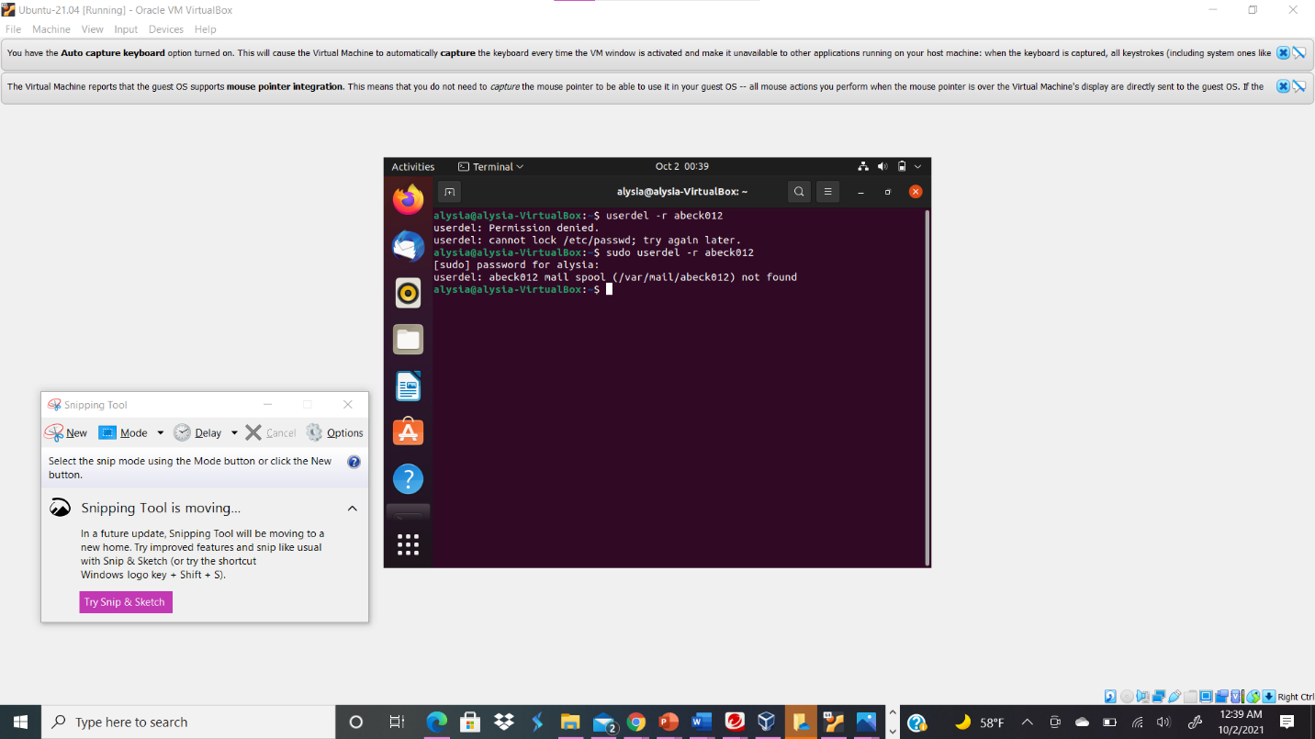
Your explanation goes here. For example:
I typed sudo userdel -r abeck012 in terminal because I wanted to delete the abeck012 user account along with the home directory.

